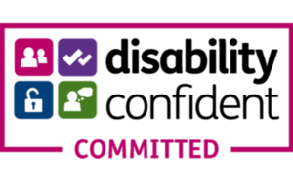

Bradley Stoke Town Council is a Disability Confident Committed employer

Bradley Stoke Town Council
is seeking a Zero hours contract/Bank

Leisure Assistant/Caretaker

Working across three Town Council sites in Bradley Stoke (Brook Way Activity Centre, Baileys Court Activity Centre and the Jubilee Centre, duties include monitoring and securing the buildings and grounds, rooms cleaned and prepared for hire, working on each site as required. The preparation of sites includes room layouts, cleaning, site maintenance, key holding, monitoring sports facilities and preparing/ removing sports equipment. Computer literacy and ability to complete mandatory checks, some cash handling and paperwork essential. Post holder will need good communication skills whilst working as part of a team and be able to deal with enquiries from members of the public, representing Bradley Stoke Town Council at all times.

Zero hours ~ on a pre-planned rota system (generally between 8am and 10pm and will include some weekend working)

Hourly Rate: £10.79 - £11.18 per hour
NJC Scale 3 – 5 (dependent on experience)

For an application form and a job description please visit the Bradley Stoke Town Council website (www.bradleystoke.gov.uk) or phone 01454 205020 or email: philip.francis@bradleystoke.gov.uk

Closing date for applications: Thursday 6th April 2023

