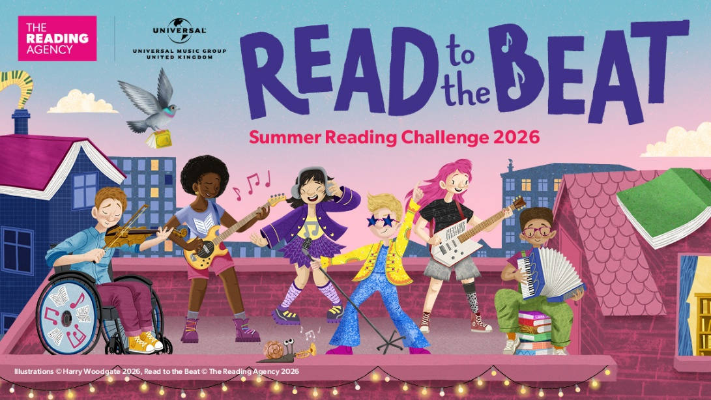

Join the Summer Reading Challenge 2026: Read to the Beat FREE at your local library and earn stickers and rewards!

Every child aged 4 and above is invited to take part! Children read any books they enjoy and take part in fun activities over the summer holiday to collect stickers and rewards including a medal and certificate.

Join the Summer Reading Challenge 2026: Read to the Beat at a South Gloucestershire library during staffed hours from Saturday 4 July finishing by Saturday 12 September, and pick up your FREE activity bag.

See the difference the Summer Reading Challenge makes to your child’s reading:

“I am a foster carer to the 2 boys, so it was lovely to widen the range of books available to them. Also, it was great to see their motivation and sense of achievement at completing the challenge.” (Downend Library)

“I love that the reading challenge happens each year. My child struggles with English and reading so this is brilliant for him and keeps him off his tech. It’s a great skill to have.” (Patchway Library)

“My 10 year old - dyslexic – not a keen reader, has loved the dyslexia section and has really enjoyed the books she’s chosen and has been really keen to come back to the dedicated section to choose another book.” (Staple Hill Library)

Children love taking part and there are lots of fabulous FREE holiday activities: West African Drumming Workshops with Batch Gueye, Crafts, Junk Modelling Workshops and Lego™ Challenges.

The Summer Reading Challenge is delivered by The Reading Agency in partnership with public libraries and powered by Universal Music Group UK.
Find out more at www.southglos.gov.uk/summerreadingchallenge or follow us on Facebook www.facebook.com/sgloslibraries for the latest updates.


