

Bradley Stoke
Youth Work

Youth Work Curriculum Framework
(Bradley Stoke Town Council has based their Youth Work Curriculum on the adoption of the National Youth Agencies National Youth Work Curriculum document: March 2024) – originally adopted by Bradley Stoke Town Council on 14th August 2023,
Updated 26th October 2026

Contents
Foreword 4
What is youth work and its curriculum? 5
Introduction 7
How can this document be used? 8
Explaining the model 9
Cornerstones of youth work 9
Values and principles of youth work 10
The youth work process 11
Trust 11
Safe environments 11
Voluntary Participation 11
Process and praxis 12
Youth work themes 15
Identity and belonging 15
Health and wellbeing 16
Healthy relationships 16
Economic and financial wellbeing 17
Leadership, civic engagement, and participation 17
Arts, culture, and heritage 18
Creativity and fun 19
Global citizenship 20
The environment and sustainable development 20
Skills development 21
Related professions 22
Appendix 23
Informing practice 23
National Occupational Standards 24
Quality Standards 25
Legislation 26
Key organisations 27
Further Information 28

Foreword
It is over 30 years since a youth work curriculum for England was suggested. Those discussions led to a wide range of curricula being produced by local authority areas. Although they were different in many ways, they had key things in common: they set out the youth work process, its potential outcomes and a common set of themes that youth work can support.
The intervening years have seen many changes to and reductions in the provision of youth work and youth services. There is no common model for delivery across the country, and there is no equity in resources available in different areas. In some areas, open-access youth work is still provided by the local authority alongside more targeted work and is often in partnership with the voluntary sector. In others, the local authority has pulled back, and the voluntary sector is delivering all youth work services for young people. There are also areas where youth work has disappeared, and with it, the understanding of what youth work is, what it does both for and with young people and how it is an important part of the education of and support provision for young people.
This curriculum framework makes it clear that youth work is a form of education; it sets out what it is and how to apply the principles and values that underpin it. Our curriculum begins with young people as a starting point and builds our support and youth work practice around them, their peers and their communities.

Leigh Middleton Chief Executive NYA

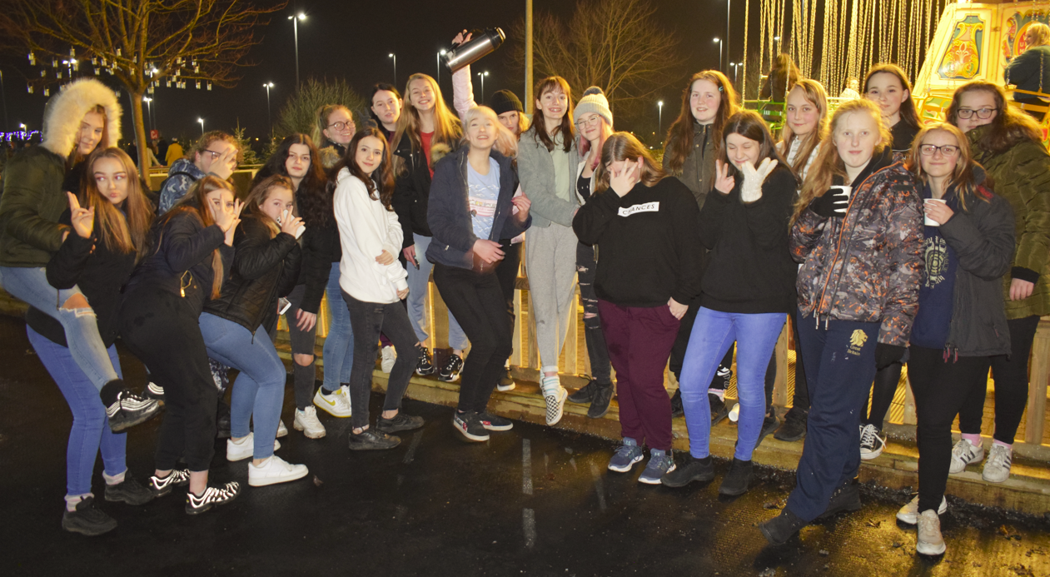

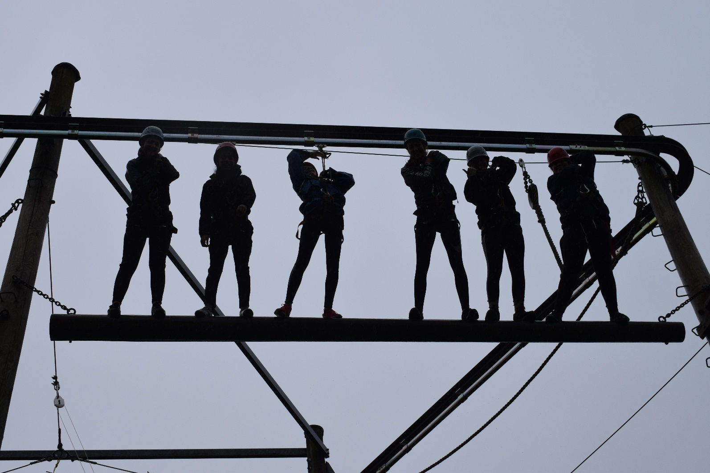

What is youth work and its curriculum?
‘Youth’ is the adolescent developmental phase between childhood and adulthood that brings significant physical and emotional changes. The brain undergoes huge physical changes during adolescence that impact on behaviour, self-image, social interactions and decision making. It is also an important time for making significant life choices and decisions, experiencing increasingly complex social interactions and dealing with a digitised world. It requires particular skills to support young people at this important time to allow them to safely explore risky impulses, form new relationships and take on new challenges. As such, youth work engages with young people as individuals with strengths, assets, potential and lived experiences.
Predominantly working with children and young people between 11 and 19 years of age, youth work supports young people through adolescence, ranging from 8 to 25 years of age dependent on context and need. It differs from other services in that it is voluntary for young people to engage with youth work, and the process starts from where young people are at, their interests, goals and experiences, focusing on personal and social development through a strengths-based (asset) approach.
Youth work is a form of education pedagogy; it provides non-formal education and offers informal learning opportunities. The curriculum sets out the educational process that underpins good youth work. It is set in the context of youth work values, principles and ethics. It is not a dictated set of subjects or a syllabus, but rather a framework to support and develop practices that are a catalyst for learning. Outcomes are not prescribed, so as to be flexible to the needs, interests and concerns of young people. As such, at the heart of the youth work curriculum are young people as individuals, groups and communities.
The curriculum articulates the diverse nature, fluidity and flexibility of youth work practices and how these elements enable young people’s learning and development in a broad range of contexts. The process of youth work is person centred, focusing on the young person and their needs, whether as an individual or within a group.

Youth work happens in a variety of spaces, and the trusted adults that deliver youth work range from volunteers to part-time or full-time professionally qualified practitioners. Routes into and through professional youth work practice are many and varied, but the heart of good youth work is
relationships and relational practice – whether this is a volunteer working one night a week in a drop- in universal youth club or a professionally qualified youth worker working to support highly vulnerable young people in specialist settings.
The youth work curriculum supplements a formal body of validated training from levels two to seven. This training is professionally approved by the Education Training Standards Committee of the National Youth Agency (the professional statutory regulatory body for youth work) and is recognised by the Joint Negotiating Committee for youth work, which sets the pay and terms and conditions
for youth workers in England. Equally, the curriculum can be used to identify practice needs and to up-skill the many volunteers who are part of the youth workforce. It can also be useful for allied professions, such as social work or teaching. Building on good practice expertise and knowledge from the youth work sector enables the strengths from this profession and curriculum to enhance the experiences of young people in different contexts.
Youth work as a process can be reactive (responding to an issue or need that has been identified by or with young people) and proactive (helping young people to develop skills, knowledge or experiences that enrich their life chances). Youth work needs to be adaptable to the changing
dynamics of practice and to intervene and adjust accordingly, identifying and responding to issues of concern to young people as well as planning activities to meet preidentified needs or concerns.
This includes:
- Situated learning (location of practice), including community and culture.

- Experiential learning (learning through experience), including critical dialogue.

- Developmental group work, including peer education.

- Creativity in learning, including play-based education.

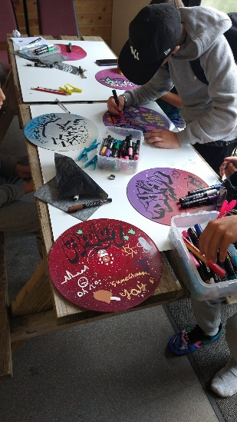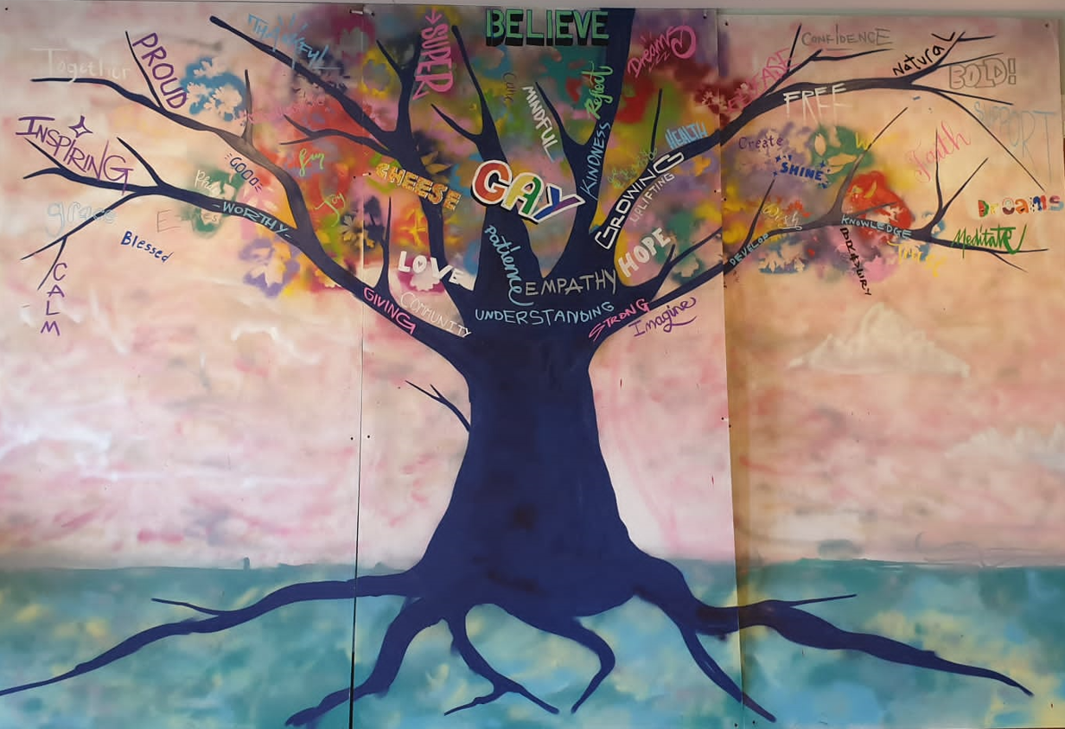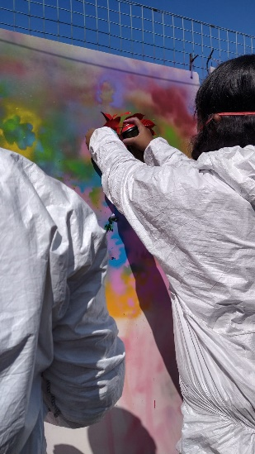
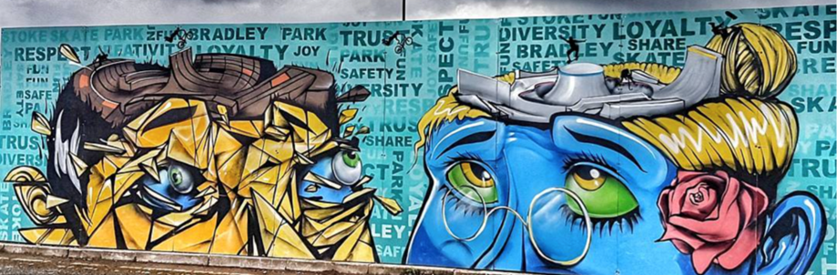

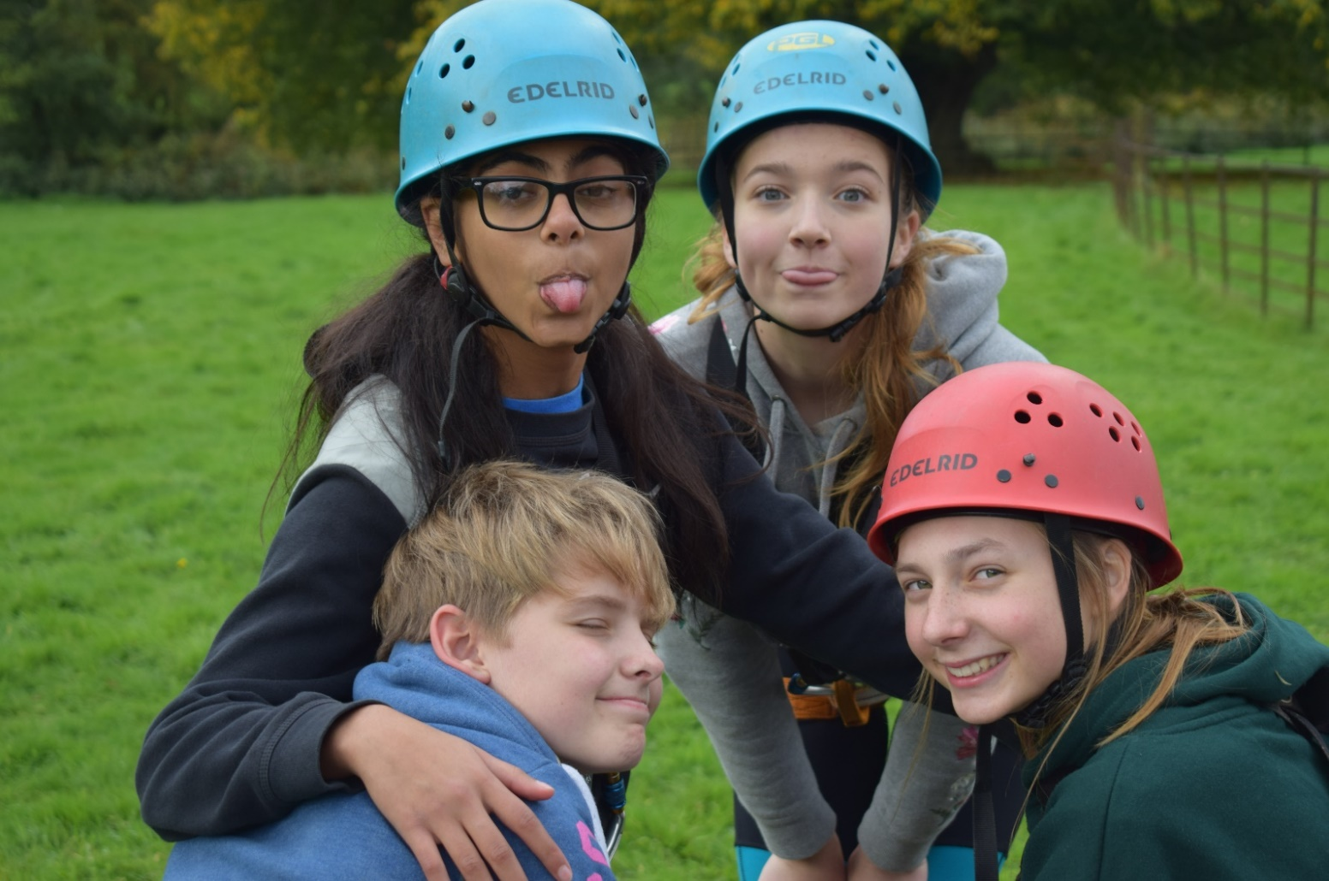

Introduction
This document sets out a youth work curriculum framework for England. Its purpose is to enable a greater understanding of youth work practice, provide an educational framework and act as a reference tool to be used by decision makers, policy makers, commissioners, youth workers and young people.
It is illustrated by examples of youth work practice from young people and youth workers that highlight how the curriculum is fluid and flexible and how it underpins high-quality youth work. Examples from young people show the difference that having trusted relationships and opportunities has made to them.
The youth work curriculum is underpinned by the description of youth work articulated in the National Occupational Standards for Youth Work 2019:

Engaging with young people to facilitate their personal, social and educational development and enable them to gain a voice, influence and a place in society. Youth Workers help young people to engage with their local communities, taking account of cultural diversity. They support the young person to realise their potential and to address life’s challenges critically and creatively.
Youth work may take place in a variety of settings including community venues, uniformed groups, schools, youth cafés and on the street, whilst using numerous approaches such as outdoor pursuits, drama workshops, health initiatives, peer education and single issue and single focused gender work to engage with young people. Youth work may be carried out by volunteers or via paid employment in the sector.

How can this document be used?
This curriculum can be used as a framework to:
- Understand why youth work is important in the lives of young people.

- Describe what youth work is and how this is underpinned by our values, beliefs, context and national governance frameworks.

- Develop youth work practice through youth workers and service leaders that are responsive to the needs of young people.

- Design a youth offer that is asset based and co-produced, responsive to local needs and based on dynamic relationships with young people.

The following sections give more detailed information on the different parts of the youth work process at the heart of the curriculum. They explain:
- What is meant by a youth work curriculum and how it might be used by different individuals and groups.

- How the cornerstones of youth work set out the broad purpose and aims of youth work.

- How values and principles inform the relationships that are the essential element of the youth work process.

- How the relationships between young people and youth workers create opportunities for learning, and the broad themes that young people identify as areas of interest.

The sections also demonstrate how this curriculum links together and references the following documents, which underpin and support youth work practice: the National Occupational Standards for Youth Work, the Values and Principles of Youth Work and the Youth Work Code of Ethics.

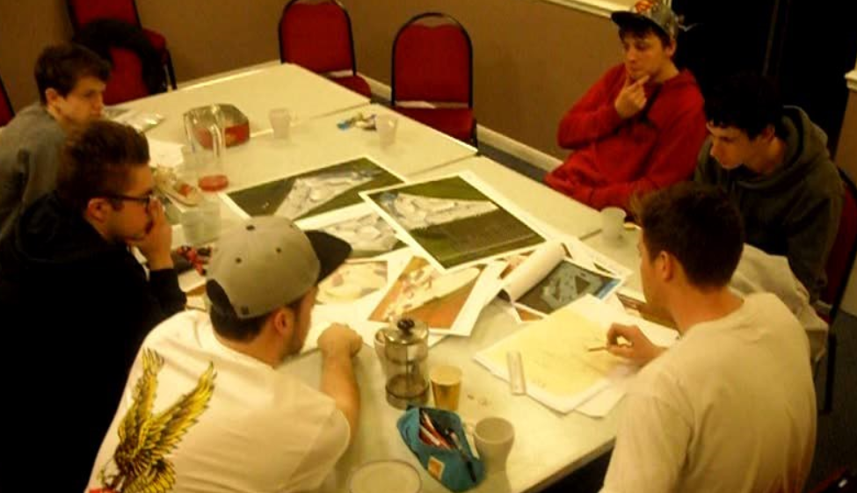

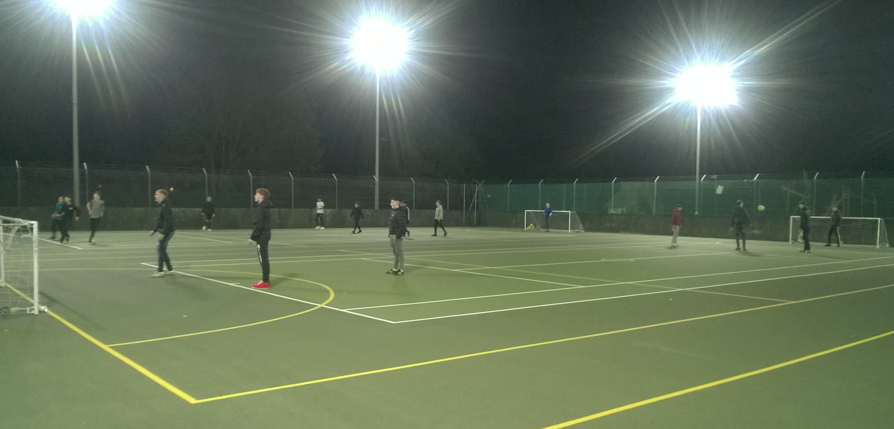

Explaining the model
At the heart of the youth work curriculum are young people: young people who are sufficiently confident to make decisions now and in the future about their lives. As well as benefiting young people themselves, for wider society, youth work helps to engage young people in playing an active role in their local communities and tackling a broad range of societal issues and disadvantages.

Cornerstones of youth work
The curriculum framework is founded on four cornerstones, which describe the broad aims of youth work:
- Education. Youth work offers informal learning opportunities that can complement formal learning in schools and colleges. It gives young people the opportunity to learn – about themselves, about others, about issues they care about or that concern them and about society and how to engage in their communities.

- Empowerment. Youth work helps young people to develop the skills and confidence to make decisions and act on issues that affect their own lives, the lives of others, their communities and society. This enables young people to take control, have a voice and get involved as advocates.

- Equality. Youth work is for all young people. It respects differences and builds connections between different groups and individuals. It recognises and promotes human rights, social justice and anti-oppressive practices, supporting and challenging young people to reflect on their understanding of themselves and their behaviour towards others.

- Participation. Youth work supports young people and works with them to become partners and leaders in their own learning, to help them gain influence over issues they are concerned about and to engage them with democratic processes.

Values and principles of youth work
Youth work relationships are underpinned by youth work values and principles. The values provide an ethical foundation that inform the way youth workers make decisions about their work. We use those values to develop principles that allow us to collectively understand how we apply values to youth work practice.
Youth work values and principles:1

- Good youth work is delivered by developing a voluntary and trusting relationship between the young person and the youth worker.

- Good youth work is underpinned by contextual safeguarding approaches, where the welfare of young people is paramount.

- It is a rights-based informal educational process and an asset-based empowerment approach. It complements, extends and supports formal education by encouraging and providing other opportunities for young people to achieve and fulfil their potential.

- It does not seek to position young people as a ‘problem’; it develops a positive narrative around young people.

- Good youth work embraces the value that young people bring to society and works with them to develop solutions to challenges experienced individually, collectively and societally. Youth work equips young people with knowledge and skills for life across a range of dimensions, including socially, economically and politically.

Participation and active involvement: young people can choose to be involved, to relax, to meet friends, to form new relationships, to have fun and to find support. Youth work should be informed by the lived experience of each young person, starting from where young people are in relation to their own feelings, values, views and principles. It recognises that young people have strengths and abilities and goes beyond the point where young people start, encouraging them to be critical and creative in their responses to their experiences and the world around them.
Equity, diversity and inclusion: Youth work treats young people with respect, valuing differences and promoting the acceptance and understanding of others. It is underpinned by the principles of social justice, equality and rights and embraces and celebrates diversity and interdependence.
It recognises the value of collective identities and inclusivity, fostering positive collective action, a sense of belonging and a sense of community by challenging oppressive behaviours and ideas.
Partnership with young people and others: Youth work recognises each young person as a partner in their learning process, which enables them to fulfil their potential. Youth work understands
the networks and relationships between groups of young people and between them and their communities, families and cultures. It actively responds to these networks, helping young people to form stronger relationships and collective identities.
Personal, social and political development: good youth work recognises that young people need the opportunity to grow and take positive risks, learning from these individually and collectively. It creates the space and opportunities for young people to develop a broad set of social skills and encourages young people’s autonomous agency and political voice, recognising young people as decision makers and leaders.

- | NYA NOS Suite overview 2020 (Link to the complete version can be found in the appendices).

The youth work process
Youth work places young people at the centre of the practice. All young people are full of potential, spirit and expertise. Youth workers aim to empower young people to overcome the challenges, disadvantages or obstacles that stand in their way of achieving their maximum potential. Youth work helps young people to think critically about how these different areas interact, including within their wider peer groups and community, to challenge their circumstances and enable them to make informed choices about their lives.

Trust
Youth work relationships are built on trust and respect built over time. They are affected by external factors and have ups and downs, as is true of any relationship. However, the ‘power balance’ is more equal as the relationship is entered into voluntarily by the young person and starts from where they are at. This is what sets youth work practice apart from other professional relationships with young people that are dictated by predetermined outcomes.
Youth workers use their relationships to have conversations that understand young people’s place in the world and the barriers they may be facing, both personally and those beyond their control.

Safe environments
Youth workers provide young people with appropriate safe environments (physical or otherwise) to safeguard the welfare of all young people. These include places where they can gather with their peers, safe from physical and emotional harm, or where they can disclose concerns to the youth worker.

Voluntary Participation
The relationship between a youth worker and a young person is a voluntary one and starts from where the young person is at in their lives and in relation to their own feelings, values, views and principles. This means that young people are liberated to co-design and lead their own experience, through engagement with youth work on their own terms and as ‘equals’ with the youth worker. This helps develop the trust that allows good youth work.

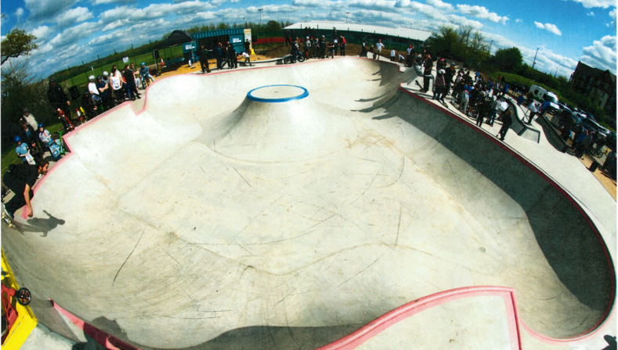

Process and praxis
Youth work is a distinct educational process adapted across a variety of settings to support a young person’s personal, social and educational development in order to:
- Explore their values, beliefs, ideas and issues.

- Enable them to develop their voice, influence and place in society.

- Facilitate the learning of a set of practical or technical skills and competencies that enable them to realise their full potential.

The principles of youth work are supported by reflective practice and peer education, establishing and maintaining relationships with young people and community groups. This is underpinned by:
  - Knowledge of how young people develop during adolescence and appropriate support.
  - Trusted relationships and voluntary engagement of young people.
  - Starting from young people’s own position, addressing their expressed or observed concerns and needs.
  - Understanding how to establish boundaries, challenging behaviour and de-escalate conflict.
  - Challenging oppressive attitudes and behaviours.
  - The importance of safeguarding in providing a safe environment for young people.

Models and approaches for youth work are expressed as informal or non-formal education:
  - Non-formal learning is typically planned and intended; the educational value is often an implicit part of the activity. This includes peer education, volunteering and social action.
  - Informal learning is based in situations and location of practice, and it includes critical dialogue, group participation and peer education.

Through youth work, young people gain non-cognitive ‘soft skills’ and 21st century competencies:

  - Confidence and self-efficacy; motivation and inspiration; self-determination and self- control; social confidence, interpersonal skills and teamwork. The activity that can be considered youth work is various and a means to an end, not the end in itself.

Open-access or universal youth work, including using buildings and mobile provision:

  - Centre or facility based
  - Detached and street based youthwork
  - Outreach youth work
  - Outdoor learning
  - Digital youth work
  - Junior/transition youth work
  - Any other activities, including one-off activities, residentials, social action and volunteering.

Ethical Conduct and Practice

All youth workers should work within the parameters of the Youth Work code of ethics, currently held by the Institute for Youth Work
- We have a duty of care to young people. In the youth work relationship the best interests of young people have priority.

- We do not seek to advance ourselves, our organisations, or others – personally, politically, or professionally – at the expense of young people.

- Our relationship with young people remains within professional boundaries at all times, to protect the young person and the purpose of the work.

- We work in a fair and inclusive way, promoting justice and equality of opportunity, challenging any discriminatory or oppressive behaviour or practice.

- We seek to enhance young people’s personal and social development by:
  - Enabling them to make informed decisions and pursue their choices;
  - Supporting their participation and active involvement in society;
  - Helping them to become independent and move on when the time is right.

- We promote the welfare and safety of young people, while permitting them to learn through undertaking challenging educational activities. We avoid exposing young people to the likelihood of harm or injury. This includes implementing safeguarding policies and procedures.

- When we receive or collect personal information about young people, we make them aware of with whom and for what purpose that information will be shared. We do not disclose confidential information unless this is necessary to prevent harm or is legally required.

- In our engagement with young people, and in our resulting relationship, we strive to be honest and non-judgmental

- We respect the contribution of others concerned with the welfare and well-being of young people and will work in partnership to secure the best outcomes for young people.

- We encourage ethical reflection and debate with colleagues, managers, employers and young people.

- We make sure we have the knowledge and skills necessary to work effectively with young people. We work in a reflective way to develop our abilities. We take account of the impact of work on ourselves.

- We maintain consciousness of our own values, beliefs and interests, are aware when these conflict with those of others, and approach difference respectfully.


UNCRC
Quality Standards
Creativity and Fun
Global Citizenship
Economic and Financial Wellbeing
Skills Development
and Participation
Young Person(s)
Sustainable Development
Leadership, Civic Engagement
Environment and
Health and Wellbeing
Healthy and Safe
Relationships
National Occupational Standards
Identity and Belonging
Art, Culture and Heritage
Outcomes Framework 2.0
P
a
P
r
t
R
i
c
O
i
C
p
E
a
S
t
i
S
o
n
Y
o
u
t
h
E
q
W
u
o
a
r
l
k
i
t
V
y
a
l
u
e
s
E
d
u
P
c
R
a
A
t
i
X
o
I
S
n
E
Y
o
m
u
p
t
h
o
W
w
o
e
r
r
k
m
E
e
t
n
h
i
t
c
s

Youth work themes
The themes listed here are based on what we know young people want to address and engage in, based on research and consultations such as Make Your Mark.2 This is not meant to be a checklist of what youth work should do. What is explored and offered will be determined locally with young people through the youth work process. It assumes starting with a positive relationship with young people to understand their needs, concerns and interests, enabling youth work to support their personal, social and political development.

Determining what specific aspect of a theme young people want to explore is important. Involving young people in leading their own youth work experience is essential, since adults do not always understand young people’s concerns.

Aspects of these themes run all through young people’s lives. An activity they take part in, an intervention by a youth worker or an experience they have can be examined through the lens of different themes. Each thematic approach would give them different perspectives and learning all drawn from the same activity, intervention and experience. So, for example, a young person might learn about financial literacy though an activity related to the purchase of some resources for a youth project to deliver a sports activity event. The primary driver for the activity was a creative and fun activity, but the secondary learning outcomes as a result of that are cross cutting across a
range of other themes (health and wellbeing, economic wellbeing, skills development). This would be experienced very differently to a project with primary outcomes of financial and economic wellbeing as drivers.

Good youth work projects and activities link back to the themes, rather than being driven by them. The youth work process, with its person-centred dynamic approach, enables this to happen through situational experiential learning opportunities driven by young people.

Identity and belonging
Identity, meaning who we are, how we think about ourselves and the characteristics that define us and make us different from others, is not fixed. Identity is formed by how we experience different social and cultural classifications, including race, socio-economic status, gender, class, sexuality, ability and disability, family histories and religions, and where we were born, grew up or live. It is expressed through everyday interactions, such as the way we speak and dress, the music we listen to, the role models we look up to, or by how we relate to others, for example through joining a group or finding a place where we feel we belong. Both forming and expressing an identity are complex and plural.

Adolescence is a stage in life where this process often involves conflicts and contradictions, as neurological developments add an extra layer of complexity and plurality. Some young people find themselves at odds with their families, religions and cultures because of the ways in which their identity develops. Youth workers can support them as they move through this exploration and signpost them to further support if they need and want it.
Youth work helps young people to explore and understand their identity and to find a sense of belonging by:
- Offering space where young people can be with others who share their experience, whether that be a community of interest, a protected characteristic or a common life experience.

- Supporting young people in thinking about what makes up their identity and how they think other people see them.

- Supporting young people in discovering their personal values, principles and preferences.

- Valuing each individual and their differences.

- Supporting young people in understanding their prejudices and valuing diversity and equity.

- Creating safe spaces and groups where oppressive behaviours and views are challenged.
________________
2| The United Kingdom Youth Parliament holds an annual UK-wide ballot called ‘Make Your Mark’, where all young people, aged 11–18, can vote on what they feel is important in their lives and what they think Members of Youth Parliament should campaign for in the year ahead.

Health and wellbeing
Health and wellbeing are not just about an individual’s physical, mental or emotional health, but rather how these and the wider contexts – including socio-economic status, gender, race, sexuality, culture, religion, neurodiversity and disability – affect a person’s ability to achieve their goals or contribute to their community or society. For example, a person can be perfectly ‘healthy’, but may unable to find meaningful employment or have limited access to leisure.

For young people, improving their health and wellbeing today will improve both their future outcomes as adults and, in turn, the welfare of the next generation of young people when those adults become parents.

Young people’s right to participation and involvement in decisions that impact them takes on increased relevance with regards to their health and wellbeing. This is not exclusive to accessing youth-friendly information and services or confidential medical advice, nor to providing consent to medical treatments, but is also about having the right and opportunity to contribute and participate in services.
Youth work helps young people to explore and understand issues relevant to their health and wellbeing by:
- Promoting the positive physical, social, emotional and mental health of young people.

- Helping young people make informed choices about how they live, approach risk and take responsibility for their own behaviour in relation to their lifestyle.

- Providing activities that promote good health, such as physical exercise and educational leisure including outdoor and play activities.

- Making appropriate support and services accessible when necessary.

- Providing appropriate, accurate information and guidance.

Healthy relationships
Humans are social beings, and it is essential for us to have the capacity to form and maintain relationships across a number of different groups: with families and friends and at school, college or work. As young people become more independent of their families, they have to learn how to develop healthy relationships, whether they be friendships, sexual relationships or those with colleagues and people in the community.

Youth work can give young people the opportunity to meet their friends and other young people beyond their family and communities, opening them to mixing with people from different backgrounds and with different values, beliefs and aspirations. Through this, young people can learn how to negotiate appropriate boundaries in different relationships. More specifically, relationships and sex education can help young people understand what safe and healthy sexual relationships are and how to give and respect consent. Developing a sense of self-esteem and self-worth helps young people to establish confidence in their sexuality, gender, bodies, abilities and broader identity.

Social media and digital technology offer lots of opportunities for young people to relate with people from all over the country and the world, but the principles of safe and healthy relationships remain the same. Young people need to be able to safely negotiate digital relationships, which can have different elements and different boundaries.
Youth work helps young people to understand their right to have healthy and safe relationships by:

- Offering relationship support and guidance to young people, including sex and relationship education, in settings and in a way chosen by the young people.

- Providing a trusted and safe relationship for each individual young person.

- Modelling positive respectful relationships and exploring the differences between healthy and unhealthy relationships.

- Helping young people to understand and negotiate the difference between the online and offline worlds.

- Offering opportunities for young people to meet with their friends and mix with others beyond their usual peer groups.

Economic and financial wellbeing
Economic and financial wellbeing is an important part of young people’s lives, contributing to their welfare and security. Many young people work in the least secure jobs with the worst conditions, and they often start their working life with debts from education. Having financial understanding of budgeting, bank accounts and credit cards, pensions, tax and other areas will help them to manage a complex system.

Even without skills that specifically relate to financial literacy, many of the attributes young people develop through youth work are referred to as soft skills – teamwork, decision making, reflection and critical thinking, for example. These are transferable skills that support young people in all aspects
of their lives, including employment. Employers increasingly look for evidence of these attributes alongside those acquired in formal education.
Youth work can help young people to have more control over the economic and financial aspects of their lives by providing:

- Opportunities to understand budgeting, either personally or via projects that involve applying for funding or grants.

- Financial literacy education, for example access to learning about credit, interest rates and how to work out if a deal is as good as it looks.

- Access to further opportunities for study and employment, as well as advocacy for employment rights and fair pay.

- Opportunities to develop and build entrepreneurship, building on young people’s skills, interests and passions.

Leadership, civic engagement and participation
The United Nations Convention on the Rights of the Child states that young people have a right to ‘express their views, feelings and wishes in all matters affecting them, and to have their views considered and taken seriously’.3

The engagement of young people in local democratic processes is essential; it fosters
a sense of belonging and allows communities to become stronger. Services that are offered have the best chance of making an impact when they are informed by the people that use them. Young people engaging in projects around these topics can learn to understand power, how to use power, how to advocate on behalf of themselves and others and, therefore, how to increase their sense
of agency. They can also learn wider transferable skills, including confidence, public speaking, organisation, campaigning, running workshops and meetings, and leadership. There are many ways to open up these opportunities, through volunteering, social action, leadership programmes and formal structures.

Youth Councils and formal structures give young people a voice to advocate and campaign for change and influence decisions. Other forms of involving young people, such as through
consultations, citizens’ juries and participatory budgeting, are more time limited and may focus on a particular area of interest.
Youth work supports leadership, civic engagement and participation by:

- Enabling young people’s voices to direct discussion, activities and projects that they participate in.

- Providing opportunities for young people to participate in democratic decision making within youth projects and engage in campaign groups or youth councils.

- Helping young people to understand different types of engagement and the respective power that this gives to individuals.

- Advocating for and encouraging young people to challenge and question services and organisations they come into contact with, to be heard and responded to; and lobby local government on issues they are passionate about.
____________
| Article 3. See appendices.

Arts, culture and heritage
Arts, culture and heritage can be tangible, in the sense of galleries, museums, theatres, paintings and books, or more intangible, in the sense of folklore, customs and traditions. These often stem from different ethnic, religious or national backgrounds and are expressions and celebrations of those. As well as better representation of their own cultures and heritages, people often have a desire to learn about the cultures of other groups within their society and beyond.
Britain is a multicultural society with a range of variances between the social or cultural groups within it, yet many arts, cultural and heritage projects can often seem closed to people through lack of exposure or access, and some groups have fewer opportunities to showcase their arts in public. Young people, for example, often do not see themselves and their lives in galleries, museums and theatres and often don’t have access to recording equipment. When they are visible, they are most commonly represented by others. An example of this is cis-gendered actors playing transgendered characters.
Youth work helps young people to partake in and explore arts, culture and heritage by:

- Providing opportunities for young people to develop and perform their artistic and creative aspirations, such as writing poetry or lyrics and linking music with dance.
- Giving young people the opportunity to explore their social, cultural and community heritage and bringing artists into youth work settings.
- Helping young people to engage with the arts, culture and heritage sector as audience members, visitors, curators and creators.
- Understanding the barriers to participation in arts, culture and heritage and working with young people to overcome these.
- Exploring cultural diversity and commonalities through arts and culture.

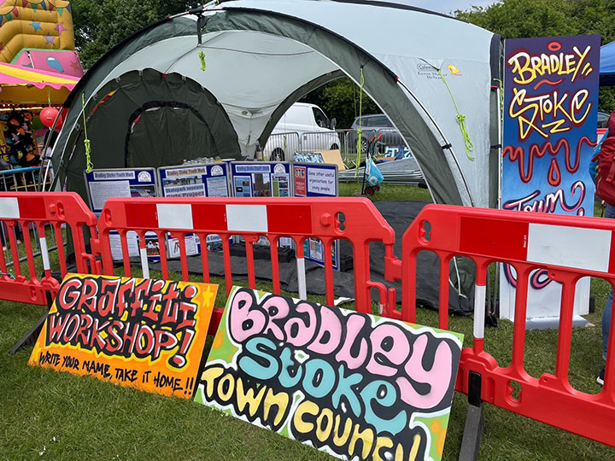

Creativity and fun
Young people attend youth services for many reasons, and one of the most important is to relax, socialise and have fun. Research shows that we all are more likely to try new things, push ourselves, learn and develop positive mental health when we are having fun.
Developing creativity and critical thinking helps young people to look at things in different ways, come up with ideas and understand how to apply knowledge to different circumstances. This can be achieved individually and via shared creative activities, which can in themselves be fun.
Giving outlet to other ways of thinking and learning beyond formal education can enable young people to apply ideas, imagination and dreams to their reality. The learning that takes place through these activities can sometimes be incidental to the activity itself, but can include critical thinking skills, open-mindedness, teamwork, decision making and creative skills.
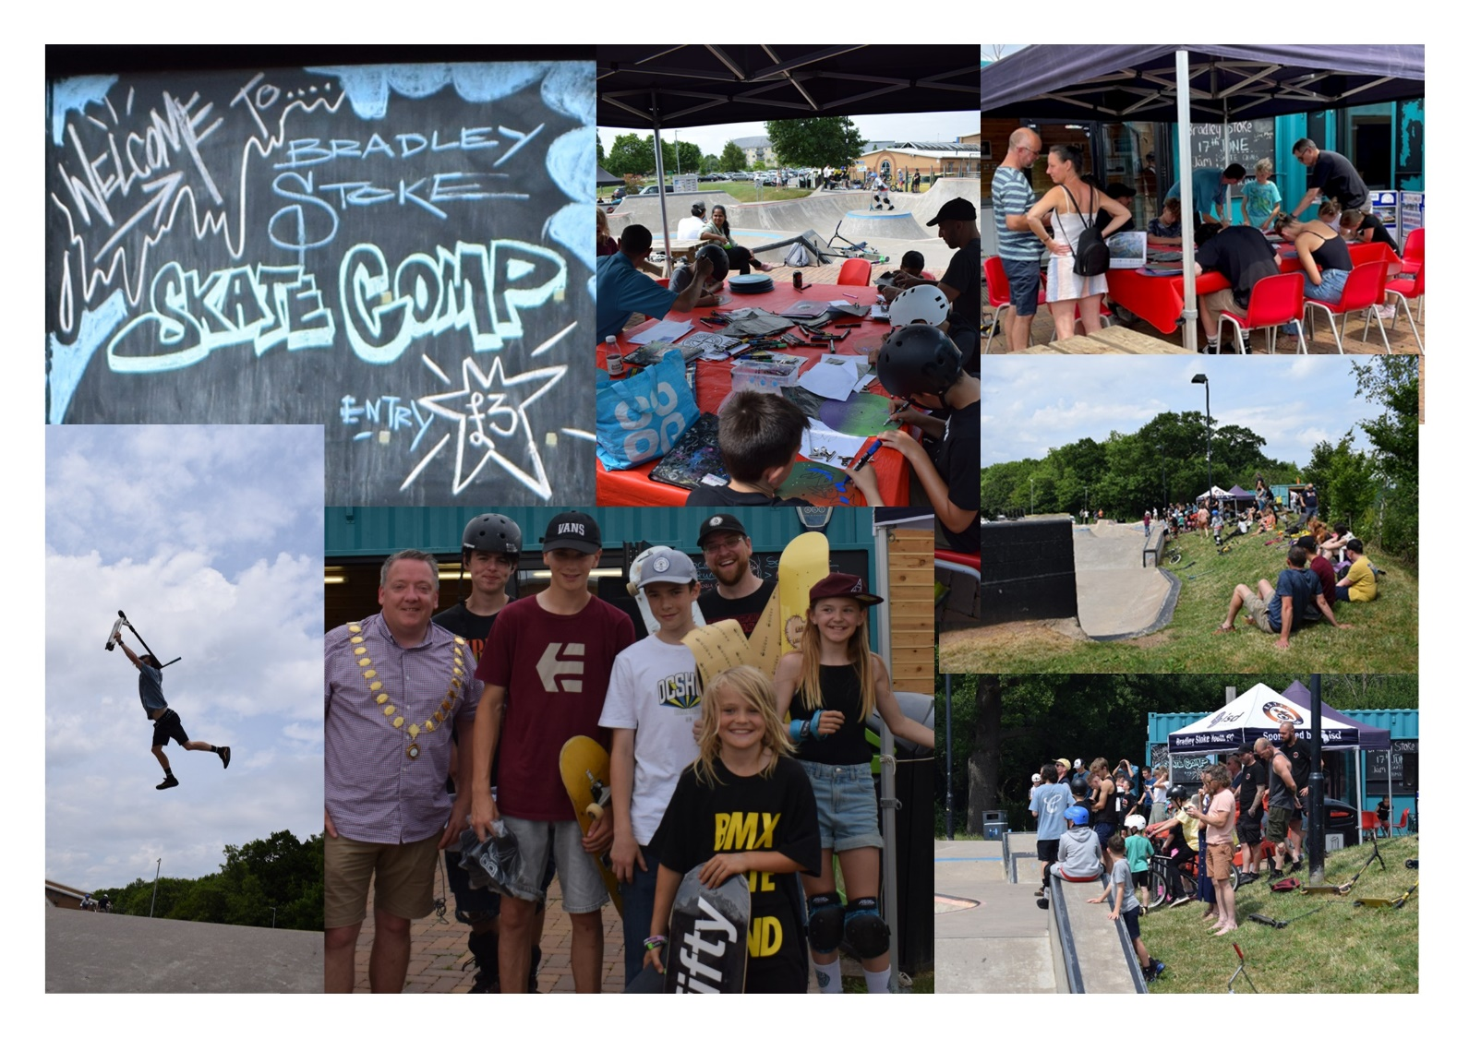
Youth work gives young people the opportunity to have fun and develop their creativity by:

- Providing spaces where young people can meet their friends and socialise.

- Offering activities that young people enjoy and want to participate in.

- Helping young people to learn from these activities and to question and look at issues from different perspectives.

- Supporting young people to plan for and develop their own recreational activities and opportunities.

Global citizenship
We are global citizens, our lives are interconnected and impacted by events across the world, and the decisions we make have global impacts. Advances in travel and technology have opened up many different ideas and influences and are bringing about constant change. Studies show that young people are increasingly interested in understanding this global impact, human rights and social justice, but that they also have an appreciation of the local.
Exploring some of that is challenging, and youth workers can support young people in reflecting and developing their understanding of their place both locally and globally. This includes through international experiences, whether in this country or by giving young people the opportunity to travel, and by encouraging them to look outwards beyond their own communities and broaden their horizons. Meeting people from other countries helps young people to understand their own communities and cultures. It also reinforces similarities and promotes their understanding of difference, their place in the world and the impact they have on it.
Youth work can help young people to develop as global citizens by:

- Providing opportunities to explore how a local community and everyday choices have global links and influences.
- Offering opportunities to understand the impact of globalisation on their lives.
- Exploring social justice and human rights and how they apply to all people.
- Offering opportunities to develop links with young people from other countries, both virtually and through international experiences.
- Helping young people to access opportunities to volunteer and work abroad.

The environment and sustainable development
There is a strong link between global citizenship and the environment and sustainable development. The impact of humans on the environment and sustainability are issues that concern many young people, and they are leading movements to demand that governments take action locally, nationally and globally, as well as following lifestyle choices that promote sustainability and have environmental benefits.
At a local level, there are examples of young people organising peer education, litter picks and lobbying organisations, councils and governments who, in turn, are responding to this collective action. Youth work does not only help to educate young people in this area, it can also provide opportunities to connect with or lead such campaigns and can give young people the chance to consider and critique the United Nations’ Sustainable Development Goals (SDGs) and how they might implement and contribute to them.
Youth work can help young people to consider the environment and sustainable development by:

- Enabling young people to consider their impact on their environment.
- Implementing the SDGs in their own practice.
- Offering opportunities for young people to develop creative responses to areas of interest.
- Supporting young people in taking collective action, including linking with and signposting to other groups.

Skills development
Through the process of participating in youth work, young people learn and develop a wide variety of skills. Often, the acquisition of these skills is incidental (i.e. as a result of the work) rather than predetermined. Young people may express a wish to develop
specific skills, e.g. cookery, music production or football. Youth workers may offer opportunities that challenge and stretch young people, for example the expedition section Duke of Edinburgh Award Schemes, which gives young people the opportunity to develop map-reading skills and camp crafts. It also contributes to young people learning to communicate clearly, make decisions, work together, contribute to a group, plan, solve problems, be organised and other skills.
Throughout the youth work relationship, young people learn social and personal skills. They develop an understanding of themselves, their communities and society, as well as what they want to change and how to challenge themselves and take ownership. These skills are all transferable
into their wider lives of school, families, communities, workplaces and so on. It is part of the youth work process for youth workers to help young people to reflect on and identify the learning and development of skills that take place over a period of time and that come about as a result of their experiences and learning.
Youth work is about giving young people skills through:

- Offering opportunities for young people to learn specific skills.
- Developing social and personal skills over time.
- Providing opportunities to reflect on and identify learning.
- Providing further opportunities to apply and develop those skills.



Related professions
Youth work complements and can support the work of a range of other professions, illustrated below; youth workers can provide an essential bridging role between young people, families and services. Youth work is also an essential part of multi-agency working, with its unique position of being led by young people and driven by the goals of the young person.
Teaching: Youth work approaches are often the most appropriate when addressing wider, Personal Health and Social education-based topics. Youth work is person centred and led by young people and their learning needs rather than being outcome focused. This creates positive spaces for individualised, differentiated, informal and non-formal learning opportunities. This approach can work well within compulsory education settings. The complementary style of this pedagogy is well suited to young people who may struggle with formal educational approaches. Examples of this may be young people with attachment difficulties or those who have experienced trauma.
Social care: Youth work approaches are used highly successfully within social care in a variety of arenas. The skills of professional youth work are beneficial as they encourage the empowerment of young people and help them to have a voice in their journey. Research tells us that young people in the care system often feel unheard and that decisions are made about them and for them, leaving them feeling impotent and disempowered. Youth workers advocate for young people and help young people to develop skills to advocate for themselves. Youth work relationships and skills are also ideally placed when helping young people to transition to independence.
Health: Youth work has a historic place in health-based structures in England, both through supporting engagement in activities for young people who are longer-term inpatients in clinical settings, and through the provision of health education. Youth work approaches are demonstrably successful for working with young people around substance use and misuse, and sexual and reproductive health. Relationships with trusted adults who are trained, skilled and equipped in these key areas are transformational in connecting into new education and learning around these topics.
Youth justice: Youth work operates within the secure estate and at most levels of youth justice engagement. The curriculum and its approaches are able to engage with young people from different perspectives and with a focus on helping young people to realise their goals and ambitions. The unintended or indirect outcome of this is a reduction in engagement with criminal activities and a reduction in harm. Youth work relationships are able to apply contextual safeguarding in order
to create spaces for young people to explore their life experiences and choices that feel safe, and focused on them, rather than others. Youth workers work with young people who are victims of crime as well as perpetrators. Youth work recognises young people as children and young people first, and focuses on this as the key component of relational practice.

Informing practice Appendix

A rights-based approach
The curriculum is underpinned, informed and supported by a range of documents that set out young people’s rights and consider the outcomes young people might achieve through the youth work process. There are a number of important international declarations of rights that underpin youth work practice.
The United Nations Declaration on Human Rights ‘proclaimed that childhood is entitled to special care and assistance’.4
In the United Nations Convention on the Rights of the Child, there are 54 articles that set out the rights that all children and young people should receive. Youth work is rights based and uses Article 12 in particular:
- Article 12: Every child has the right to express their views, feelings and wishes in all matters affecting them, and to have their views considered and taken seriously.

Youth work is also underpinned by:

- Article 13: Children have the right to get and share information as long as the information is not damaging to them or others.

- Article 14: Children have the right to think and believe what they want and to practice their religion, as long as they are not stopping other people from enjoying their rights. Parents should guide their children on these matters.

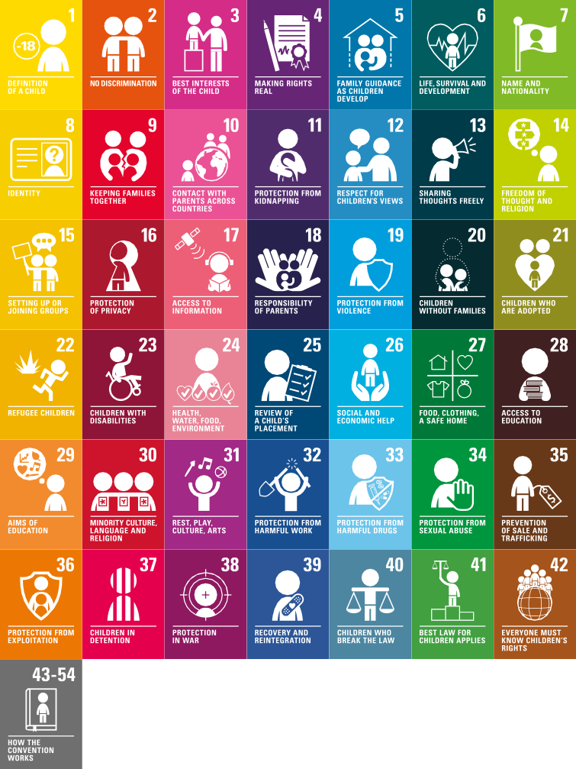









- Article 15: Children have a right to meet together and to join groups and
organisations, as long as this doesn’t stop other people from enjoying their rights.

- Article 16: Children have a right to privacy. The law should protect them from
attacks against their way of life, their good name, their families and their homes.

- Article 31: Children have a right to relax and play, and to join in a wide range of activities.

4| United Nations Convention on the Rights of the Child.

National Occupational Standards
There are a range of documents that underpin both the knowledge and skills that youth workers need and the development of youth work practice.
In particular, the National Occupational Standards for youth work (NOS) is a core element of the training and the benchmark of professional standards. The Joint Education and Training Standards Committee works across the Home Nations to uphold the professional standards of youth
work qualifications through the NOS, and thus, they are owned and established by the sector, not the government.
Updated in 2019, the NOS set out the values of youth work that should underpin all practice and describe the competencies required to carry out the tasks undertaken by the youth work workforce. They do not describe a specific role but the standards of performance and the knowledge required in youth work practice and in formal youth worker training.
The application of the NOS depends on the national, regional and local context, and NYA have published a document summarising this for England.
See ‘Youth Work in England, Policy and Practice and the National Occupational Standards’:

National Youth Work Curriculum - National Youth Agency (nya.org.uk)
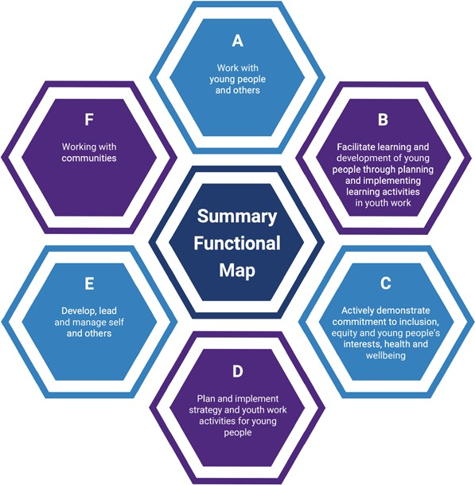

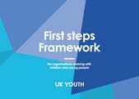
Quality Standards
- The NYA Quality Mark is a reflective tool that intends to support local authorities and youth work service providers to develop a culture of learning and growth. The Quality Mark is built around three areas: young people’s personal and social development and learning,
quality of youth work practice, and leadership and management. The Quality Mark offers three levels, providing progression from a foundation level through to advanced and outstanding levels. Once an organisation has completed their self- assessment, they can go for the NYA Quality Mark Award.

- The NYA Hear by Right framework is an organisational development tool to ensure that youth voices and active participation are at the heart of organisational development and decision making.

- The Framework of Outcomes for Young People 2.0 was developed by the Centre for Youth Impact with the sector on behalf of the Local Government Association. It has a partner publication. The Youth Programme Quality Intervention uses domains that link to the Framework of Outcomes for Young people 2.0 (safe spaces, supportive environments,
interactive environments, engaging environments) to create a cycle of self-improvement for individuals and teams.

- A Guide to Commissioning Outcomes for Young People from the National Youth Agency supports local authority commissioners in understanding the challenges of commissioning youth work and involving young people in the process in a meaningful way.

- First Steps and Safe Spaces by UK Youth provides a quality assurance framework across two levels. An evolution of their previous ‘Ambition’ quality mark, the overall focus is on safeguarding and ensuring that appropriate policies and procedures are in place across key functional areas such as health and safety, HR, governance and diversity/equality and inclusion.

- The London Youth Quality Mark, which supports member organisations towards better practice in:

- Involving Young People; Health and Safety; Outcomes for Young People;

- Partnerships; Safeguarding; Leadership and Management;

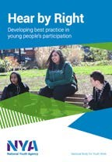
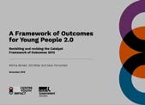
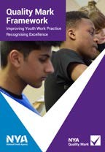
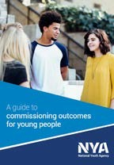
- Diversity, Equality and Inclusion; New Improvements; Staff and Volunteers.

Legislation
What youth work is planned and delivered will also be subject to external factors, notably by government policy, laws and legislation.
In England, youth work is primarily recognised under ‘Services to Young People’ as outlined in Section 507B of the Education Act 1996.
This requires that every local authority in England must, so far as reasonably practicable, secure for qualifying young persons in the authority’s area access to sufficient educational and recreational activities (also referred to as positive leisure-time activities) which are for the improvement of their well-being, and sufficient facilities for such activities. The Department for Digital, Culture, Media and Sport (DCMS) currently have responsibility for this duty.
The guidance for delivering this duty is currently being reviewed by DCMS, but, at present, there is no indication as to what levels of youth work should be delivered or how, nor what types of youth work activities should be undertaken or what it should aim to achieve.
Youth work is also implicit in other policy, such as:
- The Children Act 2004 (later built on by the Children and Families Act 2014) which focuses on moving towards early identification and intervention of young people’s needs to help sup- port the child, but also their wider family and living environment.

- The Children and Social Work Act 2017, which places duties on the police, clinical commis- sioning groups and local authorities to work together (as well as with other partners local- ly) to safeguard and promote the welfare of all children in their area.

- Working Together to Safeguard Children 2018 statutory guidance, which refines this:
  - Paragraph 59 recognises that ‘youth services not delivered by local authorities or district councils’ are of importance.
  - Paragraph 60 confirms that this also applies to volunteers.

Another policy obligation that this Curriculum supports is the UK Government’s ratification of the United Nations Convention on the Rights of the Child in 1991. This recognises children’s rights to express their views and to receive information on all matters that affect them, in accordance with their age and maturity. This is therefore recognised in numerous policies for participation of young people across Government and throughout national, local and regional levels, for instance:
- Ofsted’s Criteria for all Local Authority Children’s Services.

- For Care Leavers.

- For youth services and provision of ‘positive leisure-time activities.

- In matters of education.

- And various others such as the NHS Youth Forum.

Key organisations
British Youth Council
Youth Voice National programmes and networks
British Youth Council - National Youth Agency (nya.org.uk)
Centre for Youth Impact
Impact measurement in youth work and services for young people
Homepage | YMCA George Williams College
Federation of Detached Youth Workers
Resources: https://www.fdyw.org.uk
Institute of Youth Work
Youth work ethics https://iyw.org.uk/code-of-ethics/
Local Government Association Resources and policy information for local authorities, managers and leaders https://www.local.gov.uk/search/all/ Youth%2BWork
National Youth Agency
Resources: https://nya.org.uk/resource/nya- guide-youth-work-youth-services/
People Dialogue and Change
Digital youth work https://padlet.com/dan_moxon1/codesign

Proud Trust
For LGBT+ Young People - The Proud Trust
UK Youth
Support for local youth organisations https://www.ukyouth.org/about-us/

Regional Youth Work Units

Network of Regional Youth Work Units England blog | A Network of Regional Youth Work Units, in England, collaborating across regions to promote good youth work and young people’s voices. (wordpress.com)

Partnership for Young London
About Us | PYL (partnershipforyounglondon.org.uk)

Youth Focus WM
Youth Focus West Midlands – Supporting Quality Work With Young People (yfwm.org.uk)

Youth Focus NW
Home - Youth Focus North West (youthfocusnw.org.uk)

Youth Focus NE
Home - Youth Focus: North East (youthfocusne.org.uk)

Youth Focus SW
https://youthfocussouthwest.org/

Yorkshire and Humber Youth Work Unit
Home - Youth Work Unit

Further information

Identity and belonging
Salto Youth
Exploring identity and its role in international youth work
https://www.salto-youth.net/downloads/4-17-2311/UnderstandingYouth_OnlineVersion.pdf?
The Proud Trust Resources
Work with LGBT+ young people https://www.theproudtrust.org/resources/
ThinkuKnow.co.uk
Exploring your identity online
https://www.thinkuknow.co.uk/14_plus/Need-advice/exploring-your-identity-online/

Health and wellbeing
Association of Young People’s Health
Resources: AYPH – Working to understand the health and wellbeing of young people
Brook
Sexual Health and Wellbeing resources https://www.brook.org.uk/
Young Minds
Resources: https://youngminds.org.uk
Sport England
Resources: https://www.sportengland.org/know-your-audience/demographic-knowledge/children- and-young-people#research

Healthy relationships
Family Planning Association
Sex and relationship education and government guidance
Family Planning Association (fpa.org.uk)
Childline
Resources on sex and relationships https://www.childline.org.uk/info-advice/friends-relationships-sex/
Family Lives
Checklists, resources and signposts to further support https://www.familylives.org.uk/advice/teenagers/sex/healthy-relationships/

Economic and financial wellbeing
Youth Focus NW and United Utilities
Money management modules https://www.unitedutilities.com/corporate/responsibility/communities/education/managing-money/

The Money Charity
Education, information and guidance on money matters for young people https://themoneycharity.org.uk/work/young-people/

Money for Life
A website specifically for 16 to 25 year olds https://www.moneyforlife.org.uk/

Leadership, civic engagement and participation
Resources and information around youth social action

https://iwill.org.uk
NYA- Hear by Right
Participation within youth services https://nya.org.uk/hear-by-right/
British Youth Council
Supporting youth voice from the local to the international level https://www.byc.org.uk/

Arts, culture and heritage
Bridge Organisations, funded by the Arts Council
Connecting the cultural sector with the education sector (including the youth sector) https://www.artscouncil.org.uk/children-and-young-people/bridge-organisations
Arts Award
Qualifications that support children and young people up to aged 25 https://www.artsaward.org.uk/site/?id=64
Heritage Fund
Kick the Dust https://www.heritagefund.org.uk/blogs/what-kick-dust

Creativity and Fun
The Durham Commission
Creativity and education
https://www.artscouncil.org.uk/sites/default/files/download-file/Durham_Commission_on_ Creativity_04112019_0.pdf
European Commission
Unleashing young people’s creativity and innovation https://ec.europa.eu/assets/eac/youth/library/publications/creativity-innovation_en.pdf
British Educational Research Association
Creativities in Education (Special Interest Group) https://www.bera.ac.uk/community/creativities-in-education

Global citizenship
European Commission
Database of national policies and structures of countries participating in Erasmus, not just EU Member States
Youth Wiki: Europe's Encyclopedia of National Youth Policies
Erasmus+ project database

Oxfam
Resources on global citizenship
https://www.oxfam.org.uk/education/who-we-are/what-is-global-citizenship

The environment and sustainable development
UK Student Climate Network
Young people-led network campaigning on climate change
https://www.climateculture.earth/directory/uk-student-climate-network
United Nations
Report on young people and sustainable development https://www.un.org/development/desa/youth/world-youth-report/wyr2018.html
UNICEF
Resources to support young people to have a voice on climate change https://www.unicef.org/environment-and-climate-change/youth-action
World Wildlife Fund
Resources for children and young people on the environment and climate change
Climate change | WWF
Global Goals
Goals set globally for sustainable development agreed by world leaders in 2017 https://www.globalgoals.org

Skills Development
United Nations
World Youth Skills Day https://www.un.org/en/observances/world-youth-skills-day
National Careers Service
Skills Health Check
https://nationalcareers.service.gov.uk/skills-assessment/skills-health-check/home
Youth Employment Funders Group
What works in soft skills development for youth employment (international study) https://mastercardfdn.org/wp-content/uploads/2018/08/soft-skills-youth-employment-accessible2.pdf

