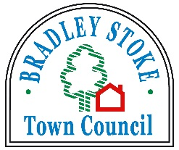

Play Area Inspection Policy

- Bradley Stoke Town Council is committed to providing safe & clean play areas for the local community in accordance with:

The Health & Safety @ Work Act 1974

The Management of Health & Safety @ Work Regulations 1992

The Environment Protection Act 1990

The Occupiers Liability Act 1984

- Regular checks will be carried out & recorded by trained Bradley Stoke Town Council employees.

- Yearly checks will be carried out & recorded by an independent professional body.

- Any problem that is highlighted by the checks will be reported to the Bradley Stoke Town Councils Office as soon as is possible.

- The Bradley Stoke Town Council Office will undertake any appropriate action as soon as is possible.

Reviewed 30/04/26

