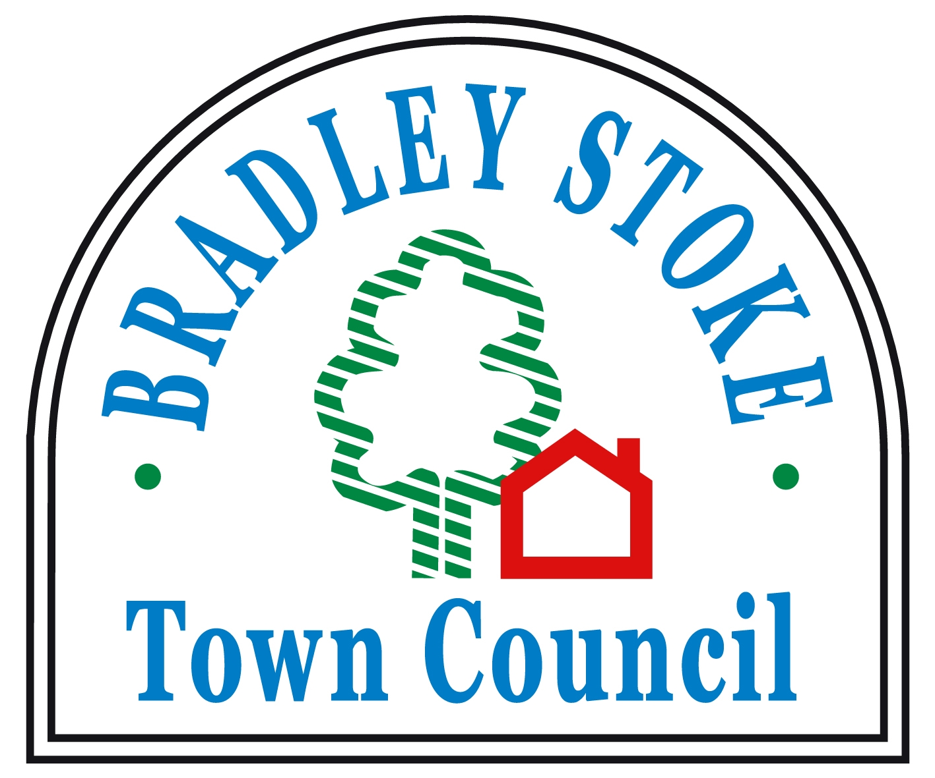
Bradley Stoke Town Council
Land Acquisition Policy

1. Purpose
The purpose of this policy is to ensure that Bradley Stoke Town Council only considers the purchase of land in circumstances that offer clear, demonstrable benefit to the community, present minimal financial risk, and align with the Council’s strategic objectives. This policy prevents unsolicited, speculative, or unnecessary land acquisition.

2. Policy Statement
Bradley Stoke Town Council will not purchase land unless all criteria in Section 4 are met. The Council will reject all proposals for land acquisition that do not satisfy these requirements.

3. Scope
This policy applies to:
- All officers and councillors involved in considering or recommending land acquisition.
- All types of land, including freehold and leasehold, whether developed or undeveloped.
- Acquisitions via purchase, transfer, or long-term lease agreements.

4. Criteria for Land Acquisition
The Council may only proceed with a land purchase if all of the following conditions are satisfied:

4.1 Strategic Need
The acquisition must directly support a formally adopted Council strategy, such as:
- Delivery of a defined community service.
- Protection or enhancement of public open space.
- Enabling infrastructure or facilities identified in an approved Council plan.

A clear rationale must be documented showing why the land is essential and why alternative options (leasing, partnerships, existing land) are not suitable.

4.2 Demonstrable Community Benefit
The land must provide measurable and long-term benefit to residents of Bradley Stoke. This may include:
- Recreational, environmental, cultural, or amenity improvements.
- Protection of community assets at demonstrable risk.
- Enhancement of public access or community wellbeing.

Public consultation must be undertaken where appropriate, and results must show clear support.

4.3 Financial Due Diligence
A full financial appraisal must show that:
- The purchase price is justified and independently assessed.
- Acquisition, maintenance, and future liabilities can be funded without placing undue burden on the precept.
- There is a clear long-term funding plan for ongoing management or development of the site.

No acquisition may result in unplanned or unbudgeted expenditure.
4.4 Legal and Risk Assessment
A comprehensive legal evaluation must confirm:
- Clear and marketable title.
- No unresolved disputes, environmental liabilities, or restrictive covenants that would limit intended use.
- Compliance with all statutory requirements for acquisition by a local council.

A risk assessment must demonstrate that risks are manageable and mitigated.

4.5 Transparent Decision-Making
All decisions on land acquisition must:
- Be taken at a properly convened Council meeting.
- Include published supporting documents (except confidential commercial information).
- Be approved by full Council with a recorded vote.
- Not be delegated to individual councillors or officers.

5. Prohibited Acquisitions
The Council will not purchase land when:
- The acquisition is speculative or investment-led.
- A third party requests or pressures the Council to purchase land for their benefit.
- The land does not meet all criteria in Section 4.
- The purchase would create significant financial risk or dependency.

6. Review of Proposals
Any proposal to acquire land must include:
- A written business case meeting all Section 4 criteria.
- Maps, title information, and environmental or planning reports as required.
- Full costing and long-term management implications.

Incomplete proposals will not be considered.

7. Policy Review
This policy will be reviewed every three years or earlier if required by legislative changes or organisational need.

Adopted by Bradley Stoke Town Council on 21st January 2026

