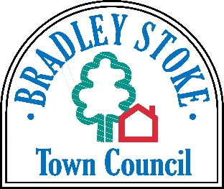 CUSTOMER
SERVICE
CHARTER
Who We Are?

Bradley Stoke Town Council

Mission Statement

Bradley Stoke Town Council will work to promote and develop the interest and diversity of this vibrant community

Aims

- To consider and respect the views of our service users and residents of Bradley Stoke

- To be efficient, effective and accessible

- To provide a quality service to the service users and the wider community as a whole

- To be flexible and forward thinking, where possible

- To communicate with service users and members of the public, whilst respecting confidentiality

- To respond to service users needs

- To have a robust complaints procedure

Reviewed by Bradley Stoke Town Council - 8th July 2026

