


Bradley Stoke Neighbourhood Team
Patchway Police Centre

BRADLEY STOKE TOWN COUNCIL

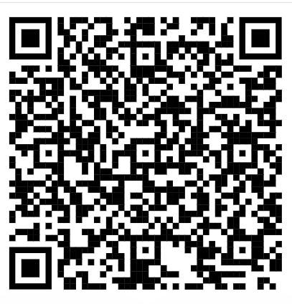

QR CODE BS BEAT PAGE – LINK TO REPORT CRIME/TEAM DETAILS

Newsletter

Monthly crime statistics
(Statistics likely to be the month prior)

October 2025

Burglary – 7
Public Order – 5
Sexual Offences – 7
Theft – 21
Violence Against the Person – 40

Shoplifting Operation at Willow Brook Centre

The Bradley Stoke Neighbourhood Policing Team recently took part in a targeted operation addressing shoplifting and related offences at the Willow Brook Centre. This initiative was a joint effort between local police and Willow Brook Security, aimed at tackling commercial crime and improving community safety.

The operation brought together officers and security personnel to address a shared concern affecting local businesses and residents. Through proactive patrols and collaborative engagement, the team was able to identify prolific offenders and gain valuable insight into the challenges faced by Willow Brook Centre.

This partnership highlights the importance of joint working in reducing crime and supporting the local community.

Avon and Somerset Police Geographic Model Update

As of 3 November 2025, Avon and Somerset Police officially transitioned to a new Geographic Policing Model, aligning our Patrol and Neighbourhood teams under three Basic Command Units (BCUs):
- Bristol
- Somerset
- North East

This change is part of our ongoing commitment to improving service delivery and operational efficiency.

What does this mean for the community?
There will be no change to how members of the public report crime or access police services. However, internally, there will be a restructuring of how officers are deployed and respond to incidents, allowing us to better meet demand across the region.

Local Neighbourhood Policing Teams will continue to be visible and active within their communities—engaging with residents, addressing concerns, and tackling local issues.

Useful Contacts

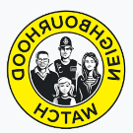

Neighbourhood Watch

Contact: Trevor Wilmot
Tel: 07547 659 714
Email: trevor.wilmot@avonandsomerset.police.uk

Street Safe

StreetSafe is a service that allows you to report safety concerns in public places without giving us your name (anonymously). This includes issues like poorly lit streets, abandoned buildings, or vandalism, as well as instances where you feel unsafe due to someone following or verbally abusing you.
StreetSafe is not for reporting crimes or emergencies. If you witness a crime or emergency, please call the police on 101 or report a crime online. If you're unsure whether something is a crime or not, read our advice.
Examples of situations that should be reported to StreetSafe include a poorly lit alleyway that makes you feel unsafe or a park with broken equipment that poses a safety hazard.

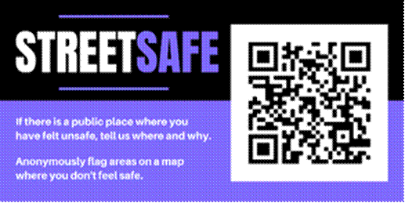

Edited by PCSO 6535 Ali

