


Bradley Stoke Neighbourhood Team
Patchway Police Centre

BRADLEY STOKE TOWN COUNCIL

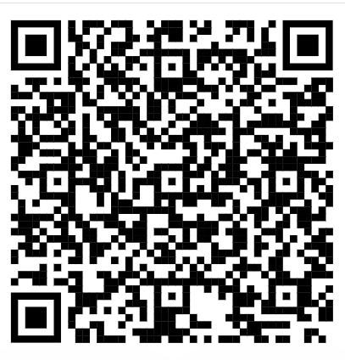

QR CODE BS BEAT PAGE – LINK TO REPORT CRIME/TEAM DETAILS

Newsletter

Monthly crime statistics
(Statistics likely to be the month prior)

August 2025

Burglary - 8
Public Order – 10
Sexual Offences – 8
Theft – 5
Violence Against the Person – 29

Operation Harmony: Making Bradley Stoke Safer

On 5th August 2025, the Bradley Stoke Neighbourhood Team launched Operation Harmony—a targeted initiative to tackle vehicle-related crime and improve safety across our community.

Working in partnership with police officers, special constables, PCSOs, and the Traffic Department within the police, the team focused on identifying vehicles with no insurance, expired MOTs, and serious mechanical defects.

The results of the operation were significant:
- Over 20 vehicles were stopped and checked.
- 6 drivers received tickets for careless driving and vehicle defects.
- 2 vehicles were seized—one due to a disqualified driver, the other for no road tax.
- 1 vehicle was found in such poor condition it was immediately prohibited from being driven. The driver was fined £300 on the spot.
- 1 e-scooter was also seized.

This successful operation has paved the way for future initiatives aimed at keeping Bradley Stoke safe and ensuring our roads are used responsibly.

A special thank you goes to PCSO Oliver Kirk and PS Polly Tucker for their dedication and behind-the-scenes work in organising this impactful operation. Their efforts have made a real difference in tackling issues that matter to our community.

Together, we’re building a safer Bradley Stoke—one operation at a time.

Neighbourhood Guarantee: Supporting Safer Communities Across South Gloucestershire

Avon and Somerset Police have introduced a new initiative called the Neighbourhood Guarantee, a commitment recorded with the Home Office to improve community safety and tackle key issues such as crime and anti-social behaviour (ASB).

As part of this programme, Neighbourhood Officers are conducting one-hour foot patrols in key areas across South Gloucestershire. These patrols are designed to provide a visible police presence, deter crime, and engage with local residents.

While the programme is expected to run until the end of September, it has temporarily impacted local coverage in Bradley Stoke. PCSO Adam Ali and PCSO Oliver Kirk, who usually serve the Bradley Stoke area, have been redeployed to support patrols in other parts of South Gloucestershire.

We appreciate the understanding of our residents during this time and remain committed to maintaining a strong presence in Bradley Stoke. These efforts are part of a wider strategy to ensure all communities across South Gloucestershire feel safe, supported, and heard.

Useful Contacts

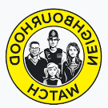

Neighbourhood Watch

Contact: Trevor Wilmot
Tel: 07547 659 714
Email: trevor.wilmot@avonandsomerset.police.uk

Street Safe

StreetSafe is a service that allows you to report safety concerns in public places without giving us your name (anonymously). This includes issues like poorly lit streets, abandoned buildings, or vandalism, as well as instances where you feel unsafe due to someone following or verbally abusing you.
StreetSafe is not for reporting crimes or emergencies. If you witness a crime or emergency, please call the police on 101 or report a crime online. If you're unsure whether something is a crime or not, read our advice.
Examples of situations that should be reported to StreetSafe include a poorly lit alleyway that makes you feel unsafe or a park with broken equipment that poses a safety hazard.

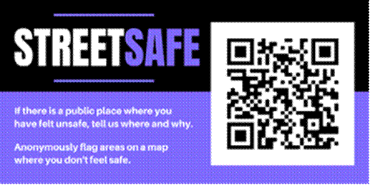

Edited by PCSO 6535 Ali

