Bradley Stoke Neighbourhood Team
Patchway Police Centre

BRADLEY STOKE TOWN COUNCIL
STOKE LODGE AND THE COMMON



QR CODE BS BEAT PAGE – LINK TO REPORT CRIME/TEAM DETAILS

April NEWSLETTER

Monthly crime statistics
(Statistics likely to be the month prior)

March 2025

Arson and Criminal Damage – 3
Burglary – 1
Public Order – 14
Theft – 6
Vehicle Offences – 2
Violence against the person – 33
Anti-social Behaviour (recorded as crime, not including calls to police/unrecorded) – 12

General Update

In recent months, staffing has considerably lowered for South Gloucestershire NPT. Due to the lack of numbers, our workload has increased irrespective of demand. This will have an impact on seeing officers as a visible presence. We have been notified that the numbers will increase, and I will update councillors and staff when this occurs.

Summer demand is almost upon us. This will likely start around May or June time.

Summer demand will increase the demand for school talks and proactive engagement with ongoing policing issues. This will include a proactive operation to tackle knife crime in the next coming months. This will require myself and my staff to attend meetings and schools to engage and hold talks.

VAWG (violence against women and girls) is on the priority list.
Hot spots policing can be effective at reducing a wide range of different crimes, including violence, in a variety of different contexts. Police target resources and activities to those locations, where crime and harm are most concentrated. To implement this strategy, the police will need to know where and when VAWG is concentrated.
We have worked with partner agencies to distribute posters to be vigilant in schools about any unusual behaviour. We want young people to feel safe and secure in their location. Being vigilant is key.

We are often used to assist response policing at this time, which will lessen our time for community-based policing.

PCSO recruitment has opened again now – unknown recruitment numbers at this point. (Still ongoing)

Theft is still going unreported, we are yet to see a change in this.

Community Engagement

TALK TO US EVENT

Wednesday 14th May 2025, 11:00 to 12:00

Willow Brook Centre
Savages Wood Road
Bradley Stoke
BS32 8EF

PARKING ISSUES

We are aware that this is an ongoing issue across Bradley Stoke and surrounding councils.
We can enforce white zigzags, however; this is more of a council issue.
We are finding it difficult at the moment to conduct regular school patrols due to lack of staffing. We are in the throws of arranging a joint venture with the council to target poor parking.

We have actively been working with the council and schools to educate them in what is a police matter and what is a council matter in terms of parking.

SCHOOL VISITS

So far this year, Bradley Stoke Beat Team has visited 8 schools. With more being visited in the future. This is to educate pupils on police practice and to provide a good working relationship with schools to understand who your local police are.

Business Engagement

Willowbrook has been regularly visited by staff and we are in communications with any issues via email with the centre manager.
Bradley Stoke Beat Team have had meetings and sat with the centre management in recent weeks to try and ascertain whether our presence could influence change.

Useful Contacts

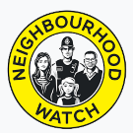
Neighbourhood Watch

Contact: Trevor Wilmot
Tel: 07547 659 714
Email: trevor.wilmot@avonandsomerset.police.uk

Street Safe

StreetSafe is a service that allows you to report safety concerns in public places without giving us your name (anonymously). This includes issues like poorly lit streets, abandoned buildings, or vandalism, as well as instances where you feel unsafe due to someone following or verbally abusing you.
StreetSafe is not for reporting crimes or emergencies. If you witness a crime or emergency, please call the police on 101 or report a crime online. If you're unsure whether something is a crime or not, read our advice.
Examples of situations that should be reported to StreetSafe include a poorly lit alleyway that makes you feel unsafe or a park with broken equipment that poses a safety hazard.

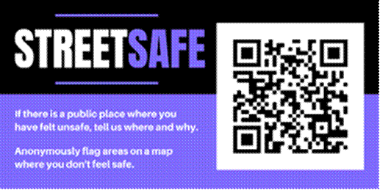

Edited by PC JONES-HILL

