BRADLEY STOKE TOWN COUNCIL

Leisure, Youth & Amenities Committee

Minutes of the Meeting of the Leisure, Youth & Amenities Committee of Bradley Stoke Town Council held at The Jubilee Centre, Savages Wood Road, Bradley Stoke on Monday 22nd June 2026 at 7.00pm.

PRESENT: Councillors: Tom Aditya
John Bradbury
Terri Cullen (Chair)
Natalie Field
Jenny James
James Nelson
Ben Randles
Kulwinder Singh Sappal

Officers: Sharon Petela (Town Clerk)
Angela Athay-Hunt (Youth Work – Team Leader)
Raphaela Boghi (BSTC Projects & Events Officer)

1 Election of Chair of Leisure, Youth & Amenities Committee for 2026/27

Councillor Kulwinder Singh Sappal proposed that Councillor John Bradbury be elected to the position of the Chair of the Leisure, Youth & Amenities Committee for 2026/27, seconded by Councillor John Bradbury.

Councillor Ben Randles then proposed that Councillor Terri Cullen be elected to the position of the Chair of the Leisure, Youth & Amenities Committee for 2026/27, seconded by Councillor Terri Cullen.

A vote was taken: Councillor John Bradbury – 3 votes
Councillor Terri Cullen – 5 votes

Councillor Terri Cullen was therefore elected as Chair of Leisure, Youth & Amenities Committee for 2026/27 and assumed the chair.

2 Submissions from the Public

2.1 Councillor Tom Aditya thanked staff for installation of wooden swings and benches on the Beacon Playscheme but suggested that there should be additional benches in the vicinity of Davis Pond. It was highlighted that there are potential budget constraints with the purchase of more benches, but the Town Council does have a Memorial Benches policy in place which would enable the local community to purchase benches which could be installed in this vicinity.

2.2 Councillor Tom Aditya suggested that taster sessions should be organised for younger children at the skatepark. The Youth Work – Team Leader explained that working with a younger cohort is something that the youth work team will be looking at in the near future.

3 Apologies

Apologies were received from Councillor Jon Williams and representatives from Bradley Stoke in Bloom and Bradley Stoke Radio

4 Declarations by Members

None
5 Announcements by the Chair

None

6 To confirm Minutes of Previous Meeting held on 20th April 2026

Acceptance of the Minutes of the meeting of the Leisure, Youth & Amenities Committee held on 20th April 2026 were proposed by Councillor Kulwinder Singh Sappal and seconded by Councillor Jenny James with the following two minor amendments:

Welcome to the meeting
“Vaisakhi (Sikh traditional new year and anniversary festival celebrating the manifestation of the Khalsa 1699)”.

4 Announcements by the Chair
- Took part in the Lent Lunch at St Mary’s Church School, Bradley Stoke

A vote was taken, 6 in favour, 2 abstentions, proposal carried. Minutes were then signed as a correct record.

7 To deal with Grant Funding Applications

7.1 Service Level Agreements (SLA)

None

7.2 Community Development Grant Aid (CDGA)

7.2.1 CDGA36 – Bradley Stoke Radio (BSR)

The group has submitted the following update.

We are heading into World Cup fever with a weekly two hour show hosted by new presenter Jimmy R every Monday night. James will be following all the action on the pitch from Mexico, USA and Canada alongside keeping us informed of all things local and sports related every Monday evening from 6-8pm. Our regular programming continues and we support one another through the studios and maintain as accessible community asset as we possibly can through volunteer hours.

We are still looking and bringing people into the station that respond to the social media page poster. We are working a 1:1 peer training and skills to encourage people to join and volunteer in the community radio station.

We were disappointed that the weather stopped all play for the Community Festival as this is our big event of the year when we can reach our audience in person. We are looking at our volunteer availability and potential to be at other events through the summer/autumn. We will not let this dampen our spirits!

Bradley Stoke Radio did get out to the Luke Wheaton memorial football tournament, where hundreds of young footballers, coaches, volunteers and families gathered for one of the area’s biggest grassroots tournaments. With dozens of clubs and hundreds of matches across the weekend, it was a celebration of teamwork, resilience and community spirit.

Bradley Stoke Radio supported the event throughout, providing the public address system, entertainment and staging. Presenters kept crowds updated with match announcements, safety messages and competition news, while a lively soundtrack maintained a fun, family-friendly atmosphere.

The staging area became the hub for trophy presentations, team photos and volunteer recognition, helping to create a professional festival feel. For many young players, the weekend offered far more than football — it created lasting memories with teammates and friends.

Bradley Stoke Radio was proud to help bring the tournament to life and support a fantastic celebration of grassroots sport in South Gloucestershire.

CDG 13/4/2026 £2694.26 | Outgoing description | Amount | Remainder
 | Insurance (27/4/26) | £102.70
 | Virgin media (20/4/26) | £58.80
 | Virgin media (18/5/26) | £70
 | Insurance (26/5/26) | £102.70 | £2348.86 (16/6/26)

7.3 Grant Aid (GA)

None

7.4 Larger Grant Aid

None

7.5 Ex-gratia Payments

None

8 Matters arising from the minutes of the meeting held on 20th April 2026

None

9 Matters within the scope of the Leisure, Youth & Amenities Committee

9.1 Bradley Stoke in Bloom (BSIB) update by Steering Group

Update submitted – see Appendix A.

The replacement planters at the entrances to Bradley Stoke were also discussed. BSTC Officers have been in contact with South Gloucestershire Council (SGC) Active Travel Team on a number of occasions asking for an update as it is hoped that they will be moving and installing the planters for the Town Council, either as a gesture of goodwill or at a minimal cost. This was also discussed with the Active Travel team at the Bradley Stoke Community Festival.

Concerns were also raised regarding the replacement ‘Welcome to Bradley Stoke’ sign which has just been installed by SGC on Bradley Stoke Way adjacent to The Worthys. The new sign bears no resemblance to the previous sign which apparently, SGC had safely stored and were going to replace.

Officers were tasked to contact SGC to raise concerns regarding the replacement sign and also to chase up about the planters.

9.2 Youth Work update

Angela Athay-Hunt, the new Youth Work Team Leader presented her report having been in the full-time post since 11th May 2026.

Current Session Updates

Skate Park Sessions (Tues/Thurs) - consistently good numbers & active, growing younger participant cohort. Weekly activity tables introduced (art, craft, baking, planting). More structured placement of Youth Workers during session to engage all young people. Volunteer’s introduced from older cohort with aspiration to become Assistant Youth Support Workers to support wider offers, piloting during summer holidays.

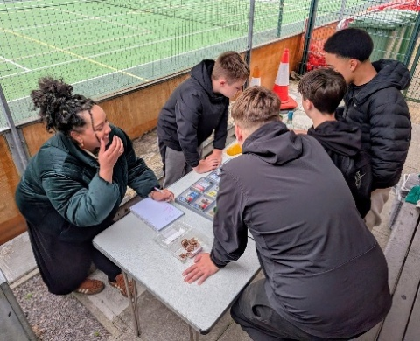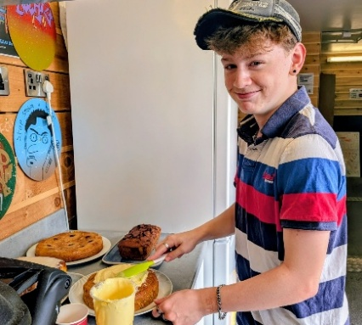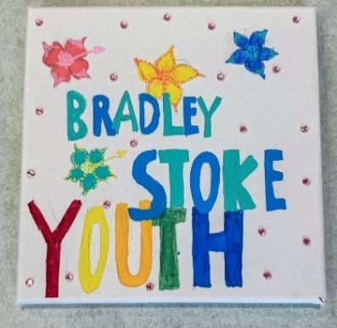

Girls Project (Tues) - reinvigoration planning to attract younger cohort through schools engagement, summer offers & Detached session communication (including Circus, dance & Indian Cookery during summer).

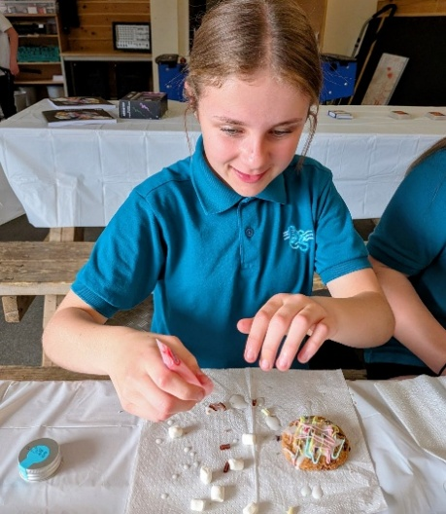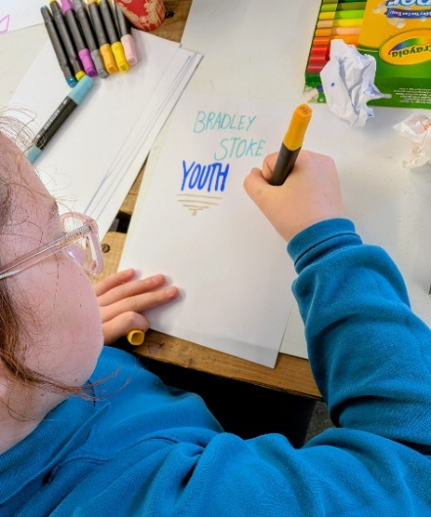

Multi-Sports Session @ Jubilee (Thurs) - improved equipment planned & workshop offers including Young Persons Drugs & Alcohol Service (YPDAS), Empire Fighting Chance (boxing), football coaching for FACE Summer Tournament (we are sending a team!)

Bradley Stoke Community Festival and Skate Competition

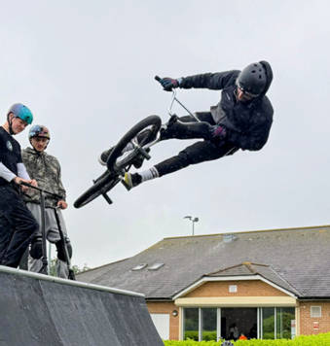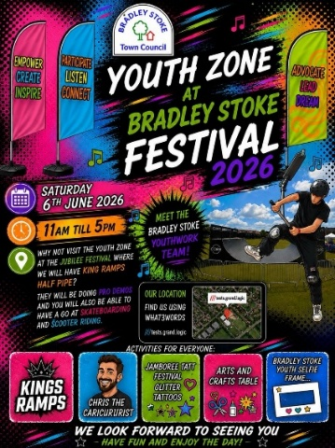
Rain did not stop play for the Youth Zone!

Chris the Caricaturist, Jamboree Tatt festival tattoos, BSY selfie frame, sail flags, arts and crafts and a youth-run tuck shop all moved to Jubilee! Positive new conversations with families not accessing youth offers. Festival tattoos and tuck were also offered at the skate-comp the following day, with young people MCing and DJing! New BSY Insta also gained good traction.

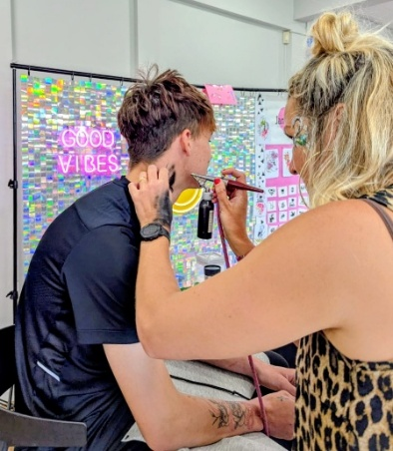
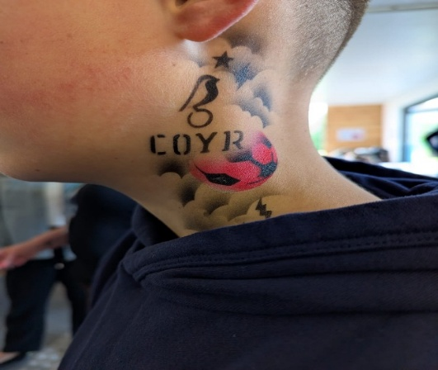
Coming Up Next 🚀

Detached Youth Work Sessions - mapping & pilot sessions have been launched with a summer timetable offer and plan to move forward including the potential use of DORIS as part of Lot 1 partnership. Working with Willow Brook Centre providing ‘pop up’ youth space as well as targeted areas of the locality.

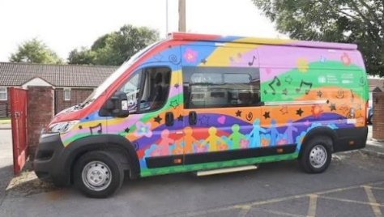

Positive Empowerment - South Glos Youth Awards, set up of Youth Voice/Forum, youth planning sessions

Up Next - Summer Offers and New Offers

Diversification of summer youth offer including -
- Increased core offer sessions with weekly Youth Curriculum themes & activity
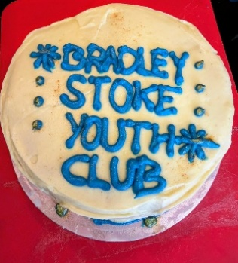
- Girl’s Group impact sessions (Circus, Indian Cookery)
- Junior & Senior Drama workshops
- SEND sessions (family & older teen) in partnership with West England Music & Arts (WEMA)

‘Moving on Up’ pilot session for 9 - 13 year olds with view to creating an initial monthly offer, utilising other Activity Centres, from the Autumn.
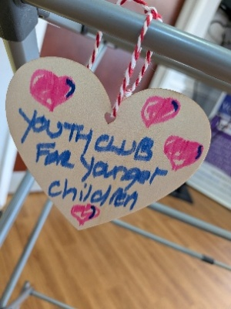

Trip to YouFest & West Country Water Park

New Community Partnerships - locality schools (BSCS, Patchway, Abbeywood), Willowbrook Centre, WEMA, Empire Fighting Chance

Discussion then took place on a range of topics linked to the report and thanks were passed to Angela for her presentation.

Officers were tasked to contact SGC, and the local police beat team to raise concerns regarding eBikes and eScooters speeding along the newly installed cyclepaths.

9.3 Update on BSTC Projects & Events

Raphaela Boghi, the new BSTC Projects & Events Officer presented her report having been in the full-time post since 27th May 2026.

The initial three weeks following appointment were dedicated to developing a thorough understanding of the events and communications programme delivered by the Town Council and the role this plays in supporting Bradley Stoke residents.

A council-wide events calendar has been established, giving all office staff clear visibility of upcoming activities. Communication templates have been developed to ensure consistency across all channels, and a structured process has been documented covering event communications, channel management, and project tracking. This framework ensures events are managed effectively and that learning is captured and carried forward.

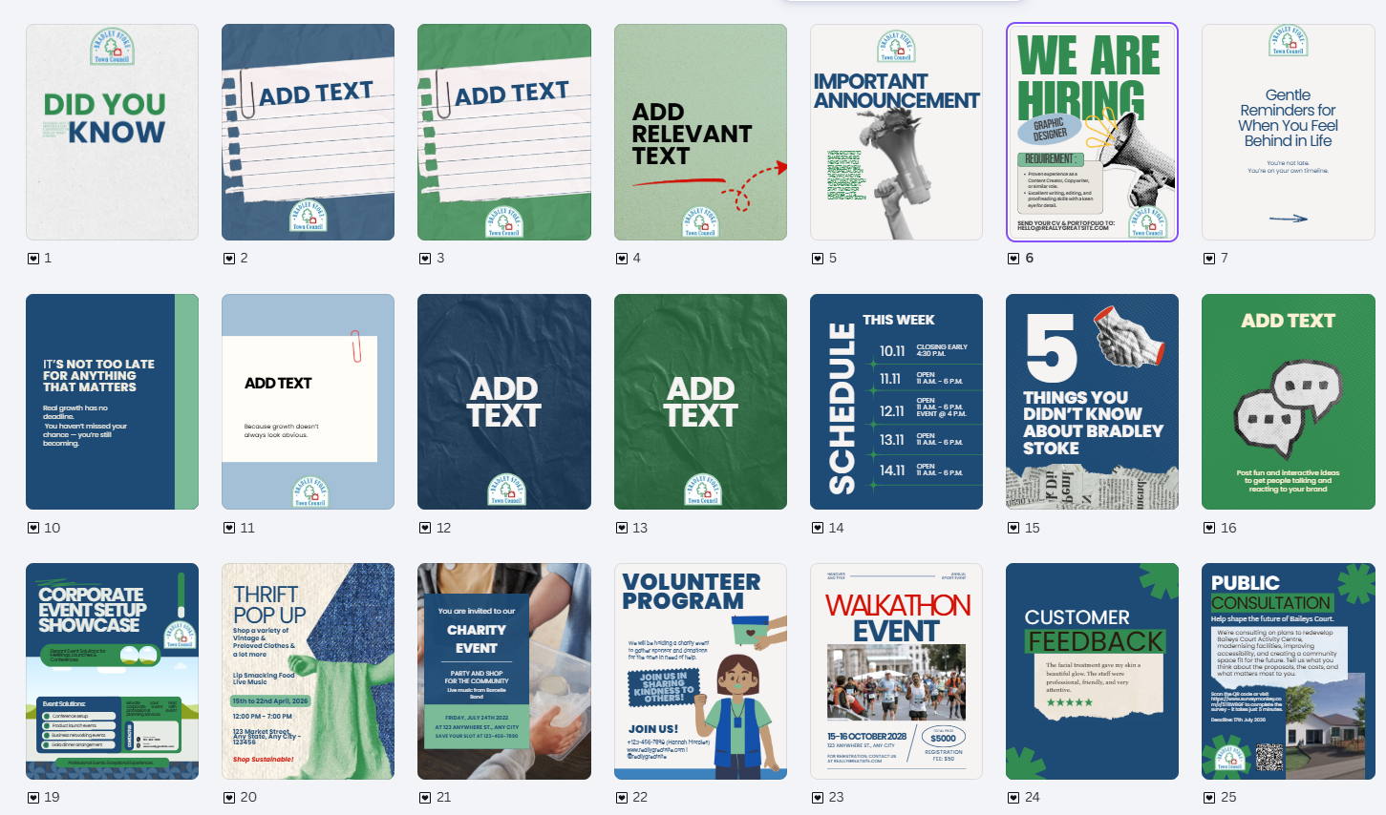

The priority is to grow the Town Council's social media presence in order to reach more residents across Bradley Stoke. Once a stronger following has been established, the focus will shift to nurturing those connections, ensuring the community is well informed and actively involved, both online and in person.

A central challenge remains reaching residents who are not currently engaged with the Council's existing communications channels. Digital communications can only go so far, and some of our most valuable connections happen face to face, in the street, at the school gate, and in local spaces.
Councillors are uniquely placed to help bridge this gap. As people who are already out and about in the community, your conversations and personal recommendations carry a weight that no social media post can replicate. Word of mouth remains one of the most powerful tools available to us.

With this in mind, there is a direct ask of all councillors: please share upcoming events with the residents you speak to, encourage attendance, and where possible, follow up afterwards. When residents come to an event, enjoy it, and hear about the next one from a familiar face, they are far more likely to return and to bring others with them.

Building a connected, engaged community is a shared effort. The more voices carrying that message, the further it reaches.

9.3.1 Community Orchard and Nature & Wellbeing Hub

One Planet Matters will be running a hands-on experience of conservation and maintenance activities at Bradley Stoke Community Orchard and Wellbeing Garden.
- Where: Brook Way Activity Centre
- When: 28th June, 2pm – 5pm

Marketing
- Community Notice boards
- Social Media posts
- BSTC Website
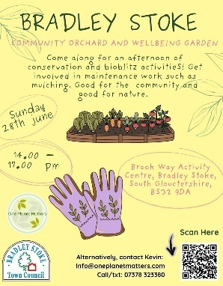

9.3.2 Repair Café

A Make-Do Day will be planned as a trial event to gauge resident interest and assess appetite for this type of community activity in Bradley Stoke.

The proposed programme includes Dr Bike cycle repairs, plant swapping, clothes repair, and sustainable crafts.

For context, Stoke Gifford runs a well-established monthly Repair Café at St Michael's Church coffee shop on Saturdays, covering appliance repairs, bike maintenance, and clothes mending. This provides a useful benchmark and demonstrates that there is existing demand for this kind of provision in the local area.

The trial will allow the Council to test the concept, gather feedback, and make an informed decision about whether to develop it into a regular offering.

- Where: Oak Hall
- When: To be defined (likely in Autumn)

Once the event’s details have been confirmed, it will be publicised on the appropriate communication channels.

9.3.3 Community exercise classes on Jubilee Green Leisure Equipment

Following budget approval, the wellbeing and fitness programme is now in the organisation and promotion phase, with activity under way to attract residents to take part. The classes are designed for people who do not currently exercise regularly, with provision for different abilities and levels of experience. The environment is intentionally inclusive and welcoming, with no expectation of prior fitness or experience.

The programme will run over eight weeks. A short survey will be completed by participants at the start and end of the programme, providing a before and after picture of how participants feel. This data will give the Council a clear evidence base for the impact of the programme and inform decisions about future provision.
- Where: Jubilee Green
- When: 2nd July – 20th August, 5:30pm – 6:30pm

Marketing
- Community Notice boards
- Social Media posts
- BSTC Website
- Eventbrite
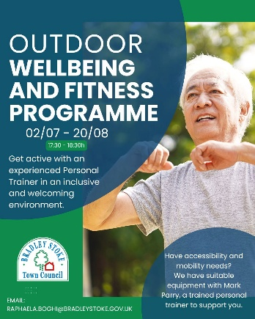

9.3.4 Bradley Bear has been hired

Bradley Bear – or Brad, to close friends – is BSTC new hire. He made his first appearance on our social media, telling the story behind Bradley Stoke and asking residents to vote on his new role:
- Chief Community Officer
- Official Town Ambassador
- Head of Community Vibes
- Director of Good Things

The result of the poll was shared on Monday, the 22nd of June – C was chosen by the community.
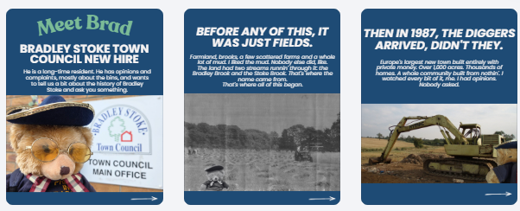
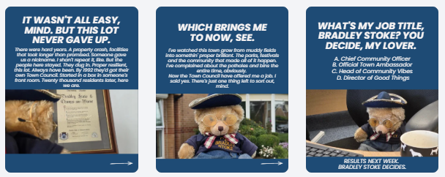

Did you spot Brad on Instagram/Facebook? It is anticipated that Bradley Bear will eventually have his own section on the Town Council website.

9.4 Review of origins of current Service Level Agreements

Documentation circulated.

Discussion took place on the origins of Service Level Agreements (SLA). These have historically been running since 2002/2003 and have supported specific community groups and organisations across Bradley Stoke since the early days of the town.

Following further discussion, Councillor Natalie Field proposed that a section relating to Service Level Agreements is added to the Grant Funding section of the Town Council website, seconded by Councillor Ben Randles, carried unanimously.

Councillor James Nelson then suggested that a table of current organisations supported by SLAs, along with their most recent application documentation, is incorporated into this section of the website. Councillors were in support of this idea.

10 To agree the date and time of the next meeting

Following discussion, Councillor Ben Randles proposed that the next Leisure, Youth & Amenities Committee meeting on Monday 24th August 2026 at 7.00pm is held at Bradley Stoke Skatepark, Fiddlers Wood Lane, Bradley Stoke, BS32 9BS, seconded by Councillor Kulwinder Singh Sappal, carried unanimously.

The meeting closed at 8:30pm

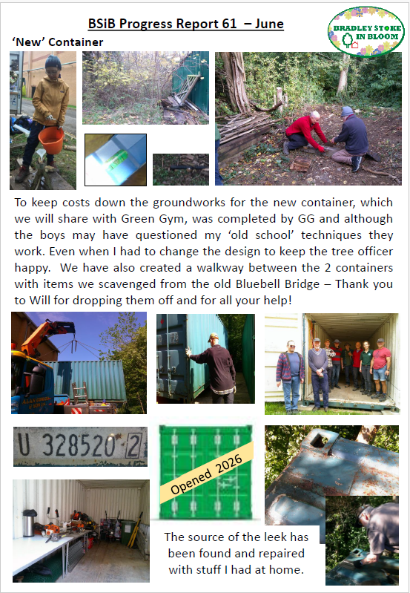
APPENDIX A

APPENDIX A

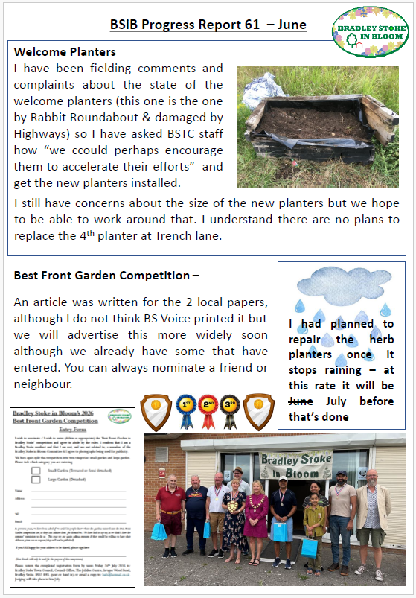

APPENDIX A

