BRADLEY STOKE TOWN COUNCIL

Leisure, Youth & Amenities Committee

Minutes of the Meeting of the Leisure, Youth & Amenities Committee of Bradley Stoke Town Council held at The Jubilee Centre, Savages Wood Road, Bradley Stoke on Monday 20th October 2025 at 7.00pm.

PRESENT: Councillors: Sue Bandcroft (subbing for Natalie Field)
John Bradbury
Jenny James (Chair)
James Nelson
Kulwinder Singh Sappal
Jon Williams

Officers: Sharon Petela (Town Clerk)
Graham Baker (Youth Development & Participation Worker)

Representatives from: Mamas Bristol CIC

1 Submissions from the Public

1.1 Councillor John Bradbury commented that, following the recent successful purchase of the land at Dewfalls Drive at auction, there will be a number of matters to consider going forward, including the future use of the land and the associated ongoing maintenance costs, as the site has been acquired as an asset for the whole town. Councillors also suggested that it would be useful to establish whether South Gloucestershire Council (SGC) has identified any other similar areas of open space within Bradley Stoke.

2 Apologies

Apologies received from Councillor Natalie Field, Ivy Brown (BSTC Projects & Events Officer) and representatives from Bradley Stoke in Bloom and South Gloucestershire Armed Forces Day

3 Declarations by Members

None

4 Announcements by the Chair

The Chair informed the meeting that they have attended a Bat Walk on Three Brooks Nature Reserve + joined in with the Jubilee Green outdoor gym equipment taster session + visited the Community Welcome Spaces at Jubilee Centre and Baileys Court Activity Centre + joined the Three Brooks Nature Conservation Group workday removing brambles from the Reserve and Sherbourne Brake + visited Bradley Stoke Sew N Sos and talked about the red dress projects (the group thanked the Town Council for their continuing support) + attended Concord Church’s 3rd birthday celebration with others from Bradley Stoke + attended the Splatts Abbey Wood Student Project Leaders training session + visited the Three Brooks Park Run + took part in the September litter pick with McDonalds + attended the Diwali event in Thornbury which was organised by Avon Indian Community Association.

5 To confirm Minutes of Previous Meeting held on 18th August 2025

Acceptance of the Minutes of the meeting of the Leisure, Youth & Amenities Committee held on 18th August 2025 were proposed by Councillor Kulwinder Singh Sappal, seconded by Councillor Jon Williams. A vote was taken, 5 in favour, 1 abstention, proposal carried. Minutes were then signed as a correct record.
6 Service Level Agreements, Community Development, Grant Aid and Youth Grant Aid Applications

6.1 Service Level Agreements (SLA)

None

6.2 Community Development Grant Aid (CDGA)

6.2.1 CDGA35 – Mamas Bristol CIC

The representatives from the group were invited to present the following report:

Mamas Bristol is looking to invest in an “interactive projector” for our SEND project and biweekly week long quiet activity for our stay & play.

When we run play sessions, we have a bouncy castle running 1 week which can be a struggle for children who do not like loud, white noise and we run a quiet "playtray" activity the next week - which is a tuff tray with a task, game, sensory play or small world. However, children don't understand how to interact with this method of play for many reasons and it's not creating the educational, learning & inclusive impact we would want to have within our sessions.

We have the bouncy castle running bi weekly, but our struggles with this during our weekly sessions are, spatial awareness hazards when bouncing, loud noise & we feel we can have more positive, powerful impact with a projector for many of the reasons below.

An interactive projector makes learning fun through;
- Using the body to control the equipment which aids physical exertion - different & safer to that of our bouncy castle and vestibular & visual sensory input.
- Educational music and speech to encourage Gestalt Language Processing and aid auditory sensory input.
- As the projector is mobile, this can be used on the floor which can benefit a service user with physical impairment as it can be used free of a wheelchair. It can also be placed to project onto a table, if the impairment meant they required the support of their wheelchair which makes this equipment accessible to ALL and super inclusive!

Games are designed to be fun, physical, educational and imaginative and there are hundreds on the system, so we can select a programme to suit a child's preference or particular interest. This is especially important for a child with SEND to gain their small window of attention span and hold interest to make meaningful connections and an optimal learning environment.

As there is no limit to the amount of children that could use this equipment, children can interact together and can learn how to have others in their "space", how to work together to finish tasks and create a meaningful social interaction and play time without creating too much dependent demand for each other. The “Covid Generation” of children have really struggled with these social interactions and understanding – at our venue we still see the effects of Covid isolation amongst toddlers. Social and emotional education is something my own SEND children struggle with, and I can see the benefit of this equipment for children with these needs.

Our centre will be the only North Bristol facility that has an interactive projector, with the only known projectors based in South Bristol currently.

We also are one of the cheapest centres available that hosts equipment as specialist as ours making us extremely attractive and accessible to all Bradley Stoke locals.

Bradley Stoke doesn’t have a children’s centre or specialist SEND provision, and the only other permanent play facility is at Bradley Stoke Leisure Centre. When comparing ticket costs, their comparative costs for a 1 hour session off peak are 60-75% more expensive than ours and we offer Nurture, Education & Inclusivity alongside all the knowledge our volunteers hold for supportive measures.

External neighbourhood visitors bring more revenue into Bradley Stoke for businesses. We know that once guests visit our centre, they will go on to visit cafes, shop locally, visit the leisure centre/library or spend time within local parks and amenities.

The whole piece of equipment - £7,000. (RRP: £8,400). We have managed to negotiate a discount of £1,400 from the equipment costs, and we have been offered £3,000 from the fund Stoke Park Friends within Quartet as they can see the benefit to the local community. We have also received £750 grant funding from Patchway Town Council.

Following discussion Councillor Kulwinder Singh Sappal proposed that, as this request does not specifically fit within the Community Development Grant Aid application criteria, a one-off ex-gratia payment of £2,000 should be made instead towards the purchase of an interactive projector for the organisation’s SEND project, seconded by Councillor James Nelson, carried unanimously.

6.3 Grant Aid (GA)

6.3.1 GA515 – South Gloucestershire Armed Forces Day

The group has submitted the following report:

The South Gloucestershire Armed Forces Day committee organises a local event to commemorate the national armed forces day annually.

This event is held in South Gloucestershire. The aim is to recognise, remember and show our gratitude to the armed forces community, past and present, and to support the role of our cadets. The event aims to support the community to come together for this day with various stalls, entertainment and pageantry to make this an exciting and meaningful annual event.

This event offers a day of fun, enjoyment, reflection and recognition – the stalls, entertainment and activities put on enable a fun and exciting day for South Glos residents, and the Armed Forces personnel, veterans and cadets local to Bradley Stoke, and their families will be invited to participate in the event with activities such as a parade, drills, and an Armed Forces reception.

This is an annual event, a small event was held in 2024 and a full scale event in 2025. Prior to the covid-19 pandemic this was an annual event in the calendar. The 2026 event takes place in Page Park, Staple Hill on Saturday 20 June 2026.

Following discussion Councillor Sue Bandcroft proposed that South Gloucestershire Armed Forces Day are awarded £500 grant aid towards the running costs of the 2026 event, seconded by Councillor Kulwinder Singh Sappal. A vote was taken, 5 in favour, 1 abstention, proposal carried.

6.4 Larger Grant Aid

None

6.5 Ex-gratia Payments

See minute 6.2.1

7 Matters arising from the minutes of the meeting held on 18th August 2025

None

8 Matters within the scope of the Leisure, Youth & Amenities Committee

8.1 Bradley Stoke in Bloom (BSIB) update by Steering Group

Update received (see Appendix A).

8.2 Youth Development & Participation Worker (YDPW) update by Graham Baker

Graham Baker, Youth Development & Participation Worker presented the following bi-monthly report and also displayed data charts generated by the Upshot database giving breakdowns of the numbers, genders, ages, wards and areas of young people attending youth work sessions across the Bradley Stoke youth provision.

Headline news since last LYA Committee report on the 18thAugust 2025.
- Youth work sessions: in this 9- week reporting period (including one week’s staff break at the end of the school summer holidays) we have delivered the following youth work sessions and activities:
- Core youth work sessions: 32 core youth sessions took place at the Skatepark, Jubilee Centre (Girls Project), Jubilee Hardcourts and surrounding area.
- Additional sessions/ activities: over the school summer holidays we delivered 4 weeks of our core youth sessions with additional Wednesday skatepark sessions and/ or off-site trips. This reporting period covers the last week of the programme and therefore 1 additional extended session.
- Each core youth work session comprises of between 2hrs and 2.5hrs of face-to-face youth work, however, sessions are sometimes extended to 3 hours or more, particularly during holiday periods.
- Most sessions have generally been well attended, however, there has been the usual reduced numbers during the school/ college summer holidays. During this reporting period the Skatepark sessions were averaging approximately 40 young people and Jubilee sessions 30, however, as previously explained, both have had a seasonal drop, and attendance is now generally rising. Most of the young people continue to be in the 12-to-18-year age range, with the majority in the 14 to 17 age range. The gender breakdown is still approximately 35% girls and young women and 65% boys and young men. The majority attending the skatepark building sessions see them as ‘youth club’ sessions with only a minority engaging with use of the skatepark. More data will be presented at Committee.
We continue to provide loan scooters and helmets and engage skatepark users of all ages and encourage positive behaviour and ownership of the park. We also offer support, tools, and parts for equipment maintenance, including utilising the SGC bike repair box scheme along with our other tools and equipment. The bike maintenance offer often helps build positive relationships.
- Our Girls & Young Women’s (G&YW) Project have held 8 weekly core sessions at the Jubilee Centre with most attendees within the 14 to 17 age range. Following some recruitment success, the last three sessions have seen the welcome introduction of two new assistant youth support workers, and they are both settling into their roles. 1 to 1 work, including supportive signposting and/ or referrals, sometimes take place because of, or additional to, the sessions (please also see 1-2-1 support section later in this report).
- Various meetings/ discussions/ contact with other agencies: these have involved the usual South Glos Youth Work Partnership meetings, the National Lottery Community Fund, International Women’s Day, SGC re our Skatepark lease and various communications with the local police and VRP (Violence Reduction Partnership). We are meeting with the local police later in October to further discuss local themes and issues. We are also still awaiting feedback on the possibility of a South Glos wide ‘Youth MAM’ as opposed to individual area MAMs.
- FareShare Go: we continue to receive two food donations a week from FareShare Go and recently underwent our annual inspection (the skatepark) with the following positive feedback, ‘Thank you for taking the time to speak with me last week - your premises looked great, and I’m happy to sign you off for another year of FareShare Go collections’. In addition, they were keen to know if we would be interested in hosting some corporate volunteers from FareShare and will shortly be exploring the possibility of an appropriate project.
- Possibility of small youth work office space: following recent recruitment and planned further recruitment for detached/ outreach and other p/t youth work staff, it would be helpful to consider a small accessible space that p/t youth work staff could utilise/ operate from, i.e. somewhere with minimal storage for detached bags/ sessional resources/ space to brief/ debrief and write up the session. Action: to discuss possibilities, including the potential to utilise a small space such as the Beech room at the Jubilee Centre.

Following discussion, Councillor Jon Williams proposed designating the Beech Room at the Jubilee Centre as a youth work office space, as soon as is possible, seconded by Councillor Kulwinder Singh Sappal, carried unanimously.

Our recent and planned youth work strands explained below:
Girls’ Project youth work sessions have taken place on eight Tuesdays throughout this reporting period, with staff having a one week break at the end of the school summer holidays. The sessions offer a safe space and a range of activities, discussions, and support. We continue to promote the Girls Project using closed group Instagram and this helps inform/ remind people of upcoming sessions and any specific focus, for example we recently held two further sessions of the ever-popular Art Workshops with Olas Arts. We also engage &/or support individuals/ small groups outside of the formal sessions, including supportively signposting to organisations or other useful info when appropriate.
- Skatepark building and outreach youth work sessions: during this reporting period, there has been some expected sessional drop off in numbers over the summer period, however, sessions were still well attended, and numbers are rising again (a familiar trend) as the Autumn term progresses. As previously mentioned, when attending the site for various reasons, we regularly provide extra ad hoc support and/ or engagement, with young people and the wider community. The youth work sessions engage both regular skatepark users and young people who attend mainly for the youth work sessions (referred to as ‘Bradley Youth’) and a safe, supportive, social space that also offers free food and drink. Our food offer is supported by the Fare share (recycled food) charity through bi-weekly collections from Tesco (Hatchet Rd; 14 free food pickups during this reporting period).
- Jubilee hardcourt area youth work sessions: These sessions continue to be an opportunity for informal engagement in sporting activities; basically, a kick about or a chance to play and/ or try various sports (including, football, pickleball, tennis and volleyball) as well as offering a safe, supportive space to be. Squash and hot chocolate are always available along with the occasional BBQ, etc. These sessions have recently been enhanced by the availability of the adjoining space including completing the paving of the small compound adjacent to the outside toilet and the conversion of a storage room to a small kitchen. Along with the previous installation of awnings, this has helped create a safe associational space. The space would be further enhanced by the installation of picnic tables and thereby enable additional activity when weather permits. As with all our sessions, we offer an environment for support, discussion and challenge on numerous topics, issues, lifestyle choices, challenges and anti-social behaviours. We also offer support and activities outside of the formal sessions, including supportive signposting, advocacy, etc (again see 1-2-1 below).
- Occasional outreach and ad hoc youth work sessions with young people in the Jubilee Centre area, Willowbrook, etc. As mentioned previously, we continue a limited amount of outreach and ad hoc sessions. Detached, outreach and project youth work sessions will increase in frequency when we recruit additional part team sessional youth workers.
- One to one support: 1-2-1 / small group work has continued throughout this period. This work can cover a wide range of issues including, liaison with parents/ carers, peer conflict, informal counselling, bereavement, mental health and well-being, college/ schoolwork experience placements, NEET, CV writing support, references, etc. For example, this period has involved further liaison with agencies offering bereavement counselling, CV support/advice and references, mental health support and CAMHS, and support around friendships and healthy relations, including the ongoing impact of social media. This is often ad hoc when young people drop by the office or when out and about in the community buying resources, maintenance issues at the skatepark, etc and demonstrates the benefits of being based in the community.
- Recruitment: A recent recruitment round had some success and enabled us to fill a couple of vacancies, primarily with our Girls & Young Women’s project, however, we are currently embarking on another recruitment round. We still need to fill various vacancies that will enable us to deliver additional youth work sessions as well as enhancing our staffing numbers on some existing sessions. We continue to receive external funding from South Glos Council, through the Youth Activity (5-years), and now receive additional funding through the National Lottery (3 years); unfortunately, though we have so far been unable to utilise the Lottery monies due to the need to recruit. As stated previously, recruitment has proven to be challenging across the South Glos Youth Work Partnership. It’s hoped that the reestablishment of local Level 3 youth work courses at the City of Bristol College will be one avenue to help improve recruitment to youth support worker roles. In addition, the YD&PW has been invited to attend an SGS Youth Work EPB (Employer Partnership Board) meeting in November with the aim of developing links between Students and Employers.
- Strategic lead on other current & evolving projects.
- Development & review of Youth Work Policies & Procedures.
- Reporting, evaluating & data collection, fundraising, etc: as previously reported, we continue to fine tune the set-up of the Upshot monitoring & evaluation package. Regular reporting to SGC on SG Youth Offer funding, including monitoring reports. Contributions to funding bids, for example recent YAO continuation funding and now also Lotteries funding, etc.

A positive meeting was held today between BSTC officers and the local SGC Community Safety Officer and BSTC officers will be meeting with Bradley Stoke Police Beat Team next week to discuss ways to improve communications and policing challenges in the local area. SGC Community Safety team will also be in attendance.

Graham Baker informed the meeting that he is looking to retire within the next few months, so council will need to look at succession planning and decide what shape/form this will take to enable a smooth transition.

8.3 Annual Review of BSTC Policies & Procedures

Documentation with amendments (relating to three policies below) previously circulated.

8.3.1 Detached Youth Work Policy & Guidance

8.3.2 Safeguarding Children, Young People & Adults at Risk Policy

8.3.3 Youth Work Curriculum Framework

Following discussion, Councillor Sue Bandcroft proposed acceptance of the amended policies 8.3.1 – 8.3.3 as detailed above, seconded by Councillor Kulwinder Singh Sappal, carried unanimously.

8.4 Update on BSTC Projects & Events

Ivy Brown, BSTC Projects & Events Officer had submitted the following report:

Jubilee fitness equipment
- October 3rd was cancelled due to illness and bad weather conditions, this evening session is going to be rearranged for the near future. I have kept a mailing list of the people who signed onto this session to contact when it’s been arranged.
- October 7th – Morning session we had 7 people attend the session. The lack of attendance sparked some thought into how we can outreach in a different way. We are going to create a Instagram and Facebook reel showing the PT’s skills and advise. As well as promote it at the next older persons Tea party.

2nd November Fireworks evening
We now have 2 local primary schools coming to sing in their choir.
- Bowsland Green Primary School
- Bradley Stoke Community School – Primary phase
They will be performing for 10 minute each approx. 5:30pm- 5:50pm
The aim to encourage residents to attend the event earlier to extend the event beyond the display itself. As well as promoting the talent of local schools. With the hope that more people donate money and buy more from the vendors.

Welcome spaces are now open in Jubilee Centre and Baileys Court Activity Centre
The number of attendances is quite low. I would like the spaces to be utilised more than they have previously.
- Purchasing A frame boards to be put outside the buildings to show people walking by. As the building can look incognito.
- I would like to organise low budget events, once a month for different groups - single parents/elderly/single adults/unemployed.
Ideas:
- Mums breakfast and pamper session
- Knitting or Crochet workshop
- Repair café
- Bingo Friday

Nature and wellbeing hub
We have been assigned a new Project lead, Georgina from One Planet Matters.
- Path design designed by Georgina and myself.
- A 38m straight path from bottom to the edge of trees is 1.8m wide to ensure 2-way traffic and wheelchair accessible.
- The two 7m strips next to the flower bed quadrant is designed so people with accessibility needs can access the growing space and even take part in the growing activities.
- This design does mean removing 5 of the trees (coded as red crosses). Clearing space for the flower bed design.
- Total cost excluding VAT is £5778. We’ve budgeted £5800.

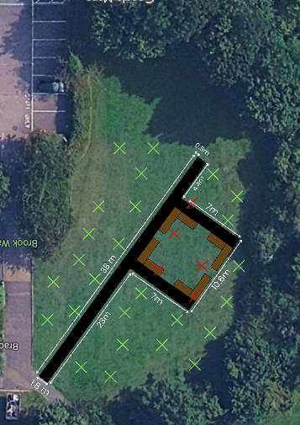

- Project Timeline
Key points:
- Hope to have it the path done by mid-November
- Start fitting the beds at end of Jan and to tie this in with free tree giveaway
- Have beds in by end of March to plant veg and start the growing

8.5 New BSTC Memorial Benches and Trees Policy

The BSTC Memorial Benches Policy was agreed at the Full Council meeting on 8th October 2025 with it being combined with a Memorial Trees Policy to create one policy rather than two.

The draft amended combined policy was circulated.

Following discussion, Councillor Jon Williams proposed adoption of a combined Memorial Benches and Trees Policy as circulated, seconded by Councillor Kulwinder Singh Sappal, carried unanimously.

10 To agree the date and time of the next meeting

Monday 15th December 2025 at 7.00pm

The meeting closed at 8.20pm
APPENDIX A
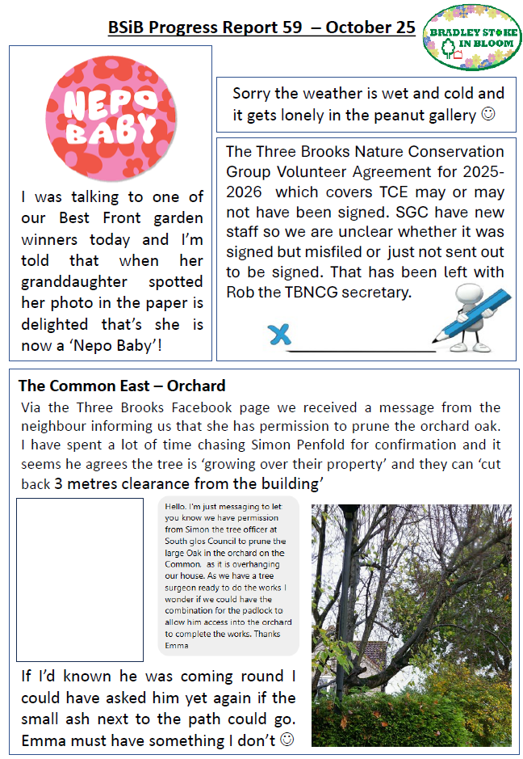

APPENDIX A
