8.3 Project and Events September/October 2026 Update

Socia Media Strategy and Performance
Our Facebook page has had views up 32% over the last two months. Much of this growth has come from interest in the upcoming fireworks display. This level of engagement helps us reach more residents and promote council events and services more effectively.
Platform | Posts | Views | Followers
Instagram | 27 | 13,569 | 253 (+28)
Facebook | 29 | 126,203 | 957 (+117)
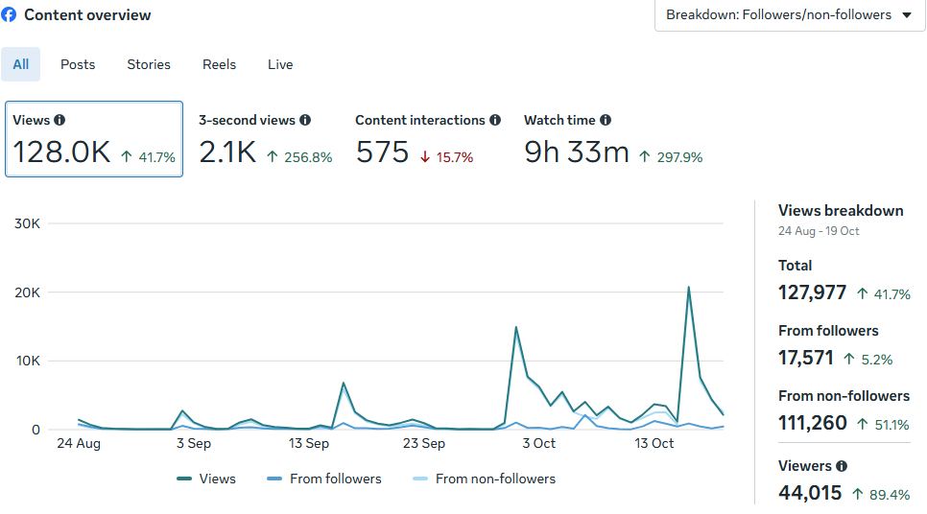
Most popular posts based on the number of views:
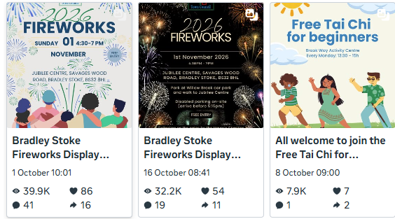
We posted less content and reached a wider audience.

Events:
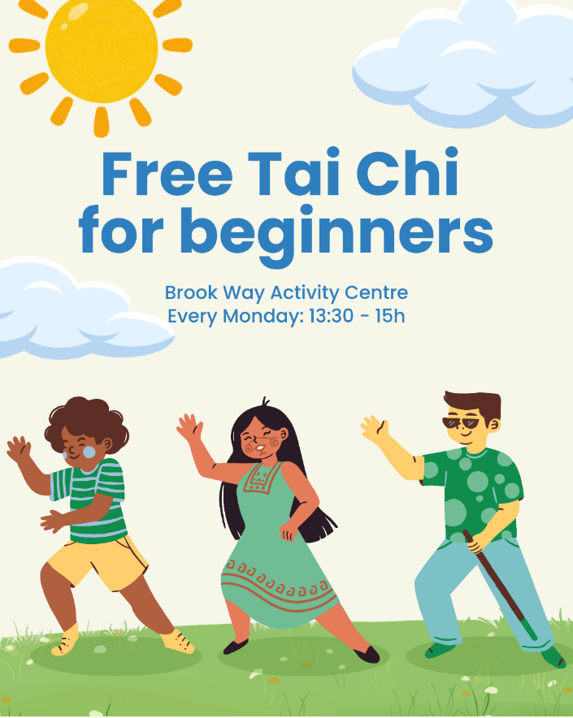
- Tai Chi Sessions
- Community Welcome Spaces
- Christmas Card Competition
- Repair Café
- Advertised for: Fun Fair/Barn Dance

Tai Chi Sessions
One Planet Matters continue running Tai Chi sessions followed by mindful gardening. These sessions run every week on Mondays at 1:30pm. The plan is to start charging attendees a fee of £5 per session, to make it financially sustainable for One Planet Matters.
- Where: Brooke Way Activity Centre
- When: Mondays, 1:30-3pm
Marketing
- Community Notice boards
- Social Media posts
- BSTC Website
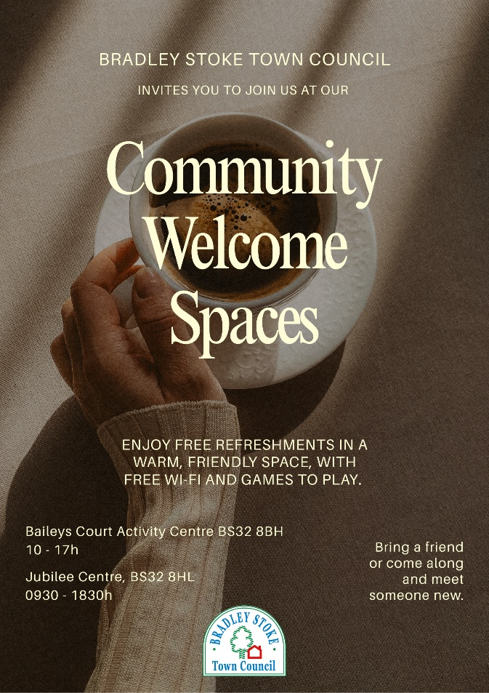

Community Welcome Spaces
The Community Welcome Spaces are open, providing residents with free refreshments, Wi-Fi and games to play. People are encouraged to bring a friend.
Where: Jubilee Centre, BS32 8HL: 9:30am to 6:30pm
Baileys Court Activity Centre, BS32 8BH: 10am to 5pm
When: Monday to Friday
1 October to 31 March
Marketing
- Community Notice boards
- Social Media posts
- BSTC Website



Fun Fair/Barn Dance
- BSTC supported the advertisement of the Barn Dance event, managed by the Rotary Club and the Fun Fair.
Marketing
- Community Notice boards
- Social Media posts
- BSTC Website


Repair Café
A Make-Do Day is planned for the 14th of November, as a trial event to gauge resident interest and assess appetite for this type of community activity in Bradley Stoke.
The proposed programme includes Dr Bike cycle repairs, plant swapping, clothes repair and sustainable crafts.
We are in search for volunteers and partners to make this event a success.

Watermark Town
A meeting is scheduled for the 20th of October to agree next steps for the tiny ponds projects and other initiatives.

International Women’s Day 2027

The first planning meeting for International Women’s Day 2027 took place on 19 October 2026. The celebration will be held on Saturday 13 March 2027 at the Jubilee Centre, under this year’s theme, How Much Longer? It was agreed that the event will offer a programme of sessions and workshops designed to benefit and celebrate women and girls in the community.

Based on last year’s event, the estimated cost is £1,600 to £2,100. This covers seven workshops, ten speakers, live entertainment, décor and refreshments. As the Jubilee Centre is now a council-owned venue, no hire charge applies, and the £765 previously allocated to venue costs can be redirected to other initiatives. We would like to confirm this budget.

The team will also explore whether neighbouring councils would contribute to the event in exchange for publicity, such as recognition on promotional materials and social media. Additional volunteers are needed to support preparations, and anyone interested in helping is encouraged to reach out.
Expenditure list from March 2026 event
Venue | Set up 1.5 hours  Event 10:30am - 4pm = 5.5 hours. Set down 4pm - 6pm = 1.5 hours. £90 per hour (+VAT) Total = 8.5 hours | £640
Tech | Venue includes a PA system with Mics | £0
Mamas workshop | Fill your cup resources | £100
Menopause Workshop | x2 facilitators | £100
Burlesque workshop |  | £75
Women in male dominated industries panel | x4 £40 expenses | £160
Women in creative industries | x4 £40 expenses | £160
Learning to DJ workshop |  | £100
Harish Dance group |  | £115
Kids workshop |  | £100
Live entertainment | Local Dancers £0  Fashion Show £150 | £150
Paper marketing |  | £200
Décor | Bunting etc. | £250
Refreshments | Tea, pastries, coffee, milk etc  x100 samosas | £230
 | Total | £2,380

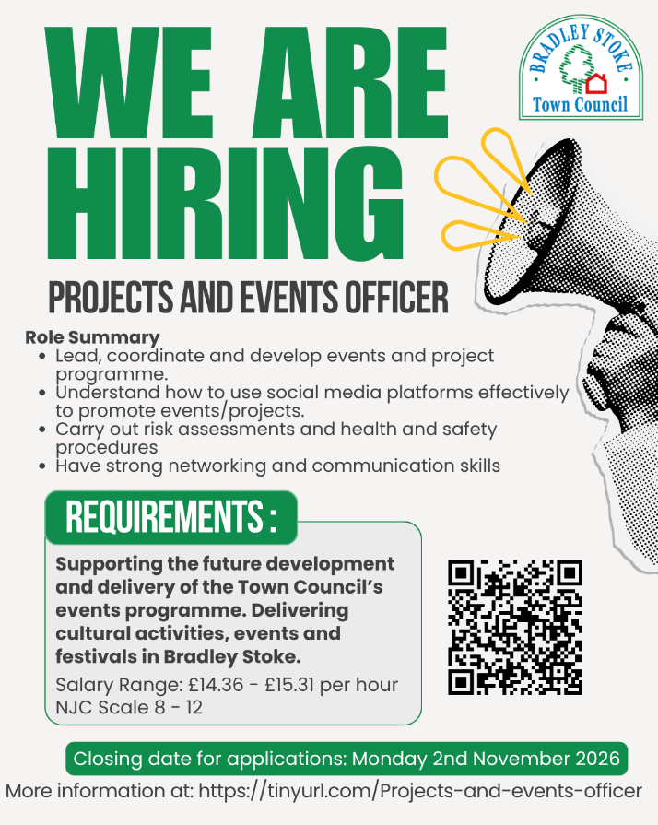
Projects and Events team changes
Jen Sheppard has joined the team as the new Events Support Officer, working 10 hours a week, supporting various projects with a future focus on the Summer Festival.
Raphaela, our Projects and Events Officer, will be leaving the council on 1 November 2026, after seeing this year’s fireworks display through. Recruitment for her replacement is underway, and applications close on 2 November 2026.

