Bradley Stoke Youth Report – September/October 2026
Skatepark Youth Sessions
Our twice-weekly Skatepark sessions continue to attract consistently high numbers of young people, with an expanding activity offer shaped around the Youth Work Curriculum and the needs and interests of the cohort. The new Bleed Kit has also now been installed!
Partnership working has strengthened, with improved communication and a more joined-up approach involving BSCS, the Beat Team, Willowbrook, the Leisure Centre and neighbouring youth provision.
We are working toward positive progression, with several young people working towards the South Gloucestershire Youth Award and older members beginning to volunteer more during sessions. Building on this, we aim to establish a small Young Leaders cohort, developing leadership skills and creating pathways as part of college programmes and employment.
Alongside this, rising interpersonal tensions at the skatepark outside organised sessions, sometimes involving locality police, remain a concern. We are addressing this through relationship building, early intervention and the launch of ‘Behind the Bikesheds’ – a targeted 1-to-1 support offer delivered through Detached Youth Work.
Our focus remains on building positive relationships, supporting young people to make informed choices and turning engagement into meaningful opportunities for personal development, leadership and future progression.

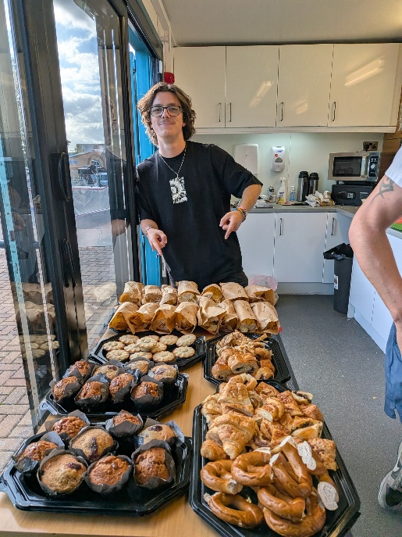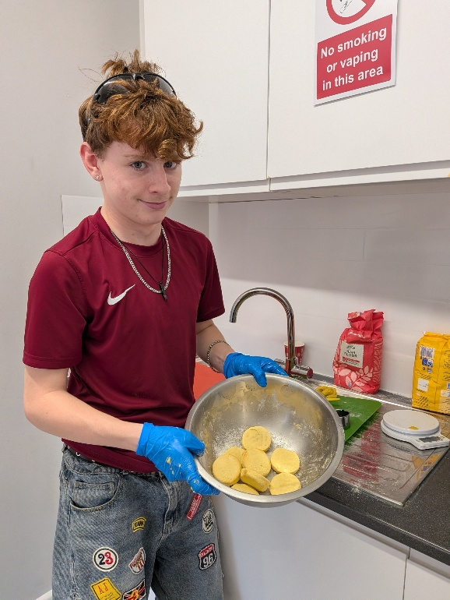

You get fed here, do stuff you might not always do & Youth Workers listen to you if you need to talk. They aren’t teachers & you can have a laugh & they say stuff you think about after. I come to Youth Club because I feel safe & I can have a laugh but I know I can talk if I need to

Jubilee Multi-Sports Sessions
Working collaboratively with the Detached Youth Work team, we are exploring ways to strengthen our youth offer throughout the winter months, ensuring young people continue to have access to positive, engaging and inclusive activities during the colder weather.
As part of this ongoing evaluation, we have identified a need for improved sports equipment and additional seating to enhance the quality, accessibility and overall experience of sessions. We are also exploring the potential use of the Woodlands Suite as an indoor youth hub, providing a warm, welcoming and safe space where young people can socialise, build positive relationships and take part in a more diverse range of activities.
To help develop and sustain this offer, we have begun reaching out to local sports clubs and partner agencies to explore opportunities for collaboration, shared resources and specialist activity sessions.
The work will continue to be reviewed throughout the winter period, with a focus on understanding engagement, gathering feedback and identifying how the offer can be developed to provide meaningful, consistent and accessible opportunities for young people within the local community.

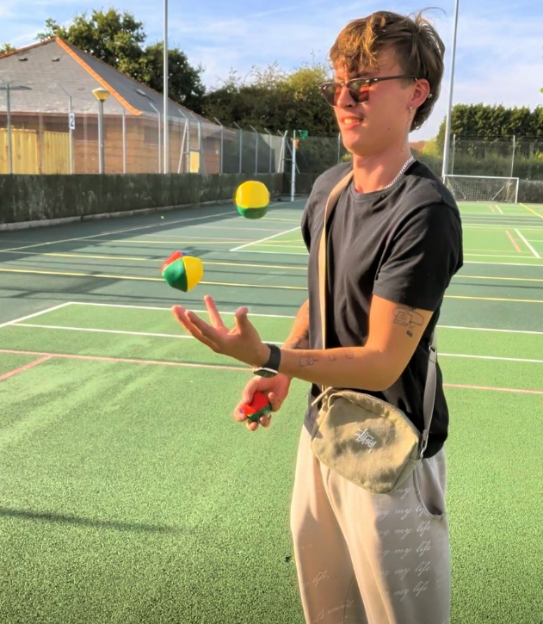

Girl’s Project
A lively and buzzing session, attracting 23 enthusiastic girls and young women aged 11 to 16. The activities are led by the group themselves, with highlights including an unforgettable First Aid session by Gary Woodland—complete with plenty of fake blood for added drama! November brings a creative burst with local artist Peta Maurice, and plans are underway for a gym session at Bradley Stoke Leisure Centre. Alongside these, popular regular activities like arts and crafts, cooking, storytelling, drama, circus skills, and karaoke keep the energy high. A Halloween/Samhain party is on the horizon, with the group keen to explore candle making, stargazing, and car maintenance! Feedback from parents and participants has been overwhelmingly positive. Building on this success, the Lead Youth Worker will soon deliver a six-week Creative Intervention programme at BSCS, supporting KS3 young women at risk of EBSA.
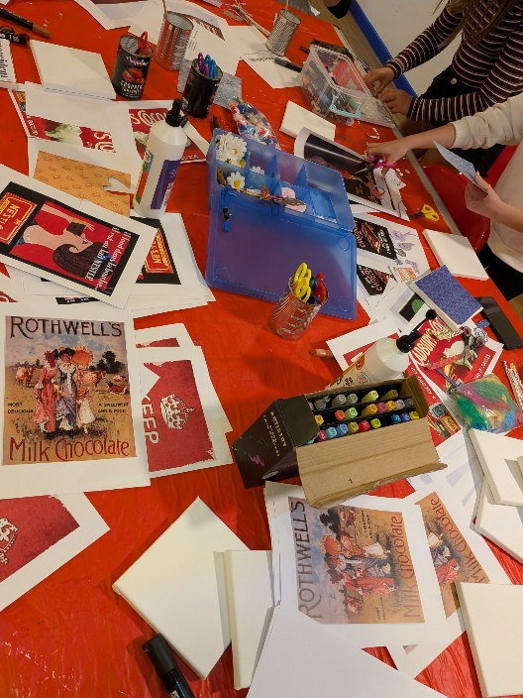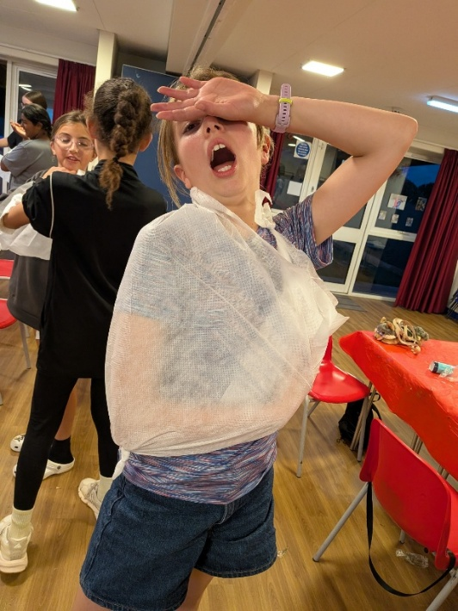
Girl’s Project is a lifeline & we are so grateful this group exists. No matter what has happened during the day she comes out beaming. We have been amazed how much her confidence has been raised & how many new friends she has made – it has made a huge difference to her in school & in her life generally as she struggled to ‘find her people’ in school. Thank you and please keep this group going. You don’t know the difference you are making to these girls!
Parent of Girl’s Project member

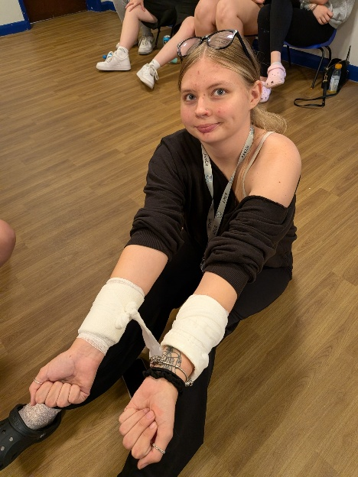

I have never been to a club like this before. I am listened to and respected & A always says, ‘we have all not been listened to in our lives, I want to hear everyone’s voice’. I feel confident to speak up & we have so much fun. I just feel I can be me & no one judges you or laughs at you. I have made friends who I don’t go to school with & you need that sometimes’
Girl’s Product attendee
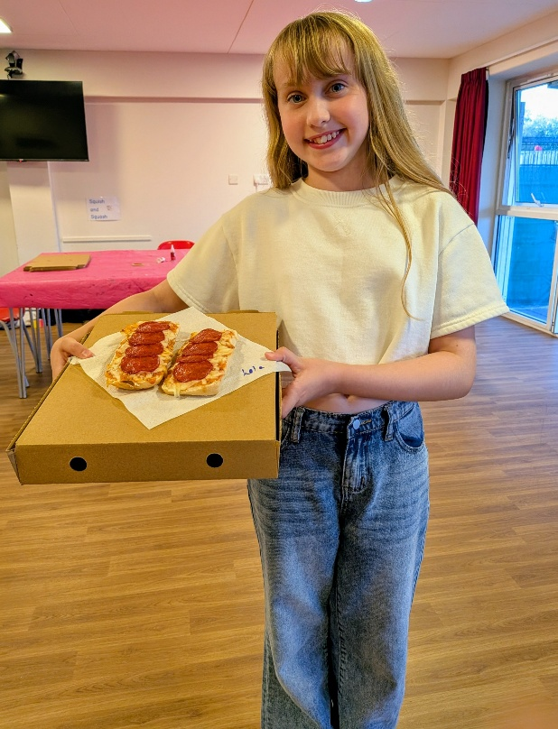

Detached & Behind-the-Bike Sheds (1-2-1)
Detached offer proving successful in collaboration with a new offer of 1-2-1 targeted, listening session (Behind the Bikesheds) largely led by Gary with mentoring/training support for Assistant Youth Wokers which also supports their Level 3 – Youth Work study. Detached works pro & reactively in communication with BSTC Site Management as well as community partners. Willowbrook Management have allowed DORIS (Detached Youth Work Van) to be situated monthly at their site – beneficial particularly during the winter months. Detached & BTBS’s is also proving a positive springboard in reaching young people who don’t always attend regular offer sessions.

Half Term Activity
During the half-term, we are launching Moving On Up, a new youth club for 9 to 13-year-olds, providing a dedicated space for younger participants to engage and grow. Another Studio 32 Youth drama session, sparking creativity and confidence in young people. The Girls Project will have an exciting opportunity with Cotswold First Aid training, building essential life skills. Additionally, the skatepark sessions are extending from 2pm to 6pm, ensuring inclusive access for all young people. Activities are inspired by young people’s ideas, and both Moving On Up and Studio 32 Youth Theatre will continue as regular session offerings moving forward.

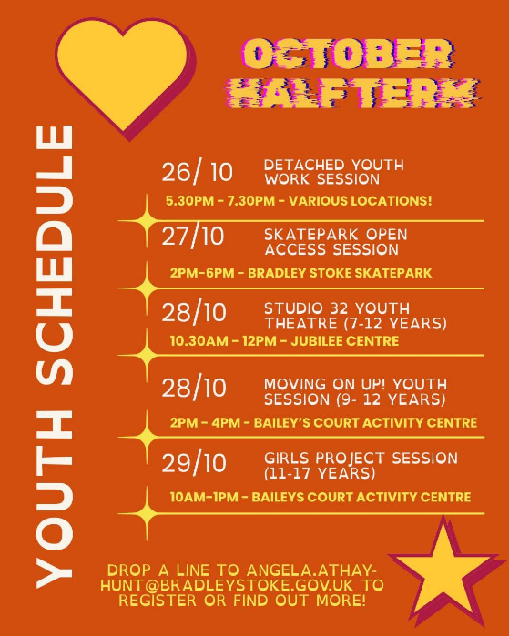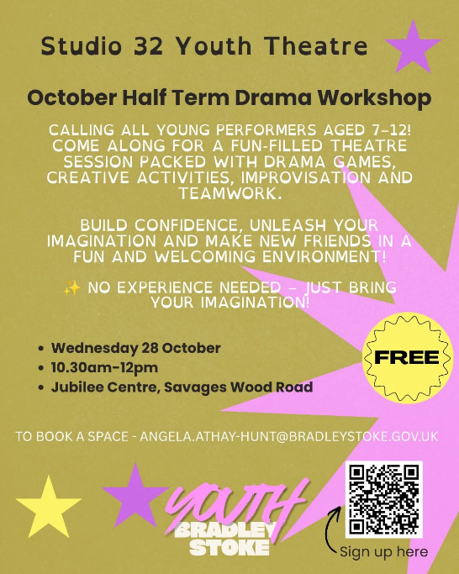

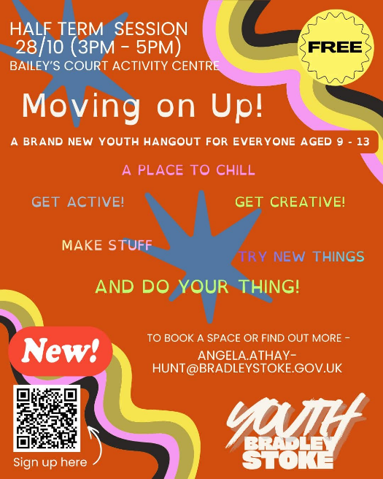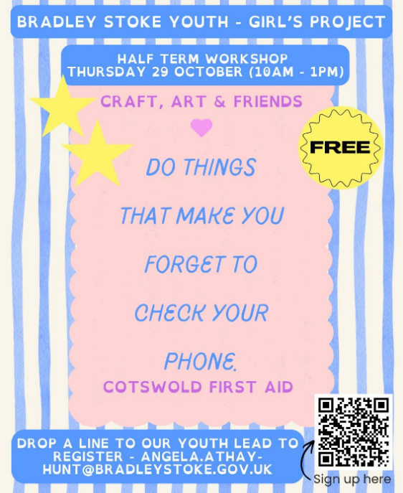

Partnership & Community Working Developments
We continue to strengthen locality partnerships to create a more joined-up approach to youth support, engagement and progression particularly in the current climate of decreased youth employment & opportunity.
Links with IMPACT Mentoring and SGS College are developing, with a particular focus on pathways into college for young people who are NEET (not in education, employment or training). SGS College is keen to explore closer collaboration through youth session visits, supported college visits with Youth Workers and engagement opportunities, including free tickets to Bristol Flyers games.
Work experience opportunities are also being explored with Bradley Stoke Community School springboarded from Creative Intervention sessions alongside youth worker-led workshops for local primary schools during Anti-Bullying Week. Relationships with Willowbrook and the Leisure Centre have further strengthened, supporting a more connected offer for young people. We have also begun early-stage discussions with West of England Music Academy (WEMA) to explore a potential intergenerational heritage funding bid, with opportunities to bring different generations together through shared activities, local history and creative engagement. These developing partnerships aim to broaden opportunities, strengthen community connections and improve outcomes for young people across the locality.

Trips, Experiences & Training
Young Leaders & Youth Workers attended the screening launch of the film Postcodes at The Station in Bristol (Creative Youth Network) – we are in contact with Creative Youth Network to look at a wider screening in Bradley Stoke as part of the upcoming tour -
‘The film features Youth Voice advocate Serena Wiebe, who has been personally impacted by knife violence. She travels from Bristol’s inner city to South Bristol’s Hartcliffe and Knowle West to connect with young people and their supporters. Directed by Neil Maggs, an acclaimed Bristol journalist and filmmaker with a background in youth work and BBC Radio 4 documentaries, the film highlights issues relevant not only to Bristol but also across the UK. Through candid conversations with young people, youth workers, and the police, the documentary reveals the tensions, myths, and misunderstandings that fuel postcode divisions and underscores the importance of listening to young people to help find solutions.
Following the film, there will be a panel discussion and Q&A facilitated by a young host aligned with Bristol’s new youth voice initiative, SCOOP as well as Neil Maggs & Serene Wiebe.

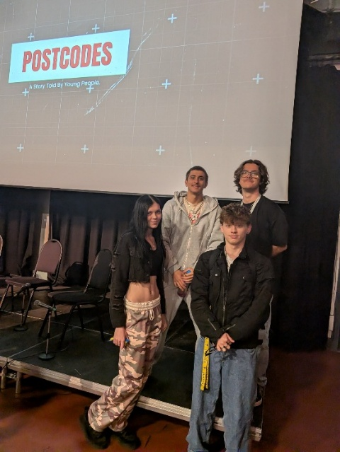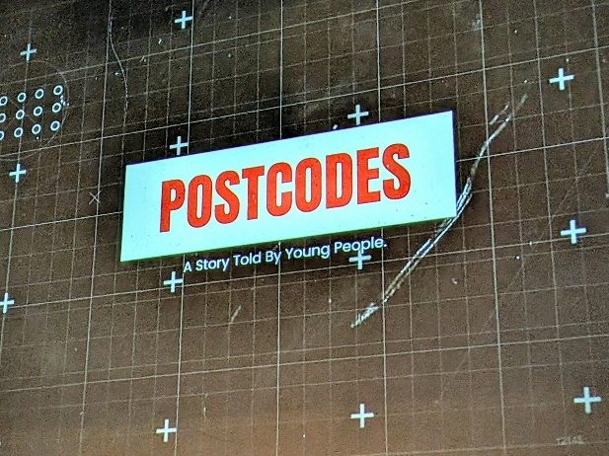
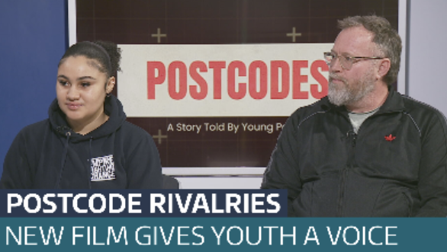
We continue to invest in the development and professional growth of our team, with two Youth Workers undertaking their Level 3 Youth Work qualification at City of Bristol College, supported throughout their learning journey. In addition, one Assistant Youth Worker is completing the Foundation Course delivered by FACE Youth Provision. These opportunities help build capacity for the future of Youth Work in Bradley Stoke.

Budgets, Contracting & Funding
Work is ongoing with South Gloucestershire HR to align Youth Work contracts, ensuring greater clarity, consistency and transparency across the service. Budget discussions, funding reviews and financial projections for both National Lottery grants are being undertaken currently to support effective planning and sustainability. Alongside this, exploration future funding streams beyond current grant periods, identifying potential new partners and developing project opportunities to help sustain and grow the youth work offer long term alongside the annual income from council.

Coming soon…….
