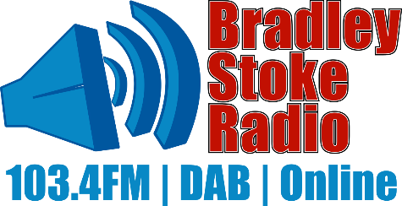
Community Development Grant Report October 2026
Between August and October, there is a slight reprieve in the radio events calendar. This allows the radio station time to catch up on all the admin, accounts, and advertising! Continued tech support and other behind-the-scenes work, as much as time allows. It is also the beginning of the next ‘season’ in events, and while writing this report, we are gearing up for a hectic season of fireworks, the Remembrance Day parade, Christmas lights switch-on, and community carols. There are emails flying between various community groups and stakeholders, including Scouts, Willowbrook, churches, and of course, the town council and BSR volunteers, to enable these events to be run as smoothly as possible!
In the studios, we are continuing to look to support new volunteers. We have had a few new voices come along and find out more. Some need to wait until they are 18 but hope to join us at events until their birthdays (this is purely due to safeguarding and the nature of the open access studios to members and not having a permanent station manager 24/7). Others come and try and find that their passion for radio plus the time commitment is a challenging equation combined with work/family life. However, we are always happy to share the studios and try to find a happy medium to be beneficial to all interested parties. Please do discuss how you can have a slot on the radio!
We are welcoming back UWE Law students this week, giving valuable experience of public speaking and them sharing their knowledge to listeners on all sorts of legal issues.
Local theatre, amateur dramatics groups and choirs have been featured regularly along with events held locally including the warm spaces, fireworks and the Christmas card competition.
CDG 11/08/2026  £771.22 | Outgoing description | Amount | Remainder
 | OFCOM (17/8/26) | £200 | £571.22
 | Virgin media (18/8/26) | £63 | £508.22
 | Insurance (25/8/26) | £102.72 | £405.5
 | OFCOM  OFCOM (18/9/26) | £600  £250 | -£194.5  -£444.5
 | BSTC (30/9/26) | £350  £920 | -£794.5  -£1714.5

Community development grant spent. Bradley Stoke Radio volunteer committee and members would like to thank Bradley Stoke town council for their continued support.

