8.4 Provision of three Older Persons Afternoon Tea Parties for 2026-27

Bradley Stoke Town Council held three very successful Older Person’s Afternoon Tea Party during 2025/2026.

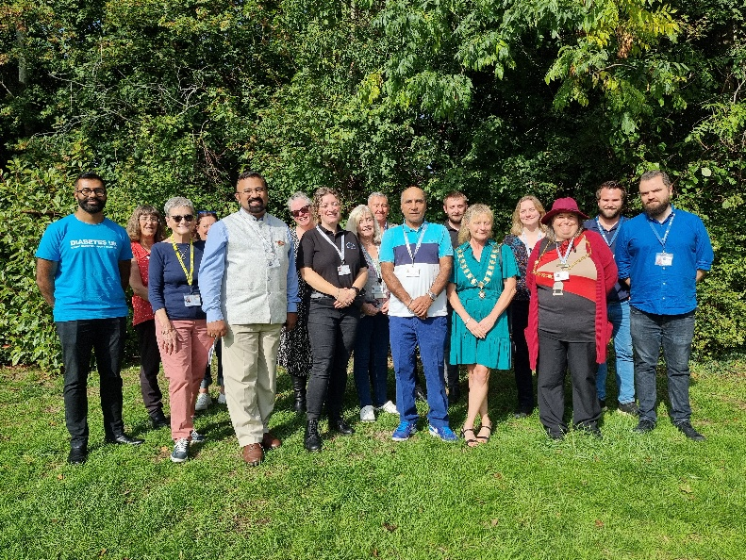
19th September 2025
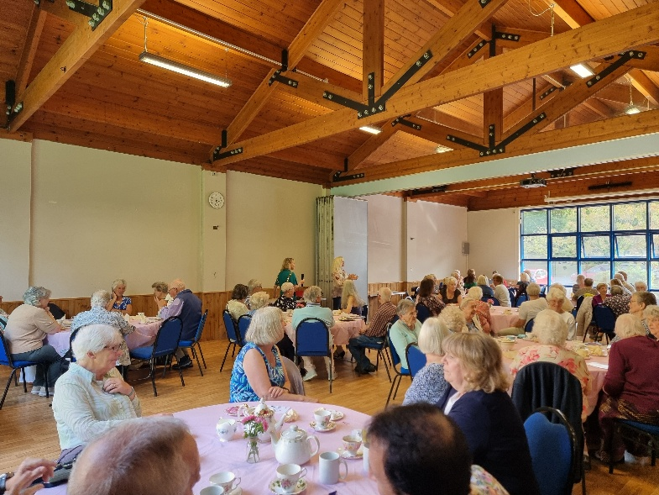
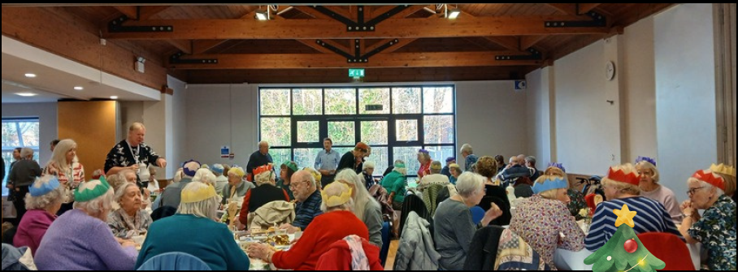
12th December 2025

27th March 2026
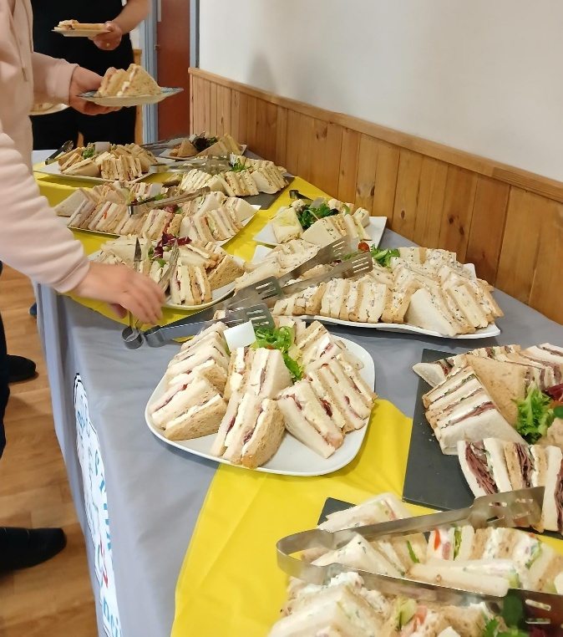

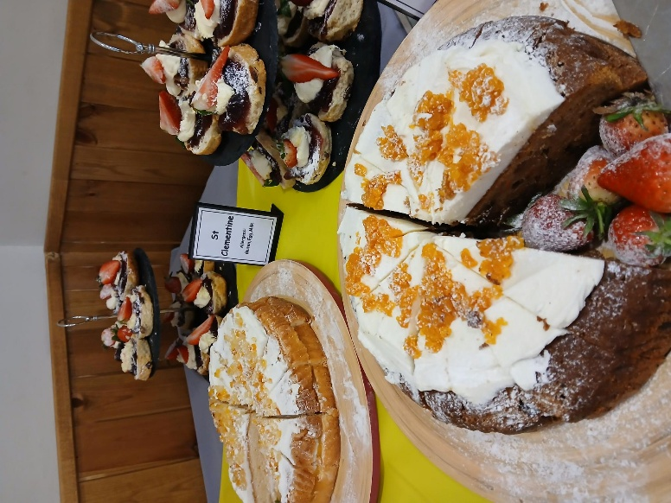

At each event, the Town Council catered for 80 attendees and all events quickly ‘sold out’ with a waiting list for any returned tickets.

We would like to organise three more events for 2026/27: (10th July 2026, 11th December 2026 and 19th March 2027).

Budget
As we have now purchased our own vintage crockery, the only significant costs involved are the catering costs. The catering cost for the March 2026 event was £698.70 + VAT

Officers would like to request that £3,000 is earmarked from the Community Development Grant Aid budget (N/C5074) towards three afternoon tea parties for 2026/27. We are also going to look into sponsorship for these tea parties.

