Project and Events April 2026 update

8.3.1 International Women’s Day
International Women’s Day was a huge success. We ran/supported 6 events across a span of 2 weeks.

The main day event at the Spitfire Hangar at Brabazon hosted nearly 300 people. The programme was diverse, hosting a range of local businesses and organisations that supported women’s education and wellbeing, with many different generations teaching, supporting and attending the event.

We raised a total of £3000 through contributions from ourselves and other parish and town councils:
- £1,500 – Bradley Stoke Town Council
- £500 - Almondsbury Parish Council
- £500 - Charlton Hayes Parish council
- £500 - Patchway Town Council

We were well within budget. but only spent £2,486.04; this allows for the Bradley Stoke funding to be reduced (see breakdown below).

Expenditure
Venue | Set up 1.5 hours  Event 10:30am - 4pm = 5.5 hours  Set down 4pm - 6pm = 1.5 hours  £90 per hour (+VAT)  Total = 8.5 hours  No charge for tech equipment as venue included a PA system with microphones | £640
Mamas workshop | Fill your cup resources | £100
Menopause Workshop | x2 facilitators | £100
Burlesque workshop |  | £75
Women in male dominated industries panel | x1 £40 expenses | £40
Women in creative industries | x2 £40 expenses | £80
Volunteer Supervisor |  | £50
Clubbercise workshop |  | £35
Learning to DJ workshop |  | £50
Kids workshops (Turtle CYP & 2nd Stoke Lodge Brownies) |  | £151.54
Photographer |  | £390
Live entertainment | Fashion Show £0  Local Dancers £100 | £100
Paper marketing |  | £209
Décor + Resources | Bunting etc. £121.75  Thank you cards £12.71 | £134.46
Refreshments + Samosas | Food & Drink £105.24  Samosas £225.80 | £331.04
 | Total | £2,486.04

What were the learnings for next year?
- Having more lead time to market the event – engage schools, youth groups and local organisations sooner.
- The venue was a little hidden, with limited parking and public transport networks.
- Low attendance at the beginning of the day – start slightly later or bring in a community that brings a big crowd.
- Involving local schools through performances or plays.

8.3.2 Community Orchard and Nature & Wellbeing Hub
The 4 planters in a quadrant style were commenced by One Planet Matter (OPM) and completed at the Community Planting Day on Sunday 12th of April which was hosted by the Town Council. The planting day was for residents to get involved with moving soil, planting fruit bushes, sowing wildflower seeds and planting herbs in the planters. There was good attendance, with a huge range of ages taking part.

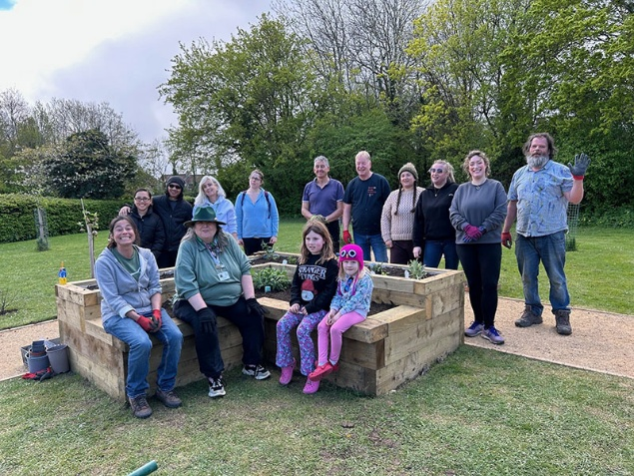

The office team have had a discussion about the regular growing group logistics and have confirmed we can create a regular session on either Tuesday or Wednesday afternoons for people who need wellbeing space. Anyone is welcome, but the idea is to support people who are retired, unemployed due to health conditions, or people who need the nature connection and socialisation. We are now waiting for OPM to get in touch when they have a project lead.

8.3.3 Repair Café
I haven’t made any headway with this. This will be something that the next Projects and Events Officer will do.

8.3.4 Mums Pamper sessions and Fedline Cooking Project (linked to Community Welcome Spaces)
Unfortunately, the last 2 mums pamper sessions didn’t take place due to circumstances beyond my control.

The sessions I did host were successful and created a small network of mums who valued the space and each other. Many wanted more regular activities as they felt it was a great way to network with other mums and didn’t have a child-free space to do this. I do believe a similar idea in the future during the welcome spaces would work well. The sessions themselves only cost about £50–80 per session now that we have the basic resources set up.

The Fedline project was a great success. I had many people email me to say that the skills they learnt were invaluable and that they wished to extend the course. I collected some of their feedback:

Did you find the course useful?
- Yes, I've learned many new tricks and ways to cook healthier food for my kids.
- Yes, the course was very useful. Helen created a welcoming and encouraging atmosphere, and I gained practical skills for my everyday cooking. Additionally, being able to take food home helped me save on costs for several weeks.
- The course gave me a lot more confidence to experiment. Living on my own, I was having ready meals bought from my local supermarket.

What was the most significant lesson you learned?
- During the cooking course, I've realised how therapeutic a class like this can be. For 2 hours, I didn't think about anything except following the cooking instructions, and at the end of it, I went home feeling very relaxed and happy.
- The most significant lesson was learning how to plan and prepare meals from scratch more efficiently. This has already increased my confidence in the kitchen.
- I learnt that you don't need to use top brands and supermarket own brands are just as good, provided you use sauces and take a bit more time.

What improvements could be made to create a better learning environment?
- The sessions were well organised. Even when the electricity tripped, Helen managed the situation professionally. I would love to see more courses like this offered in the future, as I am very keen to continue learning.
- For the main part of my course, we had some issues with the electric supply, which made things a bit difficult and didn’t give us quite as much time. However, Helen got over it and was not even flustered. I truly hope more funding is secured for future courses, as I would absolutely sign up again.

South Glos grants team said there is a lot more money to fund more courses. I believe this really adds value to individuals’ and families’ lives. However, there would be some key changes to make sure it was time efficient for us. I spent many hours/days recruiting people for the course. I think this should be Fedline’s role as we are funding them to work. The Jubilee Centre is the only facility that is suitable for the course.

8.3.5 Community exercise classes on Jubilee Green Leisure Equipment
Mark Parry is very keen to start a regular fitness class once a week in the evening for beginners and regular exercisers to learn and use the equipment. He said, with his experience, there isn’t going to be the uptake and value in just offering short courses. The labour and energy to gather a handful of people each time isn’t worth the time. However, if he could build a regular group of 12–15 people, community and real change can be made to these people.

The cost would be £50 per week and would only occur during the warmer months (Spring/Summer).

In the meantime, Mark and I filmed some demonstrations. For those of you who are interested in using the outside gym equipment and don’t know where to start, Mark Parry has given demonstrations on how to safely use the equipment for beginners all the way to regular exercisers. I am still in the process of fully launching this on the website and organising QR codes next to the equipment to get access to these.

