

Spring 2026 has been a vibrant and productive season at Bradley Stoke Radio, marked by new talent, strong community partnerships, and continued support for local arts, sports, and events.
Growing Our Team
We began the year with a refreshed recruitment and training programme and are delighted to welcome Jim to the presenting team. Jim has completed his on-air training and has already delivered several live programmes, Sidelines and Soundwaves. His Monday evening show (6–7pm) showcases his infectious passion and knowledge of sport, which has been warmly received by listeners.
Championing Local Arts & Culture
Our commitment to promoting local performing arts remains strong.
We supported the ‘Roots of Jazz’ live event at Bradley Stoke Evangelical Church through on-air promotion and advertising. The evening was a sell-out success and a fantastic celebration of live music.
The Whitfield Players featured on air with interviews about their production of Treasure Island, highlighting not only the cast but the essential backstage volunteers who bring performances to life.
St Stephen’s Drama Group joined us ahead of their January production of Sinbad the Sailor, and Thornbury Musical Theatre Group shared insights into their show Snow White.
A special thanks goes to Alice, whose programme continues to go the extra mile in covering everything from the Bristol Hippodrome and Old Vic to local amateur dramatics. Her dedication ensures performing arts remain front and centre in our community coverage.
Community Events & Local Voices
Across our live programmes and social media channels, we have highlighted a wide range of community activities, including:
International Women’s Day at the Spitfire Hangar
Community Orchard volunteer work days
Easter egg trails at the Brightwell Centre and the community egg hunt at Jubilee Field, organised by City Church
The Hallelujah Chorus event at Bristol Beacon, featuring local residents in the choir
Performances and updates from the Brightwell/Bristol Aphasia Choir
We were also pleased to welcome UWE Law students to the station this spring. Through a series of accessible on-air discussions, they helped listeners build a clearer understanding of everyday legal issues, from consumer rights to navigating common legal processes. Their contributions not only informed our audience but also demonstrated how young professionals can use their developing expertise to support and empower the local community.
We have also continued our partnership with SGS College’s Sports Journalism Programme, offering development opportunities with Geoff Twentyman, Jon Lock, and our new junior sports reporter, Jonty, who is already out and about capturing local stories.
A Snapshot of Spring
If spring at Bradley Stoke Radio could be summed up in four words, they would be: Sports, Singing, Music, and Chocolate. All have been joyfully represented across our airwaves and platforms, reflecting the energy and diversity of our community.
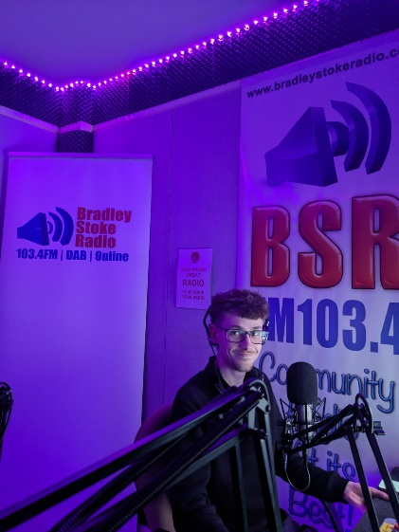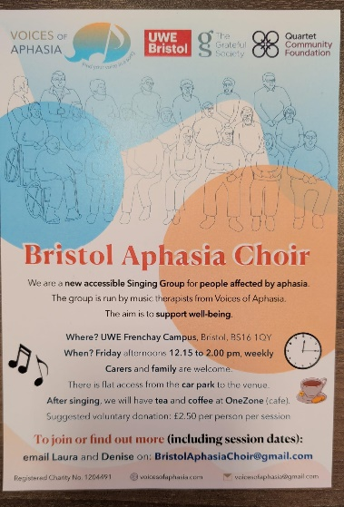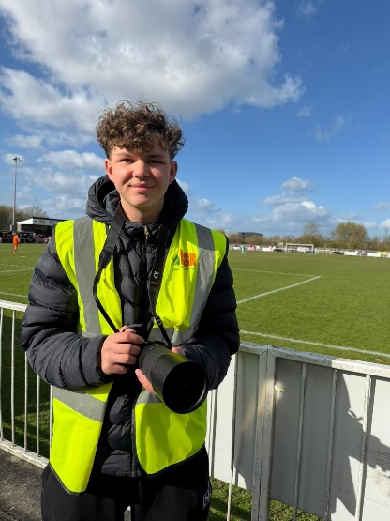


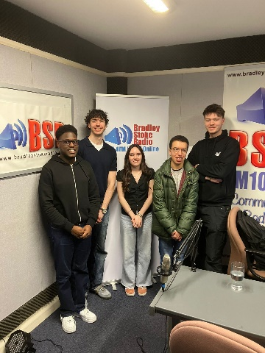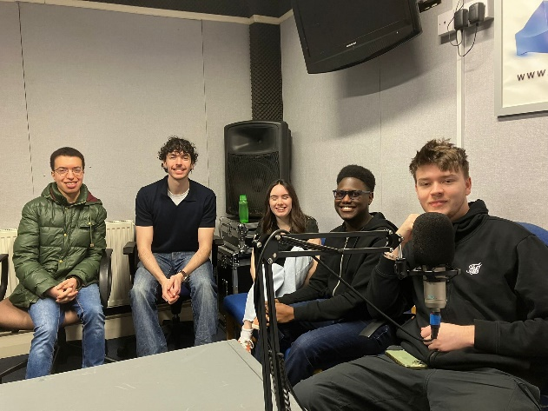
Top Right, Jim, Top Left, Jonty, Bottom left, and centre UWE Law, Bottom Right SGS and Bam academy.
CDG 16/3/2026 £4000 | Outgoing description | Amount | Remainder
 | Virgin media | £58.80 | £3941.20
 | BSTC (Electricity) | £320.72 | £3620.48
 | PPL | £926.22 | £2694.26 13/4/26

