### BRADLEY STOKE TOWN COUNCIL

**Leisure, Youth & Amenities Committee**

Minutes of the Meeting of the Leisure, Youth & Amenities Committee of Bradley Stoke Town Council held at The Jubilee Centre, Savages Wood Road, Bradley Stoke on Monday 18th December 2023 at 7.00pm.

PRESENT: Councillors: Aleena Aditya

Natalie Field (Chair)

Jenny James

James Nelson

Ben Randles

Jon Williams

Officers: Sharon Petela (Town Clerk)

Phil Francis (Deputy Town Clerk/Activity Centres Manager)

Graham Baker (Youth Development & Participation Worker)

Representative from: Bradley Stoke Radio

Bradley Stoke Youth Cricket Club

**1 Submissions from the Public**

1.1 Councillor Tom Aditya commented that the Christmas lights around the town looked very good and he was pleased his original suggestion was actioned. He asked about the cost and whether the Town Council could look at installing a Christmas tree on one of the main roundabouts for next year. The Town Clerk said she would look into this.

**2 Apologies**

None

**3 Declarations by Members**

None

**4 Announcements by the Chair**

The Chair wished everyone a Happy Christmas.

**5 To confirm Minutes of Previous Meeting held on 16th October 2023**

Acceptance of the Minutes of the meeting of the Leisure, Youth & Amenities Committee held on 16th October 2023 were proposed by Councillor James Nelson, seconded by Councillor Jenny James and carried unanimously. Minutes were then signed as a correct record.

**6 Service Level Agreements, Community Development, Grant Aid and Youth Grant Aid Applications**

**6.1 Service Level Agreements (SLA)**

**6.1.1 Bradley Stoke Youth Cricket Club (BSCC)**

The Chair of Committee invited the representatives from the group to address the meeting.

BSCC are writing to reapply for the Youth SLA Grant that has been so kindly donated in recent years to Bradley Stoke Cricket Club for the provision of youth services. We have also submitted a copy of the club’s accounts for the previous financial year (ending 31st October 2023).

Our youth section remains a priority and a guiding principle behind the strategic growth of the club and facilities. This development continued into 2023 with strong numbers and the resilience of the youth shone through, especially with the number of matches being postponed due the weather. Highlights include our u17s finishing runners up in the Bristol Youth Cricket League cup and our U9s finishing undefeated to top their league.

In addition, our All-Stars Cricket programme which sits outside main club membership introduces the game to five- to eight-year-olds. This season we had 50 youth (10 girls) learning the game in a fun way.

The club continues to see the provision of ECB Accredited Coaches to assist the development of its youth team players as essential. For 2024, successful completion of courses this winter permitting, we will have Eleven x Level 1 (Foundation) coaches, ten x Level 2 (Core) coaches, and one x level 3.

Please find below further information regarding our youth membership and the financial resources BSCC invested in the youth membership in the financial year ending October 2023.

Overview of BSCC youth teams and membership

In 2023, 124 youth members between the ages of 7 and 17 (16 U9s, 29 u11s, 16 girls u11’s (softball) , 27 U13s, 26 U15s and 10 U17s). Of these, 71 (57%) reside in the BS32 postcode, with a further 27 (21%) residing in the BS34 postcode. 19 (15.32%) are girls, boosted by the success of our girls only Dynamos programme. It is the first time the club has run an all- girls team, and we hope the success will encourage more girls to get into sport.

This year we launched Disability Cricket in the form of Table Cricket, we have 6 members so far and we hope to be part of a league next season. This season the ages were 17 years and upwards, but we are planning on promoting within the local school’s (Primary and Secondary) next season.

The committee are firm believers that despite the cost of running a youth section that membership fees should remain low to encourage participation. In 2023 we raised the youth membership for hardball (u11 mixed to u17s) to £65 (the first increase in several years), we feel this represents excellent value for money and therefore remains a negligible barrier to participation. We also introduced a discount for siblings. We kept u9s and u11s softball to £50 in recognition of lower cost overhead per games played.

For that £65 , the juniors (U15s and younger) received weekly two-hour outdoor training sessions (£50 - 75 minutes for U9s and u11 girls) from mid April until the end of August. We also ran indoor pre season training, seven weekly sessions of 90 minutes each (for U11s, U13s & U15s). In addition to this we had structured league fixtures and some friendlies for U9s, u11s girls, U11s Blue, U11s Maroon, U13s Blue, U13s Maroon, U15s Blue, U15s Maroon and U17s, and there were no match fees for these games**.** Over 80 games were played along with 2 festivals.

The investment of time from our volunteers both in completing coaching courses and delivering coaching, as well as the talent and commitment of the players concerned, has helped 15 (12%) of our youth players gain selection for this winter’s performance age group training squads run by Gloucestershire County Cricket Club (boys County/Development) and Gloucestershire Cricket Board (boys zonal and girls). These numbers have been steadily rising over the last few years. Seven have made a Gloucestershire South Zone squad, eight Gloucestershire full county squad (5 boys and 3 girls), one of our girls has also made it onto both the Gloucestershire Girls and Western Storm Emerging Player Programmes. Western Storm is one of the eight women’s regions (Southwest and Wales region) in England and Wales which is partly professional.

The club is also committed to putting all its coaching staff through Safeguarding and Protecting Children and First Aid courses every three years at the current cost of around £40 per coach per course where it cannot be completed online. We also have a Child Welfare Officer who is responsible for ensuring the club are doing as much as possible to protect the children we coach.

We also pride ourselves on making sure anyone who wants it has the chance to experience the game, regardless of ability.

Financials: As previously stated, BSCC makes every attempt to subsidise the activities of our youth section and, in so doing incur a range of costs, which are not fully covered by the membership fees paid by youth members.

The table below details a number of (not exhaustive) costs incurred by the club in support of the youth section for the 2023 playing season. This would be what the generous grant of £3,500 was put towards last year. You can see the club’s expenses for running youth cricket exceeded the grant figure.

Item Cost Youth

|  |  |
| --- | --- |
| Youth match balls | £367.57 |
| Youth league fees | £250.81 |
| Youth coaching courses | £716.00 |
| Youth equipment | £1,308.62 |
| Youth trophies | £488.37 |
| Bailey’s Court rent | £2,569.15 (1/3 of Bailey’s Court) |
| BSCS rent | £816.09 (1/3 of BSCS costs) |
| Club insurance | £381.36 (1/3 of Grounds costs) |
| Grounds | £2,754.31 (1/3 of Ground costs) |
|  |  |
| **TOTAL** | **£9,652.28** |

Next Season we anticipate our youth specific costs to be broadly similar to 2023, as well as the youth section contribution to rent and insurance. These alone will exceed the grant amount, before consideration of additional facility/equipment projects that would benefit the club as a whole including the youth section.

We anticipate that all age groups and teams run in 2024 will continue, plus a girls U13s softball team.

**In Summary**

BSCC will continue to provide an outlet for local juniors to regularly play and learn the game of cricket, taking steps to ensure that this is done safely, with appropriate supervision and oversight. We are inclusive and welcome young cricketers from around age seven (male and female) from all ethnicities and backgrounds. (In addition, our All-Stars Cricket programme which sits outside main club membership introduces the game to five- to seven-year-olds. This season we had 50 youth (10 girls) learning the game in a fun way). Our goal remains to provide a platform from which local young people can develop a passion for cricket and a healthy active lifestyle. We integrate these into the club and support their cricketing and personal development in every way possible.

Given the outlay of the club in 2023 and anticipated outlay in 2024, the club would like to apply for funding of £3,500.00 as per last year’s application that was kindly agreed.

Following discussion Councillor Jon Williams proposed that Bradley Stoke Youth Cricket Club be awarded a Youth Service Level Agreement of £3,500 towards their running costs, seconded by Councillor Natalie Field, carried unanimously.

The Chair thanked the representatives for addressing the meeting.

**6.2 Community Development Grant Aid (CDGA)**

**6.2.1 Bradley Stoke Radio (BSR)**

The Chair of Committee invited the representatives from the group to address the meeting.

Bradley Stoke Radio is a community radio station, run by volunteers from Bradley Stoke and the surrounding area. As a community group we support skill development, offer training and a social network group to all who express an interest in joining. No prior radio experience is necessary. We offer training on a 1:1 basis, (and annual group training) equipment and studio access to all over 18s according to our safeguarding policy. The content that is created and broadcast by the group of volunteers reflects local music, groups and communities, building connections, strengthening relationships, tackling loneliness, delivering local news, promoting health and well-being, working with local organisations, large and small, developing a sense of place and belonging.

The development grant will help to continue to provide this valuable service for our communities, both on air and at events providing PA, Music, entertainment and growing opportunities. The grant will continue to support the radio station on a day-to-day basis and support the production of radio that support groups and reflects events in the wider community while entertaining, creating a sense of belonging and combatting loneliness. (For members/volunteers and listeners) The grant will also enable us to continue to be at events in the community, like fireworks celebrations, The South Glos Show, Remembrance Day parade, community carols, and the community festival.

Estimated numbers – with an expanding reach on DAB, FB and Online across Bradley Stoke (And surrounding areas/road networks) Locally, alongside broadcasting 24/7, events, festivals, fireworks, Remembrance, Christmas lights, Community Carols, church services – We reach and actively engage with the widest number of people possible. Our Current membership of active members living in the boundaries of Bradley Stoke is in the region of 10. Other active members come from surrounding areas and beyond. We continue to recruit and talk to anyone who is interested in Radio and are bringing new volunteers onboard. We recruit at events, spending time talking to people, we have posters up through the councils noticeboards and we try to keep our profile as part of the community to engage with as many people as possible. We are working with UWE and SGS with students on courses that maybe interested in media through their current learning programmes along side offering bespoke training to adults who would like to be involved. We are always looking at ways to engage with more volunteers and widen our programming to sustain interesting, local content alongside our music content.

Through this continuingly challenging year we have continued to engaged with all the marked age groups above, directly. (that is, members of the public – outside of our regular members) People from all these age groups have been on air and have worked with Bradley Stoke Radio. Because these age groups have worked with us, we know that these age groups have also listened, shared content and enjoyed hearing themselves, their peers, friends, family on the radio and this number is impossible to count. We continue to have strong links with local charity groups, Southern Brooks, Southmead Hospital, Three Brooks Nature Conservation, Marie Curie, Choirs, Sports Clubs, Brightwell Centre etc. We also continue to work with local youth groups and are again planning on supporting Bradley Stoke Scouts with their Remembrance Day Parade, The local Churches and Schools for Community Carols and we have other projects in development to showcase activities, places and spaces in Bradley Stoke for 2024. We are also delighted to be a part of BSTC events like the town festival and firework display, bringing an extra element to the community and supporting these events.   
The benefits of producing local content that is relevant to the community we live in, creates a sense of pride and belonging. With people listening at the same time, creates a shared experience and combats loneliness for those isolated through health, disability, life circumstances etc. We also connect through social media creating a multi-channel community for people to access. As also mentioned above, we are able to provide 1:1 or small group, bespoke training to adults who would like to develop skills in radio production. To have studio facilities, recording equipment and space to enable peer supported training and development resulting in radio programmes is a fantastic asset and provides opportunities to individuals and the community.

As our running costs have increased in all areas including insurance, licenses, overheads, miscellaneous marketing etc, the majority of this grant will be spent on running costs through the year. Running costs also includes the ability to be at events, running the communication technology to broadcast away from the studio, maintaining working equipment to run community projects (e.g. producing radio content away from the studios).

Following discussion Councillor Ben Randles proposed that £4,000 Community Development Grant Aid be awarded to Bradley Stoke Radio towards their running costs, seconded by Councillor Jon Williams, carried unanimously.

The Chair thanked the representative for addressing the meeting and, along with councillors, thanked Bradley Stoke Radio for everything they do in the community and their visible presence at so many community events in the town.

**6.3 Grant Aid (GA)**

None

**6.4 Larger Grant Aid**

None

**7 Matters arising from the minutes of the meeting held on 16th October 2023**

None

**8 Matters within the scope of the Leisure, Youth & Amenities Committee**

**8.1 Bradley Stoke in Bloom (BSIB) update by Steering Group**

The representative from BSiB has sent the update in Appendix A.

**8.2 Youth Development & Participation Worker (YDPW) update by Graham Baker**

Graham Baker, Youth Development & Participation Worker presented the following report:

**Headline news since last LYA Committee report on the 16th October 2023.**

* **Youth work sessions delivered:** since the last report, we have delivered the following youth work sessions:
* **Four core youth work sessions per week** (**34 core sessions** during this reporting period). The sessions have taken place at the skatepark, the Jubilee Centre (Girls Project) and Jubilee Hardcourts and surrounding area.
* Each core session comprises of between **2hrs and 2.5hrs of face-to-face youth work**.
* All the core sessions have been popular and well attended. The attendance range for the Skatepark and Jubilee Hardcourt sessions has been between **25 and 50 young people** with the majority in the **12 to 18 age range**. The attendance has been near the lower end of the range during recent bad weather. The gender breakdown has been between **25% to 35%** girls and young women and **65% to 75%** boys and young men.

Since the last report, the Girls & Young Women’s Project has held **9 weekly core sessions** at the Jubilee Centre. The age range is mainly between **13 and 18** with between **10 and 16 young women** attending each session during this reporting period.

* **Xmas holiday programme:** we will continue to deliver our core youth work sessions during week commencing 18th December and will additionally be delivering an Ice-skating trip during an extended core session.
* **South Glos Youth Work conference:** Three of our youth work staff attended the Annual South Gloucestershire Youth Work Conference, on Thursday 9th November. It was a well-attended event with various workshops and Keynote speeches from SG Councillor Ian Boulton, SGC Strategic Lead for Early Help and the National Youth Agency.
* **Upshot:** following Council approval to proceed with the Upshot ‘monitoring, evaluation and learning system’, a subsequent online meeting has been held with Upshot and we are currently in the process of shaping the system to our needs. We intend to get the package up and running in late January/ early February, including training for youth work staff.
* **CCTV upgrade at Skatepark:** the work to upgrade the CCTV was completed in late October and now offers improved coverage and remote access.
* **South Glos Youth Work Partnership:** progress continues to be made concerning the Partnerships joint 5-year YAO (Youth Activity Offer) bid. The YAO funding will start from April 2024 for five years with a potential two-year extension and will hopefully bring in £14k per year for BSTC Youth Work. Informal confirmation has now been received that this funding has been agreed. In addition, BSTC have attended recent partnership meetings looking at a joint Lotteries bid (being led by Creative Youth Network) exploring additional youth work strands and funding and an initial ‘Phase One’ proposal will be submitted shortly. With the lotteries bid BSTC Youth Work hope to secure a similar amount to the SGC YAO funding, but over a shorter 3-year period.
* **Youth Work team office space:** please see discussion below.

**Our recent and planned youth work strands explained below:**

* **Girls’ Project youth work sessions** have taken placeevery Tuesday throughout this reporting period. The sessions offer a safe space and a range of activities, discussions, and support. We promote the Girls Project using closed group Instagram and this helps inform/ remind people of upcoming sessions, any specific focus, and future projects as well as help supportively signposting to organisations or useful information. We also support individuals/ small groups outside of the formal session.
* **Skatepark building and outreach youth work sessions:** we have continued to runtwo well attended core youth work sessions per week. In addition, when attending the site for various reasons, we regularly provide extra ad hoc support and/ or engagement, with young people and the wider community, e.g., incidental youth work interactions took place during the CCTV install. The youth work sessions engage both regular skatepark users and young people who attend mainly for the youth work sessions and a safe, supportive, social space that also offers free food and drink. Our food offer is supported by the Fareshare (recycled food) charity through bi-weekly collections from Tesco (Hatchet Rd).

**Jubilee hardcourt area youth work sessions:** these sessions offer the opportunity for informal engagement in sporting activities (basically a kick about or a chance to have a go at tennis, frisbee, etc), drinks squash/ hot chocolate, occasional BBQs), etc. As with all our sessions, we offer an environment for support, discussion and challenge on numerous topics, issues, lifestyle choices, and anti-social behaviours. We also offer support and activities outside of the formal sessions, including supportive signposting, advocacy, etc (see one to one below).

* **Occasional outreach and ad hoc youth work sessions** with young people in the Jubilee Centre area, Willowbrook, etc. As mentioned above, we continue a limited amount of outreach and ad hoc sessions. Detached, outreach and project youth work sessions will increase in frequency when we recruit additional part team sessional youth workers and additional long term project funding is confirmed.
* **One to one support:** 1-2-1 / small group work has continued throughout this period, including support for parents/ carers. This work can cover a wide range of issues including, liaison with parents/ carers, peer conflict, informal counselling, bereavement, mental health and well-being, college/ schoolwork experience placements, NEET, CV writing support, references, etc.
* **Staff training, development, and recruitment**: Following recent ‘Designated Safeguarding Lead’ refresher training for both the YD&PW and the Town Clerk, our Safeguarding Policy has been updated. As previously reported, there continues to be recruitment challenges across the South Glos Youth Work Partnership, however, following the setting up of new Youth Work Level 2 and 3 p/t qualification routes, at City of Bristol college, it is hoped that a new recruitment drive in the new year will be fruitful and enable our youth work vacancies to be filled and the team to develop and be able to regularly deliver all the various strands within our five year plan.
* **Youth Work team office space**: hopefully the new year will bring the confirmation of further additional/ continuation external youth work funding, from the SGC YAO, and potentially the Lotteries (see previous item in headline news). Coupled with existing current vacancies, it is important to establish a small operational office base for p/t youth workers as, unlike the current situation, not all sessions in the future will be delivered with the involvement of the YD&PW. A small operational office base would enable and require the following:
* Part time youth workers having a confidential space to meet prior to and after youth work sessions to brief/ debrief, reports, follow ups, planning, complete Upshot, etc.
* A location to keep/ pick up basic sessional equipment and resources, e.g. detached/outreach youth work bags and other basic resources and equipment for sessional delivery (NB a separate space is needed for the storage of larger items of equipment/ resources, e.g., Sports and Arts resources, BBQ, shelters/ tent, etc).
* A location that is near to key youth work delivery locations, i.e. Jubilee Centre, Jubilee Hardcourts, and Jubilee Green (including upcoming Fitness equipment); Willowbrook; Skatepark, Secondary school, etc.
* A location that can be easily accessible without the necessity and additional cost of a Leisure Assistant/ caretaker to open and close.
* A confidential space for one to one and small group work drop ins and appointments (e.g., we are relaunching the C-card scheme in the new year; ongoing help with CVs; one to support, etc).
* Possibly a small waiting area, to support some of the above activity.
* A space that is psychologically, physically, and geographically accessible to local young people.
* When not in use as a youth work space, the space can be a used as a meeting space for BSTC staff.
* NB this is a separate and more immediate need to some recent discussion about a longer-term ambition for a dedicated ‘Youth Centre’ type space, providing a range of indoor spaces and activities.

**Action:** to discuss the above needs and identify possible solutions.

* **Strategic lead on other current & evolving projects.**
* **Development & review of Youth Work Policies & Procedures.**
* **Reporting, evaluating & data collection:** including regular reporting to SGC on SG Youth Offer funding, including, as mentioned earlier, submissions for future funding.

**8.3 Provision of Dedicated Youth Work Space**

Phil Francis, Activity Centres Manager presented the following report:

Officers are keen to overhaul the small meeting room in the main council office, which will include clearing it and installing some cupboards. This would enable the meeting room to double as a dedicated youth work team space and act as a “home base” while undertaking youth work around the town including detached sessions and as meeting room during office hours. For most office hours, the room could be used for meetings as the main youth work sessions take place in the late afternoon/early evening. This allows for the room to be used as a meeting room which could be used by councillors and officers throughout most of the day but also offer a space for the youth team to use in the evening. The room is going to be cleared and cleaned with cabinets and storage cupboards added and we could also put up 2-sided pin boards (like those used in the Woodlands suite) which allow for the display of council information during the day and later opened up and used for youth posters and youth work information. Storage for both the centre and youth are currently stretched but is agreed that there are things being stored by both that no longer see use. Once we have minimized what both functions need to complete functions at 100%, we could look at facilitating a combined storage unit container to be placed near the changing rooms at the Jubilee.

**Extract from Full Council meeting on 15th November 2023**

*“Following discussion, Councillor John Bradbury proposed that the meeting room in the Town Council office be cleared and ready to be used for meetings by the last working day of February 2024, seconded by Councillor Kulwinder Singh Sappal, carried unanimously.*

*Following further discussion, Councillor Ben Randles proposed that the Leisure, Youth & Amenities Committee be tasked to identify a suitable room space which could be used as a dedicated youth space (with officers generating a briefing report), seconded by Councillor John Bradbury, carried unanimously.”*

Officers have then also looked at the idea of potentially using the Cedar Room, Beech Room and Apple room across the Activity Centres. Although Brook Way would make a good Youth Work centre, we are very limited on usage due to the existing lease agreement with the Scouts who have the building from 18:00 to 22:00 Monday to Friday. After review of all rooms currently not being used for youth work or regularly booked at similar times to the youth work sessions, we have identified the 3 potential rooms named above that could be utilized for youth work. To aid in the decision we have included the income of the 3 rooms and below are floor plans for both the centres.

**APPLE ROOM - BAILEYS COURT – Yellow outline in Appendix B**

TOTAL BOOKED HOURS FROM 1/12/22 – 30/11/23 = 541 HOURS

OF WHICH SUBSEQUENTLY CANCELLED AND NOT PAID = 32 HOURS

THOSE GIVEN FREE OF CHARGE (FOC) = 240 HOURS (INCLUDES 215 HOURS FOR COMMUNITY WARM SPACE)

TOTAL REVENUE RECEIVED = £4589.91 (INC VAT)

**BEECH ROOM, JUBILEE CENTRE – Blue outline in Appendix B**

TOTAL BOOKED HOURS FROM 1/12/22 – 30/11/23   =    526.5 HOURS

OF WHICH SUBSEQUENTLY CANCELLED AND NOT PAID   =   18 HOURS

THOSE GIVEN FOC   =   328 HOURS   (INCLUDES 72 HOURS FOR COMMUNITY WARM SPACE)

TOTAL REVENUE RECEIVED   =   £1678.33 (INC VAT)   We also receive revenue from 2 storage cupboards in Beech, 2 @ £80.50 p.a.)

**CEDAR ROOM, JUBILEE CENTRE – Red outline in Appendix B**

TOTAL BOOKED HOURS FROM 1/12/22 – 30/11/23   =    835.5 HOURS

OF WHICH SUBSEQUENTLY CANCELLED AND NOT PAID   =   74.5 HOURS

THOSE GIVEN FOC   =   365 HOURS   (INCLUDES 156 HOURS FOR COMMUNITY WARM SPACE)

TOTAL REVENUE RECEIVED   =   £3990.24 (INC VAT)

Following much discussion, Councillor Jon Williams proposed that Leisure, Youth & Amenities Committee recommends to Full Council the use of the Apple Room at Baileys Court Activity Centre for a dedicated youth workspace, making youth provision equitable across the town, with youth provision being extended to the south of the town, seconded by Councillor James Nelson, carried unanimously.

**8.4 South Gloucestershire Council (SGC) – Proposed Library Service Changes – public consultation**

Documentation has been circulated. SGC need to make savings within their library services, so are currently consulting on proposed changes across the area.

Councillors raised the following points to be included in the response to the consultation:

* The consultation is not designed for public bodies to respond to on behalf of residents of the town
* As a Town Council we encourage our residents to sign up for the open access facility
* Councillors are concerned in particular regarding the 25% budget reduction for books and other materials, but appreciate that there is a need to save money
* The reduction in staffing hours for Bradley Stoke is less than in other areas, however, the loss of the staffed 5 – 6pm hours may impact. The Town Council will continue to promote the open access provision to the community
* Difficult to assess the impact on the reduction to staffed opening hours as no details have been provided of footfall during the current opening hours and times. One possible option would be to increase the opening hours into the evening on one day per week.
* The proposed changes will impact on vulnerable groups (especially long-term unemployed and individuals with mental health concerns). Libraries provide an opportunity for human connections and interactions when they are staffed

Following much discussion, Councillor Ben Randles proposed that the Town Council respond to the consultation as discussed, seconded by Councillor Jon Williams, carried unanimously.

**8.5 Update on Red Dress Project for International Women’s Day – 8th March 2024**

In order to celebrate International Women’s Day, we are organising an innovative textile project (working with local schools and community groups across the area) to produce a piece of embroidery which can be sown onto a red dress.

The idea is that this first main event will be the start of the red dress project in the area and it is anticipated that work will be carried out on the dress throughout 2024 culminating with a finale event in March 2025.

The format for the main event has the themes of past, present and future, refreshments and will hopefully be a ‘free to attend’ event and will involve local choirs, singer and inspirational speakers. The project is based on the model used for the worldwide community development approach to produce ‘The Red Dress’ (see web link and photos below): <https://reddressembroidery.com/>

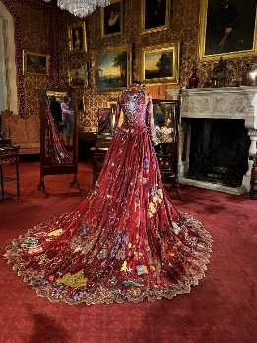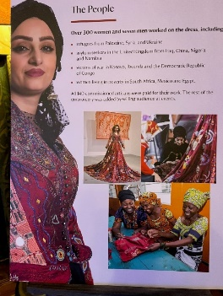

Embroidery pieces would be produced by the local schools, groups and organisations by the end of January 2024 to allow for sufficient time for the pieces to be added to the dress with a completion date of end of February .

**Update so far**

Three working group meetings has been held involving BSTC councillors, officers and representative from Southern Brooks.

Kirstie (who set-up and spearheaded the original Red Dress Project) has been booked to speak at the event.

Bradley Stoke Community School has been identified as a venue (and provisionally booked) but is going to cost in the region of £700 for use of all facilities, member of staff and audio-visual resources – need to identify where funding will come from to cover the cost of the venue. Some local SGC Ward councillors still have Member Awarded Funding left so this avenue will be explored.

Positive responses from a variety of local groups such as Bradley Stoke Radio, Little Stoke Ladies Group, Bradley Stoke Sew and Sos, and local WI Groups.

Great Western Air Ambulance Charity will hopefully be able to assist with an inspirational speaker (female paramedic or volunteer)

Bradley Stoke Community Singers able to provide a group of singers for the event

Bradley Stoke Library will help with a library display – Women in Literature ‘Empowering Women’ theme, promotion of the event in the library and compilation of a reading list.

Documentation has been circulated. SGC need to make savings within their library

**9 Date of next meeting**

Monday 19th February 2024 at 7.00pm.

The meeting closed at 8.35pm

**APPENDIX A**

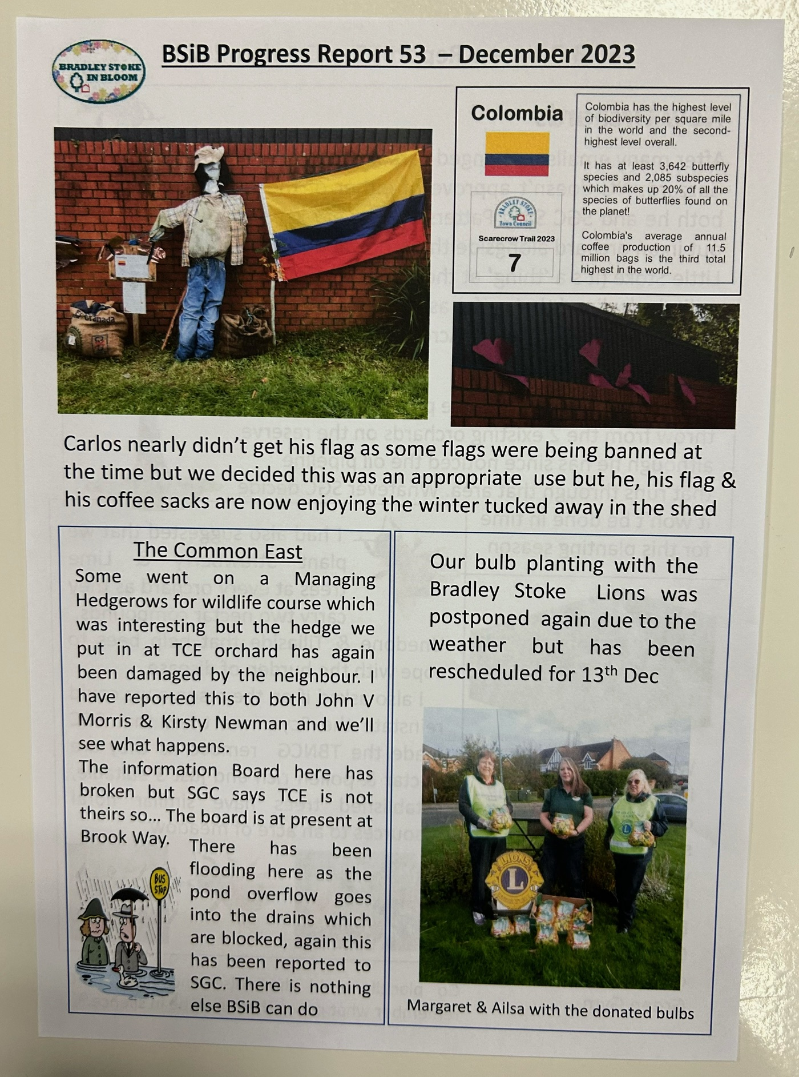

**APPENDIX A**

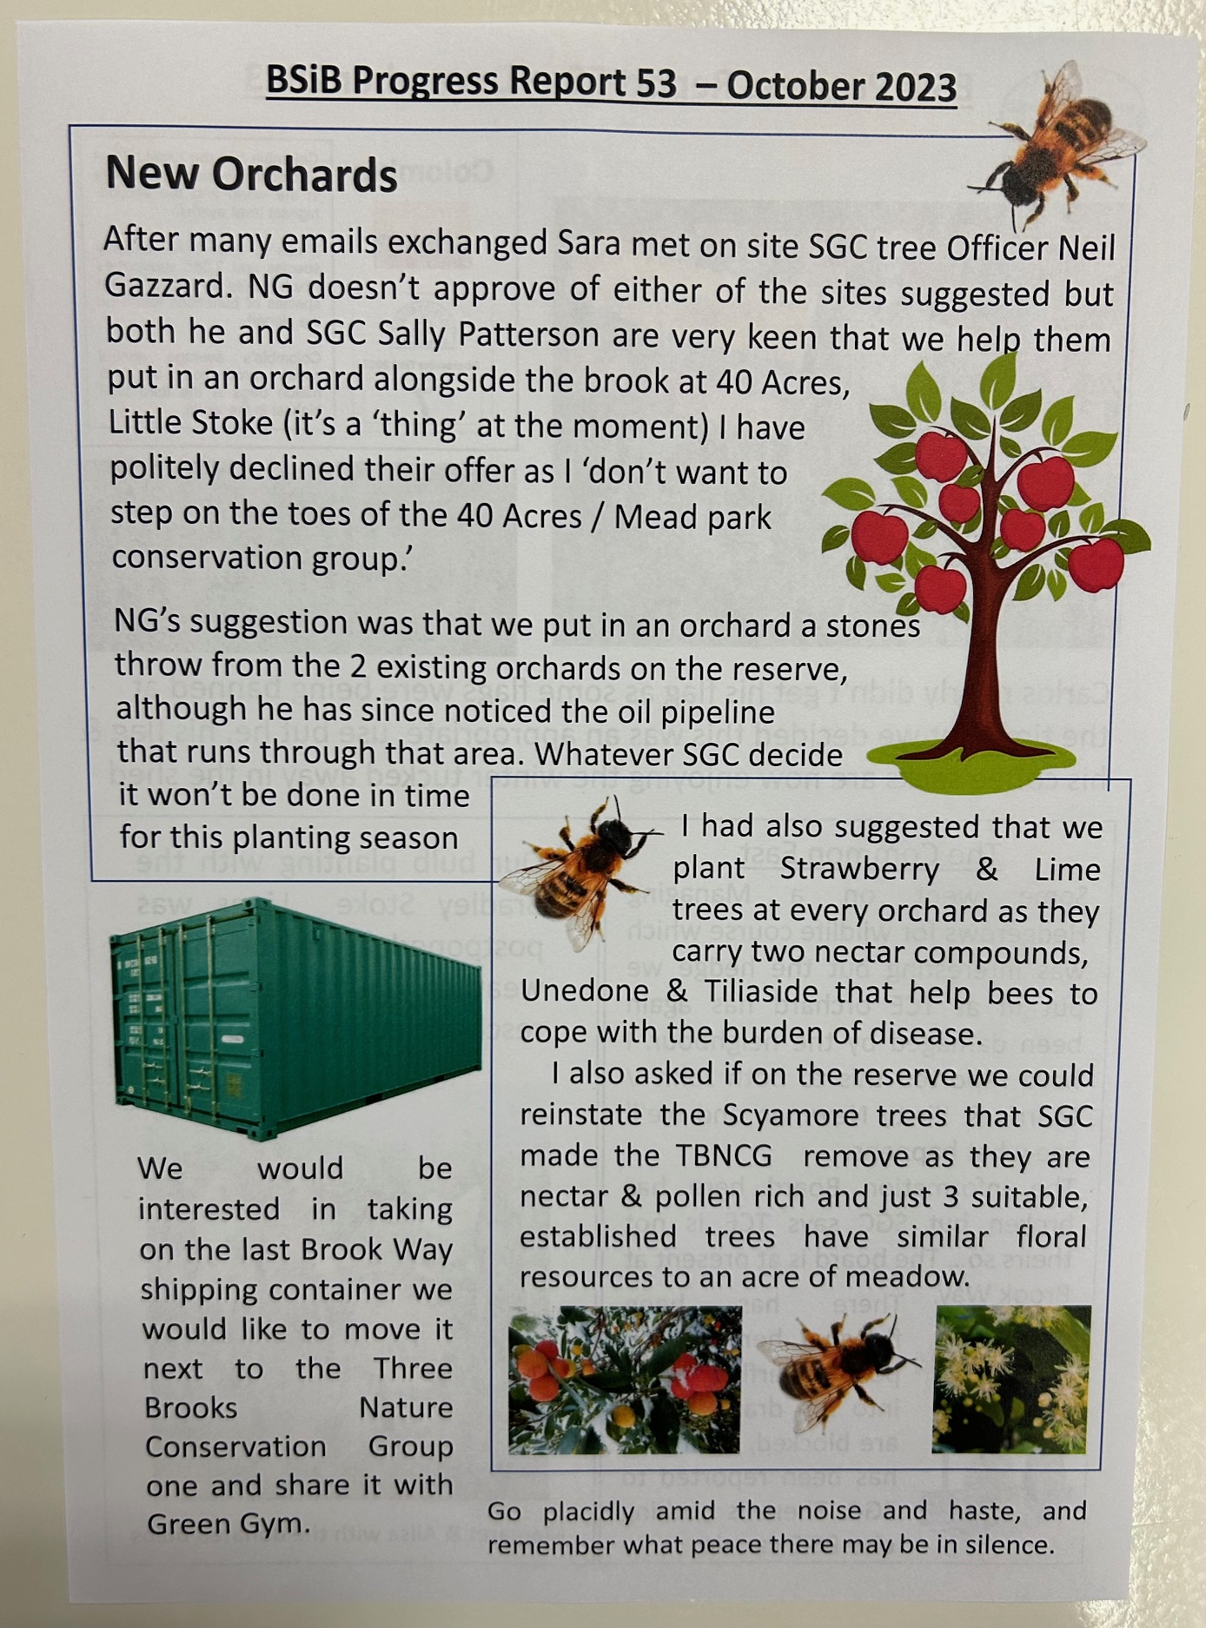

**APPENDIX B**

**Baileys Court Activity Centre**

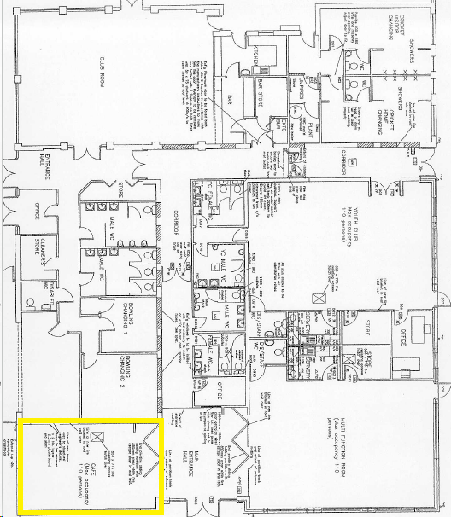

**Jubilee Centre**

