7.3 Update on the wooden bridge between Jubilee Centre and Stoke Lodge Primary School

The bridge works have been completed over the Easter holidays and it is anticipated that the entrance to the school will be ready to be re-opened when schools return on Monday 20th April 2026.

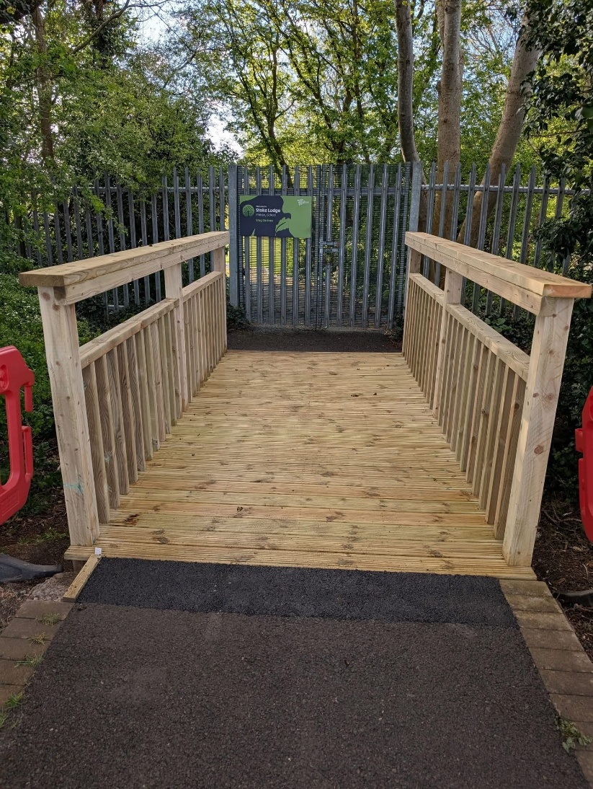

The cost of the bridge installation was £6,150 + VAT and the cost is being split between Bradley Stoke Town Council and Stoke Lodge Primary School.

