Davis Pond Jubilee Centre

Fencing Proposal
We propose the installation of fencing to safeguard the works completed at the pond and to ensure its protection and longevity for future years.

We have obtained three quotes for the installation of fencing around Davis Pond at the Jubilee Centre. The purpose of this fencing is to improve site security, prevent vandalism, and ensure the safety of young children, particularly given the close proximity of the Beacon play area.
In recent years, we have worked with Claire from Renature Reconnect to enhance the pond. As a result of this work, the pond now includes a liner and is in a healthy condition, supporting a range of plant life.
Temporary fencing has been installed (as shown in the photo) to provide short-term protection. However, this has proven insufficient, as it has been subject to vandalism. This has unfortunately resulted in damage to the pond liner in several areas.
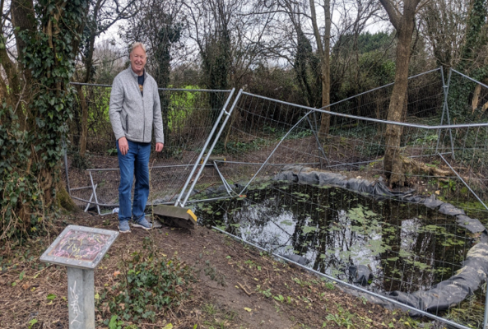
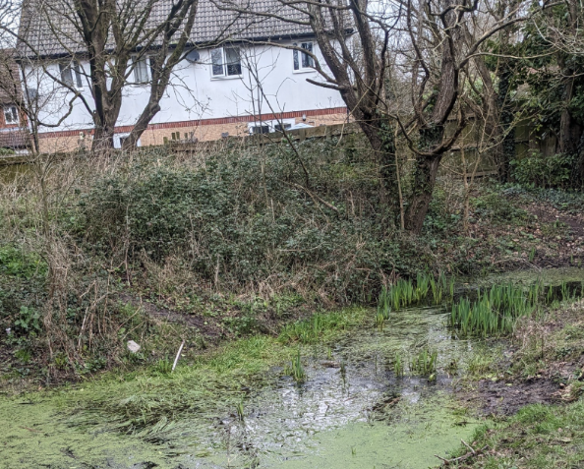
The proposed permanent fencing will run across the full front of the pond, including the overflow area, and will incorporate a gate to allow authorised access for maintenance.

Quotes received:
Supplier | Exc VAT | Inc VAT
Almondsbury forge | £5,680.00 | £6,816.00
SJPaving | £4,542.00 | £5,450.40
P James Paving & Grounds works | £5,697.00 | £6,836.40

Currently, there is no budget for the pond fencing and therefore Council may choice to utilise a part of the year end surplus against N/A 9038.

