BRADLEY STOKE TOWN COUNCIL

Full Council

Minutes of the Full Council meeting of Bradley Stoke Town Council held at the Jubilee Centre, Savages Wood Road, Bradley Stoke on 19th November 2025 at 7.00pm.

PRESENT: Councillors: Tom Aditya
Sue Bandcroft
Frederic Contenot
Terri Cullen
Natalie Field (Chair)
Anthony Griffiths
Jenny James
James Nelson
Ben Randles
Kulwinder Singh Sappal
Jon Williams

Officers: Sharon Petela - Town Clerk
Rachel Pullen – RFO/Finance Manager
Phil Francis-Barber - Deputy Town Clerk/Activity Centres Manager

Others: Councillor Franklin Owusu-Antwi (South Gloucestershire Council (SGC) Bradley Stoke North ward councillor)

1 Submissions from the Public and Councillors

  - Councillor Frederic Contenot commented that the footpath from Woodlands Lane to Pear Tree Road needs some attention as it is overgrown and deteriorating.

  - Councillor Tom Aditya commented that whilst the Community Welcome Spaces are good, it would be helpful to supply hot showers if possible.

2 Apologies for absence

Apologies were received from Councillors Dave Addison and John Bradbury

3 Applications for Dispensations by Councillors

None

4 Declarations of Interest

None

5 Announcements by the Chair

The Chair informed the meeting that positive feedback has been received from Royal British Legion for the recent Remembrance Day Parade. Thanks were passed to all stakeholders involved. There was also a lot of money raised through the Poppy Appeal at the Willow Brook Centre.

The Chair wished everyone Seasons Greetings as this is the last Full Council meeting of 2025.

6 Minutes of Previous Meeting

Minutes of meeting held on 10th November 2025 were proposed for acceptance by Councillor Kulwinder Singh Sappal and seconded by Councillor Sue Bandcroft. A vote was taken, 10 in favour, 1 abstention, proposal carried.

The minutes were then signed by the Chair as a correct record.

It was proposed by Councillor Natalie Field, seconded by Councillor Kulwinder Singh Sappal and carried unanimously, that, in line with Standing Orders 67 and 68, in view of the confidential nature (commercial sensitivity) of the business about to be transacted, it is advisable in the public interest that the press and public be temporarily excluded, and they are instructed to withdraw and as there were contractors present, agenda item 12.5 be discussed next.

12 Financial Matters

12.5 All Sites Cleaning Contract

Overview
This report summarises the results of the 2025 Cleaning Services Tender evaluation, based exclusively on the scoring matrix. Each tender submission was assessed against weighted criteria covering both qualitative and quantitative aspects of service delivery. The 15 tenders received were opened and scored on 4th November 2025 by Councillors Sue Bandcroft and Jenny James and Phil Francis-Barber, Deputy Town Clerk/Activity Centres Manager.

- Evaluation Criteria and Weightings:
- 10% – Compliance with Requirements
- 15% – Relevant Experience & References
- 25% – Method Statement & Service Delivery
- 15% – Staffing & Supervision Arrangements
- 10% – Environmental & Sustainability Measures
- 10% – Health & Safety / Risk Management
- 15% – Price / Value for Money

Summary of Top Five Tenders

Rank | Tender Reference | Total Score (%) | Price for first year
1 | Bidder A | 73.33 | £45,448.00
2 | Bidder B | 71.00 | £41,620.80
3 | Bidder C | 65.67 | £39,468.00
4 | Bidder D | 65.67 | £44,204.16
5 | Bidder E | 64.00 | £44,252.00

Detailed Analysis

Bidder A - Overall Score: 73.33%
Key Strengths:
- Excellent performance across compliance, experience, and service delivery criteria.
- Strong staffing and supervision arrangements.
- Robust sustainability and safety management measures.
- Balanced, mid-range pricing offering strong value.
Weaknesses:
- Cost slightly above average.
Summary: Achieved the highest total score, demonstrating consistent quality and capability across all areas.

Bidder B - Overall Score: 71.00%
Key Strengths:
- Outstanding compliance and service methodology.
- Excellent safety record – highest among all evaluated bidders.
- Solid environmental policies and procedures.
Weaknesses:
- Price less competitive.
- Slightly lower score in staffing and supervision structure.
Summary: Highly compliant and safety-focused offer with strong operational reliability.

Bidder C - Overall Score: 65.67%
Key Strengths:
- Consistent results across all quality criteria.
- Most competitive revised price.
- Demonstrated relevant experience and solid references.
Weaknesses:
- Weaker staffing and supervision arrangements.
- Moderate sustainability measures compared to others.
Summary: Most cost-effective option with acceptable quality standards.

Bidder D - Overall Score: 65.67%
Key Strengths:
- High environmental and sustainability performance (best among all bidders).
- Strong compliance and well-developed service delivery framework.
Weaknesses:
- Low score on price/value for money.
Summary: Strong environmental performer but less competitive on cost.

Bidder E - Overall Score: 64.00%
Key Strengths:
- High experience rating and consistent overall results.
- Competitive pricing.
Weaknesses:
- Lower compliance score.
- Modest performance in service methodology and supervision.
Summary: Solid experience and fair pricing, but weaker compliance reduced overall competitiveness.

The five companies who scored highest during the scoring process were invited to attend this evening’s meeting. Each company was then invited into the room one at a time and were given 5 minutes to present their tender. Councillors asked questions of all the companies in attendance.

Companies in attendance (listed alphabetically): ACS
Concord Homecare
Service Master Clean
Skweeky Kleen

Fairway Support Services had sent their apologies.

Confidential information on prices quoted by the five companies were circulated to councillors. Councillors then held discussions on the positives and negatives of the tenders.
Following discussion, Councillor Kulwinder Singh Sappal proposed that the contract be awarded to Concord Homecare at a cost of £39,468.00 for the first year of the three-year agreement, noting that they submitted the lowest tender, the Council has an established and positive working relationship with the company through the existing BSTC cleaning contract and the tender represents good value for money. The proposal was seconded by Councillor Ben Randles. A vote was taken: 9 in favour, 2 abstentions, proposal carried.

Councillor Sue Bandcroft then proposed that the contract be awarded for an initial three-year term, with the option to extend for a further two years subject to no issues or concerns being raised at the end of the initial period. The proposal was seconded by Councillor Kulwinder Singh Sappal and carried unanimously.

Following further discussion Councillor Jon Williams proposed that Concord Homecare should be asked to carry out British Institute of Cleaning Science (BICS) Level 1 training with all their staff, seconded by Councillor Kulwinder Singh Sappal. A vote was taken: 9 in favour, 1 against and 1 abstention, proposal carried.

The meeting then went back into open session

7 Matters arising from the Minutes of 8th October and 10th November 2025

7.1 Update on storage building at Brook Way Activity Centre

Background:
Bradley Stoke Town Council has been progressing plans for improved storage provision at Brook Way Activity Centre to support both Council operations and local community groups. The project has been under discussion for some time, with options considered for additional storage capacity behind the Leisure Centre.

Update:
Over recent months, discussions have continued with South Gloucestershire Council (SGC) regarding the requirement for planning permission for the installation of a second storage container at the rear of the Leisure Centre. The situation has been subject to ongoing clarification, with differing advice received at various stages about whether formal planning consent is required. Unfortunately, progress has been delayed by changes in staffing within South Gloucestershire Council, resulting in the loss of continuity and the need to revisit earlier correspondence and decisions.

Current Position:
Bradley Stoke Town Council is now awaiting South Gloucestershire Council to submit the planning application for the second storage container. Once this application has been lodged and determined, the Town Council will be in a position to progress the next steps of the project.

7.2 Ongoing projects

7.2.1 Redevelopment/refurbishment of Baileys Court Activity Centre

Background
The Town Council has engaged gcp Chartered Architects to prepare a Project Brief for the redevelopment and refurbishment of Baileys Court Activity Centre. The brief builds on the Stage 0 Strategic Definition and reflects consultations held with user groups in August 2025, including Abacus Pre-School, Rainbow After-School Club, Bradley Stoke Cricket Club, and Bradley Stoke Bowls Club. The project seeks to modernise the facility to better serve community needs, enhance accessibility, and achieve improved environmental performance.

Project Objectives

The redevelopment of Baileys Court Activity Centre aims to reconfigure the existing internal layouts to make more efficient use of space, addressing current issues of wasted and conflicting areas of use.

The project seeks to improve accessibility and safeguarding throughout the building, including upgrades to the main reception area and improved access routes to ensure compliance with modern standards.

It will provide new multi-use, audio-visual equipped rooms designed to support a variety of community activities and external hire, increasing the flexibility and usability of the facility.

The scheme will deliver changing facilities that comply with England and Wales Cricket Board (ECB) and Football Association (FA) standards, alongside the inclusion of a fully accessible Changing Places room to meet the needs of all users.

The redevelopment will also create safe and secure external play areas directly connected to the childcare facilities, enabling better supervision and access for children attending Abacus Pre-School and the Rainbow After-School Club.

To support Bradley Stoke Town Council’s wider environmental ambitions, the project will introduce a range of energy efficiency improvements aimed at reducing the building’s carbon footprint and operational costs.

Finally, the works will be planned and phased to ensure the continued operation of the facility throughout construction, allowing community activities to proceed with minimal disruption.

Consultation Findings
Consultations with stakeholders in August 2025 identified key operational challenges and opportunities for improvement. The Cricket Club emphasised the need for compliant changing, improved Orchard Room access, and better scoring facilities. The Bowls Club highlighted kitchen inadequacies, limited storage, and scheduling conflicts with the Cricket Club. Abacus Pre-School and Rainbow Club raised safeguarding, ventilation, and storage issues, with both requiring a direct and secure outdoor play space. All stakeholders supported modernising the facilities and improving accessibility and comfort.

MoSCoW Outcomes Summary

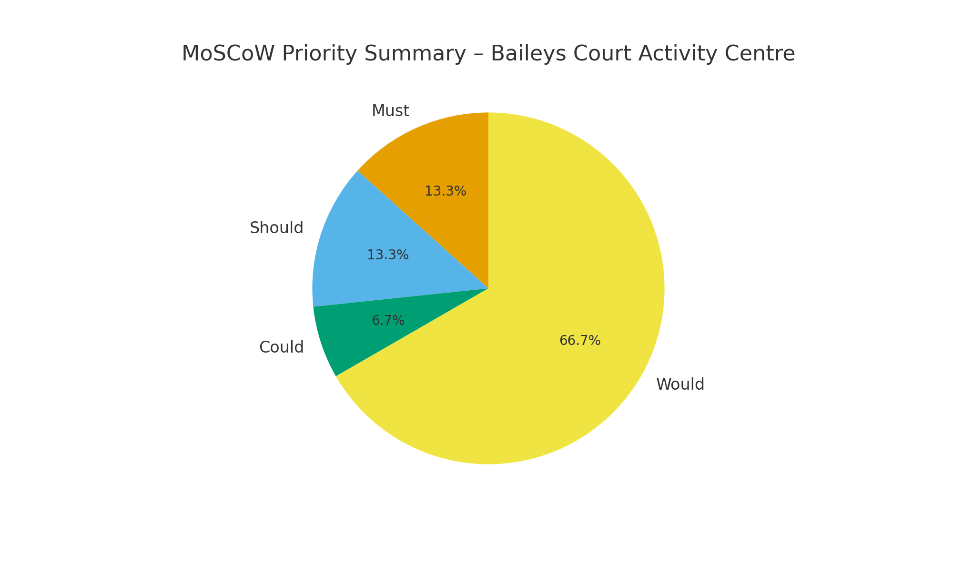
The MoSCoW analysis categorised development priorities as follows:
• Must Do – Compliance, safeguarding, accessibility, and essential facility upgrades.
• Should Do – Enhancements to kitchens, storage, plumbing, and heating systems.
• Could Do – Desirable additions such as external play space and viewing patios.
• Would Not Do – Requests outside the agreed scope, including exclusive-use kitchens and a new Bowls pavilion.
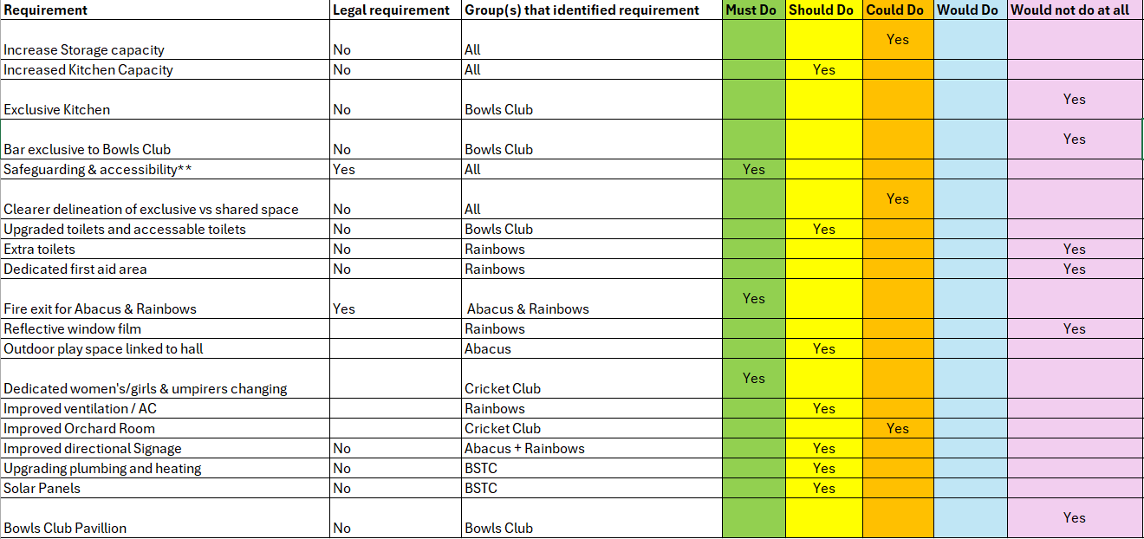
The summary chart indicates that ‘Must’ and ‘Should’ priorities dominate, demonstrating stakeholder focus on compliance, usability, and sustainability.

Programme Overview
The indicative programme prepared by gcp Chartered Architects assumes a Design and Build procurement route. No fixed delivery date has been set, though sequencing will be planned to minimise disruption to the Cricket and Bowls seasons. The following indicative stages have been proposed:
• Stage 1 – Feasibility and Project Brief Review (Winter 2025/26)
• Stage 2 – Concept Design and Cost Planning (Spring 2026)
• Stage 3 – Detailed Design and Planning Submission (Summer 2026)
• Stage 4–6 – Construction Phase (2027 onwards).
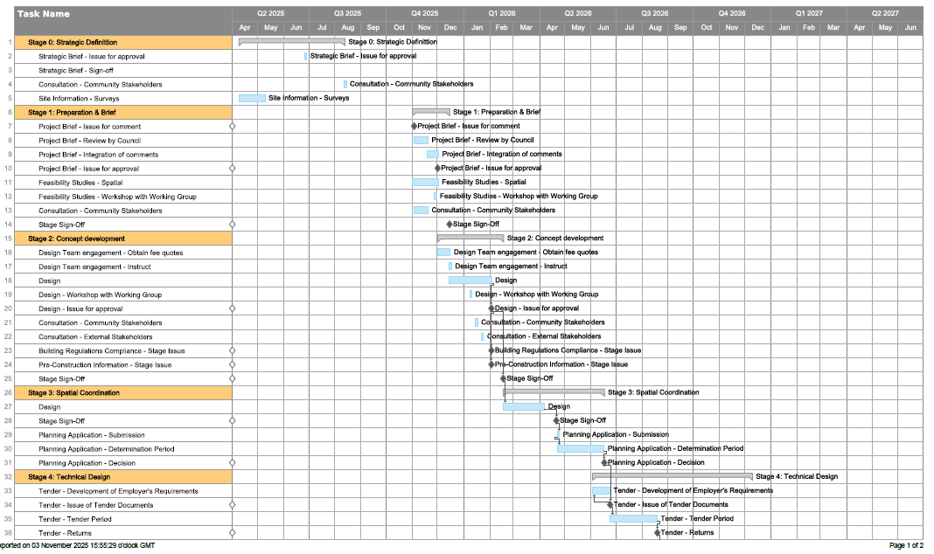
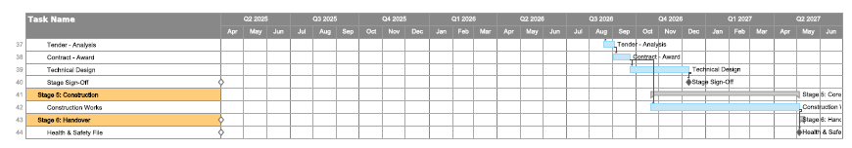

Funding and Sustainability
No set budget is currently established. Funding is expected from a combination of sources including the England and Wales Cricket Board (ECB), potential successors to the Public Sector Decarbonisation Scheme, and, if necessary, the Public Works Loan Board (PWLB). BSTC aims to achieve a net-zero in operation target through phased upgrades, electrification of heating systems, and the installation of solar PV. These improvements align with national decarbonisation goals and are expected to improve operational efficiency and reduce long-term costs.

Risks and Constraints
Key risks identified in the Project Brief include:
• Council elections in 2027 potentially affecting continuity of decision-making.
• Biodiversity Net Gain requirements impacting planning approval timelines.
• Budget uncertainty pending cost consultant appointment.
• User expectations exceeding available funding.
Mitigation will involve early consultant engagement, transparent communication, and proactive programme management.

Next Steps
The next actions recommended by gcp Chartered Architects are to:
• Finalise and approve the Project Brief (RIBA Stage 1 sign-off).
• Develop feasibility plans to meet project outcomes.
• Appoint a cost consultant to establish accurate financial projections.
• Continue engagement with key stakeholders to ensure design alignment with operational needs.

Officer Recommendation
It is recommended that the Council forms a Working Group comprising Councillors, and the Deputy Clerk, to liaise with gcp Chartered Architects on the future design choices.

Following discussion, Councillor Kulwinder Singh Sappal proposed, seconded by Councillor Jon Williams and carried unanimously, that the Working Group consists of councillors:
Sue Bandcroft John Bradbury
Terri Cullen Natalie Field
Jenny James James Nelson
Ben Randles Kulwinder Singh Sappal
Jon Williams

7.2.2 Beautification of Bradley Stoke

To consider opportunities for improving the visual appeal and biodiversity of Bradley Stoke through the planting of wildflowers and seasonal bulbs on highway verges and roundabouts, subject to South Gloucestershire Council (SGC) permissions and highway safety regulations.

Background
Bradley Stoke Town Council has expressed interest in enhancing the town’s appearance in line with wider environmental goals.

SGC’s Green Infrastructure and Climate and Nature Action Plan documents support low-maintenance, biodiversity-friendly planting such as wildflower verges and bulb planting on suitable highway land. Any such planting must, however, comply with SGC’s maintenance standards, sponsorship scheme rules, and relevant highway safety legislation.

Guidance for Councillor Consideration
When proposing potential sites or planting types, members should note the following key requirements:

Permissions and Responsibilities
- Most roundabouts and verges are maintained by SGC; written consent will be required for any changes or planting on highway land.
- Town Council works should align with SGC’s ongoing environmental maintenance programme to avoid duplication or conflict.

Signage and Sponsorship
- SGC allows up to four approach signs per sponsored roundabout under its Roundabout Sponsorship Scheme.
- Advertising or additional signage outside of this scheme is not permitted under the Highways Act 1980 and may be removed by SGC.
- Any signage must comply with the Traffic Signs Regulations and General Directions 2016 (TSRGD) and the Traffic Signs Manual to ensure it does not cause confusion or obstruction.

Road Safety and Visibility
The Road Traffic Act 1988 and Town and Country Planning (Control of Advertisements) (England) Regulations 2007 require that no feature on or near the highway endangers users or distracts drivers. SGC and the Department for Transport advise that:
- Clear sightlines must be maintained at all junctions and roundabout approaches.
- Tall or dense planting should be avoided near driver sightlines or signage.
- Planting should not include reflective, moving, or illuminated elements.

Maintenance
- Any new planting must be maintainable under SGC’s highway safety regime.
- Long-term maintenance responsibility (SGC or Town Council) must be agreed before works commence.

Next Steps
Town Councillors are invited to:
- Identify potential sites suitable for wildflower or bulb planting within the parish.
- Provide input on preferred styles or planting themes.
- Consider whether the Council should pursue partnership working with SGC or local sponsors for implementation and maintenance.

The map of the verges currently cut by BSTC outside of the SGC core cuts has been circulated.
Following discussion, Councillor Kulwinder Singh Sappal proposed that daffodil bulbs are planted now by our existing roundabouts contractor for next Spring and then, when the roundabouts contract comes up for renewal next April, seasonal bulb planting (and replenishment of bulbs) will be including within the new contract, seconded by Councillor Ben Randles. A vote was taken, 10 in favour, 1 against, proposal carried.

7.2.3 Installation of Christmas Tree or Christmas Lights decoration at Jubilee Centre

Extract from Full Council minutes – 8th October 2025
10.2.2 Installation of Christmas Tree or Christmas Lights decoration at Jubilee Centre
Recommendation that BSTC explores options for the Christmas tree replacement at Jubilee Centre, either an external artificial tree, a mature native tree which can be wrapped in lights for Christmas or rental of an illuminated light installation for this Christmas.

As requested, BSTC officers have sourced now quotes for a range of options from several companies for an external Christmas installation at the Jubilee Centre.

Ambius
1 x Live Christmas Tree
Fully decorated to the customer colour specification
Includes decorations, lighting, installation, styling and removal after the hire period. Short Term Hire/Job charge all units = £820.00
Bespoke blue cone tree -
1 x Bespoke Christmas tree (Blue Cone)
Includes decorations, lighting, installation, styling and removal after the hire period. Short Term Hire/Job charge all units = £21,536.00

Fizzco
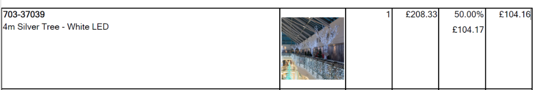

Email from Fizzco
“This tree is available for rent and could be used outdoors. The challenge would be the cost of getting it to you and collecting again – due to the size I suspect this would be a dedicated van drop which would be £300+ each way from Lincoln.”

Festive Lighting Company
Limited availability - purchase price below:



Christmas Tree World
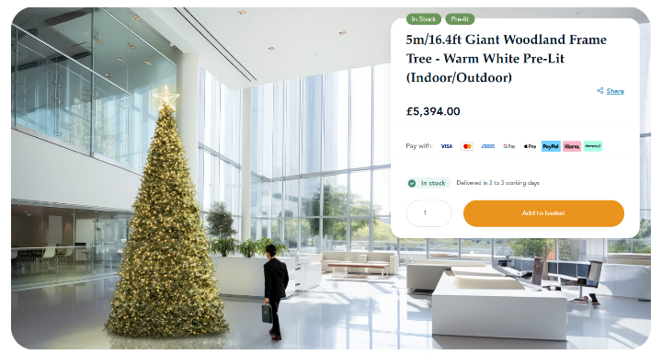

Festive Lights

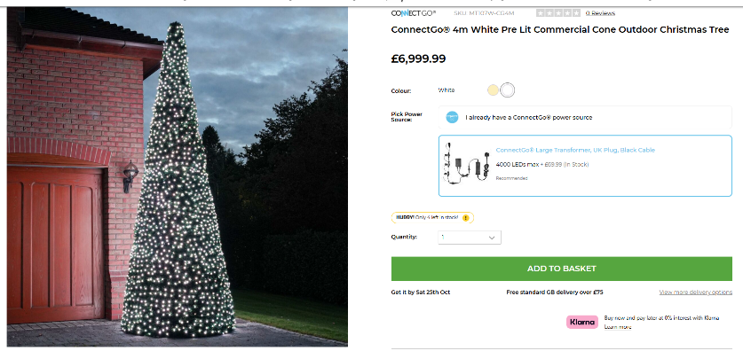

B&Q
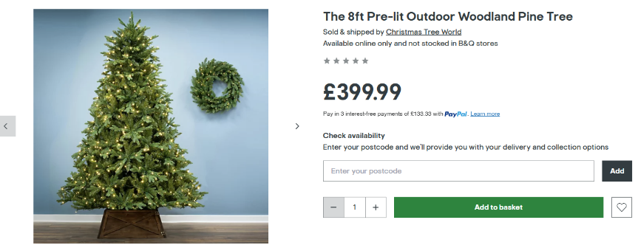

Christmas Trees Direct


Following discussion, Councillor Ben Randles proposed that BSTC purchase a 10-12ft cut Christmas Tree for this year and recycle it in an environmentally friendly way when finished with, seconded by Councillor Natalie Field, carried unanimously.

Option for future years to be considered in the New Year, including possibly commissioning a wooden tree from Bristol Wood Recycling Project.
7.2.4 Improvements to Three Brooks Nature Reserve

The following update has been received from SGC:

“I can confirm that the updated management plan for Three Brooks Nature Reserve is due any day now. As soon as received and agreed I will share with you and others.

I will need to look at the footpaths and lighting, however due to the associated costs this will be expensive and will need to be funded from sources other than the Places team.”

7.2.5 Live streaming of Council and Committee meetings

Councillors discussed that if live streamed to Facebook, this would require someone watching the meeting to have a Facebook account which not everyone has, whereas You Tube is publicly accessible to everyone.

Following discussion, Councillor James Nelson proposed that BSTC live stream council and committee meetings on You Tube with links being added to BSTC website, Facebook and Instagram pages, seconded by Councillor Ben Randles, carried unanimously.

7.2.6 Residents Survey to ascertain views and interests with a view to developing new projects and ideas

The BSTC Projects & Events Officer has provided the following update:

I have experience in writing surveys through my degree.

I understand that the Town Council wants a survey that gives realistic suggestions, as well as giving the residents freedom to express their views, values and ideas.

This can be achieved by designing the survey with closed and open-ended questions. The order in which these types of questions are written will help guide the participants to give specific information to gather tangible data. To set expectations and ensure realistic suggestions, there will be soft boundaries in place to ensure participants understand the capabilities of the council. There will be a focus on resourcefulness, i.e. giving the residents the suggestion to use our leisure facilities as a home for their ideas to blossom in. This will also support the council with the understanding of our small budget.

The survey will be created on an online and paper format to ensure it's flexible for all to take part. The surveys will be available online and handed out in events, giving the opportunity to for people to ask questions and feel supported if needed. Once the survey has run its course, the data will then be collected, processed and created into graphs and pie charts for the Town Council to effectively evaluate and analyse trends and areas of significance.

Councillors will be involved in the drafting of the residents survey.

7.2.7 Introduction of a Community Awards Scheme

The BSTC Projects & Events Officer is going to speak with the Willow Brook Centre as they used to run this scheme with a strategy then being formulated.

7.3 Additional works required at Beacon Playscheme

Background
Bradley Stoke Town Council previously commissioned refurbishment works at the Beacon Play Area, located adjacent to the Jubilee Centre. The primary contractor for the original phase of the project has since confirmed that they are unable to undertake the remaining additional works, which include the installation of new play equipment and associated surfacing.
Following this, Council officers sought to procure an alternative contractor to complete the outstanding elements of the project.

Procurement Process
Following the withdrawal of the original contractor, efforts were made to obtain quotations from multiple specialist playground companies:
- Two companies were contacted via their online quotation request forms but no response was received.
- One company initially engaged in correspondence but subsequently ceased replying to emails.
- Harlequin Playgrounds provided a detailed and itemised quotation (Ref: 1693, dated 16/10/2025), which is summarised below.
Given the difficulty in obtaining alternative quotes, Harlequin Playgrounds’ submission currently represents the only viable quotation received for these works.

Scope of Works (per Harlequin Playgrounds Quote No. 1693)

Item | Description | Total (£)
A | Heras fencing for duration of project | 314.67
B | Portaloo for duration of project | 146.67
C | Plant | 500.67
D | Labour to install AE Evans 2 bay swing | 2,800.00
E | Concrete for swing (allowing 1 m³ holes due to shingle) | 1,200.00
F | Groundworks – surfacing infill from path to roundabout pad (incl. Type 1 and geotextile) | 1,615.34
G | Supply and install rubber mulch repairs to swing holes | 1,800.00
H | Extra over to infill area by roundabout with 40 mm rubber mulch (22 m²) | 2,306.67
I | Clean, sweep and de-camp | 466.67
 | Total (excl. VAT) | 11,346.67

Following discussion, Councillor Kulwinder Singh Sappal proposed accepting the Harlequin Playgrounds quote of £11,346.67 + VAT as detailed above as it has been so difficult to source quotes for this work and the need to swiftly complete this project, seconded by Councillor Tom Aditya, carried unanimously.

Budgets to be used N/C5039 and N/C3016

7.4 Provision of Multi-Use Games Area (MUGA) at Jubilee Centre

Purpose of the Report
To update Members on the proposed provision of a new Multi-Use Games Area (MUGA) at Jubilee Green, Savages Wood Road, Bradley Stoke, and to consider the findings of the Biodiversity Net Gain (BNG) assessment, associated site plans, and mitigation proposals.

Background
Bradley Stoke Town Council has identified the need to enhance local recreational facilities at Jubilee Green through the installation of a Multi-Use Games Area (MUGA). The proposed site is an existing area of maintained grassland (approximately 1,115m²) situated adjacent to the Jubilee Centre and Beacon Play Area.
RDK Civil Engineering Ltd. has prepared full planning and site layout drawings (Ref: RDK_25150_DP02) showing the proposed development including:

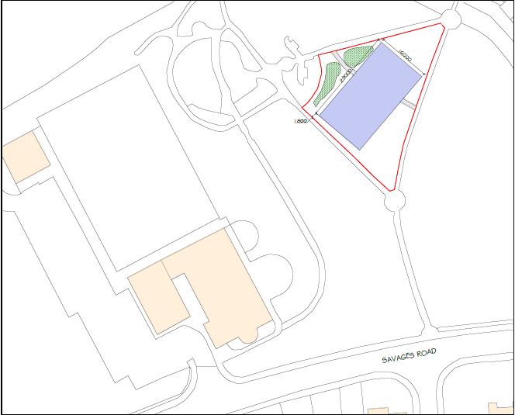
- A rectangular tarmac MUGA, approximately 29m x 16m, surfaced in asphalt.
- Associated pathways for access.
- A mounded area to be formed from site spoil, to be planted with wildflowers.

The proposal is designed to support inclusive community recreation while improving access and usability of the existing open space.

Biodiversity Net Gain Assessment
A Biodiversity Net Gain (BNG) Report was commissioned from Eco360 Ltd (Survey Date: 25th June 2025). The assessment was conducted in accordance with the Environmental Act 2021 and DEFRA Statutory Biodiversity Metric 4.0, which require a minimum 10% net gain in biodiversity value.

Baseline Conditions:
- Existing habitat: Vegetated garden grassland (low distinctiveness).
- No hedgerows or linear habitats.
- Total baseline habitat units: 0.22.
Post-Development Assessment:
- MUGA (artificial, unsealed surface): 475m², 0 habitat units.
- Neutral grassland (wildflower planting): 40m², 0.03 habitat units delivered.
Net Change:
- Total net change in biodiversity units: –0.07 (–31.12%)
Trading rules not satisfied; biodiversity net gain not achieved.

Recommended BNG Mitigation Measures
Eco360 recommends the following measures to achieve the required 10% net gain:
- On-site Enhancements:
- • Additional wildflower grassland creation totaling approximately 185m².
• Extend planting areas to the north and south-east corners of the site.
• Maintain and manage wildflower areas to achieve a 'good' condition rating.
• Implement a long-term (minimum 30-year) management plan in accordance with the Environmental Act 2021.
- Off-site Options (if required):
- • Identify nearby Council land suitable for additional habitat enhancement.
• Alternatively, purchase Government Biodiversity Credits if on-site measures are insufficient.
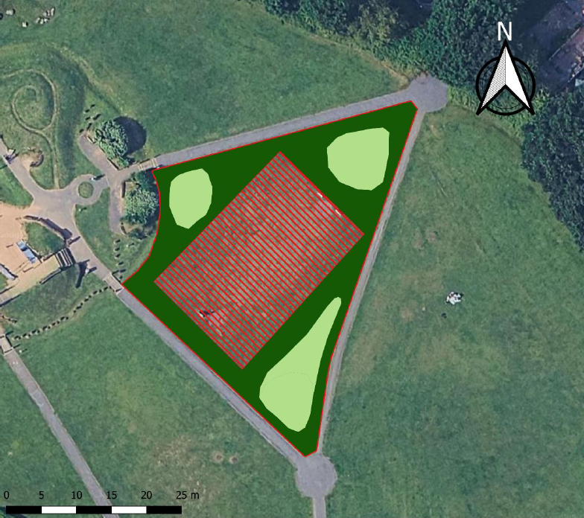

Next Steps
1. Council to consider approval of the proposed MUGA layout (RDK_25150_DP02).
2. Incorporate Eco360’s biodiversity recommendations into design and construction specifications.
3. Consult with South Gloucestershire Council (Planning and Ecology) regarding integration of wildflower planting and validation of BNG calculations.
4. Prepare a Biodiversity Net Gain Implementation and Management Plan.

Financial and Legal Implications
Funding for the MUGA is to be determined from approved capital allocations or grant sources. The Council must comply with the Environment Act 2021 Section 98, ensuring that biodiversity gains are maintained for a minimum of 30 years. Future maintenance costs for the wildflower planting and ecological monitoring will need to be factored into the annual grounds maintenance budget.

Officer Recommendations
That the Council:
- Notes the findings of the Eco360 Biodiversity Net Gain Report (July 2025).
- Approves in principle the proposed MUGA layout and site design prepared by RDK Civil Engineering Ltd.
- Endorses the implementation of the recommended on-site biodiversity enhancements, specifically the creation of an additional 185m² of wildflower grassland.
- Authorises officers to liaise with South Gloucestershire Council and Eco360 to ensure the scheme achieves a minimum 10% biodiversity net gain in line with statutory requirements.

Following discussion, Councillor Ben Randles proposed acceptance of officer recommendations as detailed above, seconded by Councillor Tom Aditya, carried unanimously.

7.5 Provision of steps and handrail between top and bottom football pitches at Jubilee Centre

Background:
The Council has previously discussed the need for improved pedestrian access between the upper and lower football pitches at the Jubilee Centre. The slope between these pitches is steep and can become slippery during wet weather, creating potential safety concerns. The proposal is to install a set of steps and a handrail to provide safer access for players, officials, and visitors.

Current Position:
Two quotations have been received for the supply and installation of suitable steps and a handrail:

Recommendation:
At present, only two quotations have been received. In accordance with Council procurement best practice and financial regulations, it is recommended that the Council defers acceptance of either quote and seeks at least one additional quotation before making a decision. This will ensure value for money, transparency, and compliance with the Council’s procurement policy.

Following discussion, Councillor Ben Randles proposed that one additional quote is obtained, seconded by Councillor Sue Bandcroft. A vote was taken, 10 in favour, 1 abstention, proposal carried.

7.6 Use of Brook Way Activity Centre car park by Bradley Stoke Surgery and Pharmacy

Background
The car park at Brook Way Activity Centre (Brook Way, Bradley Stoke) has been under discussion by the Council’s Finance Committee with regard to its use by the local medical practice and pharmacy. The relevant historical record includes:
- In the Finance Committee minutes of 23 April 2025: the Committee noted that the surgery should ask its patients to use the dedicated car park at the doctor’s surgery, rather than the Town Council-owned Brook Way car park.
- At the meeting of 25 June 2025: the item “Use of Brook Way Activity Centre car park by Bradley Stoke Surgery and Pharmacy” was under agenda item 6.1.
- At the meeting of 23 July 2025: it was recorded that “As no contact has been received from Bradley Stoke Surgery…” regarding the matter.
- At the Full Council meeting of 17 September 2025: agenda item 9.1 referred to the use of the car park by the surgery and the pharmacy; a communication from the surgery was acknowledged.
- At the Finance Committee on 22 October 2025: the update noted that the car park had been closed off on Monday 13 October.

Current Position
Recent correspondence between the Town Council and representatives of Bradley Stoke Surgery confirms that the surgery has now ceased using the Brook Way Activity Centre car park. On 24 October 2025, the surgery’s manager issued clear written instructions to all surgery and pharmacy staff advising that they do not have permission to park in the Activity Centre car park. Staff were directed instead to use nearby public or retail parking areas, with limited exceptions for the on-call GP and staff finishing late who may move their cars into the surgery’s own car park after 5 p.m.

However, despite this formal instruction, the Council’s Activity Centres Manager observed that a number of vehicles continued to park in the Activity Centre car park on several visits, and photographs were taken for reference. It remains unclear whether these vehicles belong to pharmacy staff or customers, as the surgery has confirmed that its own employees have been told not to park there. The Deputy Town Clerk has therefore requested further clarification and cooperation from both the surgery and the pharmacy to confirm compliance and ensure that the Activity Centre car park is used only by authorised users.

Next Recommended Action
It is recommended that the Council continues to monitor vehicle use at the Brook Way Activity Centre car park for a short period to confirm whether parking by pharmacy staff is still occurring. The Deputy Town Clerk should write formally to Bradley Stoke Pharmacy to remind them of the Council’s position and to request confirmation that their staff are no longer using the car park. If unauthorised parking continues, the Council should consider re-introducing access controls (such as temporary barriers or signage) and exploring the option of a formal licence agreement should the pharmacy wish to seek continued use under agreed terms. A brief update on progress should be reported back to the Finance Committee at its next scheduled meeting to determine whether further action is required.

Councillors noted the update.

7.7 Update on Sale of Pieces of Land on dewfalls Drive

Background
This report provides an update on the sale of a small parcel of land located on Dewfalls Drive and outlines considerations for the future use, consultation, and maintenance of the site.
Legal Update
A letter from SGC dated 4 September 2025 was included in the Dewfalls Drive land sale documentation. The letter confirmed that the land is not owned by SGC. This has since been verified by SGC’s Legal Team and Cllr Adam Monk. The letter was signed by a representative of the SGC Highways Team.

Next Steps and Options for Consideration

a) Public Consultation
Members could consider whether a public consultation should be held regarding the future use of the land. Possible consultation questions could include:
- Should the land remain as public open space?
- Should the land be designated as a village green?
- Should the land be used or developed for another public purpose?

These questions can form part of the residents survey which is going to be carried out.

Given current uncertainties regarding the adjoining parcel of land, it is recommended that the Council could retain the land in its current state until the situation with the neighbouring land is clarified.

b) Future Maintenance
The Council could also consider the ongoing maintenance of the site. Options include:
- Requesting South Gloucestershire Council to continue maintaining the land.
- It is likely this request would be unsuccessful, as the land is not within SGC ownership or maintenance remit.
- Including the site within the Town Council’s existing grass verge maintenance contract, ensuring consistent upkeep with other Council-maintained areas.

c) Site Management and Amenities
Councillors could also consider whether any physical measures are required, such as:
- Signage
- Barriers or bollards to prevent unauthorised access
- Litter or dog waste bins

Update from confidential Full Council minutes on 8.10.25 and 10.11.25

Extract from 8th October 2025 – now in public domain as auction has now passed
Discussion then took place regarding the maximum budget to be allocated for bidding at the auction. It was noted that the total budget would need to include the Buyer’s Premium of £900 and the administration fee of £1,500, both payable to the auctioneers.

Three separate votes were subsequently held, beginning with the highest proposed figure (1), which was not carried. A second vote on a lower figure (2) also failed, and a third vote on a further reduced figure (3) was successful.
To ensure that the final agreed figure does not influence the outcome of the auction in any way, the recorded votes are listed below as 1, 2 and 3. The actual figures will be reported at the next Full Council meeting on 19th November 2025, following the conclusion of the auction.

Maximum budget (1) proposed by Councillor Dayley Lawrence, seconded by Councillor Kulwinder Singh Sappal. A vote was taken, 5 in favour, 6 against, 1 abstention, proposal failed.

Maximum budget (2) proposed by Councillor James Nelson, seconded by Councillor Jon Williams. A vote was taken, 5 in favour, 6 against, 1 abstention, proposal failed.

Maximum budget (3) proposed by Councillor James Nelson, seconded by Councillor John Bradbury. A vote was taken, 6 in favour, 5 against, 1 abstention, proposal carried.

Maximum budget (1) - £50,000
Maximum budget (2) - £40,000
Maximum budget (3) - £35,000
Extract from 10th November 2025 – now in public domain as second piece of land was sold prior to auction
Discussion then took place regarding the maximum budget to be allocated for bidding at the auction. It was noted that once again, the total budget would need to include the Buyer’s Premium of £900 and the administration fee of £1,500, both payable to the auctioneers.

To ensure that the final agreed figure does not influence the outcome of the auction in any way, the recorded votes are listed below as 1, 2 and 3. The actual figures will be reported at the next Full Council meeting on 19th November 2025, following the conclusion of the second auction.

Maximum budget (1) proposed by Councillor Dayley Lawrence, seconded by Councillor James Nelson. A vote was taken, 3 in favour, 7 against, 1 abstention, proposal failed.

Maximum budget (2) proposed by Councillor Jon Williams, seconded by Councillor Dayley Lawrence. A vote was taken, 5 in favour, 6 against, proposal failed.

Maximum budget (3) proposed by Councillor Kulwinder Singh Sappal, seconded by Councillor Dayley Lawrence. A vote was taken, 5 in favour, 5 against, 1 abstention. As the vote was tied, the Chair used their casting vote in favour of the maximum budget (3), proposal therefore carried.

A further figure was suggested by Councillor Anthony Griffiths, but the Chair deemed that the matter had been concluded.

Maximum budget (1) - £35,000
Maximum budget (2) - £10,000
Maximum budget (3) - £20,000

Councillor Anthony Griffiths commented that there was an inaccuracy in the minutes from 10th November as his proposal was seconded by Councillor Roger Avenin, but other councillors said that they did not recollect this.

The purchase of the Dewfalls Drive land, and the associated decision-making process, was uncharted territory for the Council and therefore unprecedented. It was noted that, for future situations of this nature, the mechanism for voting on financial bidding limits consideration, where possible, should be made clearer and more efficient, if preparations to do so can be made in advance and known. On this occasion, the figures required were not known in advance, and therefore Councillors were unable to prepare in the same structured way as they do for the election of Councillors onto Committees.

It was noted that the land that BSTC purchased, completed on Tuesday 18th November 2025 and the financial summary is detailed below

Sage Ref | Payment Date | Paid from Account | Ref | Details | Net (£) | Vat (£) | Gross (£)
97332 | 17/10/2025 | Petty Cash | 4SP | Dewfalls Drive - Land Purchase-1st Instalment (Deposit) | 10000.00 | 0.00 | 10000.00
97333 | 24/10/2025 | Petty Cash | 4SP | Land Purchase - Auction Fees | 2000.00 | 400.00 | 2400.00
97607 | 12/11/2025 | Petty Cash | 5SP | Barcan+Kirby Solicitors - Upfront payment for land purchase | 416.67 | 83.33 | 500.00
97631 | 17/11/2025 | Current Account | BRA855/1 | Barcan+Kirby Solicitors - Final Payment re Dewfalls Drive Land Purchase | 7000.00 | 0.00 | 7000.00
97632 | 17/11/2025 | Current Account | BRA855/1 | Barcan+Kirby Solicitors - Sellers Costs re Dewfalls Drive Land Purchase - Sellers Fees | 4625.98 | 925.20 | 5551.18
97633 | 17/11/2025 | Current Account | 178685 | Barcan+Kirby Solicitors - Solicitors Fees & Disbursements on Completion of Land Purchase | 1590.33 | 318.07 | 1908.40
97634 | 17/11/2025 | Current Account | BRA855/1 | Barcan+Kirby Solicitors - Land Registry Fee -Dewfalls Drive Land Purchase | 45.00 | 0.00 | 45.00
 |  |  |  | Totals | 25677.98 | 1726.60 | 27404.58

Following discussion, Councillor Ben Randles proposed that BSTC explores registering the piece of land that they have purchased as a town/village green, seconded by Councillor Jon Williams, carried unanimously.

Following further discussion, Councillor Tom Aditya proposed that BSTC advise the local residents about the Town/Village Green registration mechanism, seconded by Councillor Natalie Field, carried unanimously.

7.8 Refurbishment of BSTC owned bus shelters

All BSTC bus shelters have now been cleaned and the condition report supplied by the company who were contracted to carry out the cleaning and condition review is detailed below:

Site No | Site Address | Shelter Condition | Shelter Clean Date
1 | Baileys Court Rd adj Evangelical Church, BS32 OHG | All Polycarbonate Glazing Panels in Poor Condition. All Roof Polycarbonate Panels have Cracks in them. Shelter Paintwork in Poor Condition | 11/11/2025
2 | Baileys Court Rd opp Evangelical Church, BS32 OHG | All Polycarbonate Glazing Panels in Poor Condition. 2no Roof Polycarbonate Panels have Cracks in them. Shelter Paintwork in Poor Condition. Seat top Damaged | 11/11/2025
3 | Baileys Court Rd after Bradley Stoke Way, BS32 8AT | 3no Polycarbonate Glazing Panels in Poor Condition. Shelter Paintwork in Poor Condition | 11/11/2025
4 | Baileys Court Rd before Bradley Stoke Way, BS32 8AT | All Polycarbonate Glazing Panels in Poor Condition. Shelter Paintwork in Poor Condition | 11/11/2025
5 | Baileys Court Rd opp Bailys Court Activity Centre | All Polycarbonate Glazing Panels in Poor Condition. Shelter Paintwork in Poor Condition. Seat top Damaged. Foliage Growing through Shelter | 11/11/2025
6 | Baileys Court Rd before Pursey Drive | All Polycarbonate Glazing Panels in Poor Condition. Shelter Paintwork in Poor Condition and going Rusty in places | 11/11/2025
7 | Baileys Court Rd after Webbs Wood Rd | 1no Polycarbonate Glazing panel Missing. All other Polycarbonate Glazing Panels in Poor Condition. Shelter Paintwork in Poor Condition and going Rusty in places | 11/11/2025
8 | Baileys Court Rd before Meadow Way, BS32 8BN | 1no Roof Polycarbonate Panel Cracked. All Polycarbonate Glazing Panels in Poor Condition. Solid Lower Panels Graffitied which will not Come Off. Shelter Paintwork in Poor Condition. | 11/11/2025

Following discussion, Councillor Jenny James proposed that quotes are obtained to repaint the BSTC bus shelters and replace the polycarbonate panels, seconded by Councillor Kulwinder Singh Sappal, carried unanimously.

8 To receive the Minutes of the Leisure, Youth & Amenities Committee held on 20th October 2025 and to deal with matters referred to Council not covered elsewhere on the Agenda

The Minutes of the Leisure, Youth & Amenities Committee meeting held on 20th October 2025 were received.

8.1 Youth Development & Participation Worker (YD&PW) position

The BSTC YD&PW has indicated that they are going to retire by end of February 2026 at the latest.

1. Background
Bradley Stoke Town Council has successfully operated an in-house Youth Service for many years, led by a JNC professionally qualified Youth Worker. This service is well established and highly valued by young people, parents, South Glos Council, South Glos Youth Work Partnership, local schools, the police/ local police, and wider community partners.
The retirement of the Youth Worker enables a reassessment of delivery options. The Council needs to choose between:
- Continuing direct in-house delivery by recruiting a new qualified youth worker or
- Outsourcing the service to a voluntary/community sector organisation under contract.

This report evaluates the implications of both options.

2. Assessment

2.1 Continuity and Local Identity. The current in-house service has built/ enabled:
- Trusted, long-term relationships with young people.
- A strong accessible presence in local community and at various delivery venues/ locations.
- A clear identity linking the Town Council and young people.
- Young people’s involvement in shaping the development of the skatepark, youth buildings, fitness area, etc.

Outsourcing would risk losing established relationships and potentially change the ethos, branding, delivery style and direct connection to the Town Council.

2.2 Safeguarding and Professional Standards: The Town Council delivers:
- Consistent safeguarding procedures.
- Safer recruitment.
- Line management of staff.
- Clear governance and accountability.

Voluntary organisations can sometimes vary significantly in their capacity to maintain JNC-standard youth work principles and safeguarding frameworks.

2.3 Workforce and Skills: Recruiting a new JNC-qualified Youth Worker would:
- Maintain high professional standards.
- Protect the quality of youth engagement.
- Support continuity for young people.

Outsourcing can risk reducing control over:
- Staff qualifications.
- Turnover.
- Delivery schedules.
- Quality of youth work practice.

2.4 Integration with Community Partners: The in-house model integrates strongly with:
- Wider activities of the Town Council.
- South Glos Youth Work Partnership.
- South Glos Council departments and services.
- Local organisations and schools.
- Leisure facilities.
- Local events, including the annual community festival.

Outsourcing could risk fragmenting some of these partnerships.

2.5 Financial and Operational Stability: An in-house service offers:
- Predictable and secure budgeting.
- The ability to prioritise youth work strategically.
- Efficient use of Council assets and buildings

Voluntary sector providers often depend on:
- Short-term grants.
- Fundraising.
- Project-specific funding.
- Staff employed by different funding streams.
This introduces risk of inconsistency and staff turnover.

Councillor Ben Randles proposed that BSTC continue in-house youth provision and seek to recruit a new YD&PW, seconded by Councillor Tom Aditya. A vote was taken: 10 in favour, 1 abstention, proposal carried.

If a replacement cannot be found, then other avenues can be explored in due course. Staffing Committee and Leisure, Youth & Amenities Committee to oversee this recruitment.

9 To receive the Minutes of the Finance Committee held on 22nd October 2025 and to deal with matters referred to Council not covered elsewhere on the Agenda

The Minutes of the Finance Committee meeting held on 22nd October 2025 were received.

10 To receive the Minutes of the Planning & Environment Committee held on 22nd October 2025 and to deal with matters referred to Council not covered elsewhere on the Agenda

The Minutes of the Planning & Environment Committee meeting held on 22nd October 2025 were received.

In light of the fact that it was nearly 9.00pm, in line with Standing Order 1.8, Councillor Natalie Field proposed extending the end of the meeting until 9.30pm, seconded by Councillor Kulwinder Singh Sappal. A vote was taken, 9 in favour, 2 against, proposal carried.

Councillor Jon Williams left the meeting at this point

10.1 Watermark Town Initiative (see Appendix A)

Extract from Planning & Environment Committee minutes – 22nd October 2025
Update from South Gloucestershire Council
We have also received the following email from Liz Kinsey (Project Officer- River Frome Reconnected, Flood and Water Management Team at SGC).

Become a Watermark Town | Wessex Water - It encourages community action on water efficiency/ rainwater run off etc.

I have been chatting to Wessex Water (WW) and they could potentially support some town councils and I thought this scheme could tag in well with the LCNAP. They are looking to get the list of town councils they will support by November so not too far round the corner. I have suggested to WW they might group together some of the SGC town councils so they could deliver more, save resource and offer some of the workshops at same time.

Ideally WW want town councils to take the lead on this initiative - it feels to me like this could be the watery addition to the LCNAPs and it comes with some funding (around £5k/support from WW and I would also be supportive where possible). Each community can pick which bits are their priorities and the aim is to raise awareness and improve water management practices within business and residential. Is there a sustainability/community officer who might be able to help support from the town council? I'm keen to get a few town/parish councils from Bristol Frome on WW's list if possible Bradley Stoke and Stoke Gifford would be great additions if we could make it work.
Following discussion Councillor James Nelson proposed accepting the quote for 4 drains to be done as in the proposal with separate designs on each drain at the cost of £1,710 allocated from LCNAP budget (N/C5078). As part of the proposal, the initiative of becoming a Watermark Town should be referred to full council to allow for discussion by all members. Seconded by Councillor Natalie Field, passed unanimously.
Following discussion, Councillor Ben Randles proposed that Bradley Stoke takes part in the Watermark Town Initiative, seconded by Councillor James Nelson. A vote was taken, 8 in favour, 2 abstentions, proposal carried.

Councillor Jon Williams rejoined the meeting at this point

11 Updates from South Gloucestershire Council (SGC) Ward Members relevant to Bradley Stoke and Bradley Stoke Town Council Press Spokesperson

- Councillor Franklin Owusu-Antwi – thanks from SGC for all the stakeholders who were involved in the Remembrance Day Parade + parking issues in Oaktree Crescent
- Councillor Terri Cullen – casework with local residents + ongoing discussion regarding location for new defib in north Bradley Stoke + paediatric pads in MacDonalds defib
- Councillor Ben Randles – casework relating to Active Travel Scheme + planning queries and SGC Licensing Panels

12 Financial Matters

12.1 Citizens Advice Funding for 2026/27 & Report for 2024/25

The Bradley Stoke Branch of Citizens Advice Bureau currently operate at The Jubilee Centre every Wednesday between 10am – 12pm and are careful to only see Bradley Stoke residents by referencing post codes. Non-Bradley Stoke residents are redirected to other surgeries or offices.

A breakdown of the current 2025/26 funding and the requested funding for 2026/27 is detailed below:

 | YEAR |  | Increase
SECTOR | 2025/26 Approved | 2026/27 Requested | Difference | %
Staff costs including NI, pensions etc | £13,038 | £13,430 | £392 | 3%
Staff and volunteer travel | £1,020 | £1,050 | £30 | 3%
Training & reference materials | £566 | £583 | £17 | 3%
Insurance | £337 | £347 | £10 | 3%
IT & Office equipment | £1,042 | £1,073 | £31 | 3%
Office overheads & running costs | £1,820 | £1,875 | £55 | 3%
Governance costs | £115 | £118 | £3 | 3%
Total Funding | £17,938 | £18,476 | £538 | 3%

A projected budget of £18,476 had already been applied within the 5 year Forward Budget Plan (N/C 5079) for 2026/27 based upon the projected 3% increase.

The full report in respect of the service provided within Bradley Stoke for November 2024 to October 2025 has been circulated which clearly shows the value for money as a financial outcome of £113,825 (see page 8) was achieved for Bradley Stoke residents against the town council funding of £17,938 which equates to a service return of 634.55%. The financial outcome for the prior year 2023/24 was £108,681 against funding of £17416 which equated to a service return of 624.03%.

The sessions are always very well attended.
Following discussion, Councillor Kulwinder Singh Sappal proposed granting the Bradley Stoke branch of Citizens Advice Bureau £18,476 for 2026/27, seconded by Councillor Jenny James. A vote was taken, 8 in favour, 3 abstentions, proposal carried.

12.2 2026/27 Budget – 1st draft

BACKGROUND
The basic foundations of the 2026/27 budget are already in place within the current 5 Year Forward Plan but any additional budget changes, new projects and increases in inflation, National Insurance etc will impact the current forecasts.

The Forward Plan projection assumes that all budgets are fulfilled/utilised by each financial year-end to produce a year end surplus or deficit. This stance for budget setting assumes there will be no expenditure underspends or additional income to produce any additional year-end surpluses which is a worst-case scenario. The actual true year end position cannot be clarified until mid-May after year end and audit adjustments have been applied although historically, previous years have produced additional surpluses for reallocation.

It should be noted, however, that costs associated with the purchase of open space land purchased within 2025/26 do not have a current budget allocated and total costs will be taken from any year-end surplus as at 31st March 2026. In the unlikely event that a surplus is insufficient, the cost will be taken from the £50K Forward Budget Reserve (N/C 3089) which is currently allocated to support the 2026/27 budget.

BUDGET CONSIDERATIONS

- Tax Base
The Council Tax Base is effectively the number of properties in a particular area that are liable to pay Council Tax. The Local Government Finance Act 1992 requires every billing authority to calculate its Council Tax Base in accordance with the Local Authorities (Calculation of Tax Base) (England) Regulations 2012 and must do so at some point between 1st December and 31st January leading up to next financial year.

The legislation referred to above dictates that the Tax Base must be expressed as Band D equivalents, as a single measure of the number of properties liable to pay Council Tax. All properties are therefore valued by the Valuation Office Agency (an Executive Agency of Her Majesty's Revenue and Customs) into 1 of 8 Bands, A to H. The number of properties in each Band after taking account of discounts, exemptions, and the Local Council Tax Support Scheme in a particular area are then converted to Band D equivalents using the following proportions:

Band | Proportion | Annual precept based upon the current 2025/26 BSTC Precept of £128.92 per Band D Household p/a
A | 6/9ths | £85.95
B | 7/9ths | £100.27
C | 8/9ths | £114.60
D | 9/9ths | £128.92
E | 10/9ths | £143.24
F | 11/9ths | £157.57
G | 12/9ths | £171.89
H | 13/9ths | £186.22

The tax base therefore can have a huge impact upon budget calculations as projected figures are applied at this stage pending final confirmation from South Glos Council (SGC) which will be available in December/January. The Forward Plan currently applies a tax base of 7132 Band D properties for 2026/27 which was an indicative projected figure supplied by SGC in December 2024.
The current 2025/26 BSTC approved precept of £128.92 + 2.3% = £131.88 per band D property has then been applied for 2026/27 to this projected tax base figure (7132) to produce a total precept projection of £940,568.16 for 2026/27 within the Forward Plan.
Based upon the projected tax base, the precept income will then increase by £9,405.68 for each additional increase of 1% in the Band D precept for 2026/27.

These figures can be greatly reduced if the actual confirmed tax base falls below the projection or vice versa and are impacted by any rise or fall in benefit claiming and one person households or student accommodation.

- National Insurance
The increase in employers NI from 13.8% to 15% and the threshold reduction from £9,100 to £5,000 p/a per employee as from 1st April 2025 will continue to impact.

It was initially hoped that all areas of the Public Sector would be recompensed for this increase and NALC received a response last year from the Ministry of Housing, Communities and Local Government of the United Kingdom to confirm that town and parish councils are not included in a package to compensate public sector bodies for this rise. The policy set by the Chancellor is to compensate those who are direct public sector employees funded out of public money. Parish councils are not directly funded by central government and so do not fall into this category.

The actual impact upon BSTC in 2025/26 was estimated to be in the region of £14K+. This increases year on year over the Forward Plan as annual pay increases are awarded and as staff below their pay ceiling, progress through the pay bandings following annual appraisals.

The 1st Budget draft has tried to encompass the increases which also includes the recently agreed NJC pay increase of 3.2% across the board back dated to 1st April 2025. JNC increases for the youth staff are awaited which will be backdated to 1st September 2025. These budgets will need to be further reviewed moving forwards.

- Inflation
The current 5 Year Forward Plan generally projects inflation to be in the region of 3-5% p/a which has historically been sufficient, however, the increase in employer payroll costs and the potential impact of the tariffs imposed by America and the continued foreign unrest and increase in Nato funding, may further increase inflation levels over the next few years.

The Office for Budget Responsibility (OBR) currently expects inflation to fall to around 2.1% in 2026 and other independent sources suggest inflation nearer to 2.6%–2.7% in 2026. Based upon this, current projections appear to be on track for non-fixed rate contracts and other contract renewals due next year. On a positive note, Council tied in early in 2024 to a preferential fixed price gas and electric contract with British Gas which runs until 30th September 2027.

- Larger Planned Projects
Looking ahead, some larger projects are in process or need to be taken into account and current costs/budgets are detailed below:

BROOK WAY STORAGE PROJECT
Details | Amount
Approved budget held in reserves N/C 3014 & N/C 9036(Originally £30K- part spent on planning fees etc). Estimated cost = £20 - £21K.  Surplus of £8,384 diverted towards covering tree removal at BW and repaving | £27,913.84
Current Total for Project – excludes 24/25 expenditure  Actual cost TBC – Work in progress | £27,913.84
MUGA PROJECT
Details | Amount
Approved budget held in reserves N/C 3022 + N/C 9051 | £26,000.00
S106 Funding awarded May 23 | £3,981.29
S106 Capital funding awarded October 23 - to be claimed (excludes £10,876.58 for mentoring sessions and maintenance) | £35,935.95
Current Potential Total for Project – includes £3,225 spent to date in 25/26 Actual cost | £65,917.24
BAILEYS COURT DEVELOPMENT
Details | Amount
Oct 24 Council approved stage 1+ 2 towards initial feasibility studies initial architect information gathering & surveys @ £1500 against funds held in N/C 9037 | £4,614.00
March 25 Finance increased budget by £16,396 to provide unspent budget of £20K to cover architect consultation and survey fees | £16,396.42
S106 Potential capital funding awarded from Woodstock Homes at some point in the future – TBC - Pending formal planning approval ‘Pay the Council £55,389.00 towards enhancements at Baileys Court Community Centre- upgrading and repairs projects to ensure local need can be met. (Index linked BCIS). Trigger for the above payments- Prior to first occupation’. | £55,389.55
Potential Budget Total for Project- includes £9,510 spent to date in 25/26 Actual cost TBC | £110,003.55

SOLAR PANELS FOR BROOK WAY & BAILEYS COURT
Details | Amount
Approved budget held in reserves N/C 3082 + N/C 9053 – Excludes £46.8k spent on the panels for the office and Jubilee in 25/26. External funding a possible option | £23,700.00
Current Potential Total for Project Actual cost tbc | £23,700.00

5 YEAR FORWARD PLAN & BUDGET CHANGES
The current Forward Plan, as circulated, incorporates all recently approved budgets which are highlighted in pink and the latest changes, awaiting approval, are highlighted in blue and are also detailed below.

2025/26 – Recommended Budget Changes

EXPENDITURE
Nominal Code | Description | Previous 25/26 Budget | New 2025/26 Budget | Details
5020 | Office - Postage | £900 | £500 | Franking Lease £57.60 per 1/4 (fixed to 10/4/2028) Reduce current budget as most items now hand delivered or emailed.
5070 | Insurance – All sites | £17,160 | £16,500 | Reduction based upon current expenditures
5087 | Community Festival | 26,000 | £22,000 | Reduction based upon current expenditures
6012 | JC - Licences | £1,480 | £1,800 | Increase due to PPL/PRS uplifts for festival and firework events
Nominal Code | Description | Previous 25/26 Budget | New 2025/26 Budget | Details
6048 | JC – Fire & Security | £2,230 | £3,000 | Increase to cover additional works and call outs
8033 | BC – Water/Sewerage | £3,000 | £4,000 | Increase to cover increased irrigation of Bowls Green and watering of Cricket Wickets during very dry period in the summer.
8048 | BC – Fire & Security | £5,600 | £4,000 | Reduce budget based upon current expenditures
9033 | Maintenance & Street Cleanser – New equipment Tools and Supplies | £1,500 | £2,000 | Increase based upon current expenditures
9038 | Village Green Development | £1,626 | £2,460 | Increase to cover final cost of line markings on Leisure Equipment and final cost of works on Davis Pond – includes budget uplift from N/C 3001 for mentoring sessions
9052 | Public Open Space – Land Purchase - New Budget | N/A | £0.00 | This is a new budget introduced for the recent land purchase. The final expenditure is expected to be £20.4K for Dewfalls Drive plot 1 and will be allocated from the 25/26 year end surplus
3001 | S106 Funding for Leisure Equipment Maintenance and Mentoring Sessions | £11,540.45 | £11,390.45 | £150 transferred to N/C 9038 for mentoring sessions
 | Totals | £71,036.45 | £67,650.45 | Decrease = £3,386

2026/27 – Recommended Budget Changes – 1st Budget Draft
The budget changes are detailed below are also highlighted in blue within the circulated 5 Year Forward Plan Schedule.

EXPENDITURE
Nominal Code | Description | Previous  Projected 2026/27 Budget | New  2026/27 Budget |  | Details
5013 | Office - Subscriptions | £4,028.23 | £4,200 | Small uplift based upon current expenditures
5017 | Health & Safety | £1,500 | £2,000 | Increase based upon current expenditures and restoring the budget following a reduction in 24/25
5020 | Office - Postage | £900 | £500 | Franking Lease £57.60 per 1/4 (fixed to 10/4/2028) Reduce current budget as most items now hand delivered or emailed.
5038 | Web Charges | £4,000 | £4,300 | Increase based upon current expenditures
6012 | JC- Licences | £1,524.40 | £1,855 | Increase due to PPL/PRS uplifts for festival and firework events
6030 | JC - Electricity | £12,000 | £11,000 | Reduction based upon current figures with rough estimate adjustment for solar panels – This will be monitored
6048 | JC – Fire & Security | £2,230 | £3,000 | Increase based upon current expenditures
8030 | BC - Electricity | £7,000 | £7,500 | Increase based upon current expenditures
8048 | BC – Fire & Security | £5,600 | £4,500 | Decrease based upon current expenditures
9033 | Maintenance & Street Cleanser – New equipment Tools and Supplies | £1,500 | £2,000 | Increase based upon current expenditures
Totals |  | £40,282.63 | £40,855 | Increase = £572.37

Following discussion, Councillor Jon Williams proposed acceptance of the 2025/26 and 2026/27 Budget Changes as detailed above, seconded by Councillor Kulwinder Singh Sappal. A vote was taken, 8 in favour, 3 abstentions, proposal carried.

REVIEW OF RESERVES – 2025/26 & 2026/27
Council needs to review the Earmarked Reserves as detailed below

Nominal Code | Budget Description | 2025/26 | 2026/27 | Reserve notes
3001 | S106- Leisure Equipment Revenue Funding - New | 11,390.45 | 11,390.45 | S106 grant for Revenue Funding re Leisure Equipment on Village Green see NC 9038
3010 | Projector / flipchart & screen reserve | 1,000.00 | 1,000.00 | Replacement Reserve
3011 | Tree Survey - All sites | 5,000.00 | 5,000.00 | Reserve for future survey and repairs.
3012 | All Sites Refurbishment Project | 160,000.00 | 160,000.00 | Reserve for All Sites (excluding skate Park) refurbishments and large repairs
3014 | BW Development Reserve | 27,913.84 | 27,913.84 | Remaining reserve for storage project
3016 | Play area replacements Exc Skate park | 149,329.00 | 149,329.00 | Current remaining reserve for all play area refurbishments, equipment replacements and larger repairs
3017 | Britain In Bloom Competition | 236.13 | 236.13 | Remaining funds for BS in Bloom to N/C 5092
Nominal Code | Budget Description | 2025/26 | 2026/27 | Reserve notes
3018 | On line Payment System inc install + licence | 2,189.00 | 2,189.00 | Reserve to cover online booking/payment system upgrades - See N/C 5023. In development process with Brook Way nearly complete and expected to be online on or before April 26
3019 | Street Furniture + Xmas Lights Reserve | 18,000.00 | 18,000.00 | Reserve to cover street bins, bus shelters and Xmas decorations replacement and repairs
3020 | Ground maintenance Equipment | 6,500.00 | 6,500.00 | Reserve to be set against ground maintenance new equipment/ repairs etc - see N/C 9030-9033.
3022 | Strategic Planning Projects - | 22,775.00 | 22,775.00 | Remaining reserve towards MUGA (See also NC 9051to be part funded with approved £39,377.24 S106 funding
3023 | Vehicle Replacement | 12,150.00 | 12,150.00 | Reserve for future vehicle replacements or large repairs.
3064 | Public Access Defibrillator | 1,000.00 | 1,000.00 | MAF funding originally towards Holy Trinity Defib see N/C 4003
3079 | Youth Provision (unallocated) | 39,421.49 | 39,421.49 | Remaining unallocated Funding for Youth Provision & Projects
3081 | Skate Park Replacement /Maintenance Reserve | 80,000.00 | 80,000.00 | Reserve towards future Skate Park refurbishment and for large maintenance/repair costs
3082 | Green Resources for all Sites | 23,700.00 | 23,700.00 | Remaining reserve towards solar panels for Brook Way and/or Baileys Court
3086 | JC Hardcourt repaint surface | 8,500.00 | 8,500.00 | Reserve towards expected resurfacing and remarking of hard courts at Jubilee Centre - Required every 5 - 7 years
3087 | Election reserve | 25,000.00 | 30,000.00 | Election reserve for main Council elections - increased by £5K p/a
3089 | Future Budget Reserve to fund future budgets as per forward plan or other approved expenditures | 50,000.00 | 0.00 | Unallocated Year end surplus to support 26/27 budget or to fund the purchase of open space land
3090 | Contingent reserve | 250,000.00 | 250,000.00 | Contingent reserve required under audit & financial regulations as best practice to be at least 25% of annual expenditure.
NEW RESERVE SUB TOTAL |  | 894,104.91 | 849,104.91

Following discussion, Councillor Kulwinder Singh Sappal proposed acceptance of the 2025/26 and 2026/27 Review of Reserves as detailed above, seconded by Councillor Jon Williams. A vote was taken, 8 in favour, 1 against, 1 abstention, proposal carried.

No further changes have been identified at this time within the Reserve Budgets for 2025/26 or 2026/27 although any additional land purchase costs will impact this.

Projected Year End Surplus to Carry Forward from 2025/26 & 2026/27
Based upon the current Forward Plan, which has incorporated the budget changes detailed within this report, a 2025/26 year-end position of £71,752.73 is currently predicted which assumes all budgets are achieved and/or utilised. This surplus will be carried forward into the 2026/27 budget. Final year-end figures cannot be confirmed until May/June 2026 when the pre-audit figures have been approved. The projection for 2026/27 will be dependent upon the confirmed tax base, which will be available in December/January and Council’s decision concerning any increase in the precept for 2026/27. Based upon the current projected tax base of 7132 Band D properties for 2026/27, various precept options and the resultant year end positions are detailed below as an initial indication pending confirmed figures – refer to the Forward Plan summaries circulated:

Schedule | 2026/27 Precept increase | Precept per Band D Property | Annual Increase per Band D Property | Precept raised based upon 7132 Tax Base | 2026/27Year End Surplus Position @ 31/3/27
A | 0% | £128.92 | £0.00 | £919,457.44 | £18,596.40
B | 1% | £130.21 | £1.29 | £928,652.01 | £27,796.68
C | 2% | £131.50 | £2.58 | £937,846.59 | £36,996.96
D | 3% | £132.79 | £3.87 | £947,041.16 | £46,197.24
E | 4% | £134.08 | £5.16 | £956,235.74 | £55,397.52
F | 5% | £135.37 | £6.45 | £965,430.31 | £64,597.80
COUNCIL DIRECTION FOR THE 2ND BUDGET DRAFT
The 2nd Budget draft will be presented to December Finance on 17th December 2025 and, in line with previous years, it would be useful to have some direction from Council in respect of what other information and what range of percentage increases council would like to see applied to the current precept and projections across the 5 Year Forward Plan. Information generally provided with the 2nd Budget draft based upon historic reports includes:
- The impact of the confirmed tax base figures over 5 years
- The comparison of the actual precept against CPI & RPI over a 10-year period
- Total Precept History over 10 years
- Comparison of 24/25 Precepts in surrounding and comparable Town & Parish Councils
- Precept options ranging from 0% to 10% (0% , 0.50%, 1%, 2.5%, 5%, 7.5% and 10%).

These increases will be applied to the Forward Plan to show the longer-term impact of each increase, and the Income/Expenditure Report may also highlight additional areas where further budget changes can be made or are necessary.

The final 2026/27 25 budget will then be set by Full Council on 21st January 2026.

Councillors asked for 4% to be included in the Precept options and also substantive explanations to support any Precept increase.

12.3 25/26 Scope of Internal Audit & Internal Governance Appointees

Regulations require Councils to carry out an annual review of the effectiveness of their system of internal audit as stated in ‘A Practitioners Guide (England). The Review must be balanced to the Council’s internal audit needs and should be designed to provide sufficient assurance for the council that accounting and procedural standards are being met and that the internal controls and internal audits are effective.

Councillors must judge the extent and scope of the review by reference to their own individual circumstances and knowledge of the workings of their own council. This review is the responsibility of the council as a part of it’s Governance responsibilities and cannot be carried out by the internal or external auditor or delegated to the Clerk or RFO.

Council implemented a firm scope for the internal audit years ago following changes to the annual audit which had become more focussed on accountability particularly against fraudulent activity. This scope covered all of the areas highlighted within the regulations with particular attention being paid to risk management.

In March 2022 Council decided to continue to employ South Gloucestershire Council as internal auditors on a 3-year rolling contract, providing a specialist service as an independent auditor. The contract can be reviewed in the future subsequent to any major changes in either charges or BSTC audit requirements. The current contract covers the internal audits up to 2027/28 and will be reviewed at a later date in readiness for the 2028/29 internal audit.

The scope below has been supplied by the internal auditors and is in line with current legal requirements and forms the framework upon which the 2025/26 internal audit work and report will be based. The scope is based upon the main Control Objectives as stated on the Annual Return. As such, council must formally approve or alter the format of this scope to ensure that the internal audit is effective and constructive. Council approval is required in readiness for the forthcoming internal audit which is due to take place in mid-February 2026 (dates to be confirmed).

Such approval must also be substantiated by the appointment of two councillors who will be required to visit the office to review our procedures and internal controls first hand in order to then review the internal audit report.

This usually takes place just after the internal audit and is a fairly straight forward exercise following the introduction of the financial risk management schedule some time ago. This schedule provides clear details of the internal financial procedures and controls and will be issued to the visiting councillors ahead of the visit.

The nominated councillors will also be responsible for recommending the sign-off of the Internal Audit Review and Effectiveness which is a crucial part of Council’s Governance Statement which is contained within the Annual Return and will form a part of the annual audit in June 2026

Note:
Ben Randles, Jon Williams and Sue Bandcroft completed the 2024/25 inspection.

South Gloucestershire Internal Audit Services
Checklist of financial arrangements to be examined during the Internal Audit visit, together with details of documents that may be inspected
(Unless stated otherwise, attention will be focussed on the records for the last twelve months)

1 | Accounting Records
1.1 | A copy of accounts – Electronic
1.2 | Bank statements – Electronic
1.3 | Manual cash books – Where appropriate
1.4 | Last 3 bank reconciliations
1.5 | Investment Strategy – Where appropriate
1.6 | Last 3 full Council minutes – Where not available online
2 | Financial Regulations
2.1 | Latest Standing Orders
2.2 | Latest Financial Regulations
2.3 | Details of any high value purchases
2.4 | Cheque book declaration – Provided by Internal Audit for completion
2.5 | Debit/Credit Card monthly and individual transaction limits
3 | Council Assessed Risks
3.1 | Details of current insurance provider and renewal date
3.2 | Risk register
3.3 | Risk assessments
3.4 | Risk assessments – Play areas, open spaces and sports pitches
4 | Budget Monitoring
4.1 | Approved Budget
4.2 | Precept submission form
4.3 | Grant funding documentation – Where appropriate
4.4 | Latest budget report
4.5 | Reserves – Current value and earmarked reserves
5 | Income
5.1 | Income sources
5.2 | Lettings income from previous 12 months – Hall hire / Lettings / Lease / Allotments / Cemetery
5.3 | Current fee scale for lettings
5.4 | Debt recovery – Policy, aged debtors report and write-offs
5.5 | Income received on the same date each year
6 | Petty Cash
6.1 | Last 3 petty cash claims – Details of each transaction
7 | Payroll
7.1 | List of new Council employees and job title
7.2 | Contract and letters for any new or change in contract for Council employees
8 | Assets and Investments
8.1 | A copy of the asset register
8.2 | Details of any new loans in past 12 months
9 | Exercise of Public Rights
9.1 | A copy of the Notice of Public Rights and Publication form
9.2 | Website screenshots at start and end of notice period or link to webpage history URL
9.3 | Meeting minutes referencing dates and location of display
10 | AGAR
10.1 | Website screenshots at start and end of notice period or link to webpage history URL
10.2 | Meeting minutes referencing dates and location of display
11 | Trust Funds
11.1 | Trust Deed – Where appropriate
11.2 | Charities registration number – Where appropriate
11.3 | Meeting minutes and accounts
12 | Digital and Data Compliance
12.1 | Internal Audit will review what should be published on Town /Parish Council website in line with the Transparency Code 2015 requirements and digital and data compliance. A table has been produced by Internal Audit detailing the requirements to be tested. The table requires you to copy the link from your website where this information is available – See also Assertion 10 requirements below
12.2 | Data Protection

Assertion 10 – Digital and Data Compliance - Website
The following questions with the relevant information and website links will be required.
- Please can you confirm the web address for the Council’s website:
- Please confirm Members and Council staff use an @gov.uk email address? Yes / No
- Please confirm the Council’s website meets the Website Accessibility Guidelines as set out in the Practitioners Guide 2025? Yes / No

Website Requirements - Requirements for Councils with a turnover in excess of £25,000

Local government transparency code 2015 - GOV.UK

Website Requirement | Website Link
Expenditure exceeding £500
Government Procurement Card transactions
Procurement Information
Local authority land
Social housing asset value
Grants to voluntary, community and social enterprise organisations
Website Requirement | Website Link
Organisation chart
Trade union facility time
Parking account
Senior salaries
Constitution
Pay multiple
Fraud
Additional Website Requirements - NALC
Website Accessibility Statement
Budget published
IT Policy
Data Protection Policy
FOI Publication scheme

Following discussion, Councillor Kulwinder Singh Sappal proposed acceptance of the Scope of Internal Audit as detailed above and appoint Councillors Sue Bandcroft, Ben Randles and Jon Williams to carry out the Internal Governance Inspection for 2025/26, seconded by Councillor Jenny James. A vote was taken, 9 in favour, 2 against, proposal carried.

12.4 Authorise New Finance Staff for Basic Internet Banking Access

Following the recent recruitment of 2 new staff members for the Finance Team to replace a previous retired staff member and to cover maternity leave, both positions require access to the basic Barclays Business Internet system.

The access will be view only and will only allow transfers of funds between the Barclays Accounts and will not allow payments to any external bodies or accounts. Such payments can only be carried out on a separate high security system called Barclays.Net which requires coded authorisation from 2 authorised members of staff or cheques can be issued by 2 mandated signatories.

In order to allow the new staff members access to the basic internet system to view transactions and transfer money between the Barclays, the bank has requested that a Simple Servicing Authority be completed and signed by the Town Clerk and Chair of Council. In order to authorise the authority, Council need to formerly approve the following:

The Directors considered that it was in the Company’s interest to permit Charlotte Baker and Joanna Jacob to be authorised to give instructions to Barclays Bank UK PLC (the Bank) to obtain account information and to make funds transfers between bank accounts in the Company’s name. This authority excludes making third party payments and borrowing instructions.

The service offerings available to the Individual/Individuals include(s):
• Balance enquiry • Order credit books/cheque books
• Funds transfer between accounts in the same name • Stop cheque or payment
• General transaction query • Arrange for collection of encashment/drafts
• Statement query/copy statement • Confirm authenticity of payments
• Direct Debit/Standing Order query.

Following discussion, Councillor Kulwinder Singh Sappal proposed approval of the above statement, seconded by Councillor Jon Williams. A vote was taken, 8 in favour, 3 against, proposal carried.

Once approved the authorised documentation will be sent by special delivery and PIN Sentries will be sent to staff which will be held in the office.

12.5 All Sites Cleaning Contract

Discussed earlier on the agenda

12.6 To approve Bills for Payment

BRADLEY STOKE TOWN COUNCIL
MONTHLY EXPENDITURE - 19th November 2025 - Council
Suppliers
 | A1 Maintenance Ltd
Date | Ref | Details | Net Amount | Tax Amount | Gross Amount
16/10/2025 | 1712 | JC-Replace Corridor Light | 140.00 | 28.00 | 168.00
20/10/2025 | 1713 | JC-Replace thermostatic valves to basin in gents toilet | 225.00 | 45.00 | 270.00
20/10/2025 | 1714 | BC-Serviced heating system | 125.00 | 25.00 | 150.00
20/10/2025 | 1715 | JC-Replace toilet siphon in Woodland Suite | 130.00 | 26.00 | 156.00
20/10/2025 | 1716 | BC CR -Localised Emergency light key switch | 320.00 | 64.00 | 384.00
21/10/2025 | 1717 | BW-Replace siphon in ladies toilet | 140.00 | 28.00 | 168.00
01/11/2025 | 1718 | JC-Annual Maintenance - Nov 25 | 403.58 | 80.72 | 484.30
01/11/2025 | 1718 | Office-Annual Maintenance - Nov 25 | 82.66 | 16.53 | 99.19
01/11/2025 | 1718 | BC-Annual Maintenance - Nov 25 | 724.92 | 144.98 | 869.90
01/11/2025 | 1718 | BW-Annual Maintenance - Nov 25 | 393.42 | 78.68 | 472.10
01/11/2025 | 1718 | JC CR – Annual Maintenance - Nov 25 | 340.33 | 68.07 | 408.40
01/11/2025 | 1718 | Skate Park – Annual Maintenance - Nov 25 | 84.00 | 16.80 | 100.80
 |  | Account Totals: | 3108.91 | 621.78 | 3730.69
 | AMBIENCE LANDSCAPES LTD
Date | Ref | Details | Net Amount | Tax Amount | Gross Amount
31/10/2025 | 24120 | Street Maintenance - Oct 25 | 1272.87 | 254.57 | 1527.44
 |  | Account Totals: | 1272.87 | 254.57 | 1527.44
 | AVON SPORTSGROUND MAINTENANCE CO
Date | Ref | Details | Net Amount | Tax Amount | Gross Amount
24/10/2025 | SI-823372 | BC-Bowls Maintenance – Oct 25 | 629.83 | 125.97 | 755.80
24/10/2025 | SI-823372 | BC-Bowls Maintenance – Oct 25 | 70.00 | 0.00 | 70.00
 |  | Account Totals: | 699.83 | 125.97 | 825.80
 | Bradley Stoke Cricket Club
Date | Ref | Details | Net Amount | Tax Amount | Gross Amount
27/10/2025 | BC2025-10 | BC-Cricket Wicket Maintenance – Oct 2025 | 745.83 | 0.00 | 745.83
 |  | Account Totals: | 745.83 | 0.00 | 745.83
 | KN Office Supplies Ltd
Date | Ref | Details | Net Amount | Tax Amount | Gross Amount
22/10/2025 | 45194 | JC-Floor Cable Cover | 20.84 | 4.17 | 25.01
22/10/2025 | 45278 | Firework Event- Supplies | 87.57 | 17.51 | 105.08
22/10/2025 | 45279 | Firework Event-Batteries | 13.68 | 2.74 | 16.42
23/10/2025 | 45371 | Office Finance Team - 3 x Sage Stamps | 123.60 | 24.72 | 148.32
23/10/2025 | 45402 | Office-Ergonomic Mouse | 12.98 | 2.60 | 15.58
24/10/2025 | 45540 | Office-Optical Ergonomic mouse | 20.68 | 4.13 | 24.81
24/10/2025 | 45540 | Office- Printer Cartridges | 290.54 | 58.11 | 348.65
27/10/2025 | 45706 | Office- Printer Cartridge | 86.78 | 17.36 | 104.14
31/10/2025 | 45818 | Staff - Uniforms | 120.46 | 24.09 | 144.55
06/11/2025 | 46544 | Office-Stationery | 31.00 | 6.20 | 37.20
06/11/2025 | 46544* | Office-Printer Cartridges | 46.84 | 9.37 | 56.21
 |  | Account Totals: | 854.97 | 171.00 | 1025.97
 | Magic Cleaning Solutions Ltd
Date | Ref | Details | Net Amount | Tax Amount | Gross Amount
23/10/2025 | I25283 | JC-Hand towels | 30.00 | 6.00 | 36.00
31/10/2025 | I25401 | JC-Toilet Roll, Hand Towel + Blue Roll | 83.16 | 16.63 | 99.79
 |  | Account Totals: | 113.16 | 22.63 | 135.79
 | ONE OFF SUPPLIERS - BY INTERNET PAYMENT
Date | Ref | Details | Net Amount | Tax Amount | Gross Amount
02/11/2025 | BRA/013 | Armasec - Firework Security | 1014.00 | 202.80 | 1216.80
20/10/2025 | CDGA35 | Mamas Bristol -One off ex- gratia payment | 2000.00 | 0.00 | 2000.00
31/10/2025 | 24086/4/62 | GCP Architects - BC Development Stage 2A | 750.00 | 150.00 | 900.00
20/10/2025 | GA515 | Sth Glos Armed Forces Day- 25/26 Grant Aid | 500.00 | 0.00 | 500.00
19/10/2025 | 1071 | Mint living- Prepare + Paint BW Play Area | 1000.00 | 0.00 | 1000.00
31/10/2025 | 25/26 | L.Moriarty- Glebe Rd Allotment Funding 25/26 | 40.00 | 0.00 | 40.00
16/10/2025 | 25/26 | D.Emery - Glebe Rd Allotment Funding 25/26 | 40.00 | 0.00 | 40.00
 | RE- ENERGIZE
Date | Ref | Details | Net Amount | Tax Amount | Gross Amount
30/10/2025 | 3971 | 2026 Community Festival -Management Fee -Oct 25 | 1148.00 | 0.00 | 1148.00
 |  | Account Totals: | 1148.00 | 0.00 | 1148.00
 | Shield Fire & Security Ltd
Date | Ref | Details | Net Amount | Tax Amount | Gross Amount
16/10/2025 | 11602 | Office-Repair Shutter | 55.00 | 11.00 | 66.00
 |  | Account Totals: | 55.00 | 11.00 | 66.00
 | SOLTECH IT LTD
Date | Ref | Details | Net Amount | Tax Amount | Gross Amount
24/10/2025 | 32731 | Office- Microsft 365 - 18 Email licences - Nov 2025 | 228.30 | 45.66 | 273.96
 |  | Account Totals: | 228.30 | 45.66 | 273.96
 |  | Report Totals: | 13570.87 | 1605.41 | 15176.28

Councillor Sue Bandcroft proposed acceptance of the monthly expenditures as detailed above, seconded by Councillor Jenny James. A vote was taken, 9 in favour, 2 abstentions, proposal carried.

13 To deal with Miscellaneous Matters

13.1 Feedback on the 2025 BSTC Firework Display 2025 and to agree the budget for the 2026 Display

Bradley Stoke Fireworks Display 2025
This year's Fireworks Display to Music (with a James Bond theme) was another fantastic event, made even better by perfect weather conditions. It was wonderful to see so many residents gathering to enjoy this free community event. The Town Council would like to thank everyone who helped make the event such a success.

The event would not have been possible without the outstanding support of our volunteer marshals and bucket collectors from a range of local groups, including Little Stoke Social Club, volunteers from the three Mayor's Charity groups (The Brightwell, Diabetes UK and Mamas Bristol), Bradley Stoke in Bloom, Green Gym, Three Brooks Nature Conservation Group, local young people, and Bradley Stoke Town Councillors and staff.

A big thank you also goes to Bradley Stoke Radio, who once again kept the crowds entertained before the display began, along with the choir from Bowsland School who gave a spirited performance. Bradley Stoke Rotary Club offered light refreshments, their efforts were much appreciated, and they made a profit of £250.37 which will go to charity causes. The Willow Brook Centre suspended their parking restrictions for the day which allowed the use of their car park for the event.

Photos and videos from this year’s event are available at:
https://www.bradleystoke.gov.uk/events/fireworks/

The bucket collection on the night raised £2,253.52 with an additional £55.00 donated via SumUp (as of 3rd November 2025). We have also received the following donations from the commercial food vendors:
- Doughnut and coffee van: £150.00
- Glow stick provider: £50.00
- Catering vehicles: £440.00
Current total raised at the event for Mayor's Charities (so far): £2,948.52

Feedback on 2025 event
We received an abundance of positive feedback, with many people commenting that it was the best fireworks display they had ever attended. We have also received the following two emails:

Please refrain from using noisy fireworks - they are not necessary and cause significant distress to both young children and animals. Today’s display has also seen local roads with cars parked dangerously. More thought is needed when arranging these events.

Good Afternoon, I have attended every fireworks display at the Jubilee Centre since it began. It's a family tradition of ours, now my Son is attending with his children. I am just offering some feedback on last night’s display. The music was far too loud and, I realize it was Bond Themes but, the songs were quite depressing. I understand the music is there to lessen the noise, as well as other reasons but.. fireworks are what they are.. fireworks.

This year’s event costing against the budget set can be seen below:
BUDGET 2025 - £12000 | Cost 2024 | Cost 2025
Fireworks Company | £5,500.00 | £5,500.00
Severn Ambulance - First Aid | £570.00 | £580.00
Armasec Security | £962.00 | £1,014.00
Bristol Sound Systems | £1,286.00 | £1,348.00
Traffic cones, tape etc, snow fencing, heavy duty fencing pins, batteries etc | £304.55 | £132.77
More heavy duty fencing pins for stock 2025 | £414.00 | none
Torches | none | none
Hi Vis Larger Size & torches | none | none
Barrier includes extra heras fencing for Beacon | £1,152.75 | £563.00
Road Closure SGC | £241.00 | £253.00
Coffee & snacks etc for volunteers | £97.11 | £98.14
Skip Hire | £323.28 | £319.00
Update Road Closure Sign | £35.48 | £16.00
SGC Street Trader Block Consent | £171.30 | £176.00
TOTAL | £11,057.47 | £9,999.91

Fireworks Display 2026
The 2026 Fireworks Display date has been set for 1st November 2026. At the Full Council meeting on 20th November 2024, Dynamite Fireworks were appointed to run the BSTC Fireworks Displays for 2025 and 2026. Councillors need to decide the budget for the 2026 display, whether they wish the display to be fired to music and, if so, the music theme (suggestion of ‘Rock Classics’).

Following discussion, Councillor James Nelson proposed setting the 2026 Fireworks budget at £12,000 and firing it to music (Rock Classics theme), seconded by Councillor Jenny James. A vote was taken, 8 in favour, 3 abstentions, proposal carried.

It was also suggested that light shows/drone displays could be considered for future years.

13.2 NALC – Local Council Award Scheme – BSTC Gold application including re-signing of the NALC Civility & Respect Pledge

Bradley Stoke Town Council’s Quality Gold Award which was gained in 2021 runs out at the end of 2025, so the Town Council needs to reapply for the next four years.

As part of this process, the Town Council needs to confirm the following resolution at a Full Council meeting:

Bradley Stoke Town Council confirms by resolution that all the required documents, information and condition are in place for the Bronze, Silver and Gold awards, and that these are published on the council’s website, where applicable.

Documentation relating to the new 2025 Gold Award application has been circulated to all councillors

NALC Civility & Respect Pledge
As part of this application, it would be appropriate to re-affirm the Town Council’s commitment to the NALC Civility & Respect Pledge which was originally signed up to by the Town Council on 16th November 2022 (see extract from minutes below):

13.3 To resolve to sign up to the National Association of Local Councils – Civility & Respect Pledge

Background information to this initiative has been circulated (see Appendix E)

Definition of Civility and Respect

Civility means politeness and courtesy in behaviour, speech, and in the written word.

Examples of ways in which you can show respect are by listening and paying attention to others, having consideration for other people’s feelings, following protocols and rules, showing appreciation and thanks, and being kind.

The National Association of Local Councils (NALC), the Society of Local Council Clerks (SLCC), and One Voice Wales (OVW), believe now is the time to put civility and respect at the top of the agenda and start a culture change for the local council sector.

By our council signing up to the civility and respect pledge we are demonstrating that our council is committed to treating councillors, clerks, employees, members of the public, representatives of partner organisations, and volunteers, with civility and respect in their role.

Statement
Our council has agreed that it will treat all councillors, clerk and all employees, members of the public, representatives of partner organisations, and volunteers, with civility and respect in their role.
Our council has put in place a training programme for councillors and staff
Our council has signed up to Code of Conduct for councillors
Our council has good governance arrangements in place including, staff contracts, and a dignity at work policy.
Our council will commit to seeking professional help in the early stages should civility and respect issues arise.
Our council will commit to calling out bullying and harassment when if and when it happens.
Our council will continue to learn from best practice in the sector and aspire to being a role model/champion council e.g., via the Local Council Award Scheme
Our council supports the continued lobbying for the change in legislation to support the Civility and Respect Pledge, including sanctions for elected members where appropriate.

Following discussion, Councillor Dayley Lawrence proposed that BSTC agrees with the criteria as detailed in the statement above and signs up to the Civility and Respect Pledge, seconded by Councillor Terri Cullen, carried unanimously.

Councillor Tom Aditya proposed that Bradley Stoke Town Council confirms by resolution that all the required documents, information and condition are in place for the Bronze, Silver and Gold awards, and that these are published on the council’s website, where applicable and also re-signs the NALC Civility & Respect Pledge which was originally signed on 16th November 2022. The proposal/resolution was seconded by Councillor Ben Randles, carried unanimously.

The NALC Civility & Respect Pledge was then signed by the Chair of Council/Mayor, Councillor Natalie Field.

14 To note the dates of forthcoming meetings

14.1 24 November Staffing Committee
14.2 26 November Finance Committee
14.3 26 November Planning & Environment Committee
14.4 15 December Leisure, Youth & Amenities Committee
14.5 17 December Finance Committee
14.6 17 December Planning & Environment Committee
14.7 21 January 2026 Full Council

The Meeting closed at 9.25pm

APPENDIX A

Become a Watermark Town
Join the movement to become a Watermark Town to help your community save water and improve the environment. In 2025 we are working with five town councils across our area to help them achieve Watermark Town status, which we aim to award at the end of 2025. If you are interested in joining the programme for 2026, please do get in touch at community@wessexwater.co.uk.

Working together to build stronger communities
As a Watermark Town you will lead sustainable water communities, which is good for people, places and the planet. We support all aspects of life in our region. Safe and reliable water and wastewater services are essential for our day-to-day lives, our wellbeing and our natural world. But we recognise that we must work together with local communities to help tackle climate and nature emergencies, and respond to the need for carbon neutrality, rising public expectations of the environment, higher living costs and long-term resilience. We want to build a sustainable future with the support of our customers, communities and stakeholders. We need a world where communities value water and understand their water supply and waste systems so we can protect the environment for all our communities. Together we are stronger and by choosing to become a Watermark Town you are joining a network of concerned and responsible communities across our region. We want to recognise the efforts of local communities in increasing awareness and taking action for change to save water and protect the local environment.

How to gain Watermark status
To gain Watermark Town status, your town will need to commit to the promotion of the ‘Raising Awareness’ activities and commit to at least three ‘Taking Action’ activities over at least a 12-month period. This will likely require some local officer time to support, however, we commit to supporting these local campaigns over the initial 12 months.

We will provide:
- local data and information
- 'Watermark Town’ marketing materials bespoke to your local area
- ready-to-go social media content
- funding up to £5,000 for local projects and events for the local community.

Raising Awareness activities
Campaign | What it involves | How we will help
Save Water, Save Money | Encouraging people to save money | Providing campaign materials
Bin the Wipe | Encouraging people to stop using wet wipes that block pipes | Providing campaign materials
Stop the Block | Encouraging people to stop putting fats, oils and grease down the drain | Providing campaign materials
Customer Support | Creating awareness of the support available for customers who need help with their bills or extra support | Providing training to local support groups
National Refill Day | Encouraging people to use fewer single-use plastic bottles by drinking tap water | Providing campaign materials

Taking Action activities
Campaign | What it involves | How we will help
Council Resolution | Committing to becoming a Watermark Status town | A public demonstration of commitment to lead the change
Rain Savers | Installing water butts and rain gardens and helping to reduce rainfall run-off | Providing free water butts and advice
Water Audits | Holding water-saving interventions at council and community buildings | Finding and fixing water leaks and preventing wastage
Water Guardians | Keeping a watchful eye on local waterways and spotting pollutions | Working in partnerships with local Wildlife Trusts
Water Drop-Ins | A regular time for customers to meet Wessex Water in person in their community | Sessions provided by Wessex Water
Only Rain Down the Drain | National Yellowfish campaign to let people know which public drains lead directly to rivers and waterways | Providing campaign materials for community action
Education Service | Signing local schools up for a free education visit | Our Education Advisers will provide free sessions
Water Refill Points | Installing your own public water refill point | Providing advice to help reduce single-use plastics

APPENDIX B
5 YEAR FORWARD PLAN - 2025/26 - 6/11/25- (2025/26 Precept Increase @ 5% approved 15/1/25) - A
 |  |  | Audited Figures 2022/23 | % change | Actuals 2023/24 | % change | Actuals 2024/25 | % change | Projected Budget 2025/26 | % change | Projected Budget 2026/27 | % change | Projected Budget 2027/28 | % change | Projected Budget 2028/29 | % change | Projected Budget 2029/30 |  | % change
INCOME
Bank Interest /Investment/Grant Income |  |  | £72,359 | 9% | £40,579 | -44% | £66,153 | 63% | £51,000 | -23% | £25,000 | -51% | £25,000 | 0% | £25,000 | 0% | £25,000 |  | 0%
Youth Grant & other Income - NEW |  |  |  |  | £13,129 | #DIV/0! | £21,337 | 63% | £21,337 | 0% | £14,000 | -34% | £14,000 | 0% | £14,000 | 0% | £14,000 |  | 0%
Public Works Loan |  |  | £0 | 0% | £0 | 0% | £0 | 0% | £0 | 0% | £0 | 0% | £0 | 0% | £0 | 0% | £0 |  | 0%
Activity Centres Income |  |  | £147,535 | 11% | £149,817 | 2% | £157,454 | 5% | £160,603 | 2% | £163,985 | 2% | £167,440 | 2% | £170,968 | 2% | £174,573 |  | 2%
Training & Other Income |  |  | £45,429 | 1209% | £29,519 | -35% | £20,328 | -31% | £11,900 | -41% | £1,662 | -86% | £1,705 | 3% | £1,750 | 3% | £1,750 |  | 0%
Total Income (exc. precept etc) |  |  | £265,322 | 65% | £233,043 | -12% | £265,273 | 14% | £244,840 | -8% | £204,647 | -16% | £208,145 | 2% | £211,718 | 2% | £215,323 |  | 2%
EXPENDITURE
Non Activity Centre Costs |  |  | £648,645 | 1% | £721,022 | 11% | £742,662 | 3% | £837,252 | 13% | £803,248 | -4% | £869,869 | 8% | £902,589 | 4% | £906,329 |  | 0%
Community/ Firework Events |  |  | £34,440 | 114% | £14,244 | -59% | £31,795 | 123% | £34,000 | 7% | £38,000 | 12% | £38,400 | 1% | £38,500 | 0% | £38,500 |  | 0%
Grants and Other Funding |  |  | £28,301 | 34% | £27,025 | -5% | £51,531 | 91% | £121,311 | 135% | £71,576 | -41% | £72,130 | 1% | £72,701 | 1% | £73,289 |  | 1%
Office Expenditure |  |  | £711,386 |  | £762,291 |  | £825,988 |  | £992,563 |  | £912,824 |  | £980,399 |  | £1,013,790 |  | £1,018,118
Bradley Stoke Jubilee Centre |  |  | £93,199 | 22% | £79,722 | -14% | £102,244 | 28% | £115,622 | 13% | £116,612 | 1% | £120,982 | 4% | £124,392 | 3% | £127,345 |  | 2%
Brook Way Activity Centre |  |  | £34,671 | -1% | £39,098 | 13% | £44,188 | 13% | £56,364 | 28% | £56,778 | 1% | £59,429 | 5% | £61,036 | 3% | £62,702 |  | 3%
Baileys Court Activity Centre |  |  | £83,269 | 4% | £113,450 | 36% | £99,248 | -13% | £108,671 | 9% | £112,042 | 3% | £115,981 | 4% | £118,495 | 2% | £121,117 |  | 2%
Activity Centres Running Costs |  |  | £211,139 |  | £232,269 |  | £245,680 |  | £280,657 |  | £285,432 |  | £296,393 |  | £303,923 |  | £311,164
New Assets |  |  | £80,298 | 50% | £28,125 | -65% | £122,412 | 335% | £23,915 | -80% | £24,005 | 0% | £24,098 | 0% | £24,194 | 0% | £24,194 |  | 0%
Planned Projects |  |  | £88,266 | 0% | £35,253 | 0% | £85,352 | 0% | £72,485 | 0% | £0 | 0% | £0 | 0% | £0 | 0% | £0 |  | 0%
Total Expenditure as per budget |  |  | £1,091,089 | 18% | £1,057,938 | -3% | £1,279,432 | 21% | £1,369,620 | 7% | £1,222,261 | -11% | £1,300,890 | 6% | £1,341,907 | 3% | £1,353,476 |  | 1%
Adjustments to/from Reserves at Year End |  |  | -£50,025 |  | -£102,805 |  | -£92,399 |  | -£171,652 |  | -£45,000 |  | £5,000 |  | £5,000 |  | £5,000
Total budget + reserve adjustment |  |  | £1,041,064 | 3% | £955,134 | -8% | £1,187,033 | 24% | £1,197,968 | 1% | £1,177,261 | -2% | £1,305,890 | 11% | £1,346,907 | 3% | £1,358,476 |  | 1%
SHORTFALL |  |  | Audited Figures 2022/23 | % change | Actuals 2023/24 | % change | Actuals 2024/25 | % change | Projected Budget 2025/26 | % change | Projected Budget 2026/27 | % change | Projected Budget 2027/28 | % change | Projected Budget 2028/29 | % change | Projected Budget 2029/30 |  | % change
Difference Between Income and Expenditure |  |  | £775,742 | -9% | £722,090 | -7% | £921,761 | 28% | £953,128 | 3% | £972,614 | 2% | £1,097,746 | 13% | £1,135,189 | 3% | £1,143,152 |  | 1%
LESS/PLUS:
Confirmed/Estimated Previous Year End Balance C/FWD |  |  | £60,092.68 |  | £95,212.60 |  | £189,247.21 |  | £121,666.70 |  | £71,752.73 |  | £18,596.40 |  | -£119,649.38 |  | -£253,731.75
Full Budget Funding Shortfall |  |  | £715,649.40 |  | £626,877.79 |  | £732,513.30 |  | £831,461.27 |  | £900,861.04 |  | £1,079,149.13 |  | £1,254,838.15 |  | £1,396,884.20
Less Local Council Tax Scheme Grant Funding confirmed/projected by Sth Glos |  |  | £0.00 |  | £0.00 |  | £0.00 |  | £0.00 |  | £0.00 |  | £0.00 |  | £0.00 |  | £0.00 |  |  |  | LCTR Funding was withdrawn from 2020/21 onwards
Approved/Estimated Precept per Band D property |  |  | £116.94 | 0.00% | £116.94 | 0.00% | £122.78 | 4.99% | £128.92 | 5.00% | £128.92 | 0.00% | £131.89 | 2.30% | £134.92 | 2.30% | £138.02 |  | 2.30% |  | Precept forecast @ 2.3% for 2026/27 & thereafter
Approved/Estimated Sth Glos Tax Base |  |  | 6934 |  | 6979 |  | 6957 |  | 7006 |  | 7132 |  | 7275 |  | 7420 |  | 7420 |  |  |  | SGC indicative Tax Base figures applied to 2025/26 onwards as published December 2024 by SGC
Approved/Estimated Total Precept Income |  |  | £810,861.96 |  | £816,124.26 |  | £854,180.46 |  | £903,213.52 |  | £919,457.44 |  | £959,499.75 |  | £1,001,106.40 |  | £1,024,108.40
Approved/Projected Total Precept and Local Tax Grant Funding |  |  | £810,862.00 |  | £816,125.00 |  | £854,180.00 |  | £903,214.00 |  | £919,457.44 |  | £959,499.75 |  | £1,001,106.40 |  | £1,024,108.40
Projected year end position to C/FWD (excluding shortfall funding from year end reserves) |  |  | £95,212.60 |  | £189,247.21 |  | £121,666.70 |  | £71,752.73 |  | £18,596.40 |  | -£119,649.38 |  | -£253,731.75 |  | -£372,775.80
 |  |  | The tax base and LCTR figures are based upon approved figures from Sth Glos in Dec 2021. The final precept was approved by Council in January 2022 with a 0% increase. |  | The tax base figure is based upon approved figures from Sth Glos in Dec 2022. The final precept was approved by Council in January 2023 with a 0% increase. |  | The tax base figure is based upon approved figures from Sth Glos in Dec 2023. The final precept was approved by Council in January 2024 with a 4.99% increase. |  | The tax base figure is based upon approved figures from Sth Glos in Dec 2024. The final precept was approved by Council in January 2025 with 5% increase. |  | This projection has applied the 2026/27 Sth Glos projected tax base of as issued in December 2024 - These assumptions will be considered by Council in January 2026 when finalised figures are available |  | This projection has applied the 2027/28 Sth Glos projected tax base of as issued in December 2024- These assumptions will be considered by Council in January 2027 when finalised figures are available |  | This projection has applied the 2028/29 Sth Glos projected tax base of as issued in December 2024 - These assumptions will be considered by Council in January 2028 when finalised figures are available |  | This projection has applied the 2029/309 Sth Glos projected tax base of as issued in December 2024 - These assumptions will be considered by Council in January 2028 when finalised figures are available
NOTE
This projection is partly based upon estimated annual percentage increases and as a living document does not represent a firm future position or intention. Council carefully consider the full budget position on an annual basis prior to approval and use this document as a guideline only to ensure that Council's aims and objectives are included within acceptable margins which would not produce unmanageable year end shortfalls. Any unallocated surplus funds remaining at year end are placed within the unallocated earmarked reserves in order to fund future projects or within the Future Budget Reserve to manage future deficits and therefore manage and subsidise future precept levels.

