BRADLEY STOKE TOWN COUNCIL

Extra Full Council

Minutes of the extra Full Council meeting of Bradley Stoke Town Council held at the Jubilee Centre, Savages Wood Road, Bradley Stoke on Monday 10th November 2025 at 7.00pm.

PRESENT: Councillors: Roger Avenin
Sue Bandcroft
Terri Cullen
Natalie Field (Chair)
Anthony Griffiths
Jenny James
Dayley Lawrence
James Nelson
Ben Randles
Kulwinder Singh Sappal
Jon Williams

Officers: Sharon Petela - Town Clerk
Rachel Pullen – RFO/Finance Manager
Phil Francis-Barber - Deputy Town Clerk/Activity Centres Manager

Others: Councillor Franklin Owusu-Antwi (South Gloucestershire Council (SGC) Bradley Stoke North ward councillor)

- Submissions from the Public and Councillors

None

2 Apologies for absence

Apologies were received from Councillors Dave Addison, John Bradbury and Frederic Contenot.

3 Applications for Dispensations by Councillors

None

4 Declarations of Interest

Councillor Anthony Griffiths said that he had an update to his Register of Interests and would send details to the Town Clerk.

5 Announcements by the Chair

The Chair thanked volunteers, staff and councillors for their help at the recent successful Fireworks Display with over £2,500 being raised for the Mayor’s Charities.

The Chair thanked 1st Bradley Stoke Scout Group for their organisation of yesterday’s Remembrance Day parade at the Willow Brook Centre. It was a fitting and moving ceremony.

6 Minutes of Previous Meeting

Minutes of meeting held on 8th October 2025 were proposed for acceptance by Councillor Kulwinder Singh Sappal and seconded by Councillor James Nelson. A vote was taken, 9 in favour, 2 abstentions, proposal carried.

The minutes were then signed by the Chair as a correct record.

7 To deal with any matters arising from the Minutes of the Meeting held on 8th October 2025 not covered elsewhere on the Agenda

7.1 Update on Town Council purchase of piece of land in Dewfalls Drive

Extract from Full Council minutes – 8th October 2025

10 To deal with Miscellaneous Matters
10.1 Sale of piece of land on Dewfalls Drive
A piece of land in Dewfalls Drive has recently been put up for auction

Auction Information

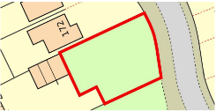
Description - Guide Price = £1,000+
**For Sale By Public Auction 17th October 2025 10:00 AM**
A Plot of Land Measuring Approximately 0.09 Acres / 376 sq m / 4,050 sq ft
Tenure – Freehold
Location - The land is situated on a residential road close to local shops and amenities. The open spaces of Little Stoke Park are within easy reach. Transport links are provided by Patchway rail station.
Description - The lot comprises a plot of land measuring approximately 0.09 Acres / 376 sq m / 4,050 sq ft.
Note - The site area depicted within the plan in the auction particulars is for indicative purposes only. Additionally, any measurements stated may not be exact. Some or all of the plot may comprise adopted highway land and if the site has trees, there may be Tree Preservation Orders in place. Buyers should rely on their own enquiries with regard to precise measurements, any consents or rights over the land and any possible development potential or alternative uses for this site.
Open Site
Addendum
Please note that this property is subject to a Buyers Premium of £900 inc VAT. This is in addition to the buyer's admin fee of £1,500 inc VAT charged by the auctioneers. Both fees are payable to the auctioneers.

Local residents in attendance were invited to address the meeting and expressed concerns regarding the potential loss of a well-used recreational grassed area, which has served the community for approximately 26 years. The area, including its grass, trees, and shrubs, has been maintained by South Gloucestershire Council (SGC) for many years, and two new trees were recently planted there by SGC.

South Gloucestershire Ward Councillors John Bradbury and Terri Cullen provided updates on their communications with SGC departments. It was reported that SGC had been operating under the belief that they owned the land, as it appears within their land maintenance maps. However, it now appears that formal ownership may never have been legally transferred to SGC by the original developer. The land is currently registered under a land-holding company, which has placed it up for sale by auction.

Extensive discussion followed, with councillors raising a number of pertinent points regarding the proposed land sale and possible next steps. It was acknowledged that the timescale before the scheduled auction is extremely limited, and that urgent action is required by the SGC Legal Department to lodge their concerns with the auction house and requesting that the auction is suspended while ownership issues are clarified with the company marketing the land.

Further discussion took place regarding the potential financial implications should the Town Council decide to submit a bid for the land at auction. It was noted that, should SGC choose to dispose of any public open space within the town in the future, it is hoped they would work collaboratively with the Town Council to facilitate a transfer of ownership at a nominal cost.

Following discussion, Councillor Tom Aditya proposed, seconded by Councillor Kulwinder Singh Sappal, and carried unanimously, that the Town Council send a formal letter to the SGC Legal Department, the SGC Chief Executive, and the SGC Cabinet Member for Resources, Councillor Adam Monk. The letter will set out the facts and concerns raised by both the Town Council and local residents and request that SGC urgently contact the auctioneers selling the piece of land to seek a delay or suspension of the auction while the ownership issues are clarified. Councillor John Bradbury will follow up with Councillor Adam Monk and Councillor Terri Cullen will speak to SGC Tree Team regarding a potential Tree Preservation Order for the site. Possible registration as a town/village green and public rights of way could also be investigated.
Discussion took place on whether BSTC should bid for the piece of land at auction to preserve it as public open space.

Following much discussion, Councillor Ben Randles proposed that, if it transpires that the piece of land is not owned by South Gloucestershire Council, the Town Council should bid for it at the auction, seconded by Councillor Jon Williams. A vote was taken, 5 in favour, 3 against, 4 abstentions, proposal carried.

Councillors commented that further discussions on the Town Council bidding for the piece of land if the auction does go ahead, should take place within a closed session at the end of this meeting due to the commercially sensitive information involved.

The Chair thanked the residents for attending the meeting and suggested that the Town Clerk and Councillor Terri Cullen are the liaison points for the local residents.

It was proposed by Councillor Dayley Lawrence, seconded by Councillor Kulwinder Singh Sappal, carried unanimously, that, in line with Standing Orders 67 and 68, in view of the confidential nature (commercial sensitivity) of the business about to be transacted, it is advisable in the public interest that the press and public be temporarily excluded, and they are instructed to withdraw.

10 To deal with Miscellaneous Matters
10.1 Sale of piece of land on Dewfalls Drive

It was noted that BSTC does not have a specific budget allocated within the Forward Plan for this purpose; however, the required funding could be drawn from reserves.

Discussion then took place regarding the maximum budget to be allocated for bidding at the auction. It was noted that the total budget would need to include the Buyer’s Premium of £900 and the administration fee of £1,500, both payable to the auctioneers.

Three separate votes were subsequently held, beginning with the highest proposed figure (1), which was not carried. A second vote on a lower figure (2) also failed, and a third vote on a further reduced figure (3) was successful.

To ensure that the final agreed figure does not influence the outcome of the auction in any way, the recorded votes are listed below as 1, 2 and 3. The actual figures will be reported at the next Full Council meeting on 19th November 2025, following the conclusion of the auction.

Maximum budget (1) proposed by Councillor Dayley Lawrence, seconded by Councillor Kulwinder Singh Sappal. A vote was taken, 5 in favour, 6 against, 1 abstention, proposal failed.

Maximum budget (2) proposed by Councillor James Nelson, seconded by Councillor Jon Williams. A vote was taken, 5 in favour, 6 against, 1 abstention, proposal failed.

Maximum budget (3) proposed by Councillor James Nelson, seconded by Councillor John Bradbury. A vote was taken, 6 in favour, 5 against, 1 abstention, proposal carried.

Following further discussion, Councillor Tom Aditya proposed that the Town Clerk and Deputy Town Clerk be delegated to bid at auction on behalf of Bradley Stoke Town Council, seconded by Councillor Kulwinder Singh Sappal, carried unanimously.

The Town Council was successful in bidding for the piece of land at auction and the costs of land purchase incurred to date are:
Purchase of land at auction £17,000
Auction Fees £2,400
Solicitors Fees £1,000

In addition, the appointed solicitors have advised the following:
- A review of the Searches provided within the Auction Pack - £300
- A review of the Title documentation - £750
If both the Title and Searches are reviewed, it would be £1,000 + VAT

Following discussion, Councillor Jon Williams proposed that the Town Council pay an additional £1,000 to the appointed solicitors as per their recommendations detailed above, seconded by Councillor Kulwinder Singh Sappal, carried unanimously.
7.2 Consideration of purchase of additional piece of land in Dewfalls Drive (adjacent to the land the Town Council purchased) which has been put up for auction on Thursday 13th November 2025

A piece of land adjacent to the piece of land which the Town Council purchased on 22nd October 2025 has now been put up for auction on Thursday 13th November 2025 (see photo below):

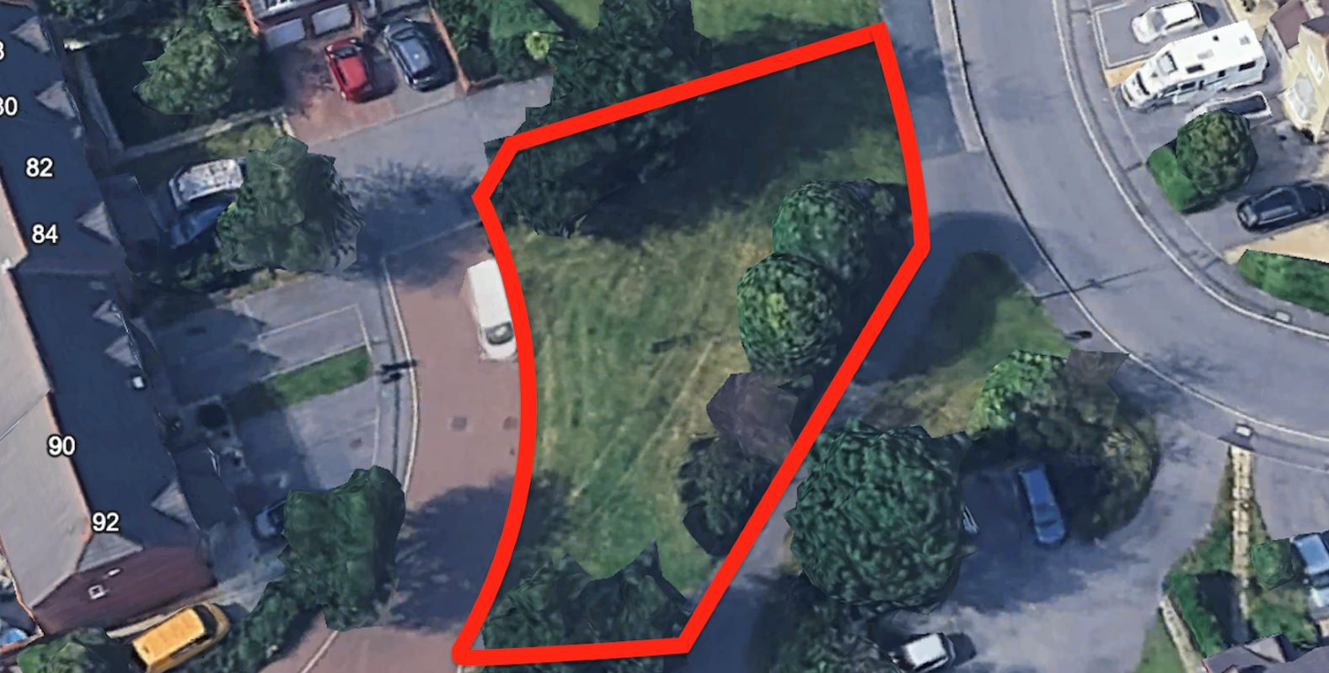

It has been suggested that the Town Council bid on behalf of a specific group of residents and use their money towards the purchase cost. Officer advice is that this is not appropriate as the ramifications /precedent that this could set is completely unforeseeable plus the auditors are likely to query this as this would need to be done in a specific legal manner, which would likely involve the local residents setting up a community group etc (see Google AI result below):

Residents can contribute funds to a town council to help it buy land on their behalf, though the formal purchase is made by the council itself for the benefit of the community.

Here's how the process generally works in the UK:
- Council's Power to Acquire Land: Town (and parish) councils have the power under Section 124 of the Local Government Act 1972 to acquire land by agreement for the benefit, improvement, or development of their area.
- Resident Contributions: Residents can fundraise or form a community group to raise money for a specific land purchase. These funds can then be given to the council or used by the community group itself.
- Community Rights: Residents and community organisations have specific legal rights, such as the Community Right to Bid (in England), which allows them to nominate land or buildings as Assets of Community Value. If a listed asset comes up for sale, the community has a six-month window to raise the funds and bid to buy it, often through a council or a community organisation.
- Council Decision: The town council's decision to acquire land, even with resident contributions, is a formal process. The council will need to:
  - Assess the proposal and ensure the acquisition is for the benefit of the community.
  - Approve the necessary budget or accept the gifted funds. All acquisitions must have the necessary budgetary approval.
  - Follow proper governance and legal procedures for land acquisition.

In essence, residents cannot directly "pay a town council to buy land on their behalf" in a simple transaction, but they can work with the council, often via a community group, to facilitate such a purchase for a public purpose.

Due to the very tight timescale, this would certainly not be possible for the residents to achieve this within the next day or two.

However, as councillors will be aware, under Section 124 (1) of Local Government Act 1972, we can purchase land for the benefit of the local community (see references below), this is how we purchased the original piece of land. Therefore, officer advice is that this is the process that we would need to follow for this new piece of land, if it is a council decision that we bid for the piece of land at auction:

124 Acquisition of land by agreement by parish and community councils.
(1) For the purposes of—
(a) any of their functions under this or any other public general Act, or
(b) the benefit, improvement or development of their area,
a parish or community council may acquire by agreement any land, whether situated inside or outside their area.
https://www.legislation.gov.uk/ukpga/1972/70/part/VII/crossheading/land-transactionsparish-and-community-councils#:~:text=75-,Land%20transactions%E2%80%94parish%20and%20community%20councils,1)(b)%20above%2C%20or

Land ownership
The Local Government Act 1972, particularly sections 124, 126, and 137, outlines the powers and responsibilities of parish and town councils regarding land ownership.

Section 124 of the Local Government Act 1972 grants parish and town councils the power to acquire land by purchase, gift, or lease. They may acquire land for various purposes, including public amenities, recreational spaces, or community facilities. This provision enables parish and town councils to take ownership of land to meet the needs and priorities of their local communities.

Section 126 of the Local Government Act 1972 allows parish and town councils to dispose of land no longer required for their purposes. They may sell, lease, or otherwise dispose of land they own, subject to certain conditions and procedures outlined in the Act. This provision enables parish and town councils to manage their land holdings efficiently and ensure that assets are used effectively to benefit the local community.

Section 137 of the Local Government Act 1972 provides parish and town councils the power to incur expenditure for various purposes considered in the interest or for the benefit of their area or its inhabitants. This includes acquiring, maintaining, or improving land owned by the parish or town council. However, any expenditure under Section 137 must be reasonable and in line with the council's overall budget and financial responsibilities.

Land ownership

Councillor Terri Cullen informed the meeting that SGC have now applied a Tree Preservation Order on the trees on this piece of land and she has informed Auction House London accordingly.

The residents commented that they are very appreciative of the actions that the Town Council have taken so far. They have managed to obtain money pledges towards the cost of the land and are investigating setting up a Company Benefit Society (Bencom) but due to the tight timescale, this is not quick to achieve.

It was noted that, once again, BSTC does not have a specific budget allocated within the Forward Plan for this purpose; however, the required funding could be drawn from reserves and paid back with year-end surplus.

Much discussion then took place with councillors and the local residents present at the meeting. Points covered during discussions included:

What happens to the land if someone purchases it but is then unsuccessful in gaining planning permission – will the land just get left – SGC can serve notice on landowners to keep the land tidy and, if ignored they will carry out the work themselves and send the bill to the landowner.

What are SGC doing to identify similar pieces of land within the area which might be coming up for sale – SGC are apparently hoping to instigate discussions with the various developers to purchase the areas of land prior to auction

How much have residents already paid for maintenance work on the land over the years when SGC thought that they owned it – residents have also asked SGC the question as to why SGC have maintained land that they do not own

Also discussed:
- Tree Preservation Orders within the town
- Who owned the land previously
- Planning process for applications
- Registration as a village/town green
- SGC exploring restricted covenants on pieces of land

BSTC Finance committee agreed to write to SGC re. land ownership issues and whether they have identified other pieces of land in a similar position. It is also intending to draft a policy regarding land purchases going forward.

Following discussion, Councillor Jon Williams proposed that, due to financial constraints, the Town Council does not purchase this piece of land at auction, seconded by Councillor Natalie Field. A vote was taken, 5 in favour, 6 against, proposal failed.

Councillor James Nelson then proposed that the Town Council bids for this plot of land at the forthcoming auction and suspends Financial Regulations 6.17 + 6.19 + 11.3 + 11.4 to enable adequate funds to be added to a Town Council debit card to allow the Town Council to register as a bidder at the auction, seconded by Councillor Anthony Griffiths. A vote was taken, 6 in favour, 5 against, proposal carried.

The Chair thanked the residents for attending the meeting.

It was proposed by Councillor Dayley Lawrence, seconded by Councillor Kulwinder Singh Sappal, carried unanimously, that, in line with Standing Orders 67 and 68, in view of the confidential nature (commercial sensitivity) of the business about to be transacted, it is advisable in the public interest that the press and public be temporarily excluded, and they are instructed to withdraw.

Discussion then took place regarding the maximum budget to be allocated for bidding at the auction. It was noted that once again, the total budget would need to include the Buyer’s Premium of £900 and the administration fee of £1,500, both payable to the auctioneers.
To ensure that the final agreed figure does not influence the outcome of the auction in any way, the recorded votes are listed below as 1, 2 and 3. The actual figures will be reported at the next Full Council meeting on 19th November 2025, following the conclusion of the second auction.

Maximum budget (1) proposed by Councillor Dayley Lawrence, seconded by Councillor James Nelson. A vote was taken, 3 in favour, 7 against, 1 abstention, proposal failed.

Maximum budget (2) proposed by Councillor Jon Williams, seconded by Councillor Dayley Lawrence. A vote was taken, 5 in favour, 6 against, proposal failed.

Maximum budget (3) proposed by Councillor Kulwinder Singh Sappal, seconded by Councillor Dayley Lawrence. A vote was taken, 5 in favour, 5 against, 1 abstention. As the vote was tied, the Chair used their casting vote in favour of the maximum budget (3), proposal therefore carried.

A further figure was suggested by Councillor Anthony Griffiths, but the Chair deemed that the matter had been concluded.

8 To note the dates of forthcoming meetings

8.1 19 November Full Council
8.2 24 November Staffing Committee
8.3 26 November Finance Committee
8.4 26 November Planning & Environment Committee
8.5 15 December Leisure, Youth & Amenities Committee

The Meeting closed at 8.15pm

