BRADLEY STOKE TOWN COUNCIL

Full Council

Minutes of the Full Council meeting of Bradley Stoke Town Council held at the Jubilee Centre, Savages Wood Road, Bradley Stoke on 8th October 2025 at 7.00pm.

PRESENT: Councillors: Dave Addison
Tom Aditya
Sue Bandcroft
John Bradbury
Terri Cullen
Natalie Field (Chair)
Jenny James
Dayley Lawrence
James Nelson
Ben Randles
Kulwinder Singh Sappal
Jon Williams

Officers: Sharon Petela - Town Clerk
Rachel Pullen – RFO/Finance Manager

Others: Councillor Franklin Owusu-Antwi (South Gloucestershire Council (SGC) Bradley Stoke North ward councillor)

1 Submissions from the Public and Councillors

  - Councillor Tom Aditya commented that improved bus services need to be initiated giving direct access to the Bristol Royal Infirmary, Southmead Hospital and Portishead.

  - Councillor Tom Aditya commented that there was a good taster session on the Jubilee Green leisure equipment today and it would be good to see similar taster sessions for young children at the skatepark.

2 Apologies for absence

Apologies were received from Councillors Roger Avenin and Frederic Contenot and Phil Francis-Barber - Deputy Town Clerk/Activity Centres Manager (DTC/ACM)

3 Applications for Dispensations by Councillors

None

4 Declarations of Interest

None

5 Announcements by the Chair

The Chair informed the meeting of two pieces of good news – firstly, Phil Francis-Barber - DTC/ACM has recently completed his Certificate in Local Council Administration qualification and secondly the member of the finance team, Nikki Rich has now had her baby.

The Chair echoed Councillor Tom Aditya’s comments that the taster session on the Jubilee Green leisure equipment was very positive and more tailored sessions will be arranged.
The Chair informed the meeting that the first planning meeting for the 2026 Community Festival has recently taken place.

The Chair commented that the Metro Mayor will be attending the South Gloucestershire Town & Parish Council Forum in Bradley Stoke tomorrow.

6 Minutes of Previous Meeting

Minutes of meeting held on 17th September 2025 were proposed for acceptance by Councillor Kulwinder Singh Sappal and seconded by Councillor Jenny James. A vote was taken, 7 in favour, 5 abstentions, proposal carried.

The minutes were then signed by the Chair as a correct record.

As there were local residents present at the meeting plus the RFO/Finance Manager needing to leave the meeting early, Councillor Kulwinder Singh Sappal proposed moving agenda items 10.1 and 9 forward in the meeting, seconded by Councillor Dayley Lawrence, carried unanimously.

10 To deal with Miscellaneous Matters

10.1 Sale of piece of land on Dewfalls Drive

A piece of land in Dewfalls Drive has recently been put up for auction

Auction Information

Description
Guide Price = £1,000+
**For Sale By Public Auction 17th October 2025 10:00 AM**
A Plot of Land Measuring Approximately 0.09 Acres / 376 sq m / 4,050 sq ft
Tenure
Freehold
Location
The land is situated on a residential road close to local shops and amenities. The open spaces of Little Stoke Park are within easy reach. Transport links are provided by Patchway rail station.
Description
The lot comprises a plot of land measuring approximately 0.09 Acres / 376 sq m / 4,050 sq ft.
Note
The site area depicted within the plan in the auction particulars is for indicative purposes only. Additionally, any measurements stated may not be exact. Some or all of the plot may comprise adopted highway land and if the site has trees, there may be Tree Preservation Orders in place. Buyers should rely on their own enquiries with regard to precise measurements, any consents or rights over the land and any possible development potential or alternative uses for this site.
Open Site
Addendum
Please note that this property is subject to a Buyers Premium of £900 inc VAT. This is in addition to the buyer's admin fee of £1,500 inc VAT charged by the auctioneers. Both fees are payable to the auctioneers.
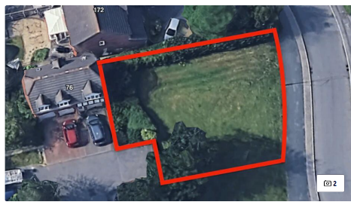
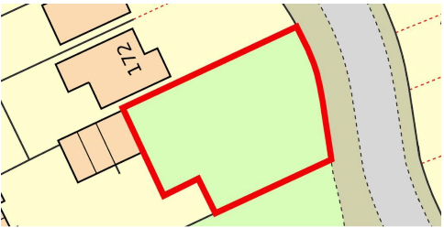

Local residents in attendance were invited to address the meeting and expressed concerns regarding the potential loss of a well-used recreational grassed area, which has served the community for approximately 26 years. The area, including its grass, trees, and shrubs, has been maintained by South Gloucestershire Council (SGC) for many years, and two new trees were recently planted there by SGC.

South Gloucestershire Ward Councillors John Bradbury and Terri Cullen provided updates on their communications with SGC departments. It was reported that SGC had been operating under the belief that they owned the land, as it appears within their land maintenance maps. However, it now appears that formal ownership may never have been legally transferred to SGC by the original developer. The land is currently registered under a land-holding company, which has placed it up for sale by auction.

Extensive discussion followed, with councillors raising a number of pertinent points regarding the proposed land sale and possible next steps. It was acknowledged that the timescale before the scheduled auction is extremely limited, and that urgent action is required by the SGC Legal Department to lodge their concerns with the auction house and requesting that the auction is suspended while ownership issues are clarified with the company marketing the land.

Further discussion took place regarding the potential financial implications should the Town Council decide to submit a bid for the land at auction. It was noted that, should SGC choose to dispose of any public open space within the town in the future, it is hoped they would work collaboratively with the Town Council to facilitate a transfer of ownership at a nominal cost.
Following discussion, Councillor Tom Aditya proposed, seconded by Councillor Kulwinder Singh Sappal, and carried unanimously, that the Town Council send a formal letter to the SGC Legal Department, the SGC Chief Executive, and the SGC Cabinet Member for Resources, Councillor Adam Monk. The letter will set out the facts and concerns raised by both the Town Council and local residents and request that SGC urgently contact the auctioneers selling the piece of land to seek a delay or suspension of the auction while the ownership issues are clarified. Councillor John Bradbury will follow up with Councillor Adam Monk and Councillor Terri Cullen will speak to SGC Tree Team regarding a potential Tree Preservation Order for the site. Possible registration as a town/village green and public rights of way could also be investigated.

Discussion took place on whether BSTC should bid for the piece of land at auction to preserve it as public open space.

Following much discussion, Councillor Ben Randles proposed that, if it transpires that the piece of land is not owned by South Gloucestershire Council, the Town Council should bid for it at the auction, seconded by Councillor Jon Williams. A vote was taken, 5 in favour, 3 against, 4 abstentions, proposal carried.

Councillors commented that further discussions on the Town Council bidding for the piece of land if the auction does go ahead, should take place within a closed session at the end of this meeting due to the commercially sensitive information involved.

The Chair thanked the residents for attending the meeting and suggested that the Town Clerk and Councillor Terri Cullen are the liaison points for the local residents.

9 Financial Matters

9.1 Receive 2024/25 Audit Sign Off & Approve Wording for Website

Rachel Pullen, RFO/Finance Manager presented the following report

BDO LLP, our external auditor, signed off the 2024/25 audit on 15th September 2025 and the formal sign off was added to our website and noticeboard on the 18th September 2025 in order to comply with the regulatory deadline being before the 30th September.

The 2024/25 external audit was signed off with no matters of concern raised or comments for further consideration that did not affect the external auditor’s opinion, as detailed within Section 3 of the Annual Governance and Accountability Return (AGAR) which has been circulated.

No other matters were raised for consideration.

Optional Council's Response to the 2024/25 Audit
In addition, Council has historically added a comment to the website following each audit sign off and may wish to consider the following statement:

Council is pleased to announce the formal sign-off of the 2024/25 audit by BDO LLP, the appointed external auditors, who have once again given council a clean bill of health for the sixteenth year running, with no procedural or accounting issues raised.

Council continues to be as transparent as possible and to implement robust financial systems and procedures to protect the public funds, ensure value for money, protect and even expand services where possible for the community. Careful budgeting, monitoring and in-depth forward planning is a major part of council’s responsibilities, and this audit continues to substantiate that council has maintained the highest governance standards.

Following discussion, Councillor Kulwinder Singh Sappal proposed acceptance of the website wording as detailed above, seconded by Councillor Sue Bandcroft, carried unanimously.

BSTC officers and staff were congratulated for their hard work involved in achieving yet another clear audit.

9.2 Appoint Named Appeals Officer for Pension Discretion Dispute Processes

Rachel Pullen, RFO/Finance Manager presented the following report

Background to Pension Discretions
Employers under the Local Government Pension Scheme must create, publish, and review policies regarding how they exercise certain mandatory employer discretions for current and past employees and have a discretions policy in place for the 3 relevant sections as below:

Table 1 - 01/04/1998 to 31/03/2008,
Table 2 - 01/04/2008 to 31/03/2014,
Table 3 - after 31/03/2014.

Bradley Stoke Town Council has a policy in place in line with guidance from the Avon Pension Fund which covers all 3 periods and is reviewed annually with last review by the Finance Committee in September 2025. The policy is published on the Council website and is also lodged with the Avon Pension Fund.

Internal Dispute Resolution Process (IDRP)
The Internal Dispute Resolution Procedure (IDRP) was established by the Local Government Pension Scheme, to outline a formal process for disagreements linked to decisions made using employer discretions.

The IDRP is designed to resolve disputes regarding LGPS pension decisions where a member disagrees with a decision an employer has made. To make a formal complaint, pension fund members should submit it in writing, to the employer, usually within six months of being informed about the decision they wish to contest. If the complaint is about a missing decision, it should be made within six months of when that decision should have been made.

The IDRP process consists of two stages:

Stage 1: Your appointed IDRP Stage 1 Appeals Officer (the adjudicator) reviews the case.
The adjudicator can extend the six-month time limit if necessary. If the adjudicator’s decision differs from the original decision, the employer or administering authority must follow the adjudicator’s ruling.

Stage 2: Avon Pension Fund conducts a further review.
If a member is not satisfied with the adjudicator’s decision, they can ask the administering authority (Avon Pension Fund) to review the complaint.

Full Procedures for Complaints Including IDRP

A - Handling disagreements informally
- If a member is dissatisfied with a decision, it is recommend addressing the issue informally first. A meeting with the decision-making body can clarify the reasons behind the decision.
- To ensure fairness and transparency, it’s crucial to demonstrate that decisions are consistent with established policies. When members see that decisions follow clear guidelines, they are less likely to feel personally targeted. Keeping thorough records of decisions is essential.

B - Internal Dispute Resolution Process (IDRP)

Stage 1: IDPR Appeals Officer to review the decision and provide a ruling.
- If informal attempts to resolve the issue fail, members have the right to initiate the formal IDRP. This process involves a detailed investigation into the decisions made and the methods used and is handled by the IDRP Appeals Officer.
- The IDRP Appeals Officer will need to provide evidence of how and why initial decisions were made during the appeals process. Therefore, maintaining detailed records of all decisions is vital.

Stage 2: Avon Pension Fund conducts a further review.
If a member is not satisfied with the adjudicator’s decision, they can ask the administering authority (Avon Pension Fund) to review the complaint again if:
- They are unhappy with the first-stage decision.
- They haven’t received a decision or interim letter within three months of lodging their complaint.
- It has been one month since the adjudicator promised a decision, but none has been received.

This review will be conducted by the Avon Pension Fund by someone who was not involved in the first stage. Again, the complaint must be submitted in writing, and after review, the Avon Pension Fund will respond in writing with their decision.

C -The Pensions Ombudsman
- If the member is still dissatisfied after stage 2, they can take their case to the Pensions Ombudsman within three years of the original decision (or lack of decision).
- The Pensions Ombudsman can investigate complaints about maladministration or disputes regarding pension decisions. However, members must first go through both stages of the IDRP before the Ombudsman will take action. The Ombudsman can also provide informal assistance during the IDRP process.

Appoint an IDRP Appeals Officer
The Avon Pension Fund has recently contacted Town & Parish Councils requesting the name of the nominated person to carry out this role. They have confirmed this must be a specific named person and not a named position and it cannot be a Council employee for obvious reasons. In addition, it cannot be a member of the Staffing Committee as the committee will make the decision concerning the discretion in the first place.

Recommendation
Based upon this, it makes sense for the Chair of Council to be the named as IDRP Officer and this can be reviewed annually in May at the Annual Town Council Meeting.

Following discussion, Councillor Dave Addison proposed that the Chair of Council, Councillor Natalie Field be appointed as the current IDRP officer and this position is appointed to the new Chair of Council at the Annual Town Council meeting each year (as per the officer recommendation as detailed above), seconded by Councillor Dayley Lawrence, carried unanimously.

9.3 Timetable for 2026/27 Budget setting

Rachel Pullen, RFO/Finance Manager presented the following report

OCTOBER Full Council Meeting – 8/10/25

- To provide/consider any additional items to be included within the budget in addition to information already provided from The Business Plan and Strategic Planning meeting.

The RFO will then calculate an initial 1st budget draft, incorporating any information already agreed and any additional items provided by October Finance to be presented to November Council.

The RFO will work with The Chair of Council and Finance who will both receive the future draft budgets in advance of the meeting for initial agreement and further direction as necessary.
…………………………………………………………………………………………
NOVEMBER Full Council Meeting – 19/11/25

The 1st budget draft will be included within the agenda paperwork and Councillors are advised to study this draft in advance of the meeting. Please refer to the nominal code (stated on the left-hand side of the report) as a reference when discussing a particular budget

- RFO will issue a 1st budget draft for consideration with any new exceptional items highlighted for discussion.
- Council will consider the 1st draft and precept level and direct any amendments in readiness for the 2nd draft

The RFO will calculate the 2nd budget draft incorporating any information provided by November Council to be presented to December Finance and will again work with the Chairs of Council and Finance ahead of the next meeting.
…………………………………………………………………………………………
DECEMBER Finance Committee Meeting – 17/12/25

The 2nd budget draft will be included within the agenda paperwork and Councillors are advised to study this draft in advance of the meeting. Please refer to the nominal code (stated on the left hand side of the report) as a reference when discussing a particular budget

1. RFO will issue a 2nd budget draft for consideration with any new exceptional items highlighted.
2. Council will consider the 2nd draft and precept level and direct any amendments in readiness for the final draft in January.
December Finance will be the final chance to make any major amendments and it is hoped that South Gloucestershire Council will have issued tax base figures etc at this point although these may not be available until mid-January 2026.
……………………………………………………………………………………
JANUARY Full Council Meeting– 21/01/26

The final budget draft will be included within the agenda paperwork and Councillors are advised to study this draft in advance of the meeting. Please refer to the nominal code (stated on the left hand side of the report) as a reference when discussing a particular budget

1. RFO will issue the final budget for adoption as approved figures need to be lodged in early February. This will be the last meeting to make any changes.

The finalised precept figures will be sent to South Gloucestershire Council in early February.

Following discussion, Councillor Kulwinder Singh Sappal proposed acceptance of the 2026/27 Budget Setting timetable as detailed above, seconded by Councillor Dayley Lawrence, carried unanimously.

9.4 To approve Bills for Payment

BRADLEY STOKE TOWN COUNCIL
MONTHLY EXPENDITURE - 8th October 2025 - Council
SALARIES |  |  |  |  |  |  | Net Amount
23/09/2025 | September Net Salaries Via Barclays.Net |  |  |  |  |  | 30,304.79
Suppliers
 | A1 Maintenance Ltd
Date | Ref | Details | Net Amount | Tax Amount |  | Gross Amount
01/10/2025 | 1698 | JC - Building Maintenance - Oct 25 | 403.58 | 80.72 |  | 484.30
01/10/2025 | 1698 | Office - Building Maintenance - Oct 25 | 82.66 | 16.53 |  | 99.19
01/10/2025 | 1698 | BC - Building Maintenance - Oct 25 | 724.92 | 144.98 |  | 869.90
01/10/2025 | 1698 | BW - Building Maintenance - Oct 25 | 393.42 | 78.68 |  | 472.10
01/10/2025 | 1698 | JC - Building Maintenance - Oct 25 | 340.33 | 68.07 |  | 408.40
01/10/2025 | 1698 | Skate Park - Building Maintenance - Oct 25 | 84.00 | 16.80 |  | 100.80
 |  | Account Totals: | 2028.91 | 405.78 |  | 2434.69
 | AMBIENCE LANDSCAPES LTD
Date | Ref | Details | Net Amount | Tax Amount |  | Gross Amount
30/09/2025 | 23942 | Street Maintenance - Sept 25 | 1272.87 | 254.57 |  | 1527.44
 |  | Account Totals: | 1272.87 | 254.57 |  | 1527.44
 | AVON SPORTSGROUND MAINTENANCE CO
Date | Ref | Details | Net Amount | Tax Amount |  | Gross Amount
30/09/2025 | SI-823340 | BC - Bowls Maintenance - Sep 25 | 496.83 | 99.37 |  | 596.20
 |  | Account Totals: | 496.83 | 99.37 |  | 596.20
 | BATH & NORTH EAST SOMERSET COUNCIL
Date | Ref | Details | Net Amount | Tax Amount |  | Gross Amount
17/09/2025 | Sept Salary | Sept 25 - Pension | 8699.72 | 0.00 |  | 8699.72
 |  | Account Totals: | 8699.72 | 0.00 |  | 8699.72
 | BDO LLP
Date | Ref | Details | Net Amount | Tax Amount |  | Gross Amount
16/09/2025 | INV-00734245 | 24/25/ External Audit Fee | 2100.00 | 420.00 |  | 2520.00
 |  | Account Totals: | 2100.00 | 420.00 |  | 2520.00
 | Water2Business
Date | Ref | Details | Net Amount | Tax Amount |  | Gross Amount
24/09/2025 | 11680097 | BW - Water 13/3/25 - 23/9/25 | 286.38 | 0.00 |  | 286.38
16/09/2025 | 13227560 | JC - Water 15/3 - 15/9/25 | 1313.84 | 0.00 |  | 1313.84
16/09/2025 | 11612883 | JC CR - Water 15/3 - 15/9/25 | 251.46 | 0.00 |  | 251.46
 |  | Account Totals: | 1851.68 | 0.00 |  | 1851.68
 | MR J BUDD
Date | Ref | Details | Net Amount | Tax Amount |  | Gross Amount
18/09/2025 | Sept 25 | BW - Window Clean 15/9/25 | 50.00 | 0.00 |  | 50.00
18/09/2025 | Sept 25 | BC - Window Clean 15/9/25 | 60.00 | 0.00 |  | 60.00
18/09/2025 | Sept 25 | Office - External Window Clean 15/9/25 | 20.00 | 0.00 |  | 20.00
18/09/2025 | Sept 25 | JC - Window Clean 15/9/25 | 65.00 | 0.00 |  | 65.00
18/09/2025 | Sept 25 | Office - Internal Window Clean 15/9/25 | 20.00 | 0.00 |  | 20.00
 |  | Account Totals: | 215.00 | 0.00 |  | 215.00
 | Bradley Stoke Cricket Club
Date | Ref | Details | Net Amount | Tax Amount |  | Gross Amount
25/09/2025 | BC2025-09 | BC- Cricket Wicket Maintenance - Sept 25 | 745.83 | 0.00 |  | 745.83
 |  | Account Totals: | 745.83 | 0.00 |  | 745.83
 | GB Sport & Leisure
Date | Ref | Details | Net Amount | Tax Amount |  | Gross Amount
09/04/2025 | 17342 | Play Areas - Wet Pour Supplies for Repairs | 198.77 | 39.75 |  | 238.52
05/06/2025 | 17709 | Rosemary Close Play Area - Angled Air Closure | 249.15 | 49.83 |  | 298.98
 |  | Account Totals: | 447.92 | 89.58 |  | 537.50
 | HMRC Cumbernauld
Date | Ref | Details | Net Amount | Tax Amount |  | Gross Amount
17/09/2025 | Sept Salary | Sept 25 - Tax/NI | 10318.29 | 0.00 |  | 10318.29
 |  | Account Totals: | 10318.29 | 0.00 |  | 10318.29
 | KN Office Supplies Ltd
Date | Ref | Details | Net Amount | Tax Amount |  | Gross Amount
26/09/2025 | 43357 | Staff Uniforms | 240.92 | 48.18 |  | 289.10
 |  | Account Totals: | 240.92 | 48.18 |  | 289.10
 | Magic Cleaning Solutions Ltd
Date | Ref | Details | Net Amount | Tax Amount |  | Gross Amount
24/09/2025 | I24903 | BC - Toilet Rolls & Refuse Sacks | 77.46 | 15.49 |  | 92.95
 |  | Account Totals: | 77.46 | 15.49 |  | 92.95
 | ONE OFF SUPPLIERS - BY INTERNET PAYMENT
Date | Ref | Details | Net Amount | Tax Amount |  | Gross Amount
19/09/2025 | AHM26213 | AHM Catering - Catering for Tea Party 19/9/25 | 656.20 | 131.24 |  | 787.44
19/09/2025 | 19 09 2025 | Bristol Vintage - Crockery for Tea Part 19/9/25 | 340.00 | 0.00 |  | 340.00
24/09/2025 | 25/26 | G Roach - Filton TC Allotment Funding | 40.00 | 0.00 |  | 40.00
26/09/2025 | 25/26 | J Reeman - Pretoria Rd Allotment Funding | 20.00 | 0.00 |  | 20.00
28/09/2025 | 25/26 | M Fletcher - Glebe Rd Allotment Funding | 40.00 | 0.00 |  | 40.00
29/09/2025 | 25/26 | A Traczuk - Blakeney Rd Allotment Funding | 40.00 | 0.00 |  | 40.00
15/09/2025 | Refund Hire Charge | Namaha Dance - BC - Refund Cancelled Hire | 21.79 | 4.36 |  | 26.15
11/09/2025 | Refund Hire Charge | Fusion Fostering - BC - Refund Cancelled Hire | 125.46 | 25.09 |  | 150.55
13/09/2025 | 25/26 | C Martin - Patchway Allotments - 1/2 Plot | 20.00 | 0.00 |  | 20.00
 | RelyOn Guarding & Security Services Ltd
Date | Ref | Details | Net Amount | Tax Amount |  | Gross Amount
23/09/2025 | 651357 | Office - Alarm Call Out 20/9/25 | 42.50 | 8.50 |  | 51.00
 |  | Account Totals: | 42.50 | 8.50 |  | 51.00
 | Shield Fire & Security Ltd
Date | Ref | Details | Net Amount | Tax Amount |  | Gross Amount
29/09/2025 | 11487 | BC - Alarm Call out | 55.00 | 11.00 |  | 66.00
30/09/2025 | 11513 | JC CR - Repair CCTV camera | 159.50 | 31.90 |  | 191.40
05/09/2025 | 11365 | BC - Rest Intruder Alarm re Power Cut | 55.00 | 11.00 |  | 66.00
05/09/2025 | 11366 | BC - Repair Entrance Shutter | 55.00 | 11.00 |  | 66.00
12/09/2025 | 11411 | BW - Replace Broken Call Point Glass | 110.00 | 22.00 |  | 132.00
23/09/2025 | 11438 | Skate Park - Engineer Visit to Provide Re-Set Codes | 49.50 | 9.90 |  | 59.40
23/09/2025 | 11439 | BC - Engineer Visit to Provide Re-Set Codes | 49.50 | 9.90 |  | 59.40
23/09/2025 | 11440 | BW - Engineer Visit to Provide Re-Set Codes | 49.50 | 9.90 |  | 59.40
23/09/2025 | 11441 | JC - Engineer Visit to Provide Re-Set Codes | 49.50 | 9.90 |  | 59.40
23/09/2025 | 11442 | Office - Engineer Visit to Provide Re-Set Codes | 49.50 | 9.90 |  | 59.40
 |  | Account Totals: | 682.00 | 136.40 |  | 818.40
 | SJP Paving
Date | Ref | Details | Net Amount | Tax Amount |  | Gross Amount
24/09/2025 | 01562 | JC - Relay/Replace Slabs | 1623.00 | 324.60 |  | 1947.60
24/09/2025 | 01563 | BC - Relay/Replace Slabs | 1372.00 | 274.40 |  | 1646.40
 |  | Account Totals: | 2995.00 | 599.00 |  | 3594.00
 | SOLTECH IT LTD
Date | Ref | Details | Net Amount | Tax Amount |  | Gross Amount
25/09/2025 | 32343 | Office - IT Contract 23/11/25 - 22/12/25 | 140.00 | 28.00 |  | 168.00
25/09/2025 | 32344 | Office - Microsoft 365 - 18 Email Licenses - Oct 25 | 217.16 | 43.43 |  | 260.59
25/09/2025 | 32345 | Office - Microsoft 365 Cloud Back Up - 25/11 - 24/12/25 | 52.50 | 10.50 |  | 63.00
 |  | Account Totals: | 409.66 | 81.93 |  | 491.59
 |  | Report Totals: | 33928.04 | 2319.49 |  | 36247.53

Councillor Dayley Lawrence proposed acceptance of the monthly expenditures as detailed above, seconded by Councillor Kulwinder Singh Sappal, carried unanimously.

7 Matters arising from the Minutes of 17th September 2025

7.1 Update on storage building at Brook Way Activity Centre

Bradley Stoke in Bloom/Green Gym are awaiting an update from the SGC Volunteer co-ordinator, so they will follow this up.

7.2 Ongoing projects

7.2.1 Redevelopment/refurbishment of Baileys Court Activity Centre

Minutes of the stakeholder consultation meetings were brought to the last full council meeting and the agreement was to have a small group of councillors and officers carry out a Must, Should, Could, Would (MSCW) exercise to look at all the stakeholder requirements with a view to grouping the requirements into a number of priorities to formulate a Responses and Priorities List. Once this is done, the council will then form a working group along with the consultants to work out the future strategy and building design.

The initial meeting for the MSCW exercise will be Thursday 23rd October 2025 at 4.15pm in the council meeting room at Jubilee Centre – councillors attending are: John Bradbury, Natalie Field, Jenny James, Ben Randles, Kulwinder Singh Sappal and Jon Williams.

Those attending will also be required to open the tender packs received for the cleaning contract tender that closes on the 17th October 2025.

7.3 Additional works required at Beacon Playscheme

Officers are working hard to obtain quotes from suppliers to put the swings into situ on their previous location, but this is proving very difficult. Meetings have been booked with alternative suppliers to see if this is feasible.

7.4 Provision of Multi-Use Games Area (MUGA) at Jubilee Centre

The project is progressing well, and the initial plans have been completed, these have been sent on to Eco360 for BNG report to be written ready for planning application.

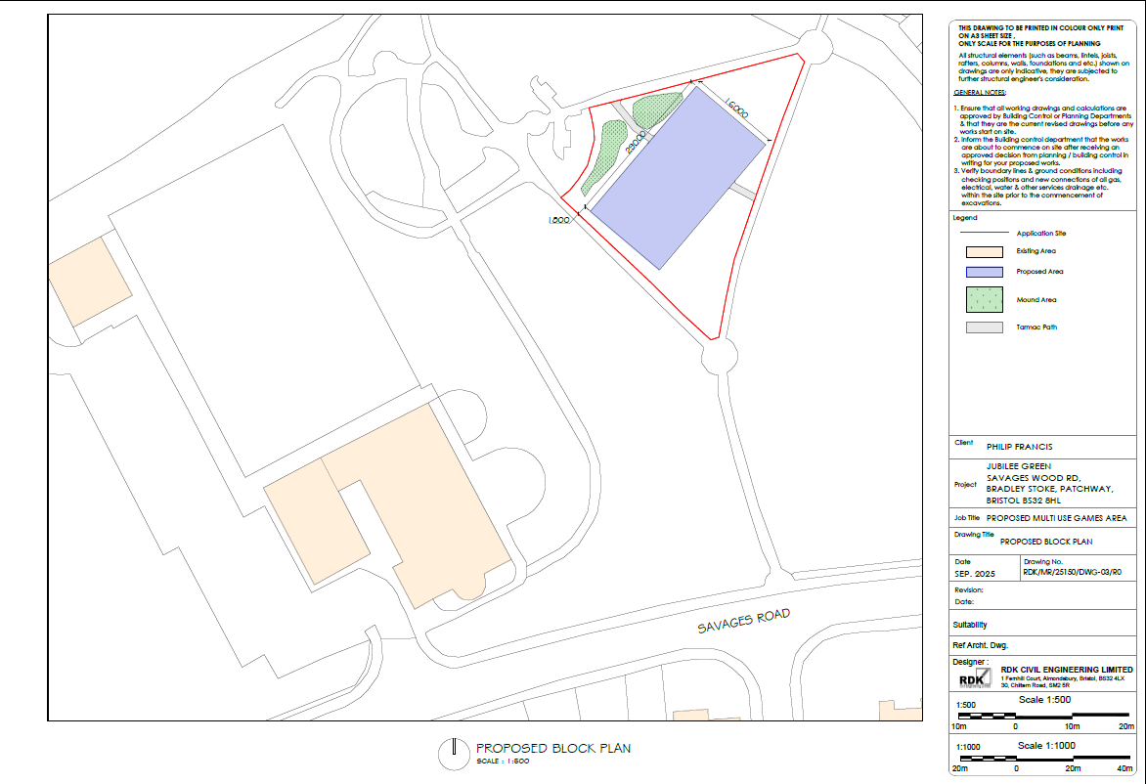

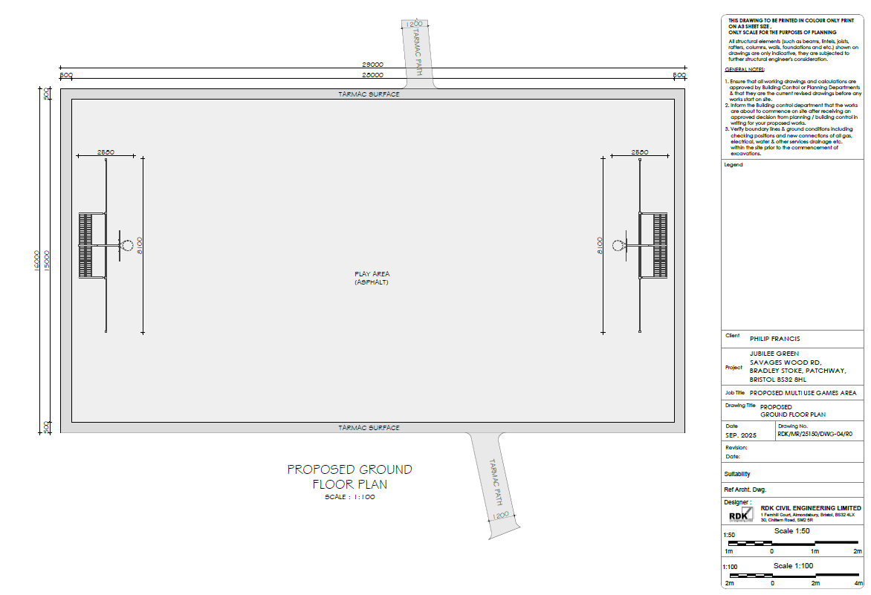

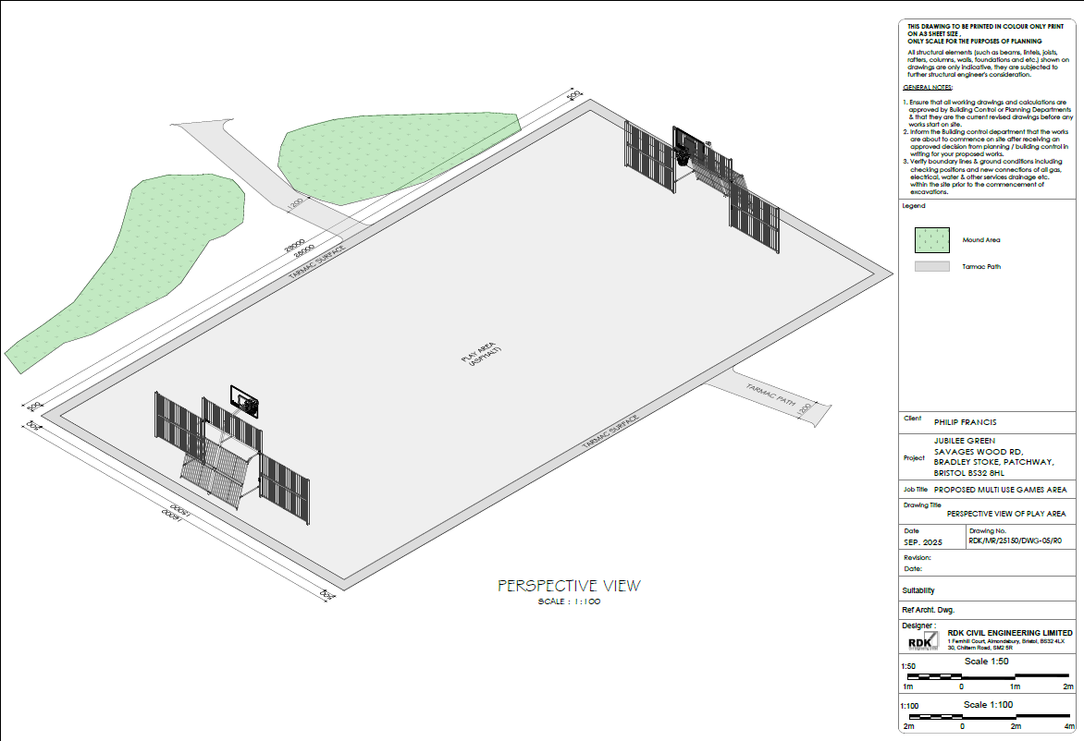

7.5 Provision of steps and handrail between top and bottom football pitches at Jubilee Centre

Councillors raised concerns regarding Health & Safety, risk assessments and potential insurance implications if this type of structural work is carried out by groups of volunteers, particularly as this is in an area with a significant slope.

Following discussion, Councillor Dayley Lawrence proposed that officers obtain quotes from external contractors to install the woodland steps and handrail between the top and bottom football pitches at Jubilee Centre, seconded by Councillor Kulwinder Singh Sappal. A vote was taken, 11 in favour, 1 against, proposal carried.

Rachel Pullen RFO/Finance Manager left the meeting at this point

7.6 Consideration of installation of memorial wall/tree in Bradley Stoke

Updated report with suggestions was circulated.

Discussion took place on memorial walls, artificial trees and living trees. It was agreed that planting of living trees is more in line with the BSTC ethos for the climate, sustainability and the environment.

Councillor Jon Williams proposed that the idea of memorial walls/trees be shelved as there has been no demonstrable demand for the service, but there being no seconder for the proposal, he withdrew the proposal.

Following further discussion Councillor Dayley Lawrence proposed that BSTC formulates a memorial tree policy seconded by Councillor Ben Randles. A vote was taken, 9 in favour, 2 against, 1 abstention, proposal carried.

Each request for a memorial tree will be decided on a case-by-case basis and numbers of trees being requested will be kept under review going forwards.

7.7 Consideration of provision of memorial benches in Bradley Stoke

7.7.1 Possible adoption of BSTC Memorial Benches Policy

Draft policy circulated.

Following discussion, Councillor Dayley Lawrence proposed adoption of the BSTC Memorial Benches policy with provision of memorial trees being added into the policy, so there is one combined policy rather than two separate policies, seconded by Councillor Kulwinder Singh Sappal. A vote was taken, 10 in favour, 2 abstentions, proposal carried.

7.8 Use of Brook Way Activity Centre car park by Bradley Stoke Surgery and Pharmacy

The surgery has been contacted following the last full council meeting with a closing date of 10th October 2025. From Monday 13th October if nothing has moved forward, BSTC will begin coning off the car park.

8 Updates from South Gloucestershire Council (SGC) Ward Members relevant to Bradley Stoke and Bradley Stoke Town Council Press Spokesperson

- Councillor John Bradbury – casework regarding SEN provision + discussions with SGC regarding alternative route to school due to safety concerns walking through There Brooks Nature Reserve + SGC planning enforcement issues + SGC update relating to flags on street furniture around the area
- Councillor Dave Addison – discussions with SGC regarding roadworks in Bradley Stoke – it has been indicated that local town councillors will be involved in discussion when Bradley Stoke Way roadworks move up to the next stretch as the next two roundabouts have many roads feeding into them and local knowledge will be important to ensure effects on local residents are minimised
- Councillor Franklin Owusu-Antwi – discussions with SGC regarding the proposed Dewfalls Drive land sale
- Councillor Terri Cullen – thanks for the Paddock Close refurbishment works + ongoing discussion with Tesco’s at Pear Tree Road regarding a location for a new defib + new temporary CCTV camera being installed by SGC on Wheatfield Drive
- Councillor Ben Randles – responses submitted to SGC on raised speed tables and crossings linked to Bradley Stoke Way roadworks

9 Financial Matters

9.1 Receive 2024/25 Audit Sign Off & Approve Wording for Website

Discussed earlier on the agenda

9.2 Appoint Named Appeals Officer for Pension Discretion Dispute Processes

Discussed earlier on the agenda
9.3 Timetable for 2026/27 Budget setting

Discussed earlier on the agenda

9.4 To approve Bills for Payment

Discussed earlier on the agenda

10 To deal with Miscellaneous Matters

10.1 Sale of piece of land on Dewfalls Drive

Discussed earlier on the agenda

In light of the fact that it was 9.00pm, in line with Standing Order 1.8, Councillor Natalie Field proposed extending the end of the meeting until 9.30pm, seconded by Councillor Kulwinder Singh Sappal. A vote was taken, 10 in favour, 2 against, proposal carried.

10.2 Recommendations from BSTC Informal Strategic Planning meeting held on 29th September 2025

All recommendations from this year’s Strategic Planning meeting have been circulated (see Appendix A)

10.2.1 Beautification of Bradley Stoke

Recommendation that BSTC looks at developing the current planting provision that the Town Council has around the town and investigates the use of sustainable planting (bulbs and hardy plants which return year-on-year and are easy/cheap to maintain) on roundabouts and verges plus the potential installation of pieces of artwork on roundabouts and verges.

10.2.2 Installation of Christmas Tree or Christmas Lights decoration at Jubilee Centre

Recommendation that BSTC explores options for the Christmas tree replacement at Jubilee Centre, either an external artificial tree, a mature native tree which can be wrapped in lights for Christmas or rental of an illuminated light installation for this Christmas.

10.2.3 Improvements to Three Brooks Nature Reserve

Recommendation that BSTC asks SGC for an up-to-date copy of the Three Brooks Nature Reserve Lake management plan and also asks them to consider required improvements to paths and lighting (from a community safety and accessibility point of view) to enable the Reserve to be fully accessible throughout the year, especially when the lake floods. The Juniper Way/Concord Way/Bradley Stoke Way paths need to be the same standard as the Diana Gardens/The Bluebells/Bradley Stoke Way paths.

10.2.4 Live streaming of Council and Committee meetings

Recommendation that BSTC explores livestreaming council and committee meetings.

10.2.5 Residents Survey to ascertain views and interests with a view to developing new projects and ideas

Recommendation that BSTC looks into carrying out a residents survey to ascertain views and interests with a view to developing new projects and ideas.

10.2.6 Introduction of a Community Awards Scheme

Recommendation that BSTC explores the introduction of a Community Awards Scheme.

Following discussion, Councillor Tom Aditya proposed acceptance of the recommendations 10.2.1 – 10.2.6 as detailed above, seconded by Councillor Ben Randles, carried unanimously.

10.3 Refurbishment of BSTC owned bus shelters

The Town Council currently owns 8 bus shelters in the south of the town
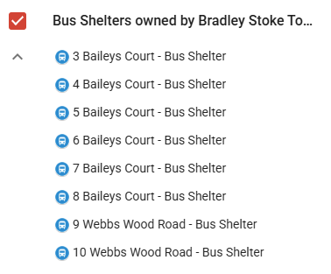
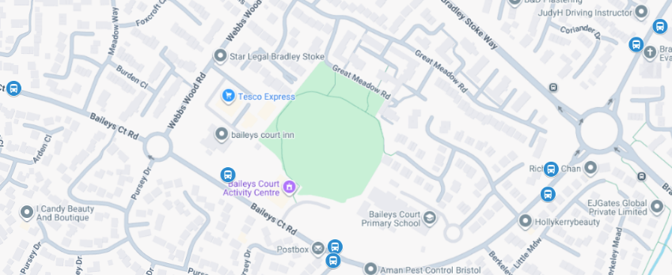

Review of our current bus stops which was carried out by the BSTC Mobile Cleansing Operative has been circulated.

None of the current bus routes use the bus stops, but some of the shelters are used by young people awaiting school transport pick-ups. Also, some are being used on a temporary basis whilst the roadworks/road closures are in place. If the bus route to the south of the town is ever reinstated by the bus companies, the shelters would be needed but in the meantime, they would benefit from a freshen-up.

Main bus routes which currently supply Bradley Stoke are the number 74 and the M1 Metrobus

Quotes for Works
A quote has been obtained from a company who carry out cleaning and repairs to bus shelters.
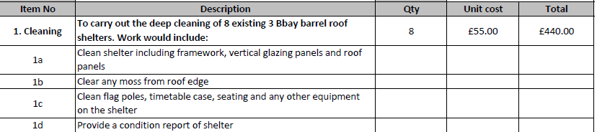

Officer recommendation
Accept the quote as detailed above and review all bus shelters once the condition report of shelters is received.

Following discussion, Councillor Dave Addison proposed acceptance of the officer recommendation as detailed above, seconded by Councillor Jon Williams, carried unanimously.

11 To note the dates of forthcoming meetings

11.1 20 October Leisure, Youth & Amenities Committee
11.2 22 October Finance Committee
11.3 22 October Planning & Environment Committee
11.4 19 November Full Council
11.5 24 November Staffing Committee

It was proposed by Councillor Dayley Lawrence, seconded by Councillor Kulwinder Singh Sappal, carried unanimously, that, in line with Standing Orders 67 and 68, in view of the confidential nature (commercial sensitivity) of the business about to be transacted, it is advisable in the public interest that the press and public be temporarily excluded, and they are instructed to withdraw.

10 To deal with Miscellaneous Matters

10.1 Sale of piece of land on Dewfalls Drive

It was noted that BSTC does not have a specific budget allocated within the Forward Plan for this purpose; however, the required funding could be drawn from reserves.

Discussion then took place regarding the maximum budget to be allocated for bidding at the auction. It was noted that the total budget would need to include the Buyer’s Premium of £900 and the administration fee of £1,500, both payable to the auctioneers.

Three separate votes were subsequently held, beginning with the highest proposed figure (1), which was not carried. A second vote on a lower figure (2) also failed, and a third vote on a further reduced figure (3) was successful.

To ensure that the final agreed figure does not influence the outcome of the auction in any way, the recorded votes are listed below as 1, 2 and 3. The actual figures will be reported at the next Full Council meeting on 19th November 2025, following the conclusion of the auction.

Maximum budget (1) proposed by Councillor Dayley Lawrence, seconded by Councillor Kulwinder Singh Sappal. A vote was taken, 5 in favour, 6 against, 1 abstention, proposal failed.

Maximum budget (2) proposed by Councillor James Nelson, seconded by Councillor Jon Williams. A vote was taken, 5 in favour, 6 against, 1 abstention, proposal failed.

Maximum budget (3) proposed by Councillor James Nelson, seconded by Councillor John Bradbury. A vote was taken, 6 in favour, 5 against, 1 abstention, proposal carried.

Following further discussion, Councillor Tom Aditya proposed that the Town Clerk and Deputy Town Clerk be delegated to bid at auction on behalf of Bradley Stoke Town Council, seconded by Councillor Kulwinder Singh Sappal, carried unanimously.

The Meeting closed at 9.30pm

APPENDIX A

NOTES FROM STRATEGIC PLANNING MEETING – 29th September 2025

Present: Councillors: Tom Aditya
Sue Bandcroft
Terri Cullen
Jenny James
James Nelson
Ben Randles
Kulwinder Singh Sappal
Jon Williams

Officers: Sharon Petela (Town Clerk)
Rachel Pullen (RFO/Finance Manager)
Phil Francis (Deputy Town Clerk/Activity Centres Manager)
Gillian Allen (Activity Centres Supervisor)

WELCOME & INTRODUCTION
As Councillor Natalie Field (Chair of Council) was unable to join the meeting remotely due to technical issues with an unstable internet connection, Councillor Jenny James (Vice Chair of Council) chaired the meeting. She then welcomed everyone to the informal meeting.

Strategic Planning is Council's process of defining its forward strategy or direction and making decisions on allocating its resources to pursue this strategy, including its capital and people. This is a process for determining where an organisation is going over the next year or more typically 5 years (long term).

In order to determine where it is going, council needs to know exactly where it stands, then determine where it wants to go and how it will get there. The results then feed directly into:

- Future budgets: Council will be establishing the 2026/27 budget from October 2025 for final approval in January 2026.
2. Forward Plan: Council review the updated Forward Plan in January 2026 for final approval in March 2026 – this includes the 5-year rolling budget.

1. APOLOGIES

Apologies have been received from Councillors John Bradbury, Frederic Contenot and Natalie Field (unable to join remotely), Graham Baker (Youth Development & Participation Worker) and Ivy Brown (Projects & Events Officer)

2. STRATEGIC PLANNING

  - CURRENT POSITION

The current 5 Year Budget Plan as at 06.09.25 has been circulated (see Appendix A). It was noted that there is currently only a four-year projected budget completed with the fifth year to be added in due course.

Discussion took place on the budget position this time last year and the budget differences going forward. Also, discussion on the Future Budget Reserve budget and spending linked to various budgets including play area refurbishment (Beacon Playscheme, Foxborough Gardens and Paddock Close already completed or nearing completion). Brook Way Play Area due to be done in near future. Rosemary Close Play Area will hopefully be refurbished with S106 funding from new build apartments on Bradley Stoke Way.
APPENDIX A
2.2 – 2.4 FUTURE DIRECTION + ACHIEVING OBJECTIVES + BUDGET IMPACT

Beautification of Bradley Stoke
Discussion took place on the idea of developing the flowers and colour around the town which is good for people’s mental health and social isolation. The wildflower beds on the roundabouts are looking good at the moment and are very colourful. The wildflower mounds surrounding the leisure equipment on the Jubilee Green have given a colour element to the open space. Discussion took place on sustainable planting on roundabouts and verges using bulbs/hardy plants which return year-on-year and are easier/cheaper to maintain. The ideas of artwork installations on roundabouts and verges were also discussed.

Following discussion, councillors agreed to “RECOMMEND to Full Council” that BSTC looks at developing the current planting provision that the Town Council has around the town and investigates the use of sustainable planting (bulbs and hardy plants which return year-on-year and are easy/cheap to maintain) on roundabouts and verges plus the potential installation of pieces of artwork on roundabouts and verges.

Installation of Christmas Tree or Christmas Lights decoration at Jubilee Centre
The Christmas tree which was planted at the Jubilee Centre has been removed as it was deceased. BSTC officers and staff robustly tried to keep the tree alive, but likely that it failed to thrive due to the soil type and exposure to prevailing winds. It was acknowledged that the electricity supply is already in place, so it is not possible to move the tree to a different location.

Discussion took place on whether to replace the tree with an outdoor artificial tree, install a mature native tree which could be wrapped with lights for Christmas or whether to investigate renting an illuminated light installation for the Jubilee Centre.

Following discussion, councillors agreed to “RECOMMEND to Full Council” that BSTC explores options for the Christmas tree replacement at Jubilee Centre, either an external artificial tree, a mature native tree which can be wrapped in lights for Christmas or rental of an illuminated light installation for this Christmas.

Improvements to Three Brooks Nature Reserve
Discussion took place on the South Gloucestershire Council (SGC) maintenance plan for the Three Brooks Nature Reserve. BSTC needs to hold SGC to account in light of the huge cost of desilting works that took place several years ago - the lake needs to be correctly managed to prevent the lake silting up again. Also, when the lake floods, the footpaths are impassable – this is particularly important at the moment as this is a ‘safe route to school’ whilst Bradley Stoke Way is closed to pedestrians. The access paths into the Nature Reserve are not accessible all year round, need proper paths and better lighting.

Following discussion, councillors agreed to “RECOMMEND to Full Council” that BSTC asks SGC for an up-to-date copy of the Three Brooks Nature Reserve Lake management plan and also asks them to consider required improvements to paths and lighting (from a community safety and accessibility point of view) to enable the Reserve to be fully accessible throughout the year, especially when the lake floods. The Juniper Way/Concorde Way/Bradley Stoke Way paths need to be the same standard as the Diana Gardens/The Bluebells/Bradley Stoke Way paths.

Rachel Pullen, RFO/Finance Manager left the meeting at this point
APPENDIX A
Live streaming of Council and Committee meetings
Discussion took place on the BSTC Council and Committee meetings being live-streamed and uploaded on YouTube or Facebook.

Following discussion, councillors agreed to “RECOMMEND to Full Council” that BSTC explores livestreaming council and committee meetings.

Residents Survey to ascertain views and interests with a view to developing new projects and ideas
The BSTC Mission Statement is “Bradley Stoke Town Council will work to promote and develop the interests and diversity of this vibrant community”. Discussion took place on carrying out a Residents Survey to ascertain views and interests of the local community with a view to developing new projects and ideas. This is a project that the BSTC Projects and Events Officer could lead on. This could be carried out through Survey Monkey or Microsoft Forms.

Following discussion, councillors agreed to “RECOMMEND to Full Council” that BSTC looks into carrying out a residents survey to ascertain views and interests with a view to developing new projects and ideas.

Introduction of a Community Awards Scheme
Discussion on the possibility of introducing a Community Awards Scheme to recognise Bradley Stoke residents and their achievements. Discussion took place on how this could work in practice and who would be involved, judging panel, categories, certificate/awards etc. This is another project that the BSTC Projects and Events Officer could lead on.

Following discussion, councillors agreed to “RECOMMEND to Full Council” that BSTC explores the introduction of a Community Awards Scheme.

Other discussion topics

- Provision of Multi Use Games Area with basketball hoops on Jubilee Green – work in progress – already ongoing Full Council agenda item
- Provision of memorial benches – work in progress – already ongoing Full Council agenda item
- Piece of land for sale on Dewfalls Drive – already on the October Full Council meeting agenda
- Organisation of healthy living events – this is in hand, linked to the development of the Community Wellbeing Hub at Brook Way Activity Centre

APPENDIX A

Bradley Stoke Town Council

SUMMARY OF RECOMMENDATIONS TO BE CONSIDERED BY FULL COUNCIL ON 8th OCTOBER 2025

1. Beautification of Bradley Stoke
Councillors agreed to “RECOMMEND to Full Council” that BSTC looks at developing the current planting provision that the Town Council has around the town and investigates the use of sustainable planting (bulbs and hardy plants which return year-on-year and are easy/cheap to maintain) on roundabouts and verges plus the potential installation of pieces of artwork on roundabouts and verges.

2. Installation of Christmas Tree or Christmas Lights decoration at Jubilee Centre
Councillors agreed to “RECOMMEND to Full Council” that BSTC explores options for the Christmas tree replacement at Jubilee Centre, either an external artificial tree, a mature native tree which can be wrapped in lights for Christmas or rental of an illuminated light installation for this Christmas.

3. Improvements to Three Brooks Nature Reserve
Councillors agreed to “RECOMMEND to Full Council” that BSTC asks SGC for an up-to-date copy of the Three Brooks Nature Reserve Lake management plan and also asks them to consider required improvements to paths and lighting (from a community safety and accessibility point of view) to enable the Reserve to be fully accessible throughout the year, especially when the lake floods . The Juniper Way/Concord Way/Bradley Stoke Way paths need to be the same standard as the Diana Gardens/The Bluebells/Bradley Stoke Way paths.

4. Live streaming of Council and Committee meetings
Councillors agreed to “RECOMMEND to Full Council” that BSTC explores livestreaming council and committee meetings.

5. Residents Survey to ascertain views and interests with a view to developing new projects and ideas
Councillors agreed to “RECOMMEND to Full Council” that BSTC looks into carrying out a residents survey to ascertain views and interests with a view to developing new projects and ideas.

6. Introduction of a Community Awards Scheme
Councillors agreed to “RECOMMEND to Full Council” that BSTC explores the introduction of a Community Awards Scheme.

