0BRADLEY STOKE TOWN COUNCIL

Full Council

Minutes of the Full Council meeting of Bradley Stoke Town Council held at the Jubilee Centre, Savages Wood Road, Bradley Stoke on 12 July 2023 at 7.00 pm.

PRESENT: Councillors: David Addison
Aleena Aditya
Tom Aditya
John Bradbury
Frederic Contenot
Terri Cullen
Natalie Field
Jenny James
Dayley Lawrence (Chair)
Brian Mead
James Nelson
Ben Randles
Kulwinder Singh Sappal
Jon Williams

Officers: Sharon Petela - Town Clerk
Rachel Pullen – Responsible Finance Officer/Finance Manager
Philip Francis - Deputy Town Clerk/Activity Centres Manager

1 Submissions from the Public and Councillors

  - Councillor Tom Aditya commented that some residents are finding it difficult to find NHS dental appointments.

  - Councillor Tom Aditya commented that some residents find it difficult to use the online GP system recently introduced at the local surgery.

2 Apologies for absence

Apologies were received from Councillor Roger Avenin and South Gloucestershire Ward Councillor Franklin Owusu-Antwi.

3 Applications for Dispensations by Councillors

None

4 Declarations of Interest

Councillor Jon Williams declared an interest in item 13.1.

5 Announcements by the Chair

The Chair explained that he has been busy on Mayoral events and visits over the past few weeks, visiting a number of school summer fetes and presenting Hedgehog Heroes signs in assemblies, touring the schools and hearing about funding issues.

6 Minutes of Previous Meetings

Minutes of meeting held on 21st June 2023 were proposed for acceptance by Councillor Jon Williams, seconded by Councillor Tom Aditya with the spelling of a word in minute 7.6 being amended from “costing” to “coating”. A vote was taken, carried unanimously. The minutes were then signed by the Chair as a correct record.

In light of the fact that there were representatives present, Councillor Jon Williams proposed that items 13.1 and 14.2 be discussed next, seconded by Councillor Kulwinder Singh Sappal, carried unanimously.

13 Financial Matters

13.1 Baileys Court After School & Holiday Club Update and Rent Request

Background
Wise Owls After School & Holiday Club currently hire the Elm Room at Baileys Court Activity Centre from Monday to Friday - 3.45 pm – 6.15pm during term time and 8am – 6pm during school holidays and have recently given notice that it will not be continuing after Friday 1st September 2023.

Historically, it has been charged the Bradley Stoke Community Charge rate which is heavily discounted (as detailed below) and normally applies to non-profit making Bradley Stoke community groups. This was approved by Council several years ago, despite the fact it is a business, to ensure such services are available locally for the community. This discounted rate also applies to the current pre-school hirers at both the Jubilee and Baileys Court Activity Centres for the same reason.

Current Hire Charges (exc. storage)
Baileys Court Activity Centre, Elm Room + kitchen - Bradley Stoke Community Rate = £14.90 p/h (inc vat)
Baileys Court Activity Centre, Elm Room + kitchen – Block Booker Standard Rate = £24.70 p/h (inc vat)

Discount = £9.80 discount = 65.77%

As a guide, the total hire income received from Wise Owls in 2022/23 amounted to £12,326.87 based upon the current Bradley Stoke community rate.

New Hirer Request
One of the workers currently employed by Wise Owls is hoping to set up a new club and is hoping to hire the Elm Room on the same terms, hire charges and hours and hope to proceed immediately after the Wise Owls closure if council approve the request as detailed below:

HIRE OF ELM ROOM.

Dear Rachel,

It was great speaking to you today. I'm just writing out my plans for the use of the Elm room at Baileys Court Activity Centre. I've been an employee for the current business (Wise Owls) since March 2017. During this time, I have worked in the Elm room & know how it's set up, run, storage, policies & what's expected from its hirers. I have a pretty good relationship with the caretakers.

My provisional plan is: (Starting Monday 4th September 2023)
Term time, 3:45 pm until 6.15 Monday to Friday.
Holidays, 8 until 6pm Monday to Friday.

I have a current waiting list of parents waiting to join my club even though it's early days. When I did research with them, this was the time they asked for to cover their childcare needs.

As of today, (Tuesday 20th June) I have submitted all correspondence with Ofsted, contacted insurance suppliers but I'm now on hold unless I can secure a venue for a long term basis.

I would kindly request that, as I'm looking to bulk book the room month after month, that I could have the same discount/ pricing that the present hirers have. I'm more than happy to attend the meeting that's booked for the 12th July hopefully I will also have more information from Ofsted & have official documents to supply. (I know there is a long delay for most places.)

OFFICER RECOMMENDATION
The current after school and holiday club is very well used and provides an important service to the local community. There is already a council precedent to offer the lowest hire charge available to pre-school and after school groups which is heavily subsidised.

The prospective new hirer has also been advised that refurbishment works are planned for the Elm Room and the school holiday club will therefore need to move to the Woodland Suite at the Jubilee Centre during the following dates|:

23 – 27/10/23
2 – 12/4/24
24/7- 30/8/24

The slightly lower Elm Room rates will still apply during these sessions as recompense for the disruption (£1.70 p/h difference).

In addition to the above, the current income provided by the current hirer amounts to £12,326 p/a which is equivalent to 18.3% of the total income received from Baileys Court in 2022/23 and this is expected to continue if the new group proceed.

Based upon the above, the recommendation from the Finance Manager RFO is to approve the continued rental for the new hirer based upon the same terms, hours and hire charges currently applied to Wise Owls.

The individual who submitted the request was then invited by the Chair to address the meeting.

Following discussion, Councillor John Bradbury proposed acceptance of the BSTC officer recommendation as detailed above, seconded by Councillor Ben Randles. A vote was taken, 12 in favour 2 abstentions, proposal carried.

The chair thanked the individual for attending the meeting.

14 To deal with Miscellaneous Matters

14.2 Presentation by Bradley Stoke Library

The representative from Bradley Stoke Library gave an interesting presentation on the work of the libraries in South Gloucestershire and outlined facilities and activities on offer in Bradley Stoke Library.

The Chair thanked the individual for attending the meeting and giving an interesting presentation to councillors.

7 Matters arising from the Minutes of 21st June 2023

7.1 Update on possible Park Run on Three Brooks Nature Reserve

Actions taken so far:
- The Town Council public consultation is still live and is running until Sunday 30th July 2023. The consultation has been advertised on the Town Council website, Facebook page and 6 noticeboards around the town. Posters have also been put up on the Three Brooks Nature Reserve.
- Bradley Stoke Radio, Bradley Stoke Matters Magazine, Bradley Stoke Journal, Bradley Stoke Voice and Bradley Stoke Library have been informed of the consultation.
- Consultation online response form is up and running on the Town Council website and hard copies of the questionnaire are available from our three activity centres and main office for anyone unable to fill in the online version.
- A public drop-in session took place on Saturday 1st July 2023 in the Cherry Room at Baileys Court Activity Centre between 9.30am and 12.30pm.

We had a total of 20 residents (18 adults and 2 children) drop-in throughout the session along with two representatives from Three Brooks Nature Conservation Group (see photo from drop-in below).

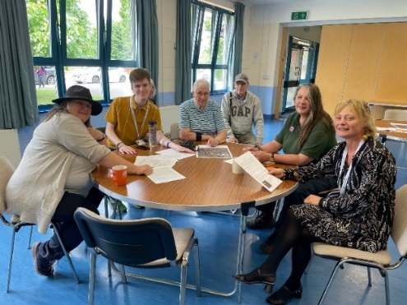

To date (as of 12th July 2023) we have had 550 responses to the consultation.

We have added the background information to the consultation on the Town Council website and a note of the date information was added to the website has been made on the responses spreadsheet and word document so we can gauge whether different responses are received following the additional information being available.

When the consultation closes, officers will compile statistics in a summary which will be presented to the Full Council meeting in September to enable councillors to agree a formal response to South Gloucestershire Council on the proposal.

7.2 Update on First Bus regarding loss of bus services

The following written description and maps (which have been circulated) of the proposed 73 bus route changes have now been received from First Bus. The changes to the service are due to be introduced from September 2023 and the Town Council are awaiting clarification from First Bus as to which services will be terminating in Eagles Wood rather than continuing to Aztec West.

Sections 3,5 & 7 on the table below refer to sections that are on the registration form to change the route and “none” means that, on that section, there are no changes.

1 | Service 73 from Belland Drive via (Return – Court Farm Road), Whitchurch Lane, Ridgeway Lane, Wharnecliffe Gardens, Fortfield Road, New Fosseway Road, Walsh Avenue, Hengrove Lane, Cadogan Road, Airport Road, Salcombe Road, Broad Walk, Wells Road, Bath Road, Temple Gate, Redcliffe Way, The Grove, Prince Street, Broad Quay, Colston Avenue, (Forward - Lewins Mead; Return - Rupert Street), The Haymarket, North Street, Stokes Croft, Cheltenham Road, Gloucester Road, Muller Road, Filton Avenue, Station Road, (Forward - Filton Road, Sainsbury's Bus Link, Fox Den Road; Return - Fox Den Road, Great Stoke Way), (Forward - New Road, New Road Bus Link), Brierly Furlong, Hatchet Road, Bristol Parkway Station, Hatchet Road, Orpheus Avenue.Brook Way, Savages Wood Road, Bradley Stoke Way, Willow Brook Centre, Savages Wood Road, Brook Way, Bowsland Way, Trench Lane, Woodlands Lane, Bradley Stoke Way to Aztec West Park Avenue.
2 | Some journeys will terminate at Eagles Wood bus stop on Woodlands Lane.
3 | None
4 | Aztec West, Approach Road  Bradley Stoke, Eagles Wood  Bradley Stoke, Willow Brook Centre  Bristol Parkway Station  Bristol Temple Meads Station  City Centre, Broad Quay  Filton Avenue, Lockleaze Road  Loxton Square  Belland Drive
5 | None
6 | Picks up and sets down at all recognised stops along line of route.
7 | None

Councillors raised concerns regarding the proposed termination of some services at Eagles Wood and the impact on bus users, traffic and local residents. Also, the Town Council will send out a press release once clarification is received from First Bus.

Representatives from First Bus (senior management and commercial team) are to be invited to September Full Council meeting to discuss bus issues.

7.3 Update on Provision of Leisure Equipment on The Jubilee Green

Ongoing

7.4 Update on Provision of basketball hoops at the Jubilee Centre

Phil Francis, Activity Centres Manager/Deputy Town Clerk gave the following update:

Officers have met with three companies and one quote has so far been received (which is significantly higher than anticipated) so cost saving options are now been investigated.

7.5 Community Infrastructure Levy funding 2022/23

Bradley Stoke Town Council has recently received a CIL funding payment of £17,420.21 for 2022/23 in respect of 2 food and drink units, incorporating a drive-through and outline planning permission to extend the existing retail terrace to provide 2 retail units (including mezzanine) at the Willow Brook Centre (planning application PT18/1491/0).

CIL Town and Parish Council Neighbourhood Portion 2022/23
Planning Reference | Site Name | Total Received | Parish Share | Parish
PT18/1491/O | Willow Brook Centre, Savages Wood Road | £29,033.68 | £4,355.05 | Bradley Stoke
PT18/1491/O | Willow Brook Centre, Savages Wood Road | £43,550.54 | £6,532.58 | Bradley Stoke
PT18/1491/O | Willow Brook Centre, Savages Wood Road | £43,550.53 | £6,532.58 | Bradley Stoke
 |  | TOTAL | £17,420.21
These funds need to be allocated to a capital project and it is therefore suggested that this funding be added to fund one of the following projects:

- Provision of Garden of Reflection at Brook Way Activity Centre – estimated cost roughly £6,000 if work carried out inhouse and working with local community groups (N/C7046)

- Provision of Leisure Equipment on The Jubilee Green – Current Budget = £21,855.05 (N/C3070) - to help attract external funding.

- Provision of basketball hoops facility at the Jubilee Centre on the Jubilee Green – Current Budget = £26,000 (N/C 3022) - to help attract external funding if required.

Following discussion, Councillor Ben Randles proposed that the 2022/23 CIL funding be allocated towards the provision of leisure equipment on the Jubilee Green (N/C3070), seconded by Councillor Dayley Lawrence, carried unanimously.

7.6 South Gloucestershire Council, Streetcare and Maintenance Team – Request for prioritised list of street cleansing/maintenance works in town

The South Gloucestershire Council team who spend time in all parishes and towns in South Gloucestershire are due to be back in Bradley Stoke at the end of June/beginning of July. The extract below from the Full Council meeting held on 16th March 2022 details what they do and the areas councillors asked them to focus on in Bradley Stoke last year.

13.4 SGC – Request for prioritised list of street cleansing/maintenance works in town

The following email has been received from SGC, StreetCare department:

I’m pleased to report the council recently agreed some additional funding for street cleaning which we are investing into a new team who will be spending time in all Parish and Town Councils across South Gloucestershire. My job is to oversee the team and manage their workload, the aim will be to spend 1 week within your Council area to address any general maintenance and street cleaning jobs that often nobody ever has the time to get done. We are aiming to start this in April and I’m hoping to schedule Bradley Stoke in for some time in April dependent on how quickly my team are up and running.

What I’m asking for is a list of 5 jobs ideally prioritised by the Town council which my team can work through, of course it may not be possible to get all of the jobs done but I will collate all the information and send you the relevant details at the end of the weeks work. Any jobs that aren’t completed we can complete on our next visit plus any addition jobs you may have found for us. It would be good to meet up and look at the jobs prior to work commencing, which also gives me an opportunity to take photos and see if the work is doable for our 2 man team.

Following discussion, Councillor Tom Aditya proposed, seconded by Councillor Ben Randles and carried unanimously, that BSTC identify the following five areas to be added to SGC list:
- Top end of Oaktree Crescent, including the numerous parking bays and open space areas which are all in need of litter picking, removal of fly-tipping, weed removal, shrubs and trees being cut back and a general tidy up of the area
- The area surrounding the Baileys Court pub, Tesco’s Express and the other shops (including the car parking area) needs litter picking, weeding and a general tidying up
- Champs Sur Marne needs a good litter pick carried out, especially in the vicinity of the school and further into the estate
- The top of the tump on the Three Brooks Nature Reserve needs a major litter pick, removal of fly tipping and exposed materials which have been uncovered over the years
- The entire length of Savages Wood Road from Tesco’s onwards needs a good litter pick carried out, weed removal and general tidy up

Councillors need to decide on roughly five priorities for this year’s visit.

Following discussion, Councillor Jon Williams proposed, seconded by Councillor Dave Addison, carried unanimously, that BSTC identify the following areas of priority for the SGC parish/town council StreetCare Maintenance team:

- Vegetation clearance of public footpath which goes from Brake Close to Sherbourne Brake
- Vegetation clearance of public footpath which goes from The Worthys to Berkeley Mead
- Vegetation clearance of public footpath which goes from The Park to Apseleys Mead
- Vegetation and rubbish clearance of public footpath which goes from Palmers Leaze to Juniper Way (including attenuation pond)
- Vegetation clearance of public footpath which goes behind houses in Ellan Hay Road (140ish)
- Replacement of piece of missing fence in Ellan Hay Road
- Top end of Oaktree Crescent, including the numerous parking bays and open space areas which are all in need of litter picking, removal of fly-tipping, weed removal, shrubs and trees being cut back and a general tidy up of the area

Councillors also raised concerns about the grassed areas at the bottom of Ellan Hay Road which have been mowed by SGC (but not litter-picked first). BSTC operative will check the area and litter pick as required.

7.7 Quotes from companies for submission of building control application to unitary authority linked to storage building at Brook Way Activity Centre

Phil Francis, Activity Centres Manager/Deputy Town Clerk gave the following update:

Included within the Brook Way Storage building project we will require sign off from building control before we commence any works. The previous agreed budget is highlighted in the picture below showing the indicative cost of doing this via a third party. I have reached out to 4 companies with 3 sending quotes based on the designs for the building.

The building control part to the project has a budget as per the below:

Project admin Incl. Site visits | Building control fee | CDM | PRACTICE (only) FEE TOTALS
£2,000.00 | £900.00 | £250.00 | £5,500.00

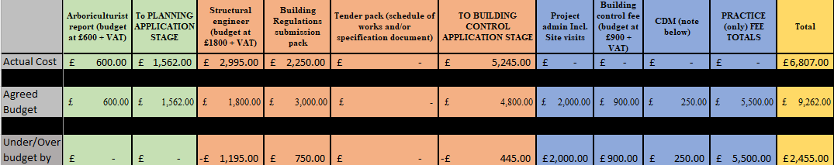

Company | Initial Design Review | Design team meetings | Design Review | Site inspection | Initial Notice Fee | Additional works Fee | Plans certificate (upon request) | Total (no additional works required) | Total (if additional works required)
ACT | Not required | Not required | £510 | £765 | Included | £120 If initial notice rejected.  Additional design review £150 per hour | £300 | £1,275  £1,575 with completion certificate | £1,995 with 1 rejection and 2 hours additional
Cook Brown | Included | Included | Included | £600 | £950 | £85 per hour for variations  £90 for energy rating certificate | Included | £1,550 | £1,720 for 2 hours additional
C2C | Included | Included | Included | Included | £1,950 | Admin fee if notice rejected £250 | Included | £1,950 | No additional hours quote specified

Based on quotations and architect feedback, officer recommendation is to continue with the project using Cook Brown due to openness of charges and coming back under originally budgeted.

Following discussion, Councillor Ben Randles proposed acceptance of the BSTC officer recommendation to use Cook Brown, seconded by Councillor Dave Addison, carried unanimously.

8 To receive the Minutes of the Finance Committee held on 21st June 2023, and to deal with matters referred to Council not covered elsewhere on the Agenda

The Minutes of the Finance Committee meeting held on 21st June 2023 were received.

9 To receive the Minutes of the Planning & Environment Committee held on 31st May 2023 and 28th June 2023 and to deal with matters referred to Council not covered elsewhere on the Agenda

The Minutes of the Planning & Environment Committee meetings held on 31st May 2023 and 28th June 2023 were received.

10 To receive the Minutes of the Leisure, Youth and Amenities Committee held on 19th June 2023 and to deal with matters referred to Council not covered elsewhere on the Agenda

The Minutes of the Leisure, Youth & Amenities Committee meeting held on 19th June 2023 were received.

10.1 Quotes for replacement of CCTV at Bradley Stoke Skatepark

Background: Bradley Stoke Skatepark was officially opened in April 2016. Initially a limited CCTV system was installed consisting of 4 cameras wired to a pre-existing CCTV column. The system was connected, via a wireless link, to the Leisure Centre CCTV system. In 2018, two additional converted 40ft containers were added to the original 20ft container and two further cameras were located on them. In addition, a hard drive recorder was installed in the containers and wired to the pre-existing column, therefore allowing a more accessible arrangement with CCTV able to be reviewed on site.

Current situation: Over the past year we have had problems, with several of the camera locations, with intermittent or permanent faults that have not been rectifiable by replacement cameras. Further investigation has indicated cabling problems and unfortunately it does not look possible to reuse existing conduit.

In addition, the upgrading of the containers, including the recent installation of a well-equipped kitchen and associated equipment, makes it desirable to enhance security and deterrence on site.

Solution: As there is no permanent electrical supply at the floodlight columns, wireless links are not an option (timed power only). Rewiring existing conduit does not seem possible, therefore it is necessary to provide additional trench work to accommodate new CCTV cabling. We have therefore requested quotes for the cables to be trenched in new conduit from the two floodlight columns nearest to the containers and from the pre-existing CCTV column (prior to skatepark build).

The specification for the works includes 8MP IP IR cameras (7 cameras across three poles/ columns and the converted containers); CAT6 cabling; upgrade to hard drive recorder; necessary groundworks (trenching and conduit), etc.

So far, we have received three quotes and are awaiting a fourth. We are also requesting clarification on some of the detail within the quotes, so they are directly comparable. This also includes the cost of groundworks (an element of the works we could arrange separately to the supply and install of the CCTV equipment).

Officers to continue to seek clarification on existing and awaited quotes and present detailed costings to next appropriate Council meeting (hopefully July Finance Committee).

11 To receive the Minutes of the Staffing Committee held on 26th June 2023, and to deal with matters referred to Council not covered elsewhere on the Agenda

The Minutes of the Staffing Committee meeting held on 26th June 2023 were received.

11.1 Adoption of BSTC Time Off in Lieu (TOIL) policy

Draft policy documentation circulated

Following discussion, Councillor Jon Williams proposed adoption of a TOIL policy with several wording amendments linked to rolling accrual, use of TOIL before Annual Leave and records of TOIL, seconded by Councillor Ben Randles, carried unanimously.

11.2 Re-evaluation of two BSTC job roles

Ongoing – awaiting response from external HR company.

11.3 Adoption of BSTC Acting-up & Honorarium Policy

Draft policy documentation circulated

Following discussion, Councillor Jon Williams proposed adoption of an Acting-up and Honorarium policy, seconded by Councillor Ben Randles, carried unanimously.
12 Updates from South Gloucestershire Council (SGC) Ward Members relevant to Bradley Stoke and Bradley Stoke Town Council Press Spokesperson

- Councillor Dave Addison – SGC spokesperson on adult care & homes. Has also been appointed to WECA Audit & Scrutiny committees
- Councillor John Bradbury – as a new SGC councillor it has been a steep learning curve, appointed to Development Management Committee plus Avon & Somerset Constabulary Police & Crime Panel
- Councillor Terri Cullen – following up residents concerns regarding bus provision in the town
- Councillor Franklin Owusu-Antwi – update sent on SGC Waste & Recycling contingencies/provision linked to industrial dispute between Suez & unions.
- Councillor Ben Randles – following up Woodstock Homes planning application and residents concerns. Issues with overflowing brook at end of Brake Close and dealing with various stakeholders/agencies.

13 Financial Matters

13.1 Baileys Court After School & Holiday Club Update and Rent Request

Discussed earlier on the agenda

13.2 Quotes for replacement/update of Elm Room kitchen at Baileys Court Activity Centre

Phil Francis, Activity Centres Manager/Deputy Town Clerk gave the following update:

Following the letter submitted to council by Abacus pre-school I have been seeking ways to improve the facilities available at Baileys Court activity centre. In particular the pre-school has raised concerns that the kitchen area was looking worn and is no longer in a fit state. The kitchen in the Elm room is the original kitchen put in when the building was built. The cupboards have been repaired many times and are in a poor state with doubts that any further fixes could be made due to the worn nature of the wood.

I have spoken with 3 companies asking for quotations to replace the kitchen with a more modern and inviting feeling and adding a hide and slide oven. The oven would be a new addition to the rooms usage as at the moment the users are going down the corridor and using the kitchen that was put in for the bowls club which isn’t ideal. By having a kitchen in the room it means that the oven would not be left unattended while cooking/baking. To save on costs the town council staff would remove the old kitchen the weekend before the week of installation.

Company | Cost | Specification | Instal | Delivery | Total (EXL VAT)
B&Q | £4,626 | - Neff built in oven hide and slide  - Bosch fridge freezer 70/30 split  Goodhome cupboards x 13  - light grey cupboards with light grey worktop | £1,895 - £2,018 | £50 | £6,571
Schmidt | £10,464.20 | - Neff built in oven hide and slide  - Bosch fridge freezer 70/30 split  - 11 Large cupboards  - Grey worktop and splashback  - Green Tea cupboards front (Same as woodlands design)  - New layout design | £1,683 | £277.50 (if delivered with Cherry) | £12,424.70 (if ordered with Cherry) £12,702.20 if ordered alone
Kitchen Den | £6,132.03 | - Neff built in oven hide and slide  - CDA fridge freezer 70/30 split  - 15 cupboards  - Light blue cupboards with grey worktop and alloy coloured splashback surround | £2,200 | £0 | £8,332.03

Please note that there will be associated plumbing and electrical costs that could come to a further £1,500 on top of quoted costs.

Schmidt Design
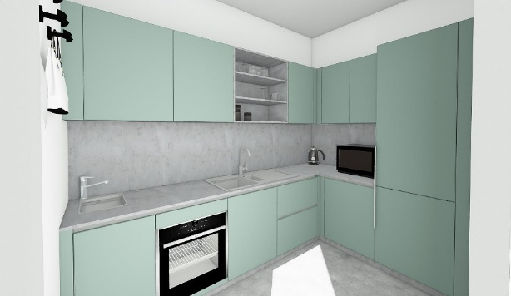
Kitchen Den Design
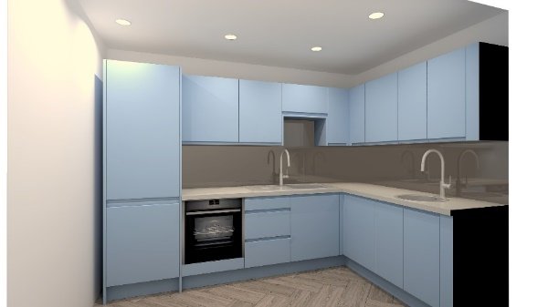
B&Q Design
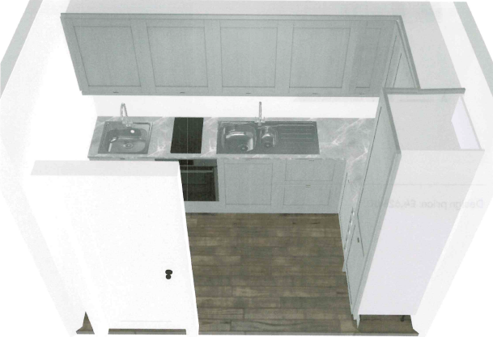

13.3 Quotes for replacement/update of Cherry Room kitchen at Baileys Court Activity Centre

Phil Francis, Activity Centres Manager/Deputy Town Clerk gave the following update:

The Cherry room kitchen is very similar in design and shape to the Elm room kitchen but again has fallen into a bad state due to constant repairs. This kitchen is hired with the cherry room but is also used by the caretakers on site as its closely situated to the buildings site office.

Company | Cost | Specification | Instal | Delivery | Total (EXL VAT)
B&Q | £3,963.57 | - 14 cupboards of varying size  - Light grey cabinets with light grey worktop  - Bosch integrated fridge  - Bosch Integrated Dishwasher | £1,895 - £2,018 | £50 | £6,031.57
Schmidt | £8,449.73 | - Bosch Integrated dishwasher  - Bosch Integrated fridge  - 13 Large cupboards  - Grey worktop and splashback  - Green Tea cupboards front (Same as woodlands design) | £1,468.50 | £277.50 (if delivered with Elm) | £10,195.73 (if ordered with Elm) £10,473.23 if ordered alone
Kitchen Den | £5,709.80 | - CDA fridge freezer 70/30 split  - 14 cupboards  - Light blue cupboards with grey worktop and alloy coloured splashback surround  - Does not include a dishwasher but could ask to be included in place of the second sink | £2,200 | £0 | £7,909.80

Officer recommendation is to pick the same company to do both kitchens. I would prefer to work with Schmidt as I have done before for the woodlands kitchen and it would match the current design bring a standard across all sites. However due to costs difference I understand the council would prefer to go with Kitchen Den, if council choose this way the design should be altered to have a small integrated fridge and integrated dishwasher which in my estimation would increase the price by £300 - £500.

Please note that there will be associated plumbing and electrical costs that could come to a further £1,500 on top of quoted costs.

Schmidt Design
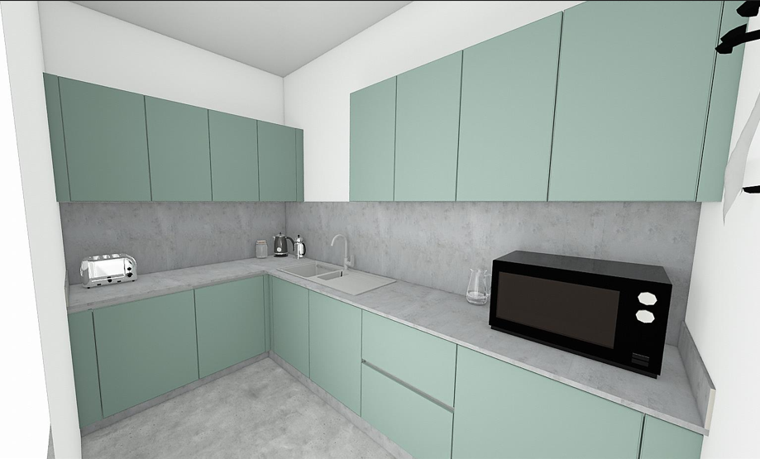
Kitchen Den Design
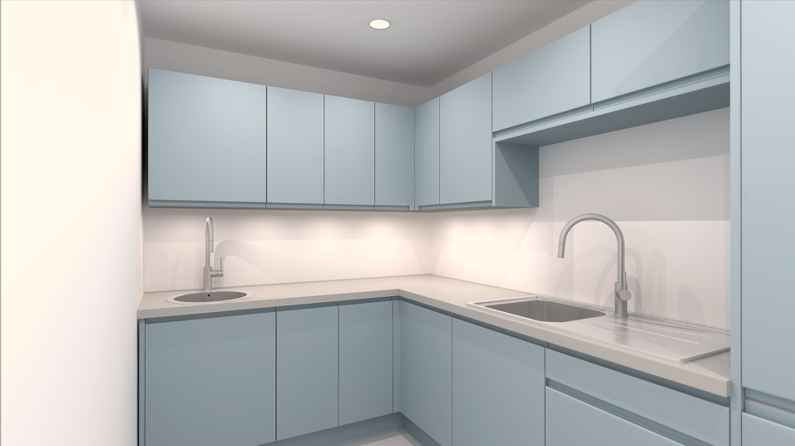
B&Q Design
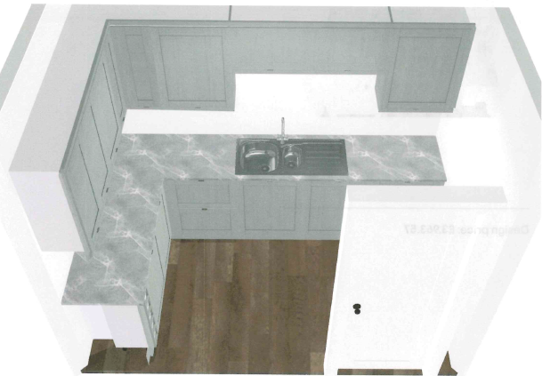

Following discussion, Councillor Jon Williams proposed acceptance of both the Kitchen Den quotes as per 13.2 and 13.3 detailed above, seconded by Councillor Natalie Field. A vote was taken, 12 in favour, 2 abstentions, proposals carried.

Councillor Natalie Field then proposed that BSTC officers investigate the provision of a dishwasher for the Cherry Room kitchen rather than the second sink, seconded by Councillor Ben Randles, carried unanimously.

In light of the fact it was 9.00pm, in line with Standing Order 1.8, Councillor Tom Aditya proposed extending the meeting until 9.30pm, seconded by Councillor James Nelson, carried unanimously.

13.4 To Approve Bills for Payment

The following Bills and Direct Debits were approved for payment (and include VAT where appropriate) by Councillor James Nelson, seconded by Councillor Tom Aditya and carried unanimously.

BRADLEY STOKE TOWN COUNCIL
MONTHLY EXPENDITURE - 12th July 2023 - Council
SALARIES |  |  |  |  | Net Amount
23/06/2023 | June Net Salaries Via Payflow |  |  |  | 25,241.74
SUPPLIERS
 | A1 Maintenance Ltd
Date | Ref | Details | Net Amount | Tax Amount | Gross Amount
01/04/2023 | 1370 | BC - Building Maintenance - July 23 | 683.33 | 136.66 | 819.99
01/04/2023 | 1370 | BW - Building Maintenance - July 23 | 370.83 | 74.16 | 444.99
01/04/2023 | 1370 | JC - Building Maintenance - July 23 | 333.33 | 66.67 | 400.00
01/04/2023 | 1370 | Office - Building Maintenance - July 23 | 125.00 | 25.00 | 150.00
01/04/2023 | 1370 | JC CR - Building Maintenance - July 23 | 320.83 | 64.17 | 385.00
01/04/2023 | 1370 | Skate Park - Building Maintenance - July 23 | 79.16 | 15.83 | 94.99
25/06/2023 | 1383 | Skatepark - Electrical works for kitchen | 1080.00 | 216.00 | 1296.00
16/06/2023 | 1392 | BC - Remove cold water tanks + connected cold feed pipework | 740.00 | 148.00 | 888.00
20/06/2023 | 1393 | BC - Repair leaking toilet in Elm Room | 50.00 | 10.00 | 60.00
25/06/2023 | 1399 | Skate Park - Supply/fit faulty alarm in disabled toilet | 180.00 | 36.00 | 216.00
 |  | Account Totals: | 3962.48 | 792.49 | 4754.97
 | AMBIENCE LANDSCAPES LTD
Date | Ref | Details | Net Amount | Tax Amount | Gross Amount
30/06/2023 | 19611 | Street maintenance - June 23 | 1272.87 | 254.57 | 1527.44
 |  | Account Totals: | 1272.87 | 254.57 | 1527.44
 | AVON SPORTSGROUND MAINTENANCE CO
Date | Ref | Details | Net Amount | Tax Amount | Gross Amount
30/06/2023 | SI-822117 | BC - Bowls green maintenance & materials - June 23 | 547.43 | 109.49 | 656.92
 |  | Account Totals: | 547.43 | 109.49 | 656.92
 | BATH & NORTH EAST SOMERSET COUNCIL
Date | Ref | Details | Net Amount | Tax Amount | Gross Amount
19/06/2023 | June Salary | June 23 - Pension | 6918.36 | 0.00 | 6918.36
19/06/2023 | June Salary | June 23 - Pension Deficit Refund | -525.00 | 0.00 | -525.00
 |  | Account Totals: | 6393.36 | 0.00 | 6393.36
 | BRADLEY STOKE IN BLOOM
Date | Ref | Details | Net Amount | Tax Amount | Gross Amount
19/06/2023 | 2023/24 | Bradley Stoke In Bloom approved funding from reserves | 500.00 | 0.00 | 500.00
 |  | Account Totals: | 500.00 | 0.00 | 500.00
 | MATTERS MAGAZINES
Date | Ref | Details | Net Amount | Tax Amount | Gross Amount
14/03/2023 | 22/2992 | 2023/24 - Annual advertising - Paid Monthly | 62.29 | 12.46 | 74.75
 |  | Account Totals: | 62.29 | 12.46 | 74.75
 | BS1 FIRE & SECURITY
Date | Ref | Details | Net Amount | Tax Amount | Gross Amount
03/07/2023 | SI18216 | BW - Shutter maintenance - July 23 | 4.92 | 0.98 | 5.90
01/07/2023 | SI18216 | Office - Shutter maintenance - July 23 | 24.59 | 4.92 | 29.51
01/07/2023 | SI18216 | BC - Shutter maintenance - July 23 | 37.71 | 7.54 | 45.25
01/07/2023 | SI18216 | JC - Shutter maintenance - July 23 | 32.78 | 6.56 | 39.34
01/07/2023 | SI18253 | Office - Intruder, fire alarms + CCTV - July 23 | 56.45 | 11.29 | 67.74
01/07/2023 | SI18253 | JC - Intruder, fire alarms + CCTV - July 23 | 78.80 | 15.76 | 94.56
01/07/2023 | SI18253 | BW - Intruder, fire alarms + CCTV - July 23 | 87.54 | 17.51 | 105.05
01/07/2023 | SI18253 | BC - Intruder, fire alarms + CCTV - July 23 | 95.10 | 19.02 | 114.12
01/07/2023 | SI18254 | Skate Park - Intruder, fire alarms + CCTV - July 23 | 55.92 | 11.18 | 67.10
 |  | Account Totals: | 473.81 | 94.76 | 568.57
 | MR J BUDD
Date | Ref | Details | Net Amount | Tax Amount | Gross Amount
19/06/2023 | May/June | BW - Window cleaning 12/6/23 | 50.00 | 0.00 | 50.00
19/06/2023 | May/June | BC - Window cleaning 12/6/23 | 60.00 | 0.00 | 60.00
19/06/2023 | May/June | Office - External window clean- 29/5/23 | 20.00 | 0.00 | 20.00
19/06/2023 | May/June | Office - Internal window clean- 29/5/23 | 20.00 | 0.00 | 20.00
19/06/2023 | May/June | JC - Window clean- 29/5/23 | 65.00 | 0.00 | 65.00
 |  | Account Totals: | 215.00 | 0.00 | 215.00
 | South Gloucestershire Chinese Association
Date | Ref | Details | Net Amount | Tax Amount | Gross Amount
19/06/2023 | 2023/24 | SG Chinese Assoc - 2023/24 SLA | 1764.37 | 0.00 | 1764.37
 |  | Account Totals: | 1764.37 | 0.00 | 1764.37
 | CONCORD HOMECARE LIMITED
Date | Ref | Details | Net Amount | Tax Amount | Gross Amount
30/06/2023 | CINV-525 | Office - Cleaning - June 23 | 357.50 | 71.50 | 429.00
30/06/2023 | CINV-525 | JC - Cleaning - June 23 | 858.00 | 171.60 | 1029.60
30/06/2023 | CINV-525 | BW - Cleaning - June 23 | 715.00 | 143.00 | 858.00
30/06/2023 | CINV-525 | BC - Cleaning - June 23 | 858.00 | 171.60 | 1029.60
30/06/2023 | CINV-525 | Skate Park - Cleaning - June 23 | 143.00 | 28.60 | 171.60
30/06/2023 | CINV-525 | JC CR - Cleaning - June 23 | 357.50 | 71.50 | 429.00
 |  | Account Totals: | 3289.00 | 657.80 | 3946.80
 | Bradley Stoke Cricket Club
Date | Ref | Details | Net Amount | Tax Amount | Gross Amount
28/06/2023 | BC062023 | BC - Cricket wicket maintenance - June 23 | 745.83 | 0.00 | 745.83
 |  | Account Totals: | 745.83 | 0.00 | 745.83
 | HMRC Cumbernauld
Date | Ref | Details | Net Amount | Tax Amount | Gross Amount
19/06/2023 | June Salary | June 23 - Tax/NI | 8369.35 | 0.00 | 8369.35
 |  | Account Totals: | 8369.35 | 0.00 | 8369.35
 | KN Office Supplies Ltd
Date | Ref | Details | Net Amount | Tax Amount | Gross Amount
19/06/2023 | I14635 | Office - Printer cartridge | 30.05 | 6.01 | 36.06
19/06/2023 | I14636 | Office - Printer paper | 58.35 | 11.67 | 70.02
19/06/2023 | I14636 | Office - Stationery | 22.77 | 4.55 | 27.32
19/06/2023 | I14636 | Office - Fan for P. Francis | 25.99 | 5.20 | 31.19
 |  | Account Totals: | 137.16 | 27.43 | 164.59
 | ONE OFF SUPPLIERS - BY INTERNET PAYMENT
Date | Ref | Details | Net Amount | Tax Amount | Gross Amount
18/06/2023 | INV106 | AAA Ambulances -First aid cover for Skate Park event 17/6/23 | 650.00 | 0.00 | 650.00
20/06/2023 | 0001865568 | Badgemaster - 13 staff + councillor name badges | 126.77 | 25.35 | 152.12
27/06/2023 | 1251 | Kings Ramps - Skate Park - Youth event exhibition 17/5/23 | 1750.00 | 350.00 | 2100.00
26/06/2023 | OL1091 | Olas Art - Spray paint workshop for youth event 17/5/23 | 450.00 | 0.00 | 450.00
20/06/2023 | 40 | Sara Messenger - 4 Knitted hedgehogs as prizes linked to hedgehog project | 15.00 | 0.00 | 15.00
 | PHILIP FRANCIS
Date | Ref | Details | Net Amount | Tax Amount | Gross Amount
15/06/2023 | Reimburse | Community Festival Event - food and refreshments for workers and volunteers | 62.29 | 12.46 | 74.75
 |  | Account Totals: | 62.29 | 12.46 | 74.75
 | RelyOn Guarding & Security Services Ltd
Date | Ref | Details | Net Amount | Tax Amount | Gross Amount
07/06/2023 | 637382 | JC - Alarm call out 6/6/23 | 35.00 | 7.00 | 42.00
19/06/2023 | 637472 | BC - Alarm call out 18/6/23 | 35.00 | 7.00 | 42.00
 |  | Account Totals: | 70.00 | 14.00 | 84.00
 | SOUTH GLOUCESTERSHIRE PLAYSCHEME
Date | Ref | Details | Net Amount | Tax Amount | Gross Amount
19/06/2023 | 2023/24 | SG Playscheme - 2023/24 Larger grant aid | 5000.00 | 0.00 | 5000.00
 |  | Account Totals: | 5000.00 | 0.00 | 5000.00
 | SOUTHERN BROOKS COMMUNITY PARTNERSHIP
Date | Ref | Details | Net Amount | Tax Amount | Gross Amount
19/06/2023 | GA496 | Southern Brooks - 2023/24 Grant aid | 500.00 | 0.00 | 500.00
 |  | Account Totals: | 500.00 | 0.00 | 500.00
 | SOUTH GLOUCESTERSHIRE COUNCIL
Date | Ref | Details | Net Amount | Tax Amount | Gross Amount
21/06/2023 | 3805303922 | Graffiti Removal - Sherbourne Ave | 96.70 | 19.34 | 116.04
 |  | Account Totals: | 96.70 | 19.34 | 116.04
 |  | Supplier Totals: | 36453.71 | 2370.15 | 38823.86

14 To deal with Miscellaneous Matters

14.1 Annual Review of BSTC Policies & Procedures

Documentation circulated to councillors with suggested amendments detailed below:

14.1.1 Business Continuity/Disaster Recovery Policy – wording changes to reflect changes to staff, suppliers and procedures
14.1.2 CCTV Policy – no changes required
14.1.3 Code of Conduct for Members – to adopt new code in line with new code of conduct adopted by SGC in May 2023
14.1.4 Code of Conduct Complaints Process – no changes required
14.1.5 Community Engagement Strategy – no changes required
14.1.6 Complaints Policy – no changes required
14.1.7 Customer Service Charter – no changes required
14.1.8 Dignity at Work - Bullying & Harassment Policy – no changes required
14.1.9 Document Management & Archive Policy – no changes required
14.1.10 Email Contact Privacy Notice – no changes required
14.1.11 Equality & Diversity Policy – no changes required
14.1.12 Expected Standards Protocol – no changes required
14.1.13 Freedom of Information Policy – no changes required
14.1.14 General Privacy Notice – no changes required
14.1.15 Grievance Procedure – no changes required
14.1.16 Hirers Privacy Notice – no changes required
14.1.17 Information & Data Protection Policy – no changes required
14.1.18 Media & Publicity Policy – no changes required
14.1.19 Member/Officer Protocol – no changes required
14.1.20 Official Social Media Engagement Policy – no changes required
14.1.21 Privacy Notice (staff, councillors & role holders) – no changes required
14.1.22 Probationary Policy – no changes required
14.1.23 Protocol on the Filming & Recording of Town Council, Committee & Sub-committee meetings – no changes required
14.1.24 Publication Scheme – no changes required
14.1.25 Risk Management Policy – no changes required
14.1.26 Training Statement of Intent – no changes required
14.1.27 Volunteer Policy – no changes required
14.1.28 Website Accessibility Statement – no changes required
14.1.29 Website Privacy & Use of Cookies Policy – minor wording changes to include reference to Room Hire pre-booking form required

Following discussion, Councillor Ben Randles proposed acceptance of all policies (with any amendments as detailed in 14.1.1 – 14.1.29 above) seconded by Councillor Kulwinder Singh Sappal, carried unanimously.

14.2 Presentation by Bradley Stoke Library

Discussed earlier on the agenda

14.3 West of England Combined Authority – WestLocal bus initiative

The following email and supporting information has been received from South Gloucestershire Council, Transport Policy Team (see Appendix A):

Dear Councillors, Town/Parish Councillors and Community Transport Operators

We are emailing you to draw your attention to a funding opportunity recently announced by the West of England Combined Authority (WECA):

WESTlocal - West of England Combined Authority (westofengland-ca.gov.uk)

In essence the fund is looking to support community designed and operated public transport solutions. WECA have allocated £2m to the fund and the deadline for funding applications is April 2024. However funding will be allocated on a “first come, first served” basis. We are keen to improve the chances of success for South Gloucestershire applicants and the Council will support local groups / organisations by providing some specialist advice from a transport consultant.

Interested parties can submit their expression of Interest via the following link - EoI_WESTlocal, at this stage in the process the form is only 12 questions and should be relatively straightforward to complete. If you think you would benefit from some consultant support please reply to this email. Also feel free to forward on to any other groups / organisations that you think may be interested.

Kind regards SGC – Transport Policy

Following discussion, Councillor Tom Aditya proposed that BSTC complete the West Local expression of interest form to work with other local parish and town councils to provide transport link to Southmead Hospital, seconded by Councillor Jon Williams, carried unanimously.

14.4 Update on 2023 Community Festival and discussion/decision on the date, arrangements and budget for 2024 Community Festival

The Town Clerk gave the following update:

Town Council Community Picnic – Saturday 10th June
The community picnic took place in glorious weather. All entries in the Hedgehog Heroes Colouring Competition were on display in the Oak Hall and those attending voted for their favourite picture. The results will be announced at the Hedgehog Heroes event on Saturday 17th June. Music was provided by the Bradley Stoke Radio team and their roving reporters were out and about around the site interviewing people picnicking and watching Bradley Stoke Youth Football Club’s 25th Anniversary Celebration matches. Refreshments were served by volunteers from Bradley Stoke Youth Football Club and the Bradley Stoke Ladies football team were selling cakes. The three Mayor’s Charities (The Brightwell, Mamas Bristol and Prostate Cancer UK) were represented at the picnic. As in past years, the free facepainting and giant bubbles proved popular. The following reports have been submitted by the various groups who held events over the weekend.

Bradley Stoke Youth Football Club – Saturday 10th June
On June 10th 2023 at the Jubilee Centre, Bradley Stoke Youth FC (BSYFC) celebrated their 25th anniversary with a football festival with over 350 children participating in the event. The age range of players on view was 4 to 16 years old showing their football skills and ability in front of some large crowds. The sun was shining and the pitches were looking fantastic. The format of the day was to have fun matches with no results and some competitive matches where the results were recorded to find a winner. All the action took place between 10am to 4.30pm and afterwards the coaches even played a match until the sun (or old age) got to them.

The event results were as follows:
Reception children – fun matches with a penalty shootout with the Minion in goals.
Year 1 children – fun matches with a penalty shootout with the Minion in goals. The Year 1 children were the winners of the Luke Wheaton Memorial Cup.
U7’s - fun matches.
U9’s – fun matches.
Mixed U9’s and U10’s – competitive matches with U10 Blacks winning the McDonalds Cup and the U9 Golds winning the Bradley Stoke Town Council Cup.
U11’s – competitive matches with U11 B’s winning the McDonalds Cup.
U11 Girls – fun matches and coaching session.
U13’s – fun matches.
Mixed U14 and U15 – competitive matches with the U15 Oranges winning the Bradley Stoke Town Council Cup.
Mixed U15 Girls and Ladies – competitive matches with The Ladies Goals Aloud Team winning the McDonalds Cup.

Every age group had an award presentation with the Mayor of Bradley Stoke (Dayley Lawrence) and Deputy Mayor of Bradley Stoke (Natalie Field) in attendance to hand out the trophies and cups. For the Year 1 presentation we were delighted to be joined by Matt Wheaton from the Luke Wheaton Legacy Trust. The presentation of the Luke Wheaton Memorial Cup is an annual event at the Festival to ensure we remember Luke who played for many years with BSYFC. The club would like to say thanks to the Bradley Stoke Town Council and the Luke Wheaton Legacy Trust for their kind donations towards the cost of the trophies which every child received at the festival. This was very much appreciated.

It is hard to believe how big the club has grown from that first training session way back in June 1998 with just one team in the League. We now have over 450 players at the club across 22 teams playing in many different Leagues.

Some highlights of BSYFC story over the years:
Sept 2005: the club started football enrichment sessions at Bradley Stoke Community School.
June 2006: the club started the first Football Festival with Bradley Stoke Town Council.
Mar 2008: the club started the School Link program providing free football coaching to Primary Schools. This grew from one school to 14 local schools.
May 2008: the club achieved the FA Charter Standard Club Award.
June 2009: the club started working with the Gloucestershire FA to address the lack of female teams in the area. Girl’s football is started at BSYFC.
July 2010: The Young Coach Mentoring Program is started.
Aug 2010: the club achieved the FA Charter Standard Community Club Award. There were only 9 other clubs in the whole of South Gloucestershire that held this award.
June 2011, 2013 and 2016: the club is awarded Gloucestershire FA Community Club of the Year.
Sept 2012: the club started free community disability football sessions.
May 2015: the club created the first ever female adult team for the town of Bradley Stoke.
Sept 2015: the club started football enrichment sessions at the new Bradley Stoke Primary School.
Nov 2022: the FA transition all clubs to the new England Football Accredited Club system with BSYFC awarded the highest 3 star level.

The club would like to thank all the volunteers and supporters for their ongoing support and help in running the football club. The club is always looking for more volunteers so if anyone would like more info, please check out our contact page on our website at www.bsyfc.co.uk

Sole Sisters 10K Run – Sunday 11th June
For 18 years Sole Sisters have hosted the Bradley Stoke 10K. This year it was a hot humid morning and we saw 480 runners cross the finish line. Our 1st place runner finished in just over 35 mins.

Sole Sisters would like to thank friends, families, neighbours, Local Guides, Brownies, Rainbows, Rangers, Bradley Stoke Church and fellow running clubs who volunteered to marshal on the day. They did a fabulous job cheering the runners along the route, handing out Water, Jelly babies, Chocolate Brownies, T-shirts and Medals. We really could not have held the race without them all.

The comments we receive following the race portray just what an important role the +80 marshals around the route play in making the event the success that it is, we wish we could have more marshals to cover every twist and turn but here are some of this year’s heart-warming comments.
· “Thank you for hosting the event and thank you to all the awesome people giving up their time on a Sunday morning to keep us safe and see us around. Fantastic encouragement from everyone. Xx”
· “Thank you to everyone that organised, marshalled and stood on the street to support. Great community event”
· Great event, lots of support and fantastic marshalling. Thank you
· Thanks to all the fabulous marshals! What a super event!
Take a look at the Bradley Stoke 10K Facebook page for more amazing comments and some super race day photos: https://www.facebook.com/profile.php?id=100090947270405.
Brightwell Charity Colour Run – Sunday 11th June 2023
Crowds gathered at Jubilee Green, Bradley Stoke on Sunday June 11th to take part in a charity colour run organised by The Brightwell - a charity supporting those with neurological conditions by providing therapies such as neuro-physio and Oxygen therapy.
Participating in two heats, it was an eye catching, fun filled afternoon of smiles, laughter and clouds of colour for all ages and abilities.
The Brightwell would like to thank the Mayor Dayley Lawrence & The Bradley Stoke Town Council for their support in making this fundraising dream viable. One of the members of the Centre who enjoyed the event said it was ‘simply the best day ever’. The Brightwell would also like to thank all that came along to show their support, purchased tickets, sponsored the event and the amazing volunteers who made the event possible. A huge £4,700 has been raised so far and the funds from this event are still rolling in! They hope to run the event again next year after its big success.

Bradley Stoke Skatepark & Festival Jam - Saturday 17th June

At this year’s festival, Bradley Stoke Town Council’s Youth Workers and local young people were delighted to once again host a popular package of Skatepark and Art activities. A mix of skate park skills and creative arts ran alongside our annual Festival Skatepark competition. The competition was interspersed with rider demonstrations and ‘have-a-go’ opportunities, with support of Kings Ramps, along with music and MC.

The following competitions took place during the afternoon:
Scooter: 12 & Under; 13+
BMX: 12 & Under; 13+
Skateboard: All ages
Roller Blades: All ages Inline & Quads

The Art activities gave young people the opportunity to participate in workshops run by Olas Arts and those attending produced their own piece of artwork to take home. The artist has worked with the Town Council in the past, running popular workshops and on this occasion used old vinyl records as a canvas for street art style creativity.

Young people’s involvement in planning and organising the festival is supported by Bradley Stoke Town Council’s youth workers. If you are a young person living in the Bradley Stoke area and aged 11 to 19 who would like to find out about our other youth work sessions and projects, or would like to get involved as a young person or volunteer, come along for a chat or contact the youth development & participation worker on 07900 253826 or email graham.baker@bradleystoke.gov.uk
Instagram: @bradleystokeskatepark
Facebook: @bradleystokeskatepark

Financial Information
The overall budget for the 2023 Community Festival was £26,780. The breakdown below details the amounts spent on this year’s festival. This does not include staffing costs:

Company | Cost (exclusive of VAT) | Description
AAA Ambulances | £650.00 | Ambulance provision for skatepark event
Brandon Hire | £1,646.25 | 10 x toilet units + 110 crowd control barriers
Bristol Ambulance | £935.00 | First Aid provision for Saturday 10th & Sunday 11th June (including an off-road vehicle for 10K Run)
Bunzl Greenham | £217.95 | 5 x rolls of orange snow fencing (which will also be used for fireworks event)
Kings Ramps | £1,750.00 | Provision of professional rider demonstrations, hosting the skatepark competition and provision of prizes
Lipstick Powder & Paint | £175.00 | Cost of face painter/bubble provider for Community Picnic
Olas Art | £450.00 | Street art project for skatepark event
Pendle Sportswear | £529.23 | 50% cost to purchase 358 trophies for all participants of Youth Football event. The remaining 50% was paid by Bradley Stoke Youth Football Club
Various outlets | £62.29 | Refreshments for volunteers/staff/councillors at Community festival weekend
TOTAL | £6,415.72

Lots of photos available on: https://www.bradleystoke.gov.uk/events/festival/

Officers will circulate the proposed specification wording which was used to tender for 2023 Community Festival for councillors to review (and give feedback) prior to further discussion and decision regarding 2024 Community Festival format at Finance committee meeting on 26th July 2023.

14.5 SGC – S106 funding application opportunity linked to P21/02958/F – Land at Hornbeam Close, Bradley Stoke, South Gloucestershire, BS32 8FE

The following email has been received from SGC Section 106 Project Implementation Officer

I am writing to all organisations and groups who are eligible to apply for S106 funding for the improvement of outdoor sports facilities raised from the following developments:

- P21/02958/F – Land at Hornbeam Close, Bradley Stoke, South Gloucestershire, BS32 8FE

A breakdown of the categories of S106 funding that is available is as follows:

Category of Open Space | Capital | Revenue
Children and young people’s provision | £10,975.15 | £11,540.45
Outdoor Sports Facilities | £35,935.95 | £10,876.58

You are able to apply for funding at the following sites:
- Children and Young People’s Provision – Jubilee Green and Bradley Stoke Leisure Centre
Skate Park
- Outdoor Sports Facilities – Jubilee Green Playing Field

Along with your organisation, I am contacting the following organisations to invite applications:

Outdoor Sports Facilities
- Stoke Gifford Parish Council – Little Stoke Park
- Bradley Stoke Community School

If you wish to contact other eligible organisations to discuss partnership applications, you are free to do so and this may strengthen your application.

Please note that S106 funding contributions may only be spent on new facilities or capacity improvements to existing facilities where the new development has, at least in part, contributed to the need for that facility or will have an impact on the existing facilities. Contributions cannot be spent on the maintenance of existing facilities.

The purpose of the application process is to: -
- Provide a fair and open process for eligible applicants to apply for funding.
- Enable the Council to make a structured assessment of applications to ensure they demonstrate the need for the project, are well planned, high quality and will benefit the residents of the new development.
- Allow the Council to rank and compare projects where there is competition for funding and make funding decisions.

You are now invited to submit a S106 application form. This will provide the Council with information to assess whether your proposal meets the criteria of the S106 agreement. There are 2 applications, and you will be asked to complete one or the other based on the complexity of your project.
- Expression of Interest (EOI) Application: This is for simpler lower value projects which cost under £100,000. You can download a copy of the EOI.
- Full Application: This is for more complex projects with a value over £100,000. You can download a copy of the Full Application.

The deadline to submit your application is 28/7/2023 – if this deadline is going to be difficult to meet, please let me know at the earliest opportunity.

BSTC officers have sought clarification from SGC regarding any potential applications we may submit, to ensure that they are made within the correct S106 funding streams (see questions and answers in bold from SGC below):

Can you please give a definition of revenue – I have taken the below from our S106 guidance notes

Capital expenditure: This is used to acquire, develop or improve an asset such as equipment, facilities or buildings. Examples could include the purchase of new equipment such as cricket nets or new play equipment, the acquisition of land for the provision of new sport/play facilities, improving the drainage of playing pitches, or improvements to a pavilion to enable more teams to play outdoor sports.

Revenue expenditure: This is used to fund repairs, running costs and maintenance of the improvements/new facilities provided by the capital expenditure. For example, revenue funding can be used to maintain new pieces of play equipment, but not existing equipment in the play area that was not funded by S106 capital expenditure. Revenue funding cannot be awarded to cover existing maintenance costs that are not related to the capital expenditure. Revenue funding can be capitalised to increase capital funding.

Can you please clarify a timeline of revenue spend – if you applying for revenue to use as revenue (some groups ask to capitalise revenue) then the revenue payment is normally paid on completion of the capital element of the project. It is then up to you to keep the revenue payment safe and use it for the ongoing maintenance of the capital improvement

Can capital and revenue be included in one combined application or does it need to be separated into two applications – Please include capital and revenue in one application. You will need to submit one application for the play project and one application for the sport project.

Can you please confirm that an application for Fitness Equipment needs to be within the ‘Children and Young People’s provision’ application, even though it will be for use by the whole community. – Correct, providing the project is taking place at Jubilee Green or Bradley Stoke Leisure Centre Skate Park (or both)

Can you please confirm that an application for a football and basketball area would be acceptable within the ‘Outdoor Sports Facilities’ category. - Correct, providing the project is taking place at Jubilee

Recommendation
It is suggested that the Town Council apply for the following:

Category of Open Space | Capital | Revenue
Children and young people’s provision | £10,975.15 – Leisure equipment on Jubilee Green | £11,540.45 – Jubilee Green equipment maintenance + Skatepark youth coaching, mentoring and session facilitation
Outdoor Sports Facilities | £35,935.95 – Open basketball + Football goalpost on Jubilee Green | £10,876.58 - Jubilee Green equipment maintenance + possible youth coaching, mentoring and session facilitation

Following discussion, Councillor Tom Aditya proposed acceptance of the officers recommendation for applying for the available S106 funding, as detailed above, seconded by Councillor Natalie Field, carried unanimously.

14.6 Request to fly the Indian Flag to commemorate Indian Independence Day Flag on 15th August 2023

The following request email has been received from the Indian Community

The Indian Community in Bradley Stoke is thankful for the support given by the Bradley Stoke Town Council to hoist the Indian National Flag for the Indian Independence Day celebrations and the Indian Republic Day celebrations during the last civic year. The help and support of the BSTC has been inspiring.

This year, the Indian Independence Day is on Tuesday, 15th of August 2023. The Indian Community in Bradley Stoke wish to have a Flag Hoisting Ceremony to commemorate that day. Can the Town Council kindly grant permission to please allow the community to hoist the flag at 8.00 am on that day at the BSTC Jubilee Centre Flagpole.

Following discussion, Councillor Jon Williams proposed that permission is given, seconded by Councillor Dayley Lawrence, carried unanimously.

14.7 Request from Jimmy Crole Funfair to use Jubilee Green from 21st – 24th September 2023

A request has been received from Jimmy Crole Funfair to use the Jubilee Green site to run a funfair from Thursday 21st until Sunday 24th September 2023 (with a set-up date from Monday 18th September 2023).

The extract below is from the Full Council meeting minutes on 13th July 2022 (which includes some historical information from prior years):

13.3 Request from Jimmy Crole Funfair to use Jubilee Green from 22nd – 25th September 2022
A request has been received from Jimmy Crole Funfair to use the Jubilee Green site to run a funfair from Thursday 22nd until Sunday 25th September 2022 (with a set-up date of 19th September 2022). The extract below is from the extra Full Council meeting minutes on 23rd June 2021:

11.1 Use of Jubilee Green by Funfair – August Bank Holiday weekend 2021
Jimmy Crole’s Funfair has requested to use the Jubilee Green for his funfair for 5 days over the August Bank Holiday weekend (Thursday 26th – Monday 30th August 2021). This is one day longer than previous years. In light of the COVID-19 pandemic, the funfair will obviously be subject to any HM Government/HSE/Showman’s Guild restrictions which may be applicable at the time and Jimmy Crole will submit all the necessary documentation including COVID-19 Risk Assessment and Safe System of Work.
The normal conditions will also apply:
Please note that you will need to provide us with the following information at least 2 weeks before arrival (otherwise the Funfair will not be able to take place):
    - Public Liability Insurance certificates
    - ADIPS certificates for each ride
    - Test certificates for each inflatable
    - A risk assessment for each inflatable
    - Food Registration Certificates for all food stalls
You will need to leaflet drop the residents in the adjacent houses to inform them of your visit.

You will need to comply with the following to ensure that there are no Licensing concerns:
- No alcohol sales
- No music (other than that ancillary to the rides)
- No food sales after 8.30pm (see reference to 8.30pm finish below)
As the site is in a built up residential area, and based on previous complaints from local residents, we will need to enforce an 8.30pm evening finish for the rides, stalls and food units. In 2019, Council decided that the Fair would be charged a total of £500.00 for the four days (Friday 23rd – Monday 26th August 2019) which equated to £125.00 per day – any of those four days which the Fair didn’t run due to inclement weather would not be charged. In 2020, Council decided that, unfortunately, in view of the ongoing COVID-19 pandemic at the time, they were not in a position to give the fair the go ahead for 2020.

Actions to be taken
Councillors will need to decide whether to permit the funfair to use the Jubilee Green for their event (subject to running in line with formal HM Government guidance etc.) and if so, how much the fair will be asked to pay. If Councillors do decide that the fair can go ahead, they will also need to decide whether the charge is made as a donation to the Mayor’s Charity or directly to the Town Council. Following discussion, Councillor John Ashe reminded those present of the history of this event, Councillor Ben Randles thanked John for the information which is hidden within the minutes over many years.

Councillor Tony Griffiths proposed to increase the fee to £1000.00, which would include the condition for Jimmy Crole to carry out any repair or damage caused on the grounds as a result, this was seconded by Councillor Roger Avenin, a vote was taken, and the resolution carried unanimously.

Councillor Tony Griffiths proposed the dates agreed suggesting that it can go ahead if this fits in with HM Government guidelines at the time of this event, he also proposed that the fee be split 50/50 with half of the fees going to the Mayors Charity and the rest to the Town Council funds. Proposed by Councillor Tom Aditya, seconded by Councillor Roger Avenin, 7 voted in favour, 2 abstained, motion carried.

Following discussion Councillor Brian Hopkinson proposed that Jimmy Crole’s funfair be permitted to use the Jubilee Centre site to run from 22nd – 25th September 2022 at a total cost of £1,000, with previous conditions in place (as detailed above), including the condition that any repair or damage caused by the funfair are addressed by them separately, with the £1,000 charge being split 50/50, with half of the fees going to the Mayors Charity and the rest to the Town Council funds, seconded by Councillor Tom Aditya, carried unanimously.

Following discussion Councillor James Nelson proposed that Jimmy Crole’s funfair be permitted to use the Jubilee Centre site to run from 21st – 24th September 2023 at a total cost of £2,000 (£500 per day), with previous conditions in place (as detailed above) plus no live prizes, including the condition that any repair or damage caused by the funfair are addressed by them separately, with the £2,000 charge being split 50/50, with half of the fees going to the Mayor’s Charity and the rest to the Town Council funds, seconded by Councillor Ben Randles, carried unanimously.

15 To confirm the dates of forthcoming meetings

15.1 26 July Finance
15.2 26 July Planning & Environment
15.3 14 August Leisure, Youth & Amenities
15.4 23 August Planning & Environment
15.5 20 September Full Council
15.6 30 October Staffing Committee
The Meeting closed at 9.30pm
APPENDIX A
West of England Combined Authority (WECA)
WESTLOCAL Transport Funding Opportunity

Background Information
WESTLOCAL – People-powered transport – designed locally, run locally
Local people know their communities best. Therefore it is fundamental that you are at the heart of creating transport solutions that work for your area. That’s why Metro Mayor Dan Norris, in partnership with North Somerset Council, has set up a new £2 million fund called WESTlocal, so communities can design and run their own public transport to better suit their needs. Maybe the challenge in your area is getting pupils to school, or getting people to a supermarket or to a large local employer at the start and end of shifts. Perhaps it’s linking together a group of villages or some other challenge that needs tackling. We need you to help identify those challenges and propose solutions. Together, we can encourage people to get out of their cars to help tackle the climate emergency and help more people to get around our amazing region.

Get started
Interested in applying? Complete our expression of interest form, and we will set up an informal meeting with you to discuss your proposed scheme. This will enable us to give you the best advice to help create a fuller scheme proposal and following that an application to the fund.
Who can apply for funding?
A wide selection of community groups, schools, faith groups, town and parish councils and more can apply for funding. You can come up with a plan as a standalone group or join up with others. Your proposed scheme must serve residents based in the area covered by West of England Combined Authority and North Somerset Council.

What kind of schemes will be funded?
We are looking for scheme ideas that:
- Are locally designed
- Introduce new provision rather than sustaining schemes and services that are already in place
- Operate not-for-profit, with any surplus reinvested in the scheme
- Help reduce carbon emissions by moving people away from reliance on privately-owned cars
- Demonstrate clear demand within the community for the service
- Have a clear plan for ongoing monitoring and improvement during the funding period
Some examples of the types of schemes you may wish to set up are:
- Bus routes operated on fixed routes and timetables
- Pre-booked minibus services to key locations such as supermarkets, shopping centres, local towns, and transport interchanges (such as major bus stops on the key transport corridors)
- Pre-booked flexible minibus services
- Car schemes such as commuter car clubs or volunteer drivers providing transport to local people in need

I've never run a transport scheme before. Where do I start? - Don't worry, you don't need any prior knowledge of running a transport scheme. We are here to help each step of the way, along with partners such as the Community Transport Association.

APPENDIX A
Simply submit an initial expression of interest and we will be in touch to discuss your idea and talk you through the next stages, to help you turn your idea into a worked up plan. You’ll then have the chance to apply for funding. If you’re successful you’ll receive ongoing support throughout the funding period to help make your scheme a success.
It may be that in implementing the scheme your group decides to operate the vehicle(s) yourselves, or you may wish to partner with a local bus or community transport operator. We can help you explore these options as part of the initial phase of developing your proposal and application.

What are the timelines?
The first step in the process is to submit an expression of interest online.
Following this, there’ll be an informal meeting to discuss your idea. You will be offered advice to help create a worked-up proposal to apply for funding. The deadline for funding applications is April 2024. However, we are keen to get successful schemes operating as soon as possible and funding will be awarded on a first come, first served basis.

WESTlocal Expression of Interests Form

* Required

By submitting this form you are agreeing that your response may be used by the West of England Combined authority and delivery partners including local council authorities for the purposes of developing WESTlocal transport.

  - What is your name? *
  - What is the best phone number to reach you on? *
  - What is your email address? *
  - What is your role within the community? *
  - Giving a brief explanation, what is your idea for new transport in your community? (For example, who the scheme would be targeted at, where the transport would take them and on what basis, what type of vehicle(s) you’d use, and who the drivers would be). *
  - Which groups are involved with the proposed scheme, and have any other groups said they will support the scheme moving forward? What kind of input/support have those groups offered?
  - Which places (towns, villages, neighbourhoods) would be served by this scheme?
Please note, any scheme must serve residents of the West of England Combined Authority and/or North Somerset Council areas.
  - Do you plan for your local group to operate the vehicle(s) yourselves or do you want to partner with a bus or community transport operator? Have you spoken with any at this stage and if so, what is their commitment to the proposed scheme? *
Have you spoken with potential passengers and local groups about your plan and if so, what have they said? *
  - Have you considered the level of demand for the scheme (and do you have any evidence to back this up)? *
  - What strengths do you have amongst your group(s) to make the scheme a success? *
  - Are there any particular concerns you have that would affect the success of the scheme and where you might require specific support? *

