Watermark Town Initiative workshop Saturday 18th April 2026
Bradley Stoke Town Council is working towards becoming a Watermark Town, as part of the Town’s Council’s Local Climate and Nature Action Plan.
The second workshop to refine the key initiatives identified at the first workshop was held on Saturday 18th April 2026 and attended by Councillors Sue Bandcroft, Natalie Field, Jenny James and Jon Williams, BSTC staff Sharon Petela and Gillian Allen, Sara Messenger (representing Bradley Stoke In Bloom, Green Gym and the Three Brooks Conservation group) and Mark Manning, a resident who works for Sustainable Drainage Solutions.
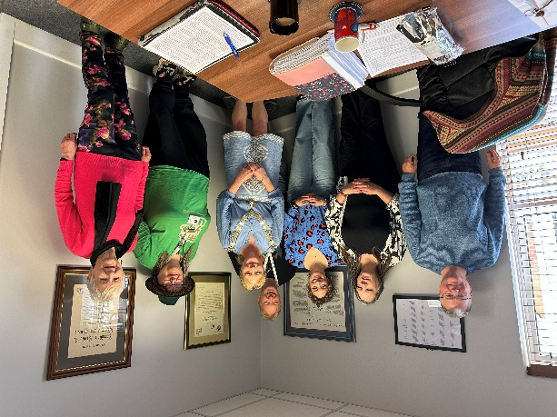
Three topic areas were considered: Waste Water and Drinking Water. The Sustainability element will be woven into the two topic areas.
May be grant funding available from Curo and Wessex Water towards projects.
Waste Water
 | Initiative | Comments | Priority | Resources Required | Timescale | Project Lead
1 | Cleaning wipes, wet wipes, tanning wipes – education on correct disposal | Would involve engaging with nurseries, Mamas, pre-schools and involve education with parents. These cause 90% of sewer blockages. Campaign resources available from Wessex Water. Fine to Flush Certification Scheme - to explore options and implement accordingly with BSTC leading by example. | First phase as it would be a quick win/campaign to do. | Explore obtaining the Fine To Flush certification (Water Research Council) for the Town Council and then involve pre-schools, nurseries, Mamas Bristol etc. Include as part of article in next BSTC newsletter. Produce social media video to promote messages | 3-4 months | BSTC
2 | 3 P’s campaign (Paper, Pee, Poo). | Campaign resources possibly available from Wessex Water. | First phase as can be a quick campaign to do | Combine with 1 (wipes etc.) as part of education campaign and include in BSTC newsletter article | 3-4 months | BSTC
3 | Disposal of cooking oils, fats | Education campaign. Campaign resources available from Wessex Water. | First phase as it would be a quick win/ campaign | Speak to Wessex Water for available resources with a view to having a stall at Community Festival and include in next BSTC newsletter. | 3-4 months | BSTC/Wessex Water
 | Initiative | Comments | Priority | Resources Required | Timescale | Project Lead
4 | Shower times & 4-minute song | ? timers available via Wessex water. Education campaign. Campaign resources available from Wessex Water. Households can order from Bristol Water or Wessex Water timers depending on which company supplies their water | First phase as can be a quick campaign to do | Contact Wessex Water for campaign resources | 3-4 months | BSTC/Wessex Water
5 | Tiny ponds | Could learn from other Councils as part of Watermark Towns Network. Explore project undertaken in Taunton | Summer phase | Contact Wessex Water to ascertain which councils did this campaign and then contact those councils | Start July. 6-8 months | BSTC
6 | Developing rain gardens [gardens storing rainwater] | Would require advice to implement; could learn from other Councils as part of Watermark Towns Network | Second phase | Development of these initially at three BSTC sites. Particularly important in locations where there are bee highways and to encourage wildlife | 6-8 months | BSTC
7 | Pond dipping areas including education | Will be added to the Town map which is being produced by Wessex Water. | Second phase
8 | Naming of ponds that have been created |  | Second phase | Wessex Water to include names on the town map | 6 months | Wessex Water
9 | Addressing Combined Sewer Overflows discharge into Stoke Brook which flows into ponds | Reducing misconnections and drains with pollution | Second or third phase
10 | Only Rain Down The Drain Campaign | Three schools have artwork. ? expand to some other schools if funding is granted. | Third phase | More costs effective option would be to undertake Yellow Fish campaign. Purchase yellow chalk paint and stencils, liaise with school to publicise (target school eco-councils). Start with BSTC sites. | 3-4 months | BSTC/TBNCG
11 | De-urbanising gardens & driveways [more soakaways] | Green drainage features e.g. porous surfaces with planted areas. Retrofitting sustainable urban drainage schemes where funding permits (e.g. rain gardens). | Identify options and possible sites. Encourage private households.
12 | Water butts and leaky butts | Slowing the flow of heavy rain
13 | In amenity areas include solar fountains

Drinking Water
 | Initiative | Comments | Priority | Resources Required | Timescale | Project Lead
1 | Develop water refill stations in public areas | Develop laminated signs with a tap to show that it is drinking water. Target pubs as well as BSTC sites. | First phase | Publicise this facility at BSTC sites | 3-4 months | BSTC
2 | Have dog water bowls in public areas | Already happens at Council premises. Target pubs as well as BSTC sites. Develop a picture wall of places in Bradley Stoke that have water bowls for dogs. | Second phase | Publicise this facility at BSTC sites and consider shallower bowls for wildlife | 3-4 months | BSTC
3 | Saving the cold water from a running tap whilst waiting for the water to become hot | Design messaging for education campaign | Summer phase: campaign/ education | Include in next BSTC newsletter as ideally a summer campaign | 3-4 months | BSTC
4 | Work with the Housing Association Curo and Woodstock Housing to include water butts at the site |  | Second phase
5 | Toilet cistern – to reduce water usage by having ‘hippo’ | Households can order a water buffalo from Bristol Water to install or water hippo from Wessex Water depending on which company is their provider | Third phase campaign | Speak to Wessex Water for provision of resources | 6-8 months | BSTC/Wessex Water
6 | Water audit | Starting with Council premises/activities to show leading by example. e.g. With Bailey’s Court development has water shutdown facility been included in the design brief. e.g. Bowls & Cricket Club – what time of day does watering occur (When cooler so water does not evaporate). Learn from audits completed by other Watermark Towns | Ongoing | Work with SDS to carry out a water audit of Bowls Green watering | 3-4 months | BSTC/SDS
7 | Rainwater harvesting | Explore options for all new build to reuse rainwater. Learn from network of Watermark Towns
8 | Raise awareness of benefits of Smart Meters to households who do not have these | Wessex Water can provide messages.
9 | Locks on outside taps | Prevents accidental damage or unauthorised usage to outdoor water supplies

