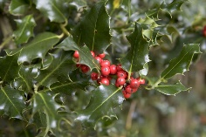
Ilex aquifolium - Holly

A table displaying which months are best to sow, plant and harvest.
 | Jan | Feb | Mar | Apr | May | Jun | Jul | Aug | Sep | Oct | Nov | Dec
Flowers |  |  |  |  |  | Plant does flower in June | Plant does flower in July
Fruits | Plant does fruit in January |  |  |  |  |  |  |  |  | Plant does fruit in October | Plant does fruit in November | Plant does fruit in December
- Botanical name: Ilex aquifolium
- Common name: Holly
- Family: Aquifoliaceae
- Plant Type: Shrub, Evergreen
Flower colour: White
Foliage colour: Green
- Key features:
- Attractive to wildlife
- Flowers
- Fruits

Common holly, Ilex aquifolium, is a useful evergreen shrub that can be grown as a specimen tree, clipped bush or hedge. There are dozens of varieties, many with variegated leaves. Plants are either male or female, and only the female plants bear berries. Both sexes are required for the female plants to produce berries, which appear from late autumn to mid-winter. For best results grow Ilex aquifolium in moist but well-drained soil, in sun or shade. The Royal Horticultural Society has given it its prestigious Award of Garden Merit (AGM).

How to grow Ilex aquifolium
- Plant size
20m height
8m spread
- Aspect
North facing, east facing, south facing, west facing
- Position in border
Middle, back
- Sun exposure: Full sun, dappled shade, partial shade, full shade
- Hardiness: Hardy
- Soil type: Well drained / light / sandy / clay / heavy / moist / chalky / alkaline / acidic

Plant calendar
A table displaying which months are best to sow, plant and harvest.
 | Jan | Feb | Mar | Apr | May | Jun | Jul | Aug | Sep | Oct | Nov | Dec
Sow | Do Sow in January |  |  |  |  |  |  |  |  |  |  | Do Sow in December
Plant | Do Plant in January |  | Do Plant in March |  |  |  |  |  |  |  | Do Plant in November | Do Plant in December
Flowers |  |  |  |  |  | Plant does flower in June | Plant does flower in July
Fruits | Plant does fruit in January |  |  |  |  |  |  |  |  | Plant does fruit in October | Plant does fruit in November | Plant does fruit in December
Take cuttings |  |  |  |  |  |  |  | Do Take cuttings in August | Do Take cuttings in September
Prune |  |  | Do Prune in March
Collect seeds | Do Collect seeds in January |  |  |  |  |  |  |  |  |  |  | Do Collect seeds in December

Ilex aquifolium and wildlife
Ilex aquifolium is known for attracting bees, beneficial insects, birds, butterflies​/​moths and other pollinators. It has nectar/pollen rich flowers, provides shelter and habitat, makes a good wildlife hedge, has seeds for birds and is a caterpillar food plant.
Attractive to Bees
Attractive to Beneficial insects
Attractive to Birds
Attractive to Butterflies​/​Moths
Attractive to Other pollinators

Is Ilex aquifolium poisonous?
Ilex aquifolium irritates skin. Its fruit is toxic.
Toxic to:
Toxic to Cats
Toxic to Dogs
Toxic to Horses
Toxic to People
No reported toxicity to:
No reported toxicity to Birds
No reported toxicity to Livestock

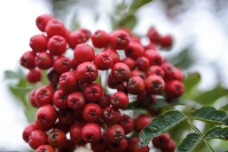
Sorbus aucuparia Rowan or mountain ash
A table displaying which months are best to sow, plant and harvest.
 | Jan | Feb | Mar | Apr | May | Jun | Jul | Aug | Sep | Oct | Nov | Dec
Flowers |  |  |  | Plant does flower in April | Plant does flower in May
Fruits |  |  |  |  |  |  |  | Plant does fruit in August | Plant does fruit in September | Plant does fruit in October
- Botanical name: Sorbus aucuparia
- Common name: Rowan or mountain ash
- Family: Rosaceae
- Plant Type: Tree, Deciduous
Flower colour: White
Foliage colour: Green
- Key features:
- Attractive to wildlife
- Autumn colour
- Flowers
- Fruits
- Prefers rich soil
The mountain ash or rowan, Sorbus aucuparia, is a native European tree, especially in high altitudes where its robust hardiness ensures its survival. Once credited with magical powers and often planted near dwellings as an insurance against misfortune, it’s now widely planted in gardens, both as the species and in its many varieties.
Sorbus aucuparia tolerates a wide range of soils and sites, regularly producing huge crops of bright red berries in dense pendent bunches, which attract birds of all kinds. It succeeds particularly well in urban gardens, and also when planted closely as a screen or informal large hedge.
Grow Sorbus aucuparia in a fertile, well-drained soil in full sun to partial shade. Water regularly in the first two years to help it become established, and stake it to prevent root-rock.
This page contains affiliate links and we may receive a commission for purchases made. Please read our affiliates FAQ page to find out more.

How to grow Sorbus aucuparia
- Plant size
15m height
7m spread
- Aspect
South facing, east facing, west facing
- Position in border
Back
- Sun exposure: Dappled shade, full sun
- Hardiness: Hardy
- Soil type: Acidic / clay / heavy / moist / well drained / light / sandy

Plant calendar
A table displaying which months are best to sow, plant and harvest.
 | Jan | Feb | Mar | Apr | May | Jun | Jul | Aug | Sep | Oct | Nov | Dec
Sow |  |  |  |  |  |  |  |  | Do Sow in September | Do Sow in October | Do Sow in November
Plant |  |  |  |  |  |  |  |  | Do Plant in September | Do Plant in October | Do Plant in November
Flowers |  |  |  | Plant does flower in April | Plant does flower in May
Fruits |  |  |  |  |  |  |  | Plant does fruit in August | Plant does fruit in September | Plant does fruit in October

Sorbus aucuparia and wildlife
Sorbus aucuparia is known for attracting bees, beneficial insects, birds and butterflies​/​moths. It is a caterpillar food plant, has nectar/pollen rich flowers, provides shelter and habitat and has seeds for birds.
Attractive to Bees
Attractive to Beneficial insects
Attractive to Birds
Attractive to Butterflies​/​Moths
Does not attract Other pollinators

Is Sorbus aucuparia poisonous?
Sorbus aucuparia can be toxic.
Toxic to:
Toxic to Cats
Toxic to Dogs
No reported toxicity to:
No reported toxicity to Birds
No reported toxicity to Horses
No reported toxicity to Livestock
No reported toxicity to People

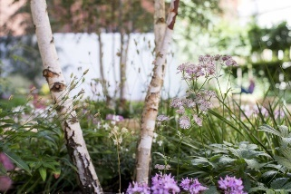
Betula pendula Silver Birch
A table displaying which months are best to sow, plant and harvest.
 | Jan | Feb | Mar | Apr | May | Jun | Jul | Aug | Sep | Oct | Nov | Dec
Flowers |  |  | Plant does flower in March | Plant does flower in April
- Botanical name: Betula pendula
- Common name: Silver birch
- Family: Betulaceae
- Plant Type: Tree, Deciduous
Foliage colour: Green
- Key features:
- Attractive to wildlife
- Colourful bark
Flowers
The silver or common birch, Betula pendula, is a fantastic tree, grown for its silver-white bark, spring catkins and pretty yellow autumn foliage. It’s a medium-sized, deciduous tree and is a British native. It is a fantastic choice for wildlife, supporting over 300 species of insect and attracting birds such as greenfinches and siskins, which eat the seeds.
Silver birch has a graceful, upright habit which gradually becomes weeping with maturity and a light canopy, so it casts dappled shade. Silver birch is a speedy grower (around 50cm a year) and relatively short-lived (to around 60 years). The Royal Horticultural Society has given it its prestigious Award of Garden Merit (AGM).
Silver birch is a favourite with garden designers. It is often planted in groups or as a multi-stemmed tree – the white bark looks especially good in winter and is perfect for showing off woodland planting underneath. Silver birch makes a good screen or windbreak and also works well as a specimen tree in a large garden.
If you’re looking for a birch for a smaller garden, buy a small whip tree (you can plant three in the same hole for a multi-stemmed look) or small sapling, or choose Betula pendula ‘Fastigiata’, which has a more upright growth habit. Or consider the slightly smaller Himalayan birch, which also has more vivid white bark.
Betula pendula thrives in most soils and situations. It can tolerate air pollution and copes well in an urban environment. It can even cope with occasional waterlogging. For the best results grow in moist but well-drained soil in sun to partial shade.

How to grow Betula pendula
- Plant size
25m height
10m spread
- Aspect
North facing, south facing, east facing, west facing
- Position in border
Back
- Sun exposure: Dappled shade, full sun, partial shade
- Hardiness: Hardy
- Soil type: Acidic / clay / heavy / moist / well drained / light / sandy

Plant calendar
A table displaying which months are best to sow, plant and harvest.
 | Jan | Feb | Mar | Apr | May | Jun | Jul | Aug | Sep | Oct | Nov | Dec
Plant |  |  |  |  |  |  |  |  | Do Plant in September | Do Plant in October | Do Plant in November
Flowers |  |  | Plant does flower in March | Plant does flower in April

Betula pendula and wildlife
Betula pendula is known for attracting bees, beneficial insects, birds, butterflies​/​moths and other pollinators. It is a caterpillar food plant, has nectar/pollen rich flowers, is used for nesting materials, provides shelter and habitat, has seeds for birds and makes a good wildlife hedge.
Attractive to Bees
Attractive to Beneficial insects
Attractive to Birds
Attractive to Butterflies​/​Moths
Attractive to Other pollinators

Is Betula pendula poisonous?
Betula pendula has no toxic effects reported.

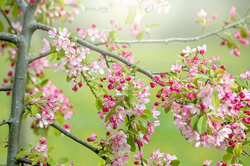
Malus sylvestris - Crab apple
- Botanical name: Malus sylvestris
- Common name: Crab apple
- Family: Rosacaeae
- Plant Type: Tree, Deciduous
Flower colour: Pink, White
Foliage colour: Green
- Key features:
- Attractive to wildlife
- Flowers
- Fruits

European crab apple (Malus sylvestris) is an ancestor of cultivated apple trees, along with some cultivated varieties of crab apple. Mature trees grow to around 10m in height and have a rounded shape and wide, spreading canopy. However, it can also be grown as part of a hedge. Its branches can appear quite gnarled on mature trees, and develop spines – it’s thought this ‘crab-like’ appearance may have led to its common name of crab apple.

Malus sylvestris has white-pink blossom in spring, followed by small, green apple-like fruits often flushed with red spots. It’s typically found in hedgerows and the edge of woodlands, however it’s notoriously hard to identify – it’s thought that most ‘crab apple’ trees in the wild are actually cultivated apples, grown from apple cores discarded by people. True Malus sylvestris can be identified by DNA testing only.
Crab apples make excellent pollination partners for cultivated apples. Their fruit can be used in jellies and as a natural source of pectin for setting jams. Like most crab apples, Malus sylvestris is extremely valuable to wildlife: its flowers are pollinated by bees and other pollinators, its leaves are used by the caterpillars of several moths, and its fruits are eaten by birds and small mammals.
Grow Malus sylvestris in moist, well-drained soil in sun.

How to grow Malus sylvestris
- Plant size
12m height
8m spread
- Aspect
South facing, west facing
- Sun exposure: Dappled shade, full shade

Malus sylvestris and wildlife
Malus sylvestris is known for attracting bees, beneficial insects, birds, butterflies​/​moths and other pollinators. It is a caterpillar food plant, has nectar/pollen rich flowers, is used for nesting materials, provides shelter and habitat, has seeds for birds and makes a good wildlife hedge.
Attractive to Bees
Attractive to Beneficial insects
Attractive to Birds
Attractive to Butterflies​/​Moths
Attractive to Other pollinators

Is Malus sylvestris poisonous?
Malus sylvestris is harmful if ingested and causes an upset stomach. Its seeds are toxic.
Toxic to:
Toxic to Dogs
No reported toxicity to:
No reported toxicity to Birds
No reported toxicity to Cats
No reported toxicity to Horses
No reported toxicity to Livestock
No reported toxicity to People

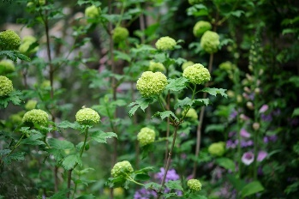
Viburnum opulus - Guelder rose
A table displaying which months are best to sow, plant and harvest.
 | Jan | Feb | Mar | Apr | May | Jun | Jul | Aug | Sep | Oct | Nov | Dec
Flowers |  |  |  | Plant does flower in April | Plant does flower in May
Fruits |  |  |  |  |  |  |  | Plant does fruit in August | Plant does fruit in September
- Botanical name: Viburnum opulus
- Common name: Guelder rose
- Family: Adoxaceae
- Plant Type: Shrub, Deciduous
Flower colour: White
Foliage colour: Green
- Key features:
- Attractive to wildlife
- Autumn colour
- Flowers
- Fruits

The guelder rose, Viburnum opulus, is a hardy, vigorous native shrub suited to growing in woodland gardens or a shrub border. It offers interest for most of the year, bearing large, lacecap-like, white flowers from late spring to early summer, followed by bunches of small, bright red, fleshy fruit in autumn. Its deciduous, three-lobed, dark green leaves turn a striking shade of red before falling.
For best results grow Viburnum opulus in moist but well-drained soil in full sun to full shade. Once eastablished it will need little or no pruning.

How to grow Viburnum opulus
- Plant size
8m height
4m spread
- Aspect
North facing, south facing, east facing, west facing
- Position in border
Middle, back
- Sun exposure: Dappled shade, full shade, full sun, partial shade
- Hardiness: Hardy
- Soil type: Acidic / chalky / alkaline / clay / heavy / moist / well drained / light / sandy

Plant calendar
A table displaying which months are best to sow, plant and harvest.
 | Jan | Feb | Mar | Apr | May | Jun | Jul | Aug | Sep | Oct | Nov | Dec
Plant |  |  |  |  |  |  |  |  | Do Plant in September | Do Plant in October | Do Plant in November
Flowers |  |  |  | Plant does flower in April | Plant does flower in May
Fruits |  |  |  |  |  |  |  | Plant does fruit in August | Plant does fruit in September

Viburnum opulus and wildlife
Viburnum opulus is known for attracting bees, beneficial insects, birds, butterflies​/​moths and other pollinators. It is a caterpillar food plant, has nectar/pollen rich flowers, provides shelter and habitat, has seeds for birds and makes a good wildlife hedge.
Attractive to Bees
Attractive to Beneficial insects
Attractive to Birds
Attractive to Butterflies​/​Moths
Attractive to Other pollinators

Is Viburnum opulus poisonous?
Viburnum opulus has no toxic effects reported.

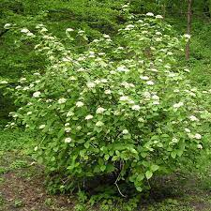
Viburnum lantana – Wayfaring Tree

This plant will provide nectar and pollen for bees and the many other types of pollinating insects.
A large, deciduous shrub to about 3m in height, with finely toothed, broadly ovate dark green leaves to 12cm long, and domed clusters of small tubular white flowers in late spring, followed by oval to rounded orange-red fruits which ripen to black

Size

Ultimate height
2.5–4 metres

Time to ultimate height
10–20 years

Ultimate spread
2.5–4 metres

Growing conditions
Chalk
Clay
Loam
Sand

Moisture
Moist but well–drained, Well–drained

pH
Acid, Alkaline, Neutral

When can I plant Viburnum?
If the ground isn't very wet or frozen, deciduous viburnums that lose their leaves over the winter should be planted in autumn or early spring. They have ample time to adjust before the hot, dry weather. Planting evergreens in the early spring or autumn is best because they keep their leaves throughout the year.

Position
- Full sun
- Partial shade

Aspect
West–facing or South–facing or North–facing or East–facing

Exposure
Exposed or Sheltered

Hardiness

Hardiness ratings - All ratings refer to the UK growing conditions unless otherwise stated. Minimum temperature ranges (in degrees C) are shown in brackets

H7 - hardy in the severest European continental climates (< -20)

Botanical details
Family
Viburnaceae
Native to the UK
No
Foliage
Deciduous
Habit
Bushy
Potentially harmful
Fruit are ornamental - not to be eaten. Wear gloves and other protective equipment when handling
Genus
Viburnum can be deciduous or evergreen shrubs with opposite, simple or palmately lobed leaves and clusters of small, often fragrant white or pink flowers, followed by red, blue or black berries
Name status
Accepted

How to grow

Cultivation
Suitable for shrub border or woodland garden. Grow in most moderately fertile, humus-rich, moist but well-drained soils in sun or part shade.

Suggested planting locations and garden types
- Cottage and informal garden
- Wildlife gardens
- Low Maintenance
- Hedging and screens

Pruning
Pruning group 8

Pests
May be susceptible to aphids and viburnum beetle

Diseases
May be susceptible to Phytophthora, honey fungus, grey moulds and leaf spot

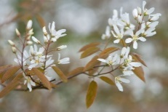
Amelanchier canadensis - Service Berry
A table displaying which months are best to sow, plant and harvest.
 | Jan | Feb | Mar | Apr | May | Jun | Jul | Aug | Sep | Oct | Nov | Dec
Flowers |  |  | Plant does flower in March | Plant does flower in April
- Botanical name: Amelanchier canadensis
- Common name: Service berry
- Family: Rosaceae
- Plant Type: Tree, Deciduous
Flower colour: White
Foliage colour: Green
- Key features:
- Attractive to wildlife
- Autumn colour
- Flowers

Amelanchier trees are small trees or shrubs, loved for their masses of star-shaped, spring flowers and intense autumn colour. They also bear edible berries, which are used in mufins and pancakes, and which are loved by birds. Due to their compact size and interest over several seasons, they make excellent trees for small gardens.
Amelanchier canadensis has more of a shrub-like form than other species, with upright blossoms. It bears white, star-shaped flowers in March and April, followed by bronze-tipped foliage which matures to a fresh green, before turning glorious shades of red and orange before falling in autumn. It’s perfect for using as a loose hedge or screen.
Grow Amelanchier canadensis in moist but well-drained, neutral to acidic soil in full sun to partial shade. A sunnier spot will result in the best autumn colour.. There’s usually very little need to prune amelanchiers, but you may wish to trim to shape in late winter.

How to grow Amelanchier canadensis
- Plant size
8m height
4m spread
- Aspect
South facing, east facing, west facing
- Position in border
Middle, back
- Sun exposure: Full sun, partial shade
- Hardiness: Hardy
- Soil type: Acidic / well drained / light / sandy

Plant calendar
A table displaying which months are best to sow, plant and harvest.
 | Jan | Feb | Mar | Apr | May | Jun | Jul | Aug | Sep | Oct | Nov | Dec
Flowers |  |  | Plant does flower in March | Plant does flower in April

Amelanchier canadensis and wildlife
Amelanchier canadensis is known for attracting bees and birds. It has nectar/pollen rich flowers and has seeds for birds.
Attractive to Bees
Does not attract Beneficial insects
Attractive to Birds
Does not attract Butterflies​/​Moths
Does not attract Other pollinators

Is Amelanchier canadensis poisonous?
Amelanchier canadensis has no toxic effects reported.

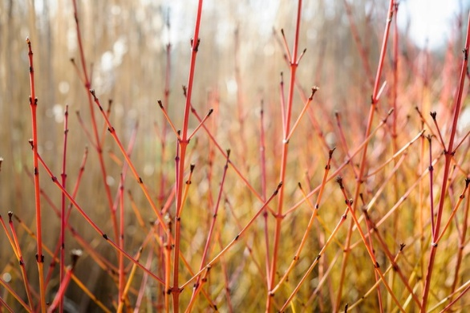
Cornus sanguinea 'Midwinter Fire' Common Dogwood
Dogwood Shrub, Deciduous

Family: Cornaceae
- Height: 3mSpread: 2.4m
- Hardy
- Attractive to wildlife
- Autumn colour
Flower colour: White

Foliage colour: Green

Position
Sun Exposure:
Full sun
Aspect:
South facing, west facing

Soil
Chalky / Alkaline / Clay / Heavy / Moist / Well Drained / Light / Sandy

Colourful-barked dogwoods are typically grown for winter colour, when their colourful, leafless stems shine like beacons in the bare winter garden. Cornus sanguinea has red stems, and looks fantastic when planted with evergreen shrubs, and among spring flowers.
Cornus sanguinea 'Midwinter Fire' has particularly striking autumn colour, especially if grown in full sun. It also bears off-white flowers in summer, followed by colourful berries.
Cornus sanguinea 'Midwinter Fire' is tolerant of a wide range of soil types. To keep the size of the plant in check and to encourage the most colourful bark, remove a third of the stems back to ground level each spring.

Plant calendar
 | Jan | Feb | Mar | Apr | May | Jun | Jul | Aug | Sep | Oct | Nov | Dec
Plant |  |  |  |  | yes | yes | yes | yes | yes
Flowers |  |  |  |  | yes | yes
Fruits |  |  |  |  |  |  |  | yes | yes | yes
Prune |  |  | yes

Cornus ‘Midwinter fire’ and wildlife
Cornus ‘Midwinter fire’ is known for attracting bees, birds, butterflies/moths and other pollinators. It is a caterpillar food plant, has nectar/pollen rich flowers and has seeds for birds.
Bees Is known to attract Bees
Beneficial Insects Is not known to attract Beneficial insects
Birds Is known to attract Birds
Butterflies/Moths Is known to attract Butterflies/​Moths
Other pollinators Is known to attract Other pollinators

Is Cornus ‘Midwinter fire’ poisonous?
Cornus ‘Midwinter fire’ has no toxic effects reported.
No reported toxicity to:
Birds
Cats
Dogs
Horses
Livestock
People

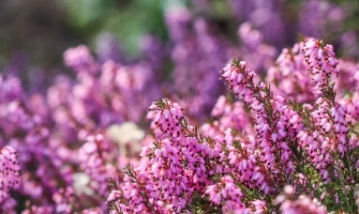
Erica carnea 'Carnea' heather

This plant will provide nectar and pollen for bees and the many other types of pollinating insects.

A spreading, low-growing, evergreen shrub to about 15cm with needle-like, mid-green foliage. Spikes of tiny flowers, shell pink darkening to lilac pink, appear from early to mid-spring

Size

Ultimate height 0.1–0.5 metres

Time to ultimate height 2–5 years

Ultimate spread 0.5–1 metres

Growing conditions

Chalk

Clay

Loam

Sand

Moisture Moist but well–drained, Well–drained

pH Acid, Neutral, Alkaline

Colour & scent
 | Stem | Flower | Foliage | Fruit
Spring |  | Pink | Green
Summer |  |  | Green
Autumn |  |  | Green
Winter |  |  | Green

Position Full sun

Aspect South–facing or West–facing or East–facing

Exposure Exposed or Sheltered

Hardiness

Hardiness ratings

All ratings refer to the UK growing conditions unless otherwise stated. Minimum temperature ranges (in degrees C) are shown in brackets
- H6: hardy in all of UK and northern Europe (-20 to -15)

Botanical details

Family Ericaceae

Native to GB / Ireland No

Foliage Evergreen

Habit Bushy

Genus Erica can be prostrate or erect, evergreen shrubs with fine, needle-like leaves in whorls, and racemes or panicles of small, bell-shaped or tubular flowers

How to grow

Cultivation A lime-tolerant heather, prefering well-drained, neutral to acid soil in full sun but tolerant of alkaline soils and some shade.

Propagation Propagate by semi-hardwood cuttings

Suggested planting locations and garden types
- City and courtyard gardens
- Cottage and informal garden
- Patio and container plants
- Low Maintenance
- Banks and slopes
- Flower borders and beds
- Ground cover

Pruning after flowering

Pests Generally pest-free

Diseases May be susceptible to fungal diseases, including honey fungus (rarely), and Phytophthora root rot, in wet conditions

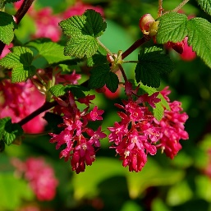
Ribes sanguineum 'King Edward VII'
- The RHS Award of Garden Merit (AGM) helps gardeners choose the best plants for their garden.

RHS Plants for Pollinators plants

This plant will provide nectar and pollen for bees and the many other types of pollinating insects.

It is included in an evolving list of plants carefully researched and chosen by RHS experts. Divided into 3 groups these lists, linked below, are maintained by a team of RHS staff and are reviewed annually.
  - Garden Plants
  - Wildflowers
  - Plants of the World
winter currant 'King Edward VII'
'King Edward VII' is an upright deciduous shrub to 2m tall, with lobed, aromatic leaves and deep red flowers in drooping racemes in spring, followed by white-bloomed, black berries

Size

Ultimate height
1.5–2.5 metres

Time to ultimate height
5–10 years

Ultimate spread
1–1.5 metres

Growing conditions
Chalk
Clay
Loam
Sand

Moisture
Moist but well–drained, Well–drained

pH
Acid, Alkaline, Neutral

Colour & scent
 | Stem | Flower | Foliage | Fruit
Spring |  | Red | Green
Summer |  |  | Green | Black
Autumn
Winter

Position
- Full sun

Aspect
South–facing or North–facing or West–facing or East–facing

Exposure
Exposed or Sheltered

Hardiness

Hardiness ratings

All ratings refer to the UK growing conditions unless otherwise stated. Minimum temperature ranges (in degrees C) are shown in brackets
- H6: hardy in all of UK and northern Europe (-20 to -15)

Botanical details
Family
Grossulariaceae
Native to the UK
No
Foliage
Deciduous
Habit
Bushy
Genus
Ribes can be deciduous or evergreen shrubs, sometimes spiny, with simple, usually palmately lobed leaves and small tubular or bell-shaped, solitary or racemose flowers borne in spring or summer, followed by juicy, sometimes edible berries
Name status
Accepted

How to grow

Cultivation
Easy to grow in moderately fertile well-drained soil in full sun. Useful for informal hedging

Propagation
Propagate by hardwood cuttings in winter

Suggested planting locations and garden types
- Coastal
- Cottage and informal garden
- City and courtyard gardens
- Flower borders and beds
- Hedging and screens

Pruning
Pruning group 2 or Pruning group 13 if wall trained, in late summer; trim hedges after flowering

Pests
May be susceptible to gall mites, gall midge and aphids

Diseases
May be susceptible to a leaf spot, powdery mildews, coral spot and sometimes honey fungus

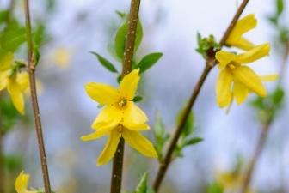
Forsythia x intermedia ‘Lynwood Variety’ - Forsythia
A table displaying which months are best to sow, plant and harvest.
 | Jan | Feb | Mar | Apr | May | Jun | Jul | Aug | Sep | Oct | Nov | Dec
Flowers |  |  | Plant does flower in March
- Botanical name: Forsythia x intermedia 'Lynwood Variety'
- Common name: Forsythia
- Family: Oleaceae
- Plant Type: Shrub, Deciduous
Flower colour: Yellow
Foliage colour: Green
- Key features:
- Flowers
Forsythias are reliable, colourful and easy to grow spring-flowering shrubs. There are many varieties, most of which grow as handsome large shrubs with an open informal habit, but they’re also excellent for growing against walls, and – with careful training – they can make eye-catching standards.
Forsythia x intermedia ‘Lynwood Variety’ bears masses of deep yellow blooms on bare stems, from early to mid-spring.
Plant Forsythia x intermedia ‘Lynwood Variety’ in sun or partial shade, ideally in moist but well drained soil. For the best blooms, cut branches back to a pair of strong buds just after flowering.

How to grow Forsythia 'Lynwood Variety'
- Plant size
3.5m height
3.5m spread
- Aspect
South facing, west facing
- Position in border
Middle, back
- Sun exposure: Dappled shade, full sun
- Hardiness: Hardy
- Soil type: Chalky / alkaline / clay / heavy / moist / well drained / light / sandy

Plant calendar
A table displaying which months are best to sow, plant and harvest.
 | Jan | Feb | Mar | Apr | May | Jun | Jul | Aug | Sep | Oct | Nov | Dec
Plant | Do Plant in January |  | Do Plant in March |  |  |  |  |  |  |  | Do Plant in November | Do Plant in December
Flowers |  |  | Plant does flower in March
Prune

Forsythia 'Lynwood Variety' and wildlife
Forsythia 'Lynwood Variety' has no particular known value to wildlife in the UK.

Is Forsythia 'Lynwood Variety' poisonous?

Forsythia 'Lynwood Variety' has no toxic effects reported.

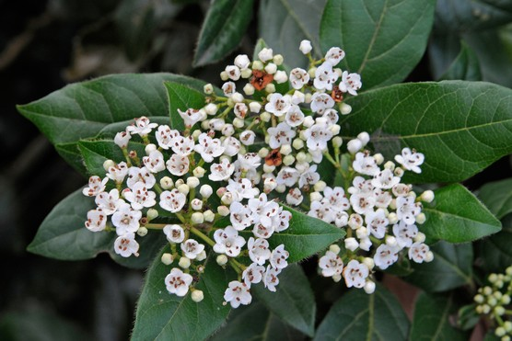
Viburnum tinus – Viburnum

Shrub, Evergreen

Family: Adoxaceae
- Height: 3mSpread: 3m
- Hardy
- Scented flowers

Flower colour:

White

Foliage colour:

Green

Position

Sun Exposure:

Dappled shade, full shade, full sun

Aspect:

South facing, west facing

Soil

Acidic / Chalky / Alkaline / Clay / Heavy / Moist / Well Drained / Light / Sandy

Viburnum tinus is a dense, evergreen shrub with dark and oval, glossy leaves, which contrast beautifully with fragrant pinkish-white flowers, followed by dark black fruit. It's a popular choice for hedging but may also be grown as a specimen shrub in a mixed border.

Grow Viburnum tinus in moist but well-drained soils in full sun to partial shade. Mulch annually with well-rotted manure or compost and cut back plants to retain their shape in early summer.

Plant calendar
 | Jan | Feb | Mar | Apr | May | Jun | Jul | Aug | Sep | Oct | Nov | Dec
Plant |  |  |  |  |  |  |  |  | yes | yes | yes
Flowers |  | yes | yes | yes
Fruits |  |  |  |  |  |  |  |  | yes | yes
Take cuttings |  |  |  |  |  | yes | yes | yes

Viburnum ‘Tinus’ and wildlife

Viburnum ‘Tinus’ has no particular known value to wildlife in the UK.

Is Viburnum ‘Tinus’ poisonous?

Viburnum ‘Tinus’ has no toxic effects reported.

No reported toxicity to:

Birds

Cats

Dogs

Horses

Livestock

People

Viburnum opulus - Guelder rose
A table displaying which months are best to sow, plant and harvest.
 | Jan | Feb | Mar | Apr | May | Jun | Jul | Aug | Sep | Oct | Nov | Dec
Flowers |  |  |  | Plant does flower in April | Plant does flower in May
Fruits |  |  |  |  |  |  |  | Plant does fruit in August | Plant does fruit in September
- Botanical name: Viburnum opulus
- Common name: Guelder rose
- Family: Adoxaceae
- Plant Type: Shrub, Deciduous
Flower colour: White
Foliage colour: Green
- Key features:
- Attractive to wildlife
- Autumn colour
- Flowers
- Fruits

The guelder rose, Viburnum opulus, is a hardy, vigorous native shrub suited to growing in woodland gardens or a shrub border. It offers interest for most of the year, bearing large, lacecap-like, white flowers from late spring to early summer, followed by bunches of small, bright red, fleshy fruit in autumn. Its deciduous, three-lobed, dark green leaves turn a striking shade of red before falling.
For best results grow Viburnum opulus in moist but well-drained soil in full sun to full shade. Once eastablished it will need little or no pruning.

How to grow Viburnum opulus
- Plant size
8m height
4m spread
- Aspect
North facing, south facing, east facing, west facing
- Position in border
Middle, back
- Sun exposure: Dappled shade, full shade, full sun, partial shade
- Hardiness: Hardy
- Soil type: Acidic / chalky / alkaline / clay / heavy / moist / well drained / light / sandy

Plant calendar
A table displaying which months are best to sow, plant and harvest.
 | Jan | Feb | Mar | Apr | May | Jun | Jul | Aug | Sep | Oct | Nov | Dec
Plant |  |  |  |  |  |  |  |  | Do Plant in September | Do Plant in October | Do Plant in November
Flowers |  |  |  | Plant does flower in April | Plant does flower in May
Fruits |  |  |  |  |  |  |  | Plant does fruit in August | Plant does fruit in September

Viburnum opulus and wildlife
Viburnum opulus is known for attracting bees, beneficial insects, birds, butterflies​/​moths and other pollinators. It is a caterpillar food plant, has nectar/pollen rich flowers, provides shelter and habitat, has seeds for birds and makes a good wildlife hedge.
Attractive to Bees
Attractive to Beneficial insects
Attractive to Birds
Attractive to Butterflies​/​Moths
Attractive to Other pollinators

Is Viburnum opulus poisonous?
Viburnum opulus has no toxic effects reported.

