Churches in the Bradley Stoke Benefice Application for a Service Level Agreement 2026-2027
2025 Report
2025 Church Youth Work Provision

The parishes of Christ the King Bradley Stoke and Holy Trinity Bradley Stoke provided youth work services in 2025, particularly through the provision of a volunteer resource network and church facilities for youth work sessions. The funds for this are legally managed by the Parish of Christ the King, Bradley Stoke. 2025 activities were supported by a Service Level Agreement of £2,350.00 from Bradley Stoke Town Council.

Group: Trailblazers
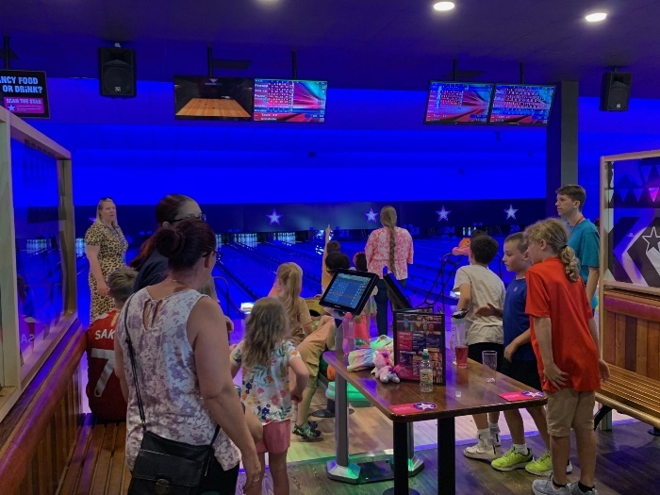
“Trailblazers” is Christ the King’s youth group aimed at children from Reception to Year 6. Trailblazers has had a fantastic year; 36 sessions took place with an average attendance of over 10 children. The evening is designed for the children to interact with each other and adults and junior leaders through games, individual and team challenges, races, a bible quiz, memory challenge and prayer square.
This year we were able to continue the arrangement of trips for the attendees at the end of each full term including going 10-pin bowling with the inclusion of some party food (see photo).
The group is lively and fun packed with a snack shack each week and we run from 6 – 7pm Wednesday evenings during term time.
Group: Fusion
Fusion (previously Friday Night ITCH) has provided a good set of sessions across 2024, aimed at the 11-14 age group, but accepting of a wider age range as friendship groups transition from Trailblazers. The group is on Friday, running 19:30 to 21:00.
Fusion kids are able to participate in pool, table tennis, table football, air hockey, large jenga and other arranged activities such as indoor cricket and various wide space format games. Running as a café format they can also relax and chat with their friends and the volunteers about daily life, social news and any other concerns. In the middle of the session we hold an intermission in a separate room with drinks and snacks to talk through a theme (with some biblical links). Through the year the kids have enjoyed time using the equipment and simply hanging out in the space we have available. This year the kids have requested a series of Board Game activities, which have been well supported throughout the sessions.

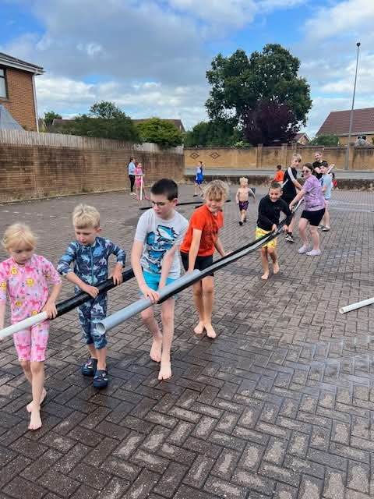
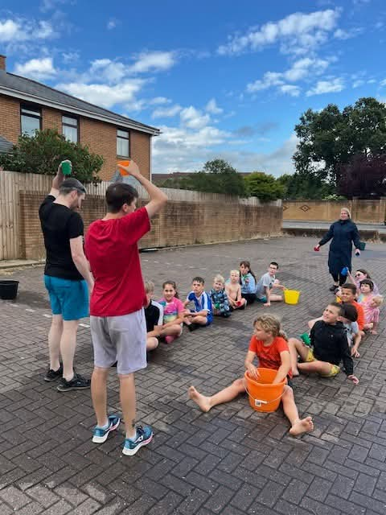
Fusion covers an age group with youths whose interests are growing and as such the sessions have had changing attendance both in numbers and individuals. Recently we have been sustained by a core group of approximately 4 children attending almost every week. We have run 28 sessions over 2025, with 115 attendees in total. The CRB checked volunteer leadership team work hard to keep continuity across the weeks and are pleased with the number of regularly attending children.

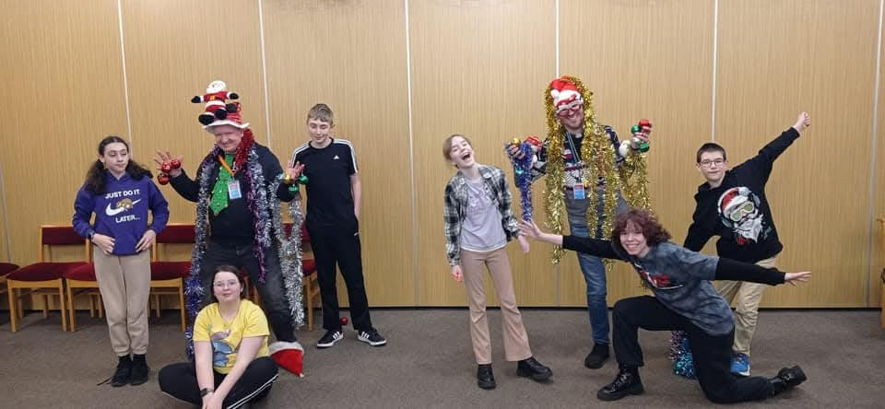

Holy Trinity Activities
There were 3 half-day day events held on Good Friday, in September at Harvest Festival time and also Christmas activities in December, at each of which there were 60-70 attendees.
Last year’s holiday club ran for three days (roughly 9:30-15:00) at the start of the summer holidays. The sessions had 80 7 to 11 years olds in attendance.
2025 Finances
Expenditure on youth work by Bradley Stoke Parish churches (including Youth Worker and room hire charges) has varied over 2025 and comes in at approximately £13,200.00. We are grateful for Bradley Stoke Town Council’s contributions in the past. We are of course, experiencing the need to pay more for energy and utilities bills to ensure the buildings are comfortable for use.
2025 Beneficiaries
We can report the following:
Number of Bradley Stoke youth benefiting from the project:
Total number attending Number of different individuals sessions attending
Trailblazers (age 5-12) 372 (~10/wk for 36 wks) 28
Fusion (age 11-15) 115 (~4/wk for 28 wks) 11
HTC Events 275 (All activities) 80
Total beneficiaries 762 (~14/wk and 69/event) 119

2025 Youth Session Provision Conclusion
2025 has seen a high number of youth sessions being provided with a good number of regular attendees, although a drop on the last year. We continue to look at the balance of the services across the community (as the age groups vary over time), which will require changing resources, as outlined within the new SLA application for 2025-2026.
Please contact us if you would like any further information about these activities.
The Church Councils of Christ the King, Bradley Stoke and Holy Trinity, Bradley Stoke thank you for your support.

SLA Application 2026-2027
We are grateful for the Service Level Agreement funding provided in earlier years and we would like to ask for this to re-start in 2026-27. Our provided resources (Vicar and a large team of volunteers) have been stable over the course of 2025-26 which has enabled us to have a core team to assist in the organisation of the volunteer community, which in turn provides a stable set of Youth sessions across the year. We wish to re-apply for the same level of SLA request we had in previous years, £2,350.00, requesting for Council support to continue this approach.
Christ the King and Holy Trinity Churches play an active role in the community and, through our youth projects we are in regular contact with approximately 80 children who come to our weekly youth groups and wider sessions.
Christ the King (CTK) And Holy Trinity Church (HTC) feels that engaging and educating youth in a safe and fun environment is key to helping them to develop social skills, life skills and confidence.
CTK and HTC continue to / intend to engage with youth through a number of groups:
- Trailblazers – this group meets on a Wednesday evening and is aimed at 5 to 12 year olds
- Fusion – this group meets on a Friday evening and is aimed at 11 to 15 year olds.
- There is a hope to develop a group for those aged 15-18, but efforts on the existing activities need to be stable for this can be assessed.
- Events are offered throughout the year which are of interest to youth as we work to partner with wider churches in Patchway and Stoke Gifford affording a wider format and style of events to the youth community. These include activities on Good Friday and at Harvest Festival, which are open to all and a Summer Holiday Club.
All of the groups are open for any youth in the community to attend. Youths attend our clubs from across Bradley Stoke and there is a very strong attendance from the local social housing families.
Trailblazers continues to have a high proportion of children from outside of the Church community – around 70%. Trailblazers has no charge for a session and is runs every week during term time.
The Friday night Fusion group had an average attendance of 4 per week with 50% from outside of the Church community. This group is free to attend and runs on Fridays during term time. We intend to run a full set of sessions with anticipated trips in 2026-2027.
We aim to provide an integrated youth service across all groups that is to a consistent high standard and that links groups together so that we do not ‘lose’ children as they transition from group to group. This is seen as a real strength and one of the reasons for providing overlapping ages across the sessions and then developing a separate provision for the 15-18 age group. These activities will continue to offer a different range of opportunities and are supported by a fantastic combined HTC / CTK Volunteer community.
All of the youth groups are run by volunteers co-ordinated with the Youth Worker Trainee – now around 20 volunteers across all of the groups. These volunteers range from 14-18 year olds who help as ‘young leaders’ (also helping them with their Duke of Edinburgh award volunteering needs) to retired individuals and everything in between.
In our youth groups the focus is on having fun, being creative, learning respect for leaders and peers, improving social skills and confidence, and team work. The groups do also represent the Christian faith whether through a story or a topic for discussion – this is done in a sensitive and engaging way without putting any pressure on the youths.
The projected annual costs of Bradley Stoke Parish youth provision for groups for 2026-27 are (maintained from 2024-2025 levels):

Hire Charges for use of Church £10,800 (detailed breakdown available based on sessions/yr)
Energy and Utilities Costs (approximated on time /yr) £ 600
Wider running (e.g. Building Maintenance, Cleaning, Insurance) £ 900
Youthwork materials £ 200 (teaching/discussion materials/DVDs/admin/photocopying)
Expenses for groups (refreshments, games equipment) £ 300
Group trips £ 400
Total projected costs £13,200
Projected income for youth provision (maintained from 2024-2025 levels):

Donations from Church Councils £10,800
(room hire and admin)
Donations from Church Councils (Youth Support) £ 650
Requested from Bradley Stoke Town Council as per 2024-2025 SLA £2,350
Total projected income £13,200

The outcomes for the youth provision over the year are expected to be:
Youth group sessions:
Trailblazers 36
Fusion 30
HTC 5 (Events)
Total number of sessions 71

Number of Bradley Stoke youth benefiting from the project:
Total number attending Number of different individuals sessions attending
Trailblazers (age 5-12) 504 (14/wk for 36 wks) 25
Fusion (age 11-15) 210 (7/wk for 30 wks) 12
HTC 300 (over 6 Events) 100
Total beneficiaries 1014 137

This project is made possible due to volunteers providing over 2,000 hours of their time at no cost.
Over the course of the year we also anticipate that the groups will be involved in community action – in previous years the groups have been involved in litter picking the local area, helping to fundraise at the Jubilee Centre Fireworks, having a stall at the Community Festival and painting fences as part of ‘the Noise’.

2026-2027 SLA Application Conclusion

We feel that this Service Level Agreement offers good value for money to Bradley Stoke Town Council as it would deliver a weekly term time youth provision to all ages at an average cost to the Council of around £33 per session (notably each attendee obtaining at least an hour of activity for just over £1.50 of Council SLA support).

The Church Councils of Christ the King, Bradley Stoke and Holy Trinity, Bradley Stoke are grateful for the on-going support received from Bradley Stoke Town Council towards its youth provision.

Without this Service Level Agreement the youth clubs will still continue as the Church feels that they are vital to the local community. However, there will be fewer resources available to run the clubs and make the clubs attractive for the youth, and potentially there may have to be fewer sessions throughout the year. This reduction in quality/effectiveness of youth service could mean the desired benefits of improving social skills and confidence for the youth cannot be achieved.

Application approved by the Parish Church Councils (PCC) of Christ the King, Bradley Stoke and Holy Trinity, Bradley Stoke.
Application submitted by Andy North, Christ the King Church.

