Residents Survey
Results and analysis of the Bradley Stoke Residents Survey
Agenda Item 7.3.3

Executive summary
The survey achieved up to 289 responses. Response numbers varied by question, with later sections generally receiving between 198 and 249 responses. The results provide a useful indication of residents’ views, but the survey is self-selecting and the respondent profile is not evenly distributed across age and gender groups.
7 / 10  Average satisfaction with Bradley Stoke as a place to live | 6 / 10  Average satisfaction with Town Council services | 5 / 10  Average feeling of being informed about Town Council work
86%  Feel very safe or safe during daylight hours | 99%  Rate community safety as important or very important | 61%  Would like more community fairs and markets

Headline findings
- Satisfaction with Bradley Stoke as a place to live is positive overall, with an average score of 7/10, while satisfaction with Town Council services is lower at 6/10.
- Residents feel substantially safer during the day than at night: 86.09% report feeling safe or very safe in daylight, compared with 43.53% at night.
- Community safety is the clearest priority, rated important or very important by 98.68% of respondents. Environment (88.26%) and enhancement of open spaces (84.72%) also rank highly.
- Fireworks is the best-attended listed Council event (55.23%). Looking ahead, 60.59% would like more community fairs and markets.
- Social media is currently the dominant information channel (74.04%), but demand for the newsletter (63.16%) and Council website (30.70%) is materially higher than current use.
- Traffic and congestion is the weakest transport-related measure: 69.53% are dissatisfied or very dissatisfied.

1. Survey reach and respondent profile
The attached SurveyMonkey export records 289 responses to the opening questions. The number answering individual questions then varies, so percentages in this report use the denominator shown for each question rather than assuming a single fixed sample size.
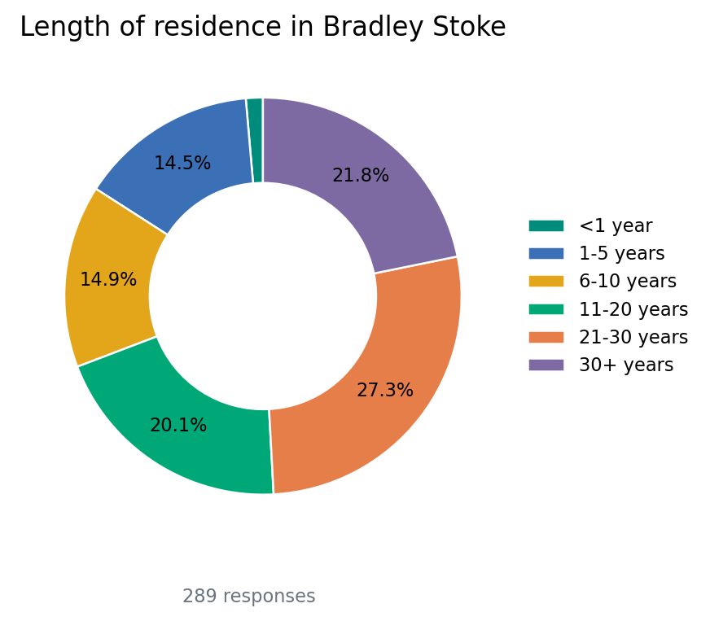
Figure 1. Length of residence in Bradley Stoke (Q2, 289 responses).
Nearly half of respondents have lived in Bradley Stoke for more than 20 years: 27.34% for 21-30 years and 21.80% for more than 30 years. This gives the survey a strong contribution from long-standing residents, but relatively few responses from residents who moved to the area within the last year (1.38%).

2. Satisfaction, safety and sense of community
Overall satisfaction with Bradley Stoke as a place to live is reported as 7/10 (265 respondents). Satisfaction with services provided by Bradley Stoke Town Council is reported as 6/10 (198 respondents).
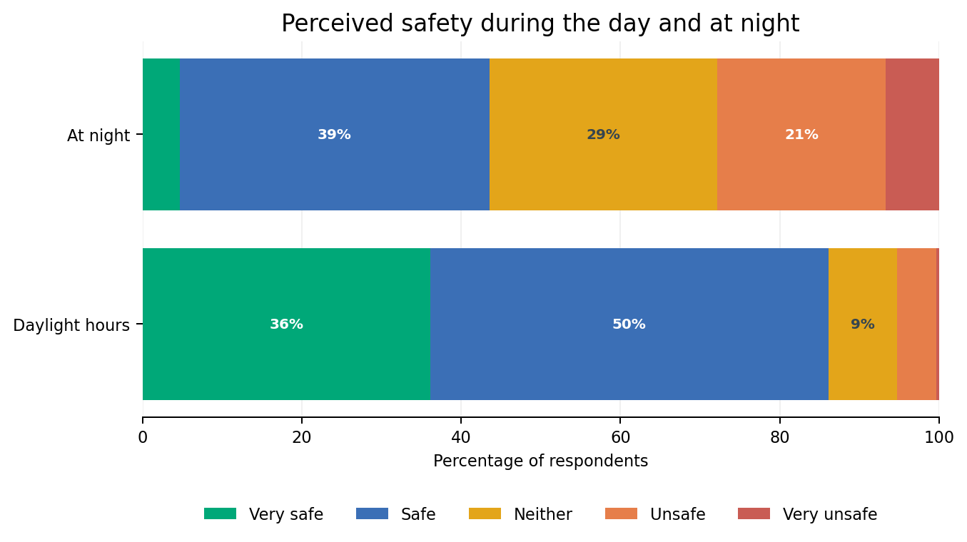
Figure 2. Perceived safety in daylight and at night (Q4).
The day/night contrast is pronounced. During daylight hours, 36.09% feel very safe and 50.00% safe. At night, only 4.71% feel very safe and 38.82% safe, while 21.18% feel unsafe and 6.67% very unsafe. This is consistent with community safety being the highest-rated priority later in the survey.
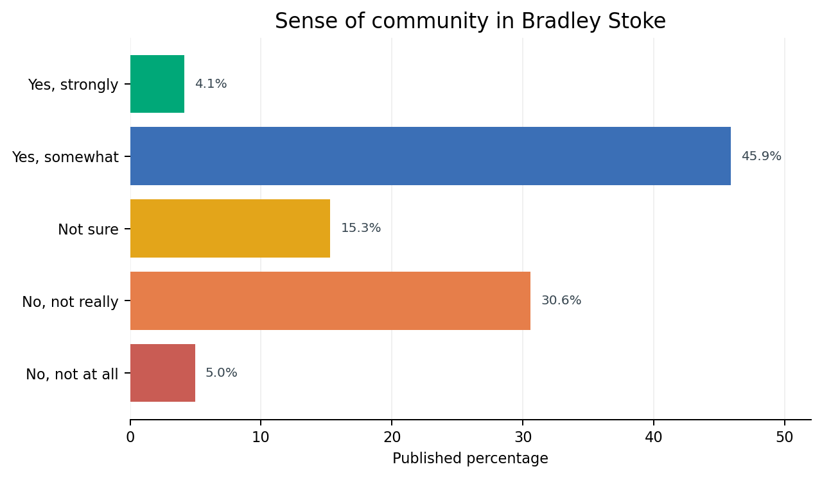
Figure 3. Published response percentages for sense of community (Q9).
The published Q9 figures show 50.00% selecting either “yes, strongly” or “yes, somewhat”, 15.29% “not sure”, and 35.54% selecting either negative option. The source export contains a small internal inconsistency for this question: the category counts total 244 while the page states 242 total respondents. The chart therefore reproduces the published percentages rather than recalculating them.

3. Use of facilities and local amenities
Use varies sharply between everyday amenities and Council/community facilities. Local shops are used daily or weekly by 94.78% of respondents. The Nature Reserve is also heavily used, with 55.64% visiting daily or weekly and only 4.84% saying they never use it.
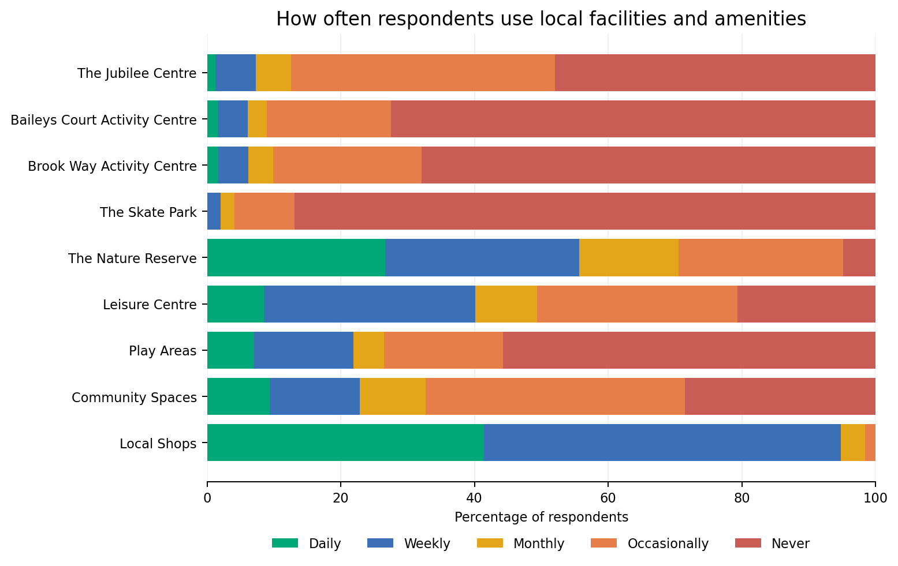
Figure 4. Frequency of use of facilities and amenities (Q6).
The Skate Park has the lowest recorded use among respondents, with 86.94% saying they never use it. Baileys Court Activity Centre (72.47% never), Brook Way Activity Centre (67.90% never) and Play Areas (55.79% never) also have high “never” responses within this survey sample. These results should be interpreted alongside the demographic profile, particularly the absence of under-18 respondents.

4. Community events and future activity
Of the listed Town Council events, Fireworks has the strongest reported reach. 35.56% selected “none of the above”, showing that a substantial minority of respondents had not attended any of the listed events during the previous 12 months.
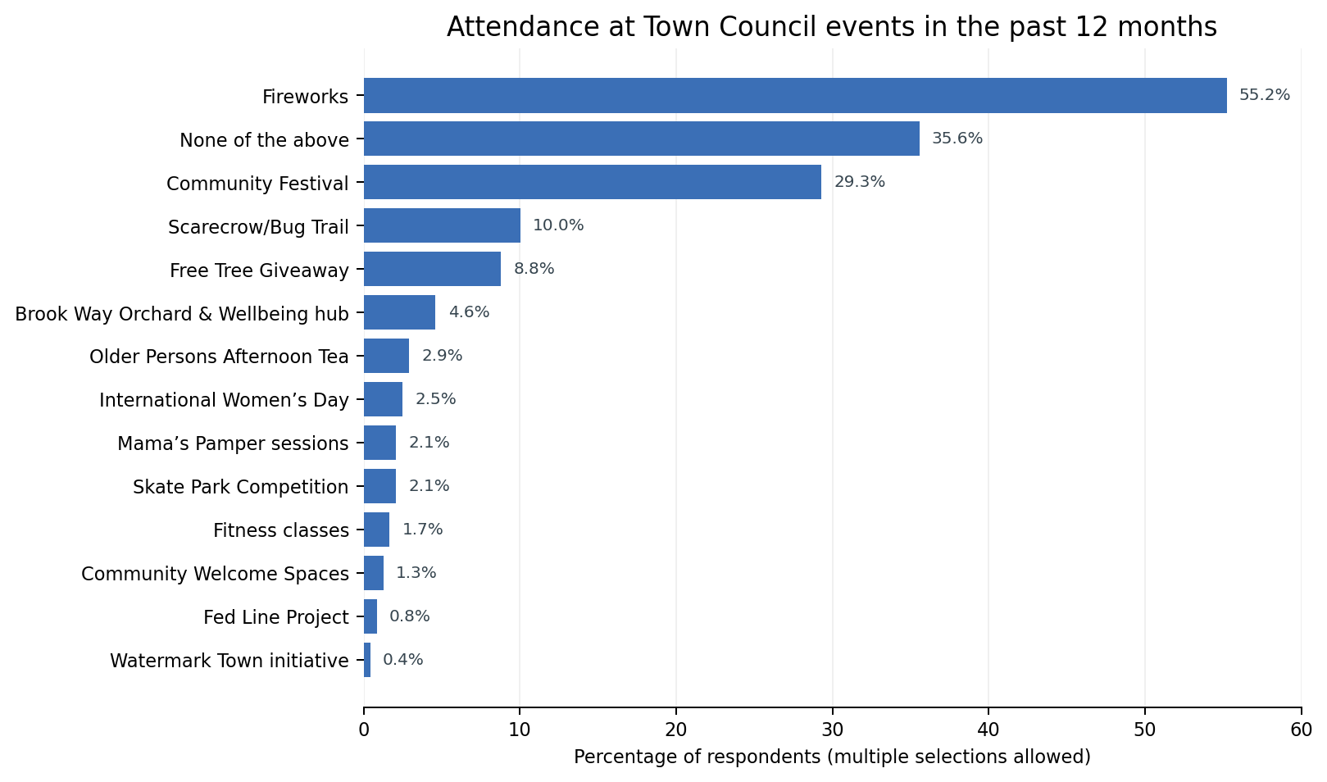
Figure 5. Attendance at Town Council events in the past 12 months (Q10, multiple selections allowed).
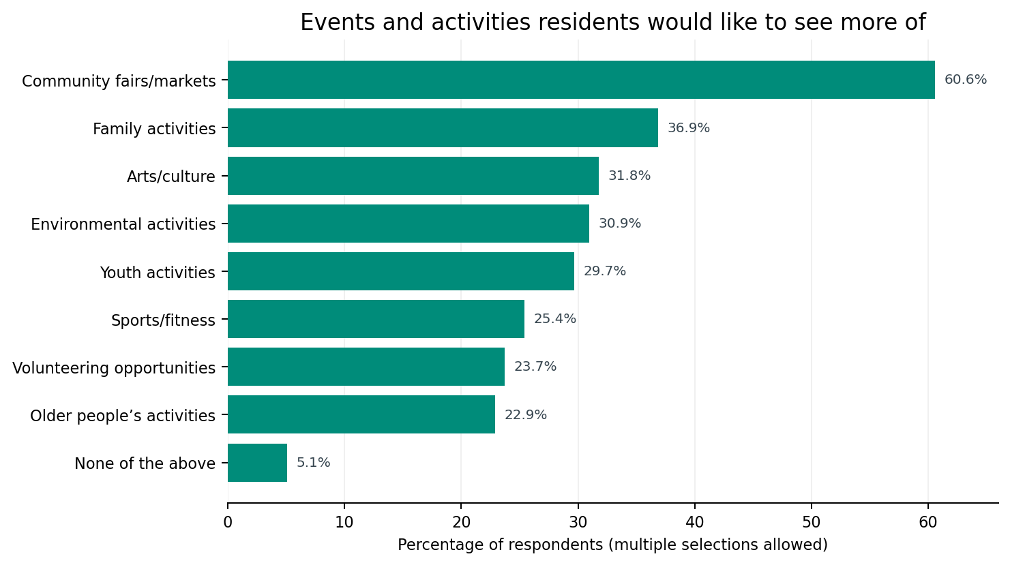
Figure 6. Types of events or activities residents would like to see more of (Q11, multiple selections allowed).
Community fairs and markets stand out as the clearest area of additional demand at 60.59%. Family activities rank second at 36.86%, followed by arts/culture (31.78%), environmental activities (30.93%) and youth activities (29.66%). Only 5.08% selected “none of the above”.

5. Communications and engagement
Residents rated how well informed they feel about the work of Bradley Stoke Town Council at an average of 5/10 (230 respondents). The channel results suggest that the issue is not simply the absence of communication, but also the mix of channels used.
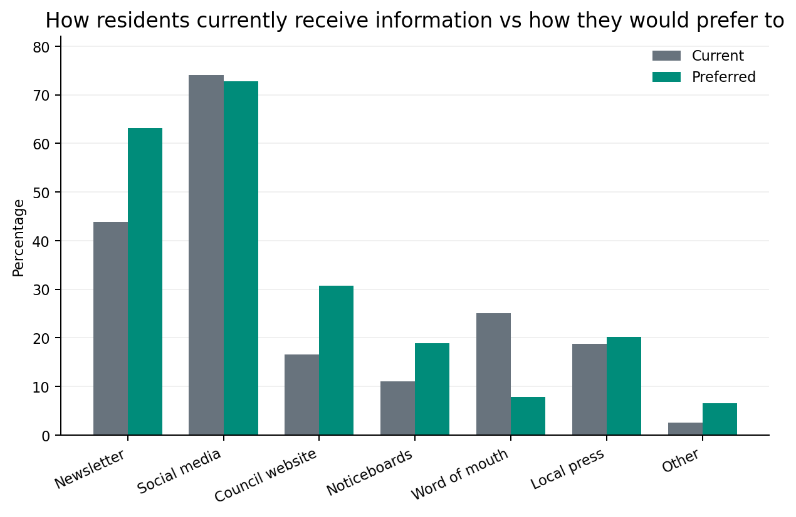
Figure 7. Current and preferred information channels (Q14 and Q16, multiple selections allowed).
Social media remains the strongest channel, with 74.04% currently receiving information this way and 72.81% preferring it. However, the newsletter shows the largest positive gap between current and preferred use, rising from 43.83% to 63.16%. Preference for the Council website also increases from 16.60% to 30.70%, and noticeboards from 11.06% to 18.86%. Word of mouth moves in the opposite direction, from 25.11% current use to 7.89% preferred.

6. Travel, roads and transport-related satisfaction
Car/van and walking are both widely used, reflecting a mixed pattern of motorised and active travel. Bus use is reported by 29.66% and cycling by 18.22%.
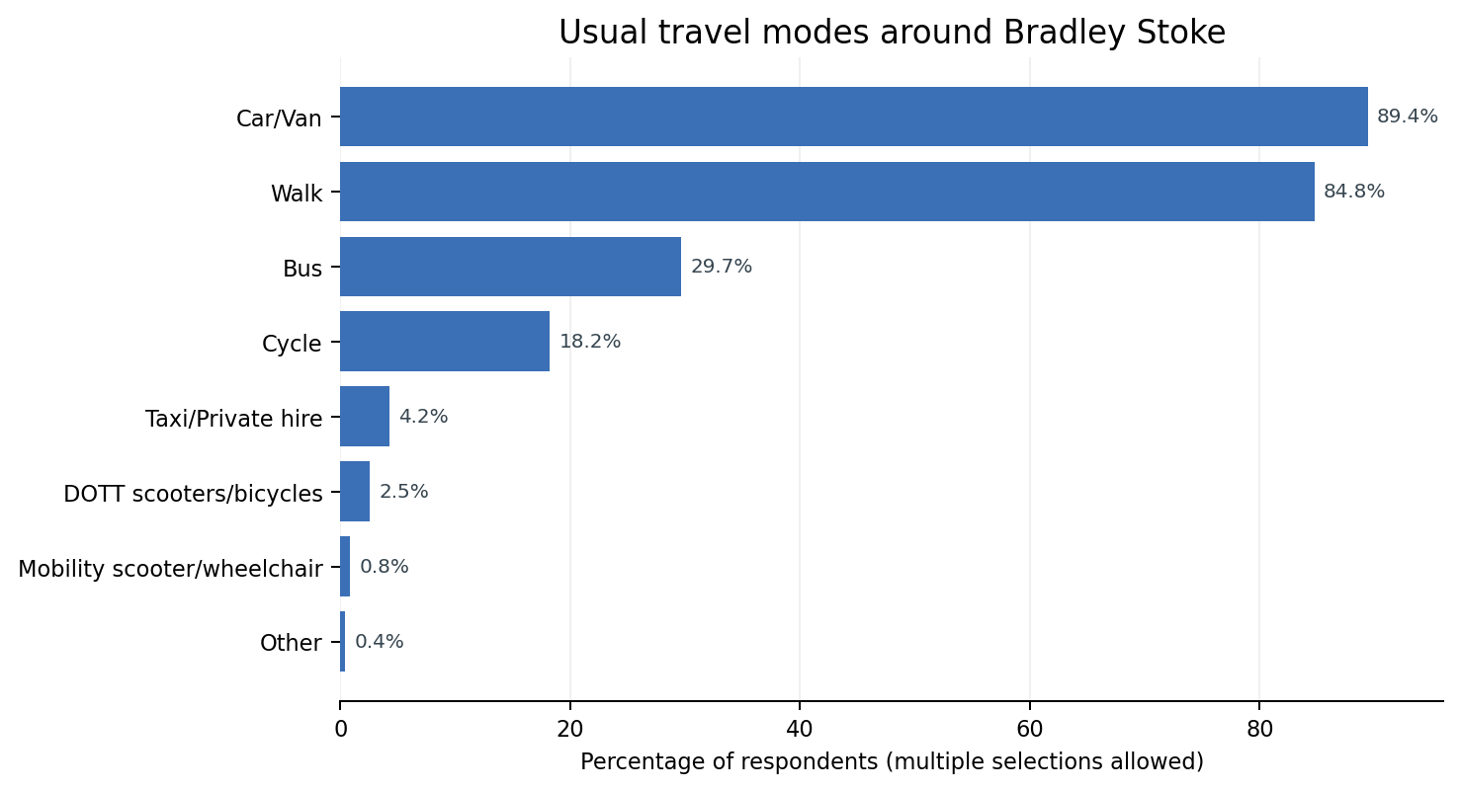
Figure 8. Usual travel modes around Bradley Stoke (Q18, multiple selections allowed).
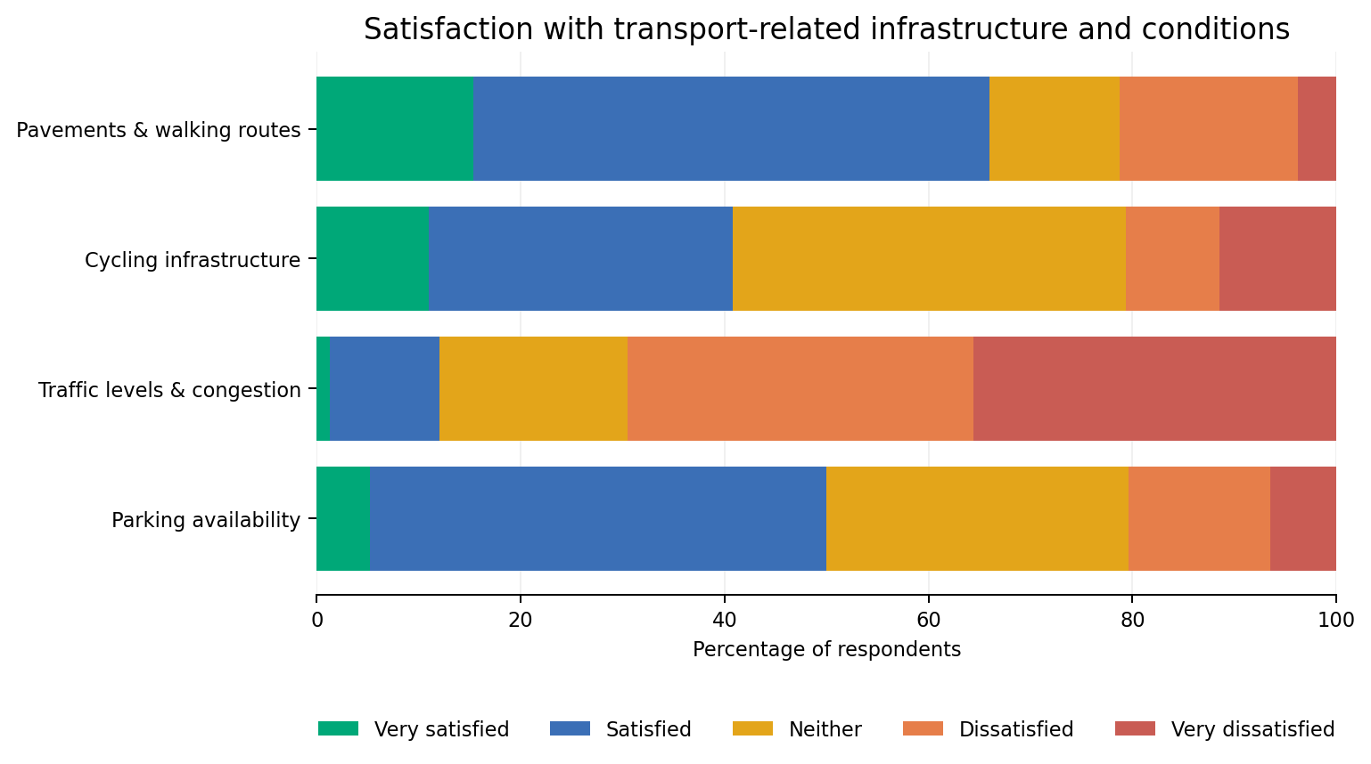
Figure 9. Satisfaction with walking, cycling, traffic and parking (Q20).
Pavements and walking routes perform relatively strongly, with 65.96% satisfied or very satisfied. Parking is more evenly balanced, with 50.00% satisfied or very satisfied and 20.43% dissatisfied or very dissatisfied. Traffic and congestion is the clear weakness: 69.53% are dissatisfied or very dissatisfied, compared with only 12.02% satisfied or very satisfied. Cycling infrastructure has a large neutral group (38.53%), with 40.83% satisfied or very satisfied and 20.64% dissatisfied or very dissatisfied.

7. Priorities for Bradley Stoke
Respondents were asked to rate nine issues from “very important” to “not important”. The chart below combines “very important” and “important” responses to show the relative strength of support.
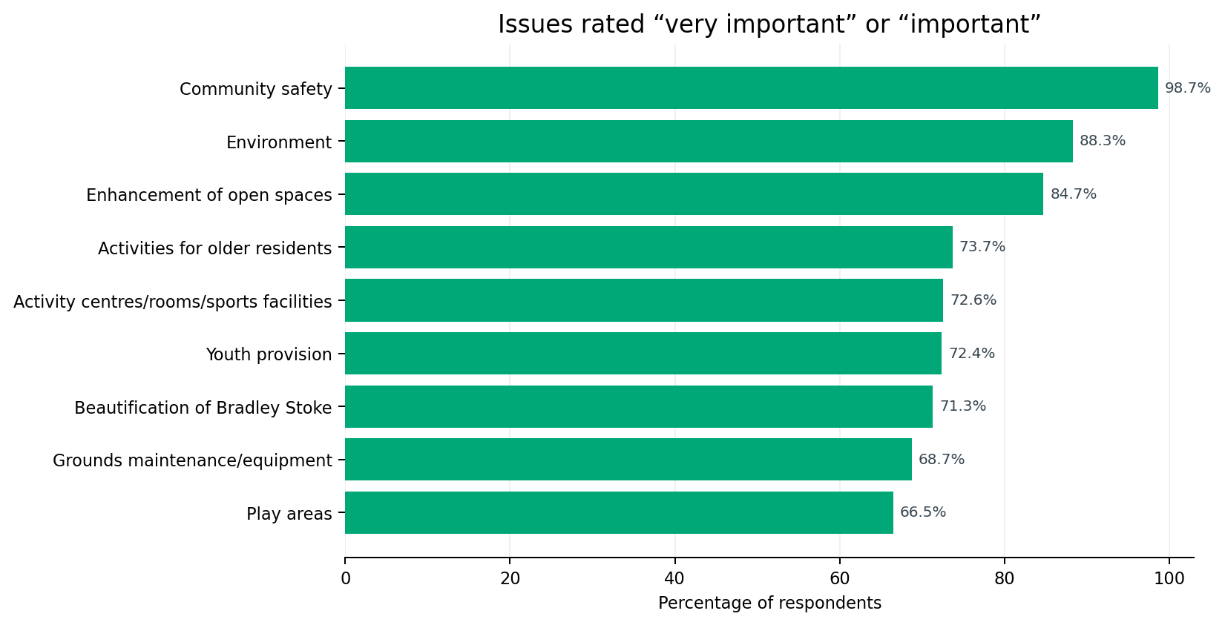
Figure 10. Issues rated important or very important (Q22).
Community safety is the dominant priority at 98.68%, including 75.00% who selected “very important”. Environment (88.26%) and enhancement of open spaces (84.72%) form the next tier. All nine listed issues receive majority support, with even the lowest-ranked item, play areas, rated important or very important by 66.52%.

8. Respondent profile and interpretation
Age profile | Gender profile
No under-18 respondents. Published figures indicate 68.61% aged 35-64. | 70.09% female, 25.89% male, 3.57% prefer not to say and 0.45% non-binary.

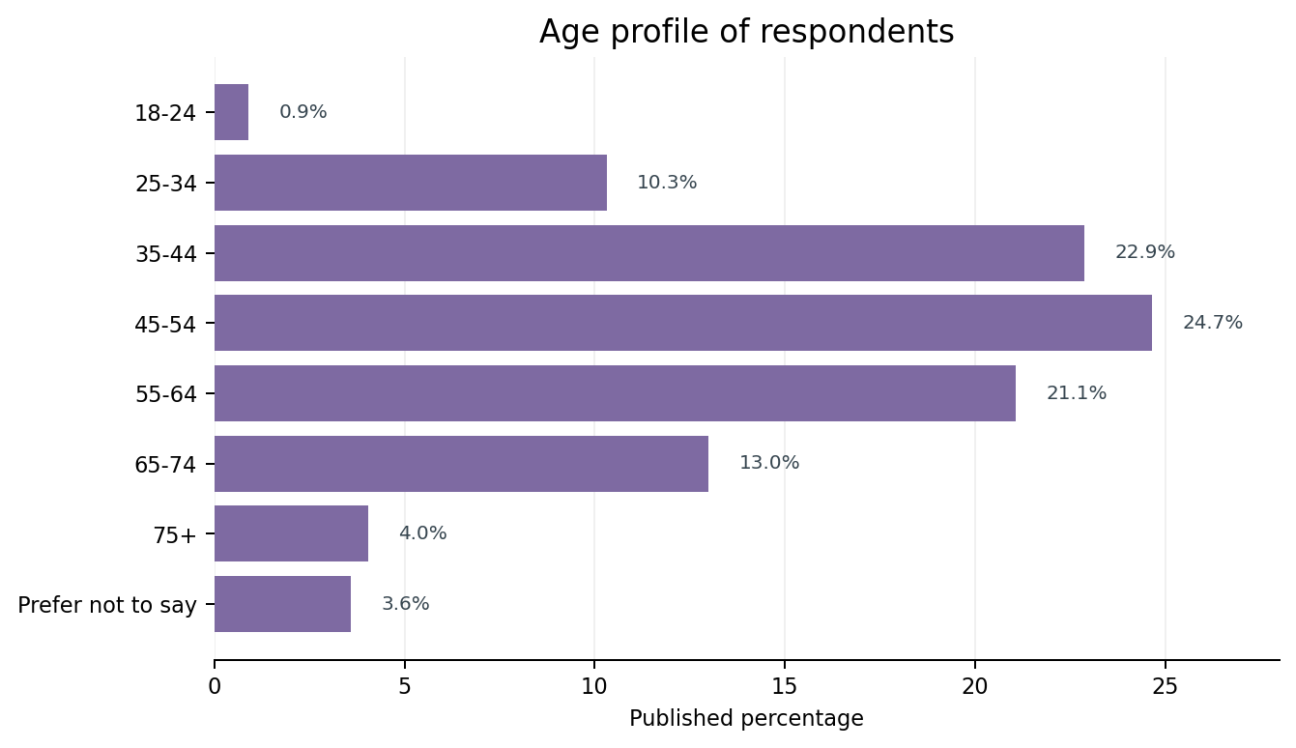
Figure 11. Published age profile (Q25).
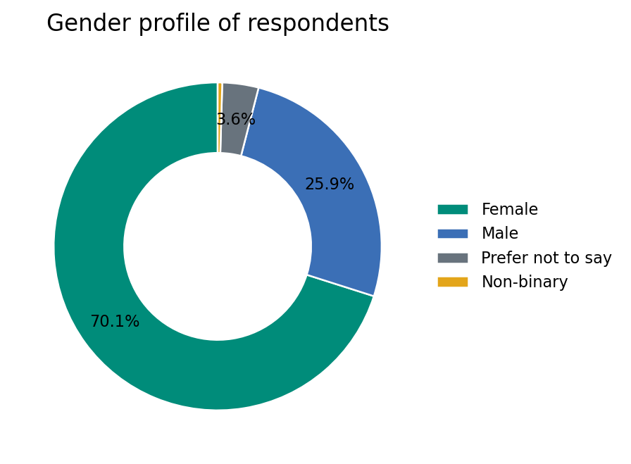
Figure 12. Gender profile (Q26).
The profile matters when interpreting service-use results. In particular, the survey contains no under-18 respondents and only 0.90% aged 18-24, while women account for 70.09% of gender responses. The age export also contains a small internal inconsistency: category counts total 224 while the page states 223 total respondents. As with Q9, published percentages are therefore reproduced rather than recalculated.

9. Qualitative responses and data limitations
Several questions invited free-text responses, including areas needing improvement, missing facilities or services, roads and junctions of concern, suggestions for improvement and other comments. The attached “Data All” PDF records the number of responses to these questions but does not contain the text of the responses. A defensible thematic analysis cannot therefore be completed from this export alone.
Free-text response volumes recorded in the export
Question | Responses
Q5 - areas where improvements are needed | 172
Q8 - facilities or services felt to be missing | 142
Q21 - roads or junctions of concern | 147
Q23 - suggestions to improve Bradley Stoke | 106
Q24 - other comments | 78
Interpretation cautions
- The survey is self-selecting, so the results should be treated as indicative of respondents’ views rather than a statistically representative sample of all Bradley Stoke residents.
- Question response counts vary materially. Percentages should be interpreted against the denominator for that individual question.
- Questions allowing multiple selections will legitimately total more than 100%.
- The attached export contains minor internal inconsistencies in at least Q9 and Q25, where the listed category counts do not match the stated total respondents. This report reproduces the published percentages rather than silently correcting the source.
- Open-text comments are not included in the attached export, so recurring themes, locations and specific service requests cannot yet be assessed.

10. Matters for consideration
The quantitative results identify several clear areas for member consideration: community safety; the environment and open spaces; traffic and congestion; the balance of communication channels; and demand for community fairs/markets and broader family, cultural, environmental and youth activity.
Before any decisions are based on individual locations, facilities or road/junction concerns, the free-text responses should be exported from SurveyMonkey and analysed thematically. That would allow the Council to distinguish isolated comments from repeated issues and, where appropriate, separate matters within the Town Council’s control from those requiring referral to South Gloucestershire Council or other bodies.
Council is asked to:
- note the quantitative results of the Residents Survey set out in this report;
- note the limitations of the respondent profile and minor inconsistencies in the SurveyMonkey export;
- request or receive a separate thematic analysis of the free-text responses before drawing conclusions on specific locations or service proposals; and
- consider how the identified priorities should inform future service planning, communications and community activity.

Appendix A - Key quantitative results
Q | Measure | Result | Responses
Q2 | Length of residence | 49.14% have lived in Bradley Stoke for more than 20 years | 289
Q3 | Satisfaction with Bradley Stoke | Average 7/10 | 265
Q4 | Safety - daylight | 86.09% very safe or safe | 266
Q4 | Safety - night | 43.53% very safe or safe; 27.85% unsafe or very unsafe | 255
Q7 | Satisfaction with Town Council services | Average 6/10 | 198
Q9 | Sense of community | 50.00% positive on published percentages | 242 stated
Q10 | Most-attended listed event | Fireworks - 55.23% | 239
Q11 | Most requested future activity | Community fairs/markets - 60.59% | 236
Q13 | How well informed | Average 5/10 | 230
Q14 | Main current information channel | Social media - 74.04% | 235
Q16 | Main preferred information channel | Social media - 72.81%; newsletter - 63.16% | 228
Q18 | Main travel modes | Car/Van - 89.41%; Walk - 84.75% | 236
Q20 | Traffic/congestion | 69.53% dissatisfied or very dissatisfied | 233
Q22 | Community safety importance | 98.68% important or very important | 228
Q22 | Environment importance | 88.26% important or very important | 230
Q22 | Open spaces importance | 84.72% important or very important | 229
Source: Bradley Stoke Residents Survey, SurveyMonkey “Data All” export dated 8 September 2026. Percentages and response counts are reproduced from the source export unless explicitly identified as combined figures.

