BRADLEY STOKE TOWN COUNCIL

Baileys Court Activity Centre Redevelopment
Public Consultation Results Report including Bradley Stoke Resident Analysis
Report date | 21 July 2026
Report author | Philip Francis-Barber, Facilities & Operations Manager / Deputy Town Clerk
Decision required | To note the full consultation and resident-filtered results and agree how each should inform the next stage of the project

Headline finding
The consultation shows strong support for Baileys Court remaining a long-term community facility and a clear expectation that refurbishment would increase future use. The separate analysis of the 75 respondents who confirmed that they live in Bradley Stoke reaches the same broad conclusion, but exposes material differences in usage, funding concerns and improvement priorities. Resident respondents placed slightly less emphasis on sports changing rooms, expressed greater concern about borrowing and debt, and were more likely to oppose the project proceeding than the full sample.

90  Total responses | 8.72/10  Importance of long-term retention | 7.94/10  Likelihood of increased use
5.36/10  Current facility performance | 63.38%  Selected café / social space | 34.92%  Selected disruption or parking concerns

Background
Bradley Stoke Town Council undertook a public consultation on the proposed redevelopment of Baileys Court Activity Centre. The final survey export supplied for this report records 90 responses. This report is deliberately limited to the consultation evidence: it does not assess the architectural design, construction cost plan, grant prospects or previous Council and Working Group decisions, except where those matters formed part of the questions put to respondents.
The consultation included questions on respondents’ connection to Bradley Stoke and the centre, current usage, how well the existing facility meets community needs, the importance of retaining the centre, priorities for improvement, likely future use, funding preferences, acceptable borrowing terms, the importance of minimising interest and concerns about the project.

Purpose of Report
The purpose of this report is to present the published consultation results in a clear form, identify the strongest and weakest signals within the data, explain the limitations of the exercise and provide an officer recommendation on how the evidence should be used in the next stage of the project.

Consultation Participation and Respondent Profile
The survey received 90 responses. Of these, 75 respondents, representing 83.33%, stated that they live in Bradley Stoke. The remaining 15 selected the survey’s “other” response. This gives the consultation a strong local component, although it does not establish that the sample is representative of Bradley Stoke’s population as a whole.
When respondents were asked to identify their relationship to the centre, they could select more than one category. The most common selections were resident, chosen by 69 respondents; member of a sports club, chosen by 25; and regular user of Baileys Court Activity Centre, chosen by 21. Eight respondents identified as a parent or childcare user, one as a local business owner and one selected other. No respondents selected hirer/organiser or stakeholder. The 125 selections therefore describe overlapping relationships rather than 125 separate respondents.
Respondent category | Responses | Published percentage
Resident | 69 | 76.67%
Sports-club member | 25 | 27.78%
Regular centre user | 21 | 23.33%
Parent / childcare user | 8 | 8.89%
Local business owner | 1 | 1.11%
Other | 1 | 1.11%

Current Use of the Centre
Weekly use was the largest single category, with 36 published responses, or 40.00%. A further 6 responses were monthly and 12 were occasional. Fifteen respondents reported using the centre rarely and 22 selected never. This indicates that the consultation reached both established users and people who do not currently use the centre.
Data-quality point
The survey export states that there were 90 respondents to this question but records 91 selections. The percentages and counts below are therefore reproduced as published and should not be recalculated as though they form a clean single-choice total.

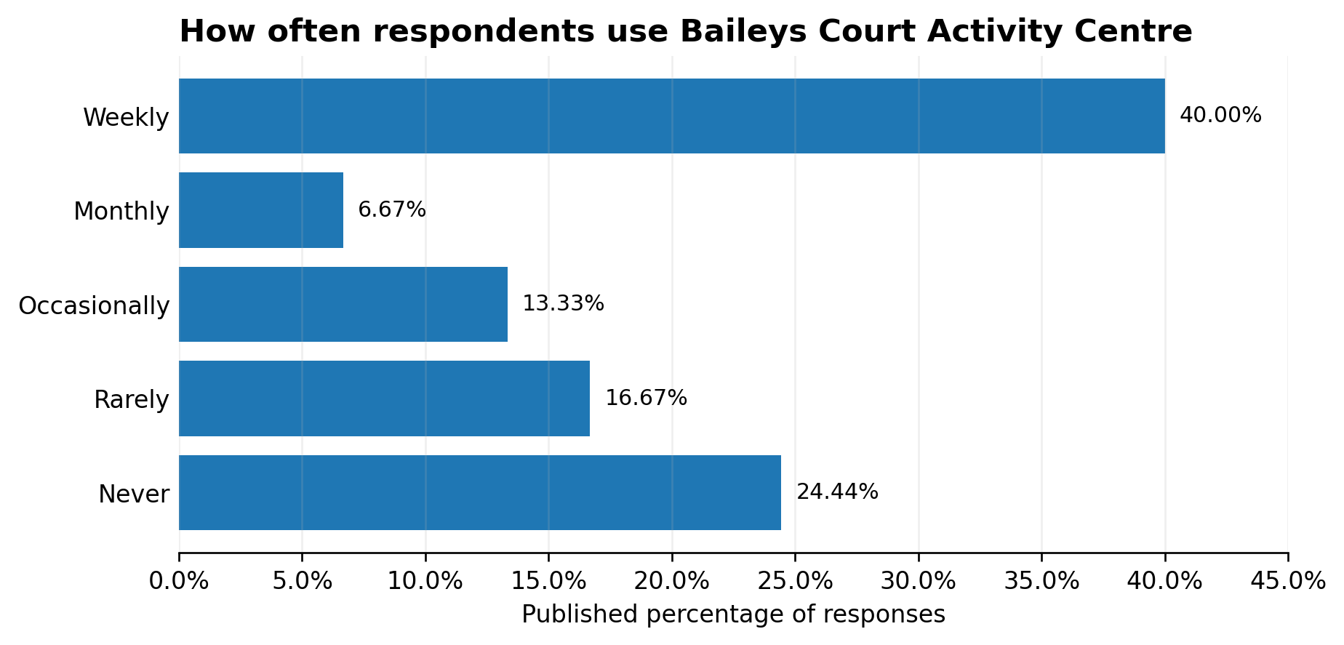
Figure 1 - Published frequency of use of Baileys Court Activity Centre.

Assessment of the Existing Facility and Strategic Importance
Seventy-three respondents scored how well Baileys Court currently meets community needs. The average was 5.36 out of 10, with a median of 5. This is a moderate result rather than evidence that the present building is performing strongly.
By contrast, 71 respondents rated the importance of Baileys Court remaining a long-term community facility at an average of 8.72 out of 10, with a median of 10. The difference of 3.36 points between current performance and long-term importance is one of the clearest findings from the consultation: respondents place substantially greater value on the centre’s future role than on its present condition or capability.
The likely effect of improvements was also positive. Respondents gave an average score of 7.94 out of 10 when asked how likely they would be to use Baileys Court more often if improvements were made. The minimum score recorded was 4, meaning that none of the 71 respondents answering this question selected the lowest three points on the scale.
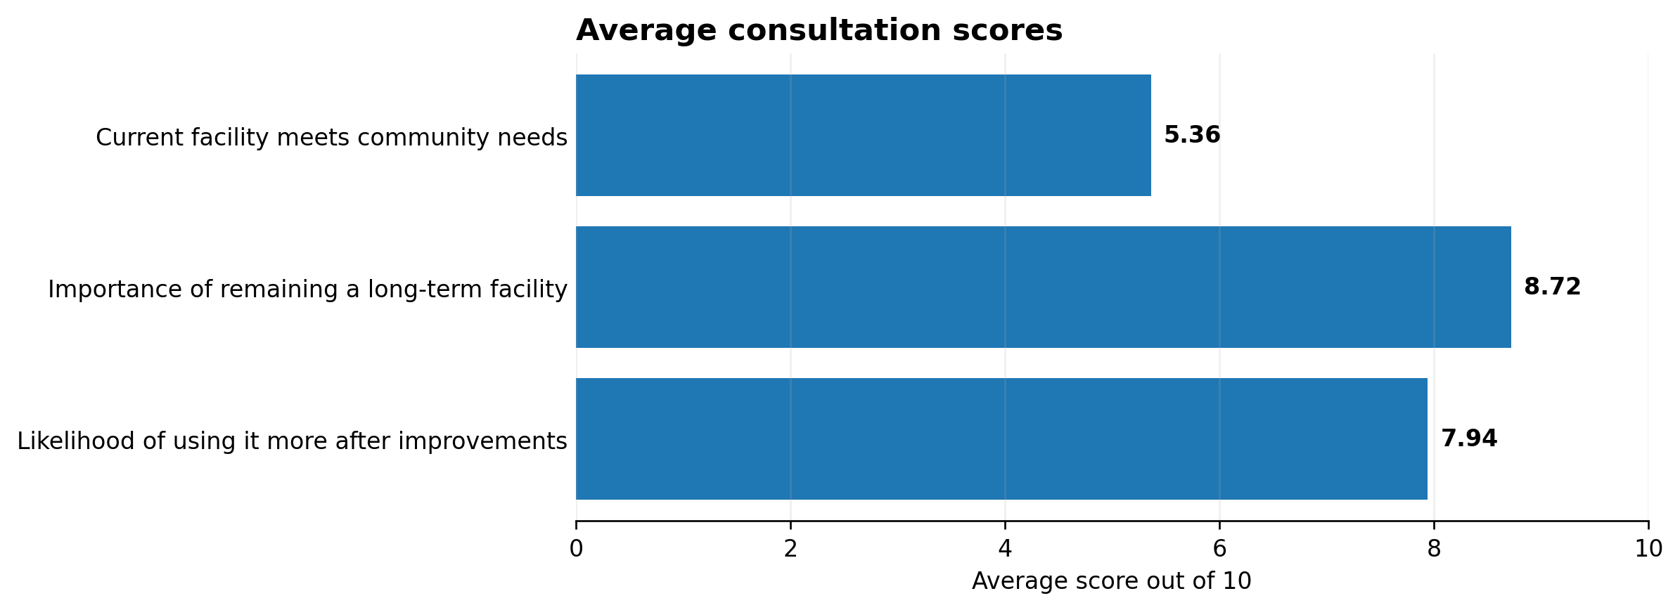
Figure 2 - Average scores for current performance, strategic importance and likely increased use.

Priorities for Improvement
Respondents were allowed to select up to five improvements. The strongest preference was for a café or social space, selected by 45 of 71 respondents, or 63.38%. Modern community halls ranked second at 50.70%, followed by improved sports changing rooms at 42.25%, upgraded kitchens at 36.62% and a Changing Places toilet at 33.80%.
The results indicate that respondents are not seeking only a sports refurbishment or only a building-maintenance project. The highest-ranked choices combine broader social and community use with sports, kitchen and accessible-facility improvements. Sustainability and energy-efficiency upgrades were selected by 29.58%, while improved external areas and better accessibility facilities were selected by 26.76% and 25.35% respectively.
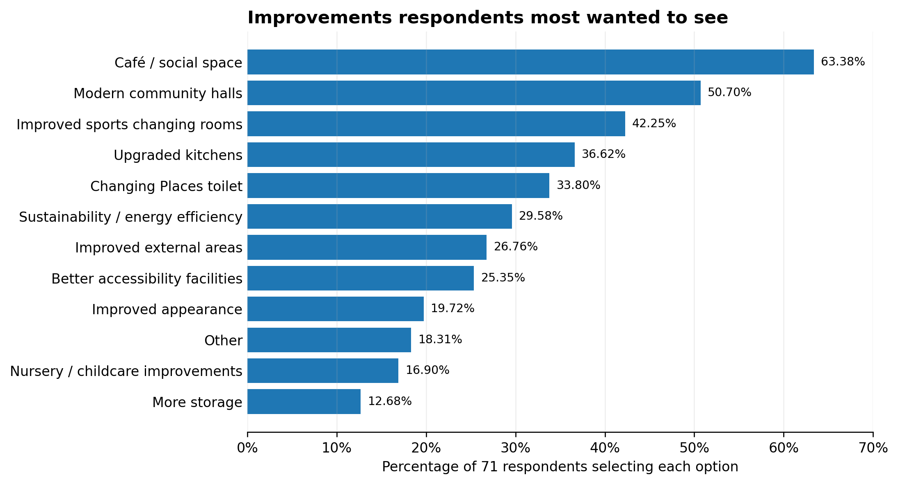
Figure 3 - Improvements most frequently selected by respondents.
Improvement | Responses | Percentage
Café / social space | 45 | 63.38%
Modern community halls | 36 | 50.70%
Improved sports changing rooms | 30 | 42.25%
Upgraded kitchens | 26 | 36.62%
Changing Places toilet | 24 | 33.80%
Sustainability and energy efficiency | 21 | 29.58%
Improved external areas | 19 | 26.76%
Better accessibility facilities | 18 | 25.35%
Improved appearance | 14 | 19.72%
Other | 13 | 18.31%
Nursery / childcare improvements | 12 | 16.90%
More storage | 9 | 12.68%

Funding Preferences
The funding question was answered by 64 respondents, equivalent to 71.11% of the full consultation sample. It asked respondents to assume that external funding would meet approximately 60% of the project cost and that the remaining balance would be about £640,000. These were consultation assumptions and this report does not validate them as a current project budget or confirmed grant position.
No preference was the largest individual response at 29.69%. A one-off precept increase for one year was selected by 18.75%. Borrowing over 5, 10, 20 or 40 years was selected by a combined 37.51%, but support was divided across the terms. Fourteen per cent did not support the project proceeding. Overall, 56.26% selected one of the specific funding routes presented, but no individual route secured majority support.
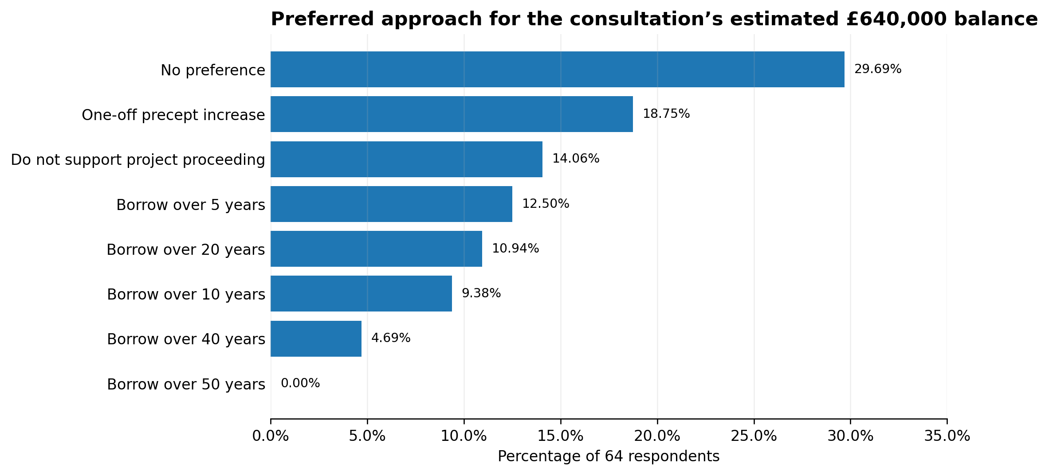
Figure 4 - Preferred funding approach for the consultation’s assumed £640,000 balance.

Borrowing Period and Interest
When respondents were asked which borrowing period would be most acceptable if borrowing were required, 5 years and 20 years were tied at 23.44% each, followed by 10 years at 18.75%. Only one respondent selected 30 years, none selected 40 years and two selected 50 years. Nineteen respondents, or 29.69%, selected none of the above. This does not create a clear preferred loan term, although 65.63% of all respondents to the question selected a period between 5 and 20 years.
Minimising total interest was important to a clear majority. Of 64 respondents, 40.63% said it was extremely important and 23.44% said very important. A further 15.63% said somewhat important. Taken together, 79.70% considered minimising lifetime interest at least somewhat important, including 64.07% who considered it very or extremely important.
Measure | Leading responses | Combined result | Interpretation
Acceptable repayment period | 5 years: 23.44%; 20 years: 23.44%; 10 years: 18.75% | 5-20 years: 65.63% | Preference is concentrated in short-to-medium terms but is not decisive.
Minimising total interest | Extremely: 40.63%; very: 23.44% | At least somewhat important: 79.70% | Any future finance comparison should show total interest as well as annual cost.

Concerns Raised
The concerns question was answered by 63 respondents, or 70.00% of the total consultation sample, and allowed multiple selections. Disruption during works and parking or traffic were the joint highest concerns, each selected by 22 respondents, or 34.92%. Borrowing or debt followed closely at 33.33%. Cost being too high was selected by 23.81%.
Twelve respondents, representing 19.05%, selected no concerns. The same number selected insufficient demand. Better priorities elsewhere was selected by 14.29%, while impact on the precept and other concerns were each selected by 12.70%. The results show that operational delivery and access are at least as prominent as direct taxation concerns and should be treated as central project risks rather than secondary communications issues.
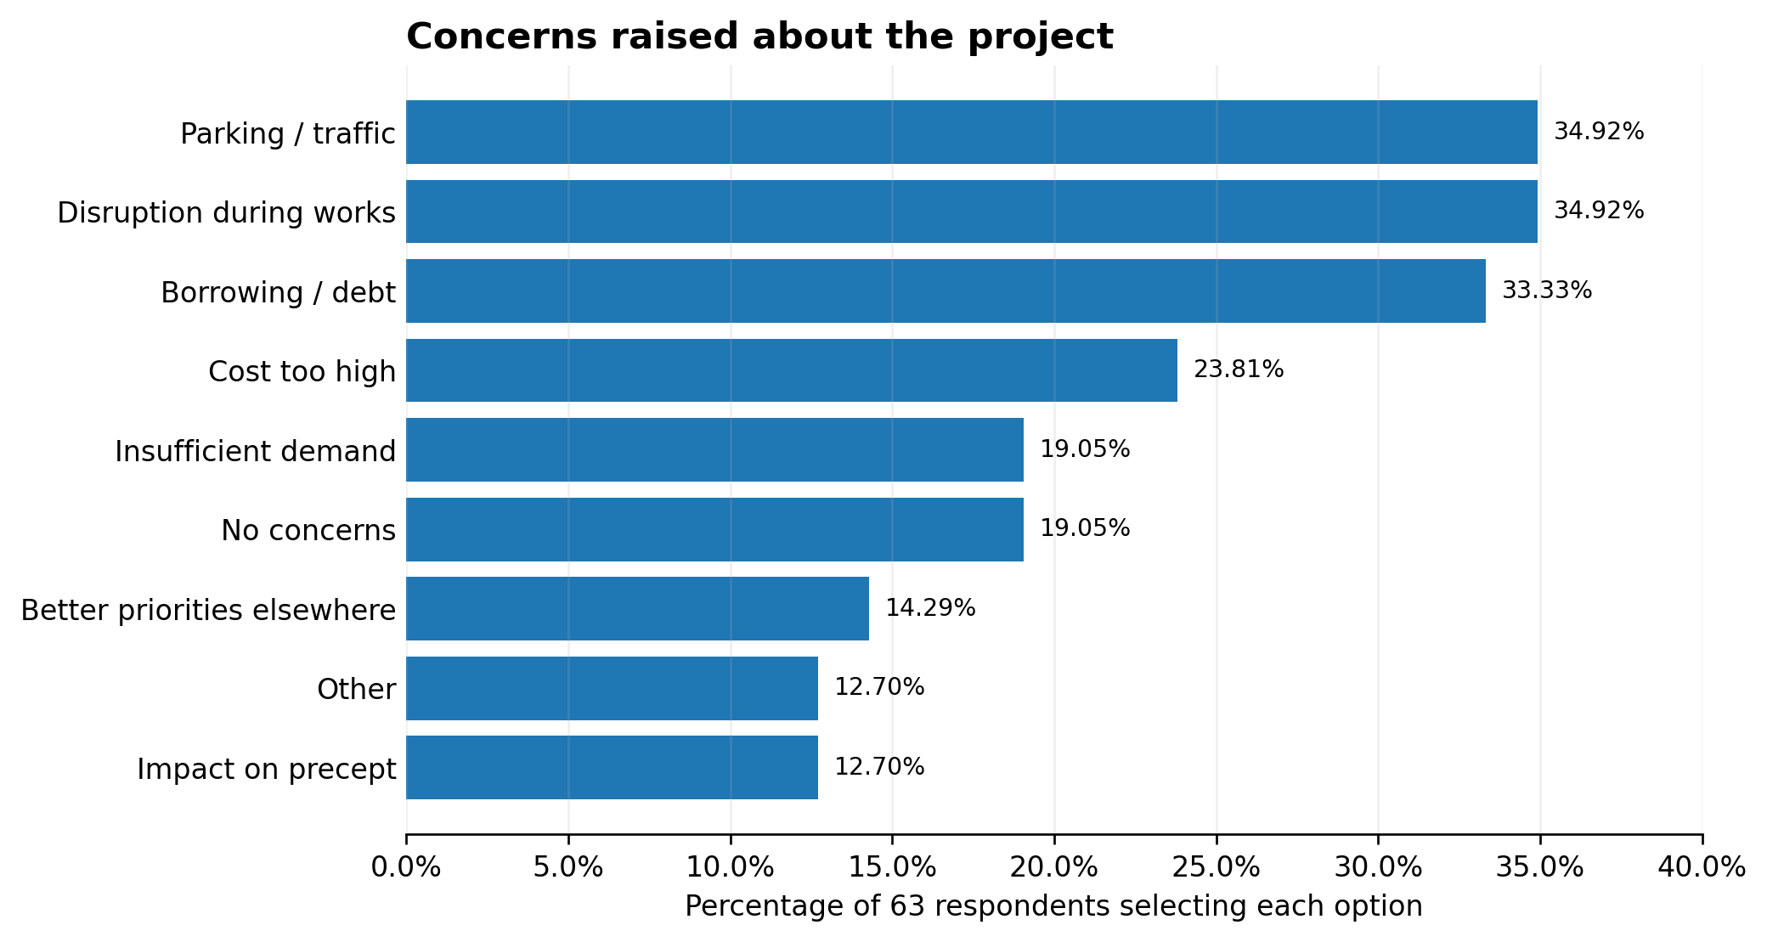
Figure 5 - Concerns selected by respondents.

Response Levels by Question
Response levels reduced as the survey progressed. Questions concerning funding, borrowing and concerns were answered by 63 or 64 respondents rather than all 90 participants. This does not invalidate the results, but it means the finance findings represent approximately seven in ten of the full sample and should not be presented as the settled view of all consultation participants.
Question area | Responses | Share of 90 | Comment
Residence and relationship | 90 | 100.00% | Full sample
Use frequency | 90 | 100.00% | Export records 91 selections
Current facility / improvements needed | 73 | 81.11% | Free-text comments not supplied
Strategic importance / priorities / likely use | 71 | 78.89% | Core future-investment questions
Funding / borrowing / interest | 64 | 71.11% | Lower response base
Concerns / additional comments | 63 | 70.00% | Free-text comments not supplied

Bradley Stoke Resident-Only Analysis
Why this analysis matters
Of the 90 consultation participants, 75 confirmed that they live in Bradley Stoke. This resident-filtered analysis is particularly relevant to decisions involving the Town Council precept or public borrowing, because those costs would fall primarily on Bradley Stoke council tax payers. It should not, however, displace the views of non-resident users when Council considers sports provision, operational requirements or the wider catchment served by the facility.

The resident-only results are not an independent second consultation. The 75 residents form 83.33% of the full sample, so the two datasets overlap heavily and are expected to produce broadly similar findings. Comparisons below identify where filtering materially changes the result; they are not tests of statistical significance and should not be presented as proof of a difference across the whole population.

Resident Participation and Profile
The filtered export contains 75 respondents who answered yes when asked whether they live in Bradley Stoke. Within this group, 69 also selected “A Resident” when asked to describe their connection to the centre. Thirteen identified as regular users and 13 as members of a sports club; eight identified as parents or childcare users. Because this question allowed multiple answers, the percentages do not total 100%.
The fact that only 69 of the 75 filtered respondents selected the separate “A Resident” relationship category is a reminder that survey categories were self-selected and not always used consistently. For the purposes of this analysis, residence is determined solely by the explicit yes response to the residence question.

Resident Use of the Centre
Among Bradley Stoke respondents, 29.33% reported weekly use, compared with 40.00% in the full sample. A further 6.67% used the centre monthly, 16.00% occasionally and 20.00% rarely, while 29.33% said never. The published export records 76 selections from 75 resident respondents, mirroring the one-response discrepancy in the full export and requiring the same caution.
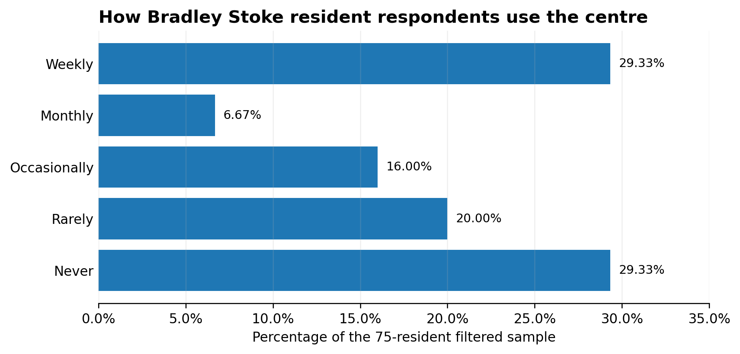
Figure 6 - Frequency of use among respondents who confirmed that they live in Bradley Stoke.
Filtering materially changes the usage profile. By subtraction from the published whole-sample counts, respondents outside Bradley Stoke account for 14 of the 36 weekly-use selections and one of the six monthly selections. They also account for 12 of the 25 sports-club selections and eight of the 21 regular-user selections. This indicates that non-resident sports and regular users had a disproportionate influence on the full sample’s usage profile. This is relevant, but it does not make their views invalid: it shows that Council must distinguish between local taxpayer sentiment and the operational catchment of the facility.

Resident Assessment of Current and Future Value
Fifty-nine Bradley Stoke residents scored how well the current centre meets community needs. The resident average was 5.31 out of 10, almost identical to the full-sample score of 5.36. This reinforces the conclusion that the existing facility is viewed as only moderately effective.
Fifty-seven residents scored the importance of Baileys Court remaining a long-term community facility at 8.42 out of 10. This is 0.30 points below the full-sample score of 8.72 but remains a strong result. The likelihood of using the centre more often following improvements scored 7.77 among residents, compared with 7.94 in the full sample. Resident support is therefore slightly less emphatic than the overall results, but the strategic signal remains clearly positive.
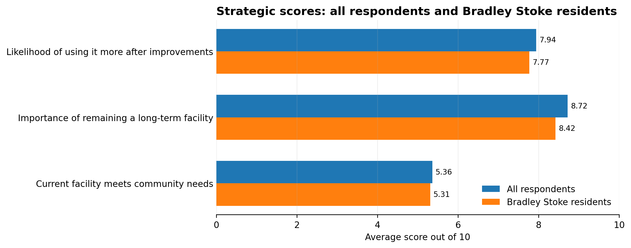
Figure 7 - Comparison of strategic scores for the full sample and resident-filtered sample.

Resident Improvement Priorities
The resident-filtered priorities remain led by a café or social space, selected by 66.67%, and modern community halls, selected by 52.63%. Improved sports changing rooms ranked third at 36.84%, followed by a Changing Places toilet and upgraded kitchens, both at 31.58%. Sustainability and energy-efficiency upgrades were selected by 29.82%, improved external areas by 28.07%, and better accessibility facilities by 24.56%.
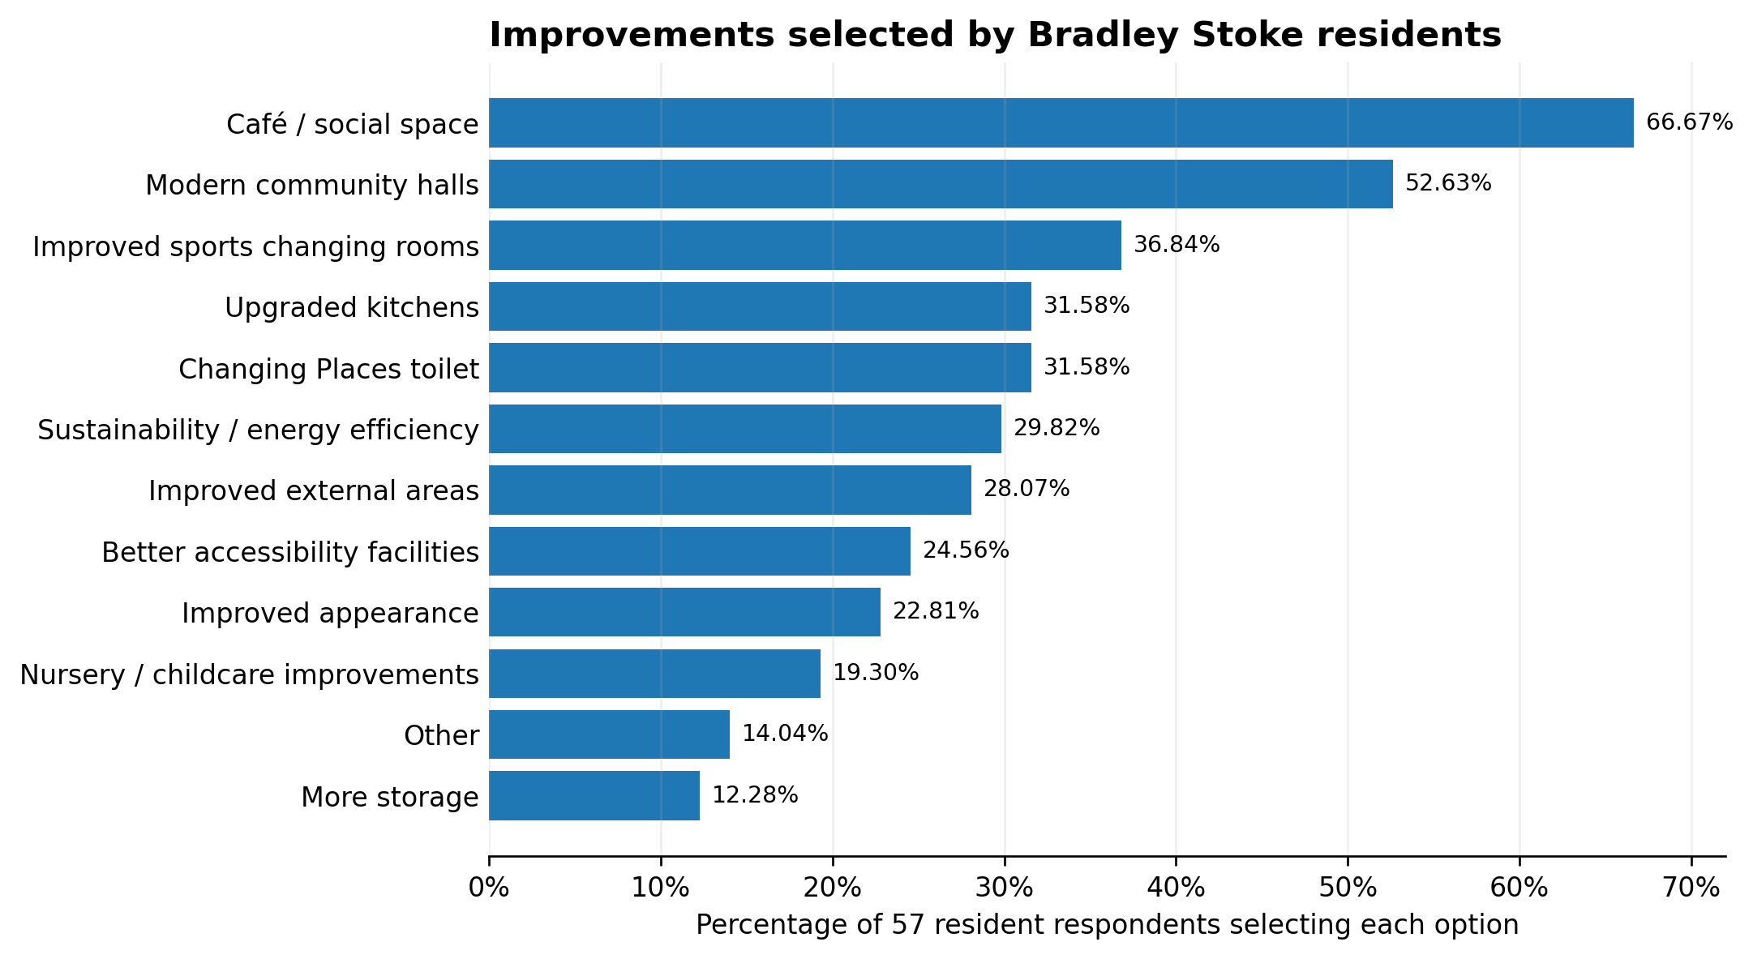
Figure 8 - Improvements selected by respondents living in Bradley Stoke.
Improvement | All respondents | Residents | Difference
Café / social space | 63.38% | 66.67% | +3.29 pp
Modern community halls | 50.70% | 52.63% | +1.93 pp
Improved sports changing rooms | 42.25% | 36.84% | -5.41 pp
Upgraded kitchens | 36.62% | 31.58% | -5.04 pp
Changing Places toilet | 33.80% | 31.58% | -2.22 pp
Sustainability / energy efficiency | 29.58% | 29.82% | +0.24 pp
Improved external areas | 26.76% | 28.07% | +1.31 pp
Better accessibility facilities | 25.35% | 24.56% | -0.79 pp
The resident-only result places slightly greater emphasis on community and social uses and slightly less emphasis on sports changing rooms and kitchens. The changes are not large enough to overturn the overall project brief, but they are large enough to challenge any claim that the consultation primarily supports a sports-led scheme.

Resident Funding Preferences
Fifty resident respondents answered the funding question. No preference remained the largest individual response at 22.00%, but it was 7.69 percentage points lower than in the full sample. A one-off precept increase and not supporting the project proceeding were tied at 18.00% each. Borrowing over 5, 10 and 20 years each received 12.00%, and borrowing over 40 years received 6.00%.
Sixty per cent of resident respondents selected one of the specific funding routes presented, compared with 56.26% in the full sample. However, the resident group was also more likely to select “do not support the project proceeding”: 18.00%, compared with 14.06% overall. There is still no majority mandate for any single funding route.
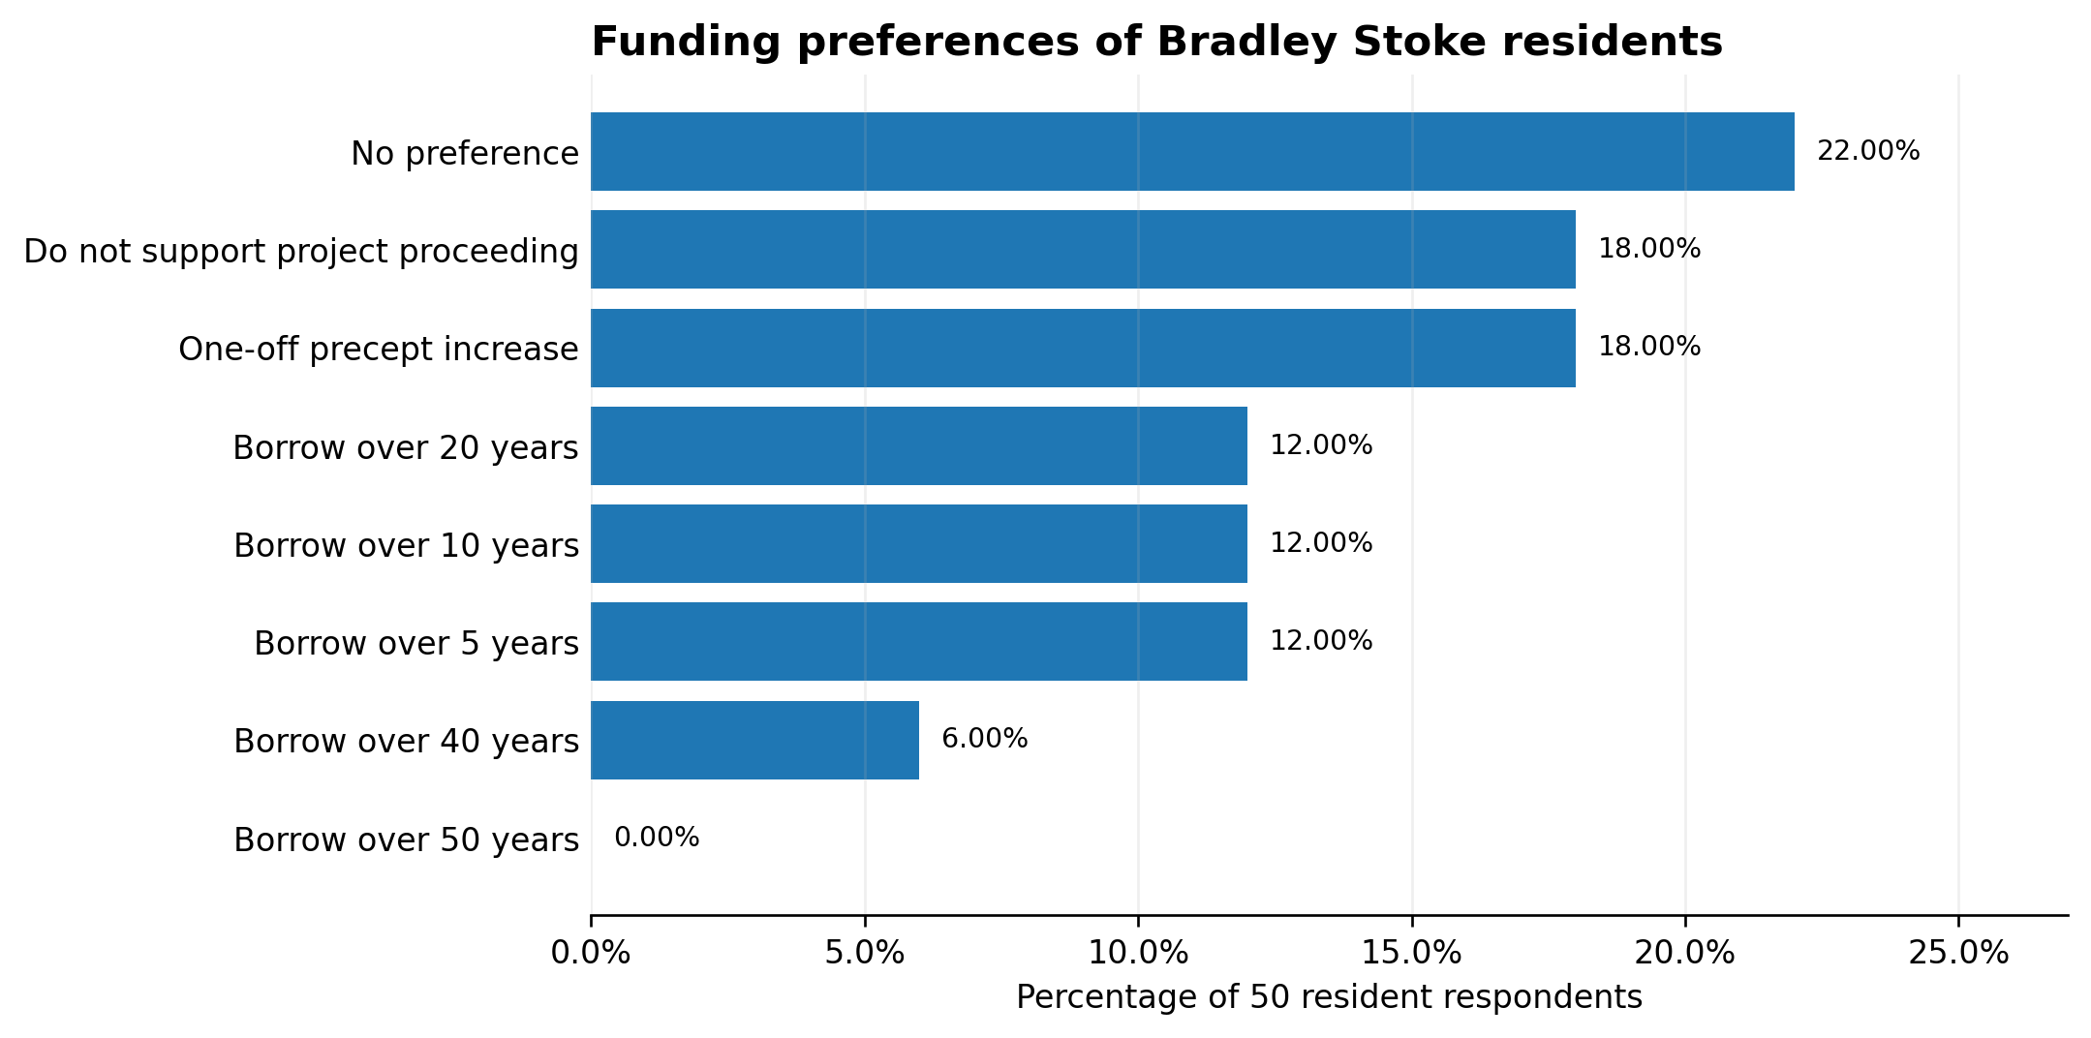
Figure 9 - Preferred funding approach among Bradley Stoke residents.

Resident Borrowing Period and Interest
If borrowing were required, 20 years was the most frequently selected term among residents at 26.00%, followed by 5 years at 22.00% and 10 years at 16.00%. Thirty-two per cent selected none of the above. Sixty-four per cent selected a term between 5 and 20 years, almost identical to the 65.63% result in the full sample. There is therefore no meaningful evidence that filtering for residents creates a clear preferred loan term.
Residents placed slightly greater emphasis on minimising total interest. Forty-six per cent said this was extremely important and 22.00% very important. In total, 68.00% considered it very or extremely important, compared with 64.07% in the full sample. Eighty per cent considered it at least somewhat important. Any future borrowing report should therefore show total lifetime interest prominently and not focus only on the annual precept impact.

Resident Concerns
Borrowing or debt was the highest resident concern at 38.78%, compared with 33.33% in the full sample. Parking or traffic followed at 32.65%, disruption during works at 28.57%, and cost being too high at 26.53%. Sixteen per cent selected no concerns. Insufficient demand was selected by 20.41%, better priorities elsewhere by 16.33%, and impact on the precept by 12.24%.
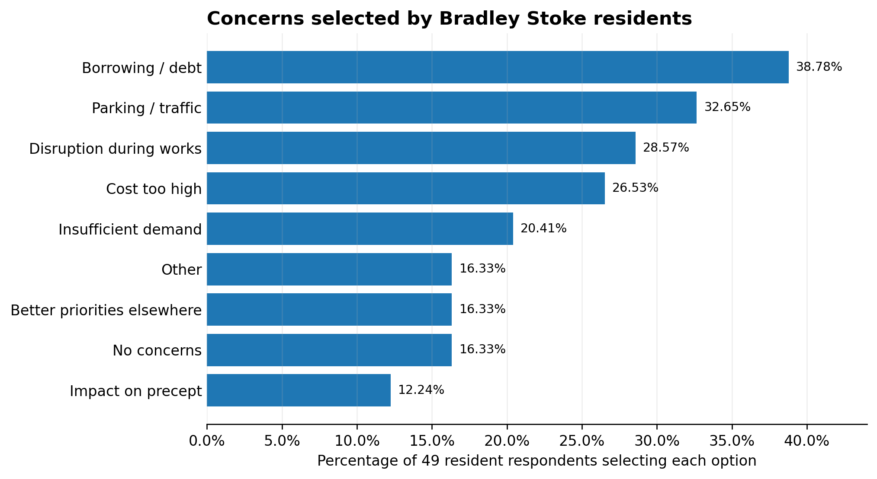
Figure 10 - Concerns selected by respondents living in Bradley Stoke.
Compared with the whole sample, residents were more concerned about borrowing or debt by 5.45 percentage points and cost being too high by 2.72 points. They were less likely to select disruption during works by 6.35 points and parking or traffic by 2.27 points. This distinction matters: resident concerns lean more heavily towards financial exposure, while the overall sample gives greater weight to operational disruption and access.

Resident Response Levels
Question area | Resident responses | Share of 75 | Comment
Residence and relationship | 75 | 100.00% | Full resident-filtered sample
Use frequency | 75 | 100.00% | Export records 76 selections
Current facility / improvements needed | 59 | 78.67% | Free-text comments not supplied
Strategic importance / priorities / likely use | 57 | 76.00% | Core future-investment questions
Funding / borrowing / interest | 50 | 66.67% | One third did not answer
Concerns / additional comments | 49 | 65.33% | Free-text comments not supplied
Only 49 or 50 residents answered the final finance and concerns questions. Those findings represent approximately two thirds of the resident-filtered sample, not all 75 Bradley Stoke respondents. This is a material limitation and must be stated whenever the finance results are presented.

Material Differences Identified by Resident Filtering
Measure | All respondents | Residents | Assessment
Weekly use | 40.00% | 29.33% | Materially lower among residents
Long-term importance | 8.72/10 | 8.42/10 | Still strong; slightly less emphatic
Likely increased use | 7.94/10 | 7.77/10 | Still positive; marginally lower
Café / social space | 63.38% | 66.67% | Slightly stronger resident priority
Sports changing rooms | 42.25% | 36.84% | Lower resident priority
No funding preference | 29.69% | 22.00% | Residents more likely to state a view
Do not support proceeding | 14.06% | 18.00% | Higher resident opposition
Borrowing / debt concern | 33.33% | 38.78% | Higher resident concern
Disruption concern | 34.92% | 28.57% | Lower resident concern
The central conclusion is not that resident opinion contradicts the full consultation. It does not. The resident subset still supports retention and improvement. The material point is that the full sample is more heavily influenced by non-resident regular and sports users, while resident respondents place relatively greater weight on social and community space and on financial risk. Council should use the appropriate evidence for the decision being made rather than treating all consultation questions as if every respondent bears the same financial or operational relationship to the facility.

Consultation Limitations
The consultation provides useful evidence of local views, but it is a self-selecting exercise rather than a statistically representative survey. No demographic weighting, sampling frame or response-rate calculation against the local population is available. The resident-filtered subset improves the relevance of the evidence to local taxation decisions, but it does not make the survey representative of all Bradley Stoke residents. The full and resident datasets also overlap by 75 respondents, so their percentages are not independent comparison groups. The results should guide Council judgement but should not be described as a referendum or as proof that the views expressed are held by the whole community.
Questions 6 and 14 record that 73 and 63 respondents respectively submitted free-text answers, but the supplied survey export does not include the actual comments. It is therefore not possible to carry out a defensible thematic analysis of what respondents believe needs improvement or of their additional comments. Those responses should be obtained and reviewed before final project scope or communications are approved.
Several questions permitted multiple selections, so percentages should not be totalled as though they were mutually exclusive. There is also a one-response discrepancy in the use-frequency question. These points should be acknowledged when the results are quoted publicly.

Overall Findings
- There is a strong strategic case in the consultation for retaining Baileys Court as a long-term community facility: the average importance score was 8.72 out of 10 overall and 8.42 among Bradley Stoke residents.
- Resident-only analysis does not overturn the full consultation result, but it shows that non-resident regular and sports users materially increase the full sample’s weekly-use rate and emphasis on sports changing facilities.
- Bradley Stoke residents place relatively greater emphasis on café/social and modern community spaces and show greater concern about borrowing, debt and overall cost.
- Current performance is materially weaker than perceived future importance: the existing facility scored 5.36 out of 10.
- Respondents expect refurbishment to increase use: the average likelihood score was 7.94 out of 10.
- The strongest improvement priority is a café or social space, followed by modern community halls and improved sports changing rooms.
- The consultation supports a mixed community, social, sports and accessibility brief rather than a narrowly sports-only scheme.
- There is no clear public mandate for one funding route or one borrowing period.
- Minimising total borrowing interest is important to most respondents and should be made explicit in any future options appraisal.
- Disruption, parking and traffic are the leading project concerns and require substantive mitigation plans.
- The missing free-text responses are a material evidence gap and should be reviewed before final decisions are made.

Implications for the Next Stage
The consultation evidence supports continued project development, but it does not authorise a particular design, final budget or funding method. The resident-filtered results strengthen the case for giving community and social functions explicit prominence and for avoiding an unduly sports-led interpretation of the consultation. The next stage should demonstrate how the project responds to the café/social function, community halls, changing facilities, kitchens and accessibility, while showing how disruption and parking will be managed.
Any future financial report should compare a one-off precept option with relevant borrowing terms and state both the annual impact and total lifetime interest. Particular weight should be given to the resident-filtered finance responses because the precept and borrowing consequences fall on Bradley Stoke taxpayers. However, only 50 residents answered the funding questions, support was fragmented and no option achieved majority backing. Council should therefore avoid claiming that residents have selected or endorsed a preferred funding route.

Officer Recommendation
It is recommended that Council:
- notes the full public consultation results and the separate analysis of respondents who confirmed that they live in Bradley Stoke;
- recognises that both datasets provide strong evidence in favour of retaining and improving Baileys Court Activity Centre, but neither constitutes approval of a final design, budget, precept increase or borrowing proposal;
- requires the project’s next stage to respond explicitly to the highest-ranked priorities of a café/social space, modern community halls, improved sports changing rooms, upgraded kitchens and accessible facilities;
- requires parking, traffic and disruption mitigation to be included in the next project report;
- requires noting of the resident-filtered responses on taxation and borrowing, and notes that no single funding approach achieved majority support;
- obtains and reviews the full free-text responses to Questions 6 and 14 before final scope approval; and
- publishes a clear summary of the response bases and methodological limitations, alongside the Council’s response to the issues raised.

