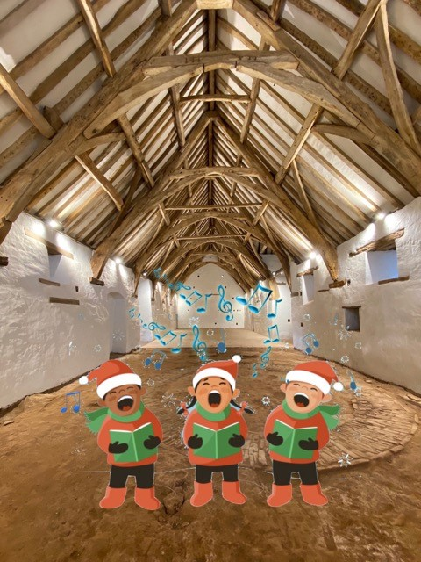
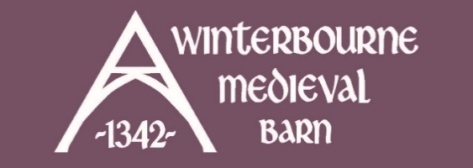
CAROLS IN THE BARN
SAT 13TH DEC | 3PM | £5 / £1
SUN 14TH DEC | 3PM | £5 / £1
Come along to Carols in The Barn to experience the old Christmas story told through a light-hearted drama suitable for all ages.
Our beautiful main barn makes a very atmospheric setting for a quirky
re-telling of the story by members of St Michael’s Church, where the drama is interspersed with lots of well-known traditional carols for everyone to sing along.

To get you in the festive spirit your ticket includes a cup of mulled wine and a mince pie to enjoy before the carols start (non-alcoholic, gluten-free, and children's alternatives available).
A lovely community event and a great start to the festive season.

Visit website for full details and tickets.
Free parking on site (pre-booked only).

