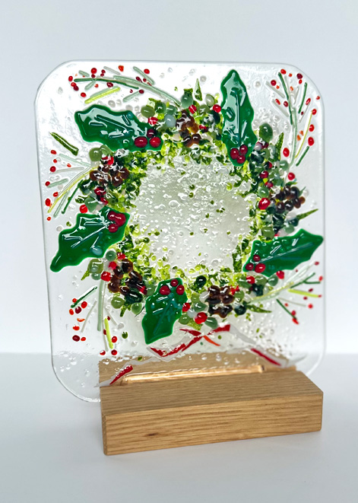
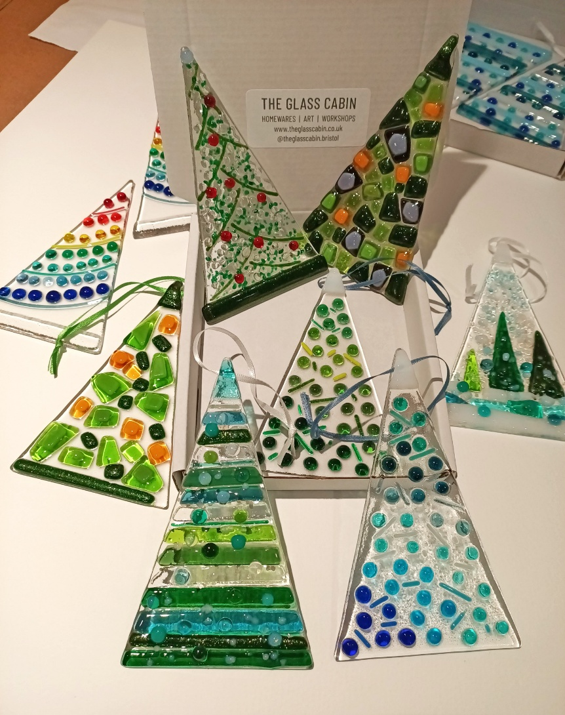
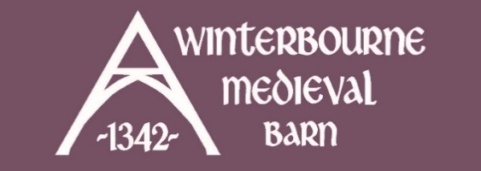
FESTIVE FUSED GLASS WORKSHOPS
THURS 13TH NOV | 10AM / 1PM | £48
MON 24TH NOV | 10AM / 1PM | £48
Join local glass artist, Rachael Durkan from The Glass Cabin at 10am or 1pm for one of her popular fused glass workshops.
Create two ‘tree’ design Christmas decorations or a Christmas Wreath, to either be used as hangings or placed in a stand (additional charges apply).
You can choose from a selection of templates to help guide your design and then pick from an array of pre cut glass and glass accessories to create your trees.
Rachael will have lots of ideas to inspire you and is on hand with design advice throughout the workshop. Suitable for complete beginners as well as those who’ve caught the fused glass bug!

Visit website for full details and tickets.
Free parking. Tea & coffee on arrival included in ticket price.

