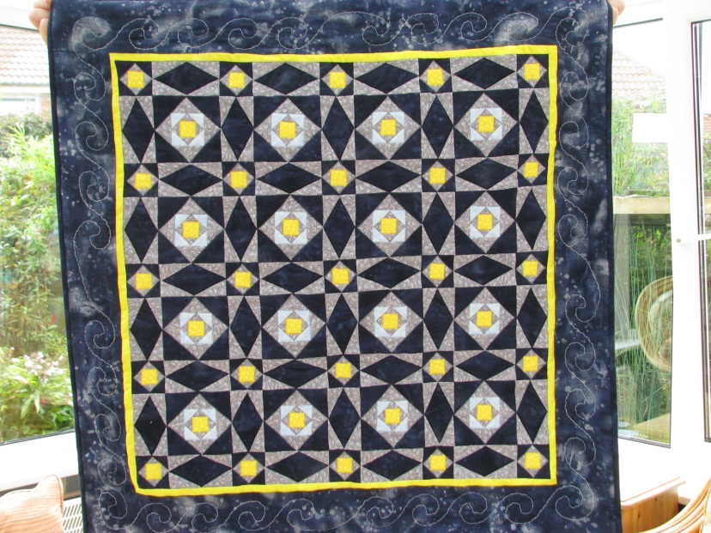

Would you like to join a
Bradley Stoke
Patchwork and Quilting Group?

This is a new venture and we would meet one afternoon a month to sew and share our skills.

If you are interested, whether you are a beginner or experienced, please come to
Bradley Stoke Library
on
Tuesday 22nd January 2013
to introduce yourself and leave some contact details

If you cannot make 22nd January, you can complete a form with your contact details on at the library.

Proposed Bradley Stoke Patchwork and Quilting Group

Please complete this form to register your interest and leave it in the sleeve provided.

Name:
Address:

Contact Telephone:

Email Address:

Are you a beginner or do you have some patchwork experience?

Is there a weekday afternoon you would not be able to come along?
If so, please specify.

As soon as we have found a venue and we have enough people interested, we will contact you.

Gill Blick and Barbara Hughes

