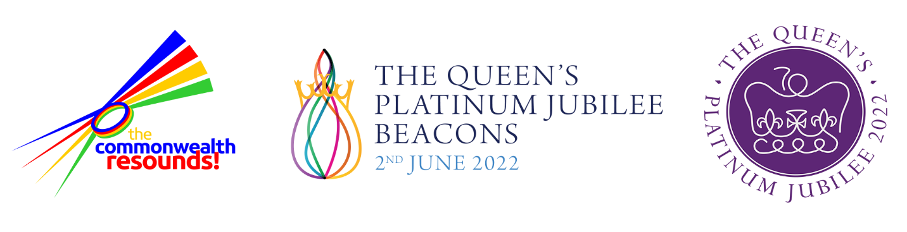

A Life Lived With Grace
Lyrics by: Lucy Kiely

Music by: Vincent Atueyi Chinemelu

Verse 1
When the world has turned to darkness
And there’s troubled seas ahead
There's a light that leads the ship
back home to shore

Chorus
A life lived with grace
A heart filled with love
Peace on earth and harmony
In the heavens above (x2)

Verse 2
When the day is slowly breaking
And the dawn can’t find its way
There's a sun that shines upon the world
Heralding a brand-new day.

Chorus
A life lived with grace….

Verse 3
When the night has come a-calling
And the daylight starts to fade
There's a reason why the world rejoices
Singing all as one today

Chorus
A life lived with grace….

British National Anthem

God save our gracious Queen
Long live our noble Queen
God save the Queen
Send her victorious,
Happy and glorious,
Long to reign over us,
God save the Queen

Origins of the British National Anthem https://www.royal.uk/national-anthem

The British National Anthem in its present form dates back to the eighteenth century. The words and tune are anonymous, and may date back to the seventeenth century.

'God Save The King' was a patriotic song first publicly performed in London in 1745, which came to be known as the National Anthem at the beginning of the nineteenth century.

In September 1745 the 'Young Pretender' to the British Throne, Prince Charles Edward Stuart, defeated the army of King George II at Prestonpans, near Edinburgh.

In a fit of patriotic fervour after news of Prestonpans had reached London, the leader of the band at the Theatre Royal, Drury Lane, arranged 'God Save The King' for performance after a play. It was a tremendous success and was repeated nightly.

This practice soon spread to other theatres, and the custom of greeting monarchs with the song as he or she entered a place of public entertainment was thus established.

There is no authorised version of the National Anthem as the words are a matter of tradition. Additional verses have been added down the years, but these are rarely used.

The words used today are those sung in 1745, substituting 'Queen' for 'King' where appropriate. On official occasions, only the first verse is usually sung.

The British tune has been used in other countries. European visitors to Britain in the eighteenth century noticed the advantage of a country possessing such a recognised musical symbol.

In total, around 140 composers, including Beethoven, Haydn and Brahms, have used the tune in their compositions.

