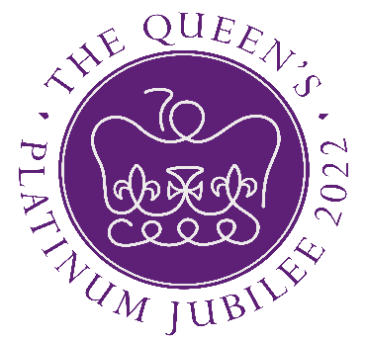

Bradley Stoke
Community Festival

Saturday 4th JUNE 2022
11.30am – 6.00pm
Jubilee Centre

For further information, https://www.bradleystoke.gov.uk/
Rob Goodwin 07971 619501 info@re-energize.co.uk or
Bradley Stoke Town Council 01454 205020

