### BRADLEY STOKE TOWN COUNCIL

**Leisure, Youth & Amenities Committee**

Minutes of the Meeting of the Leisure, Youth & Amenities Committee of Bradley Stoke Town Council held at The Jubilee Centre, Savages Wood Road, Bradley Stoke on Monday 16th October 2023 at 7.00pm.

PRESENT: Councillors: Natalie Field (Chair)

Jenny James

Dayley Lawrence (substituting for Jon Williams)

James Nelson

Ben Randles

Officers: Sharon Petela (Town Clerk)

Phil Francis (Deputy Town Clerk/Activity Centres Manager)

Graham Baker (Youth Development & Participation Worker)

Representative from: Bradley Stoke Bowls Club

Bradley Stoke Youth Football Club

Castle School Friends

Hedgehog Rescue

**1 Submissions from the Public**

None

**2 Apologies**

Apologies received from Councillors Aleena Aditya and Jon Williams and representative from Bradley Stoke in Bloom

**3 Declarations by Members**

None

**4 Announcements by the Chair**

The Scarecrow Trail 2023 maps are now on sale with the trail starting at 9.00am on Saturday 21st October 2023.

**5 To confirm Minutes of Previous Meeting held on 14th August 2023**

Acceptance of the Minutes of the meeting of the Leisure, Youth & Amenities Committee held on 14th August 2023 were proposed by Councillor Ben Randles, seconded by Councillor Dayley Lawrence and carried unanimously. Minutes were then signed as a correct record.

**6 Service Level Agreements, Community Development, Grant Aid and Youth Grant Aid Applications**

**6.1 Service Level Agreements (SLA)**

**6.1.1 Bradley Stoke Youth Football Club**

The Chair of Committee invited the representative from the group to address the meeting.

BSYFC is an England Football 3 Star Accredited Club (new name for the previous FA Charter Standard Community Club) which is the highest award a football sports club can receive. We have successfully retained this highest status since 2010 so we are very proud of this.

The club provides football training and matches for children from Reception age upwards. The club in total has 23 teams playing in the Hanham Minor League, Avon Youth League, Bristol Girls League, Saturday Youth League, Gloucestershire U18 League and the Gloucestershire County Womens League. We run dedicated football sessions for girls and have 7 girl teams from U8 to U16 age range and we also have a Ladies Team. This is proving a strong link for girls youth football to ladies adult football and the easy transition for the young players the club caters for.

We have just finished our fourth year with a squad of U18 boys with the team playing matches in the Gloucestershire U18 League and our link to Bradley Stoke Town FC men’s team allows an easy pathway for these older boys from BSYFC to adult football.

The services we provide to the community (free of charge) include:

* The Football Festival which is part of the annual Bradley Stoke Festival was again held at the Jubilee Centre in June despite the actual Bradley Stoke Festival not running this year. The club took over the Jubilee Centre and ran multiple mini football festivals covering age groups from Reception to U16’s. In total we had over 350 children playing in the matches. This 2023 event was our 17th year of the Festival which has now seen over 2,500 children participate in the Festival. We were lucky to have the Mayor and the Deputy Mayor presenting the trophies and goody bags at each of the many award ceremonies.
* Weekly Enrichment sessions first started in 2005 at the Bradley Stoke Community School when it first opened its doors. Then in Sept 2015 these sessions transferred to the new Bradley Stoke Primary School when it opened its doors to coach all of the Reception/Year 1 children. In Sept/Oct/Nov 2022 we went into the school and coached the girls of Key Stage 2 age group. The school wanted us to focus on the girls only so they could create a girls team. We coached Years 3, 4, 5 and 6 girls for 3 terms. In Sept 2023 we are again going into the school to coach Years 1 and 2 children covering Sept/Oct/Nov and December. Trophies and prizes are awarded to the children on completion of the sessions.
* We have been successful running sessions for children identified with special requirements. Last season this was done with children at Reception/Year 1 age group. We gave them access to football coaching to allow the club to be even more inclusive while ensuring a safe and happy environment for the children. We then try to integrate these children into mainstream football where possible.
* The club runs a young coaches mentoring program where we mentor young people who want to make a career in football coaching. This also includes helping them to attain their FA coaching badges. They are placed under the wing of our experienced FA Mentoring Qualified Coach Martin to ensure they can meet set objectives and to develop into the coaches of the future. We now have 7 young coaches on the program. We have 2 females and 5 male (age range 14 to 17 years old). The club last year paid for 2 male teenagers to obtain their FA Level 1 Coaching badge at a cost of £360. We provide branded training kit so they look like proper club coaches as well.
* The club provides places for DoE students who need to have a sports related placement during their award program. In 2023 we have 8 (5 male and 3 female) students who are completing their silver and gold awards. Also most of the previous DoE students have all extended and are staying with the club. For all DoE students we produce a report on them at the end of their placement. This includes feedback on achievements, setting personal targets and areas for improvement.

The SLA funding is used in all of the above areas to help towards the costs to ensure all these services are supplied to the Bradley Stoke area.

The club run weekly training sessions and matches for over 470 children and have extended their coverage to Reception children and we even have a waiting list for Pre Reception children who want to join in the fun. The club is very large and requires many volunteers to run such a complex structure. So we are constantly looking for new coaches and putting them through the training while constantly having to renew current coaches qualifications every 3 years.

Costs of training and retraining volunteers is monitored by the GFA as we are a 3 Star Accredited Club. We must ensure all coaches of all age groups have the relevant qualifications and all are up-to-date. So far in 2023 we have already funded coaches to receive training at a cost of £3,070 on their FA coaching courses. Just to give you an idea of running costs to a club this size. To supply just the training footballs to each age group this year was £2,460.

If we are successful in receiving the SLA funding again, then this will help towards the costs of allowing the club to continue all of these long standing programs for the Bradley Stoke Community which we believe are all worthwhile activities to have running and benefit the community of Bradley Stoke greatly.

The club has already made the decision there will be no increase in charges at the club due to all parents suffering the cost of living increases we are all seeing at present. In fact all of our training venues, match pitch costs, referee costs, league costs, insurance costs, affiliation costs, player registration costs, and kit costs have all increased this season but our ethos of allowing all children to have the opportunity to play football is still key as the club moves forward so therefore we must keep charges as low as possible to allow this to happen.

|  |  |  |  |  |  |  |
| --- | --- | --- | --- | --- | --- | --- |
| **INCOME** |  |  |  |  |  |  |
| Subs, Registration fees, Grants | |  |  |  | £45,486.00 |  |
|  |  |  |  |  |  | **£45,486.00** |
| **EXPENDITURE** |  |  |  |  |  |  |
| Training/Pitch Hire |  |  |  | £27,579.55 |  |  |
| Equipment |  |  |  | £4,251.56 |  |  |
| Kit |  |  |  | £2,750.00 |  |  |
| Coaching courses |  |  |  | £3,070.00 |  |  |
| League fees |  |  |  | £785.00 |  |  |
| Club Insurance |  |  |  | £534.00 |  |  |
| Club Trophies |  |  |  | £5,415.00 |  |  |
| Pitchero annual web site costs |  |  |  | £330.00 |  |  |
| Misc: Bank charges, Fines, etc |  |  |  | £386.00 |  |  |
|  |  |  |  |  |  | **£45,101.11** |
|  |  |  |  |  |  |  |
| **Surplus/Deficit for the period to 30th June 2023** | | |  |  |  | **£384.89** |
|  |  |  |  |  |  |  |
| **Closing Balance 30th June 2022** | |  |  |  |  | **£9,677.17** |
|  |  |  |  |  |  |  |
| **Closing Balance in current account @ 30th June 2023** | | | |  |  | **£10,062.06** |
|  |  |  |  |  |  |  |
| **Total Funds in Bank accounts @ 30th June 2023** | | |  |  |  | **£10,062.06** |

Following discussion Councillor Dayley Lawrence proposed that Bradley Stoke Youth Football Club be awarded a Youth Service Level Agreement of £2,300 towards their running costs, seconded by Councillor Jenny James, carried unanimously.

The Chair thanked the representative for addressing the meeting.

**6.2 Community Development Grant Aid (CDGA)**

None

**6.3 Grant Aid (GA)**

**6.3.1 GA497 – Castle School Friends**

The Chair of Committee invited the representative from the group to address the meeting.

Castle School Friends is raising funds to provide a new electronic keyboard to go in the new Drama Studio at Castle School to provide musical accompaniment for rehearsals and performances. Currently there is an old piano in place that won’t move and is falling apart. The Drama teachers and students describe it as too cumbersome, broken and ancient. They would like a keyboard that is smaller and portable which would meet all their needs. This equipment cannot be funded out of core school budgets.

This is the first time that the Friends group has applied to Bradley Stoke Town Council for funding towards equipment. Out of 1200 pupils in the school, 150 come from Bradley Stoke.

Following discussion, Councillor Dayley Lawrence proposed that Castle School Friends be awarded £280 grant funding to purchase a new keyboard for the school, seconded by Councillor Natalie Field, carried unanimously.

The Chair thanked the representative for addressing the meeting.

**6.3.2 GA498 – Hedgehog Rescue**

The Chair of Committee invited the representatives from the organisation to address the meeting.

Hedgehog Rescue is raising funds to fit out a purpose-built annex to the hospital with 15 pens and a treatment area which will create 50% more capacity, providing support for more hedgehogs in a manageable way. The total cost is around £1,100 per pen. A grant of £500 will cover around 50% of the cost of a veterinary grade pen.

Following discussion, Councillor Ben Randles proposed that Hedgehog Rescue be awarded £500 grant funding towards the purchase of a veterinary grade pen, seconded by Councillor James Nelson, carried unanimously.

The Chair thanked the representative for addressing the meeting.

**6.3.3 GA499 – Bradley Stoke Bowls Club**

The Chair of Committee invited the representative from the group to address the meeting.

Bradley Stoke Bowls Club is applying for grant funding of £500 towards the cost of a robust electric fence to be placed around the Bowls Green to keep wildlife (including foxes and badgers off the green).

Following discussion, Councillor Ben Randles proposed that Bradley Stoke Bowls Club be awarded £500 grant funding towards the purchase of a robust electric fence for the Bowls Green at Baileys Court Activity Centre, seconded by Councillor Dayley Lawrence, carried unanimously.

The Chair thanked the representative for addressing the meeting.

**6.4 Larger Grant Aid**

None

**7 Matters arising from the minutes of the meeting held on 19th June 2023**

**7.1 Provision of taster sessions at the skatepark**

Graham Baker, Youth Development & Participation Worker explained that the Town Council continues to offer loan scooters and helmets during our skatepark sessions and at our Girls Project and the focus is always on safety when using loan equipment.

The Town Council youth work team (which includes a World Series scooter rider winner) has designed a grading scheme based on the existing ‘Tricknology’ scheme. Information has been circulated.

The scheme was introduced on 5th October and much positive feedback has already been received, especially from the younger age groups (school years 4 – 8) with a number of young people having already signed up to the scheme. The main staff mentoring of the scheme takes place on Tuesdays and Thursdays when BSTC staff are on site at the skatepark. They are available to witness and record/monitor evidence and progression through the various grades.

**7.2 Annual Review of Detached Youth Work Policy & Guidelines**

Documentation circulated.

Following discussion, Councillor Dayley Lawrence proposed a minor amendment to the existing policy to change the reference to Public Health England which is now known UK Health Security Agency, seconded by Councillor Jenny James, carried unanimously.

**8 Matters within the scope of the Leisure, Youth & Amenities Committee**

**8.1 Bradley Stoke in Bloom (BSIB) update by Steering Group**

The representative from BSiB has sent the update in Appendix A.

**8.2 Youth Development & Participation Worker (YDPW) update by Graham Baker**

Graham Baker, Youth Development & Participation Worker presented the following report:

**Headline news since last LYA Committee report on the 14thAugust 2023.**

* **Youth work sessions delivered:** since the last report, we have delivered the following youth work sessions:
* **Four core youth work sessions per week** (**32 core sessions** during this reporting period). The sessions have taken place at the skatepark, the Jubilee Centre (Girls Project) and Jubilee Hardcourts and surrounding area. In addition to the ‘core’ sessions there has been additional summer and ad hoc sessions (see below).
* Each core session comprises of between **2hrs and 2.5hrs of face-to-face youth work**.
* All the core sessions have been popular and well attended. The usual attendance range for the Skatepark and Jubilee Hardcourt sessions has been between **30 and 50 young people** with the majority in the **12 to 18 age range**. The gender breakdown has been between **20% to 30%** girls and young women and **70% to 80%** boys and young men.

Since the last report, the Girls & Young Women’s Project has held **8 weekly core sessions** at the Jubilee Centre, plus an offsite trip. The age range is mainly between **13 and 18** with between **12 and 16 young women** attending each session during this reporting period.

* **Summer holiday programme:** in addition to the above 32 ‘core’ sessions, we delivered extra double youth work sessions, on Wednesdays, throughout the first four weeks of August (i.e., an **extra eight sessions**). The programme included **two off-site trips** (bowling and ice skating); street art workshops at the Skatepark and Girls Project and First Aid workshops (Street Doctors) again at both the Skatepark and Girls Project. 14 young people received recorded outcomes for participation In the Street Doctor First Aid Training sessions.
* **Scooter skills training and coaching/ mentoring:** the scheme commenced at the start of October and already has several participants. The scheme involves a graded training programme with children/ young people learning and/ or demonstrating certain scooter skills/ tricks at different levels of difficulty and receiving certification at completion of each grade/ level. A young staff member is helping to lead the scheme and support is currently being offered to children/ young people during our Tuesday and Thursday sessions (promotional materials will be separately circulated and tabled at Committee). We also continue with the loan of scooters and helmets and helping children/ young people learn about scooter maintenance through access to tools and donated spare parts.
* **Youth Work publicity:** we currently have an article highlighting our recent youth work in Bradley Stoke Matters magazine (see Oct/Nov 23 edition; page 23) and a similar article will be in our next BSTC newsletter along with updates to our website.
* **Upshot:** we have been researching and in discussion with ‘Upshot’ (Upshot.org.uk) who provide a ‘monitoring, evaluation and learning system’ which would help improve youth work project management and evaluation of impact **(see below for more info).**
* **Partnership meetings, funding, training, and multi-agency liaison:** there continues to be ongoing discussion with SG Youth Work Partnership concerning the submission of a joint 5-year YAO (Youth Activity Offer) partnership bid with further liaison in the coming months. The YAO funding will last for 5 years from April 2024 with a potential two-year extension. In addition, BSTC will also be attending a partnership meeting looking at a potential joint Lotteries bid exploring possible collaborative youth work strands. A South Glos Youth Work training conference has also been planned for November. ASB multi agency meetings have also been recently attended and are helping to improve aspects of communication between agencies.

**Our recent and planned youth work strands explained below:**

* **Girls’ Project youth work sessions**:every Tuesday we’ve delivered well attended weekly sessions, offering a safe space and a range of activities, discussions, and support. We promote the Girls Project using closed group Instagram and this helps inform/ remind people of upcoming sessions, any specific focus, and future projects as well as help supportively signposting to organisations or useful information. We also support individuals/ small groups outside of the formal session.
* **Skatepark building and outreach youth work sessions:** at the skateparkwe have continued to runtwo well attended core youth work sessions per week. In addition, when attending the site for various reasons, we regularly provide extra ad hoc support and/ or engagement, with young people and the wider community. The youth work sessions engage both regular skatepark users and young people who attend mainly for the youth work sessions and a safe, supportive, social space that also offers free food and drink. Our food offer is supported by the Fareshare (recycled food) charity through bi-weekly collections from Tesco (Hatchet Rd).

**Jubilee hardcourt area youth work sessions:** these sessions offer the opportunity for informal engagement in sporting activities (basically a kick about or a chance to have a go at tennis, frisbee, etc), drinks squash/ hot chocolate, occasional BBQs), etc. As with all our sessions, we offer an environment for support, discussion and challenge on numerous topics, issues, lifestyle choices, and anti-social behaviours. We also offer support and activities outside of the formal sessions, including supportive signposting, advocacy, etc (see one to one below).

* **Occasional outreach and ad hoc youth work sessions** with young people in the Jubilee Centre area, Willowbrook, etc. As mentioned above, we continue a limited amount of outreach and ad hoc sessions. Detached, outreach and project youth work sessions will increase in frequency when we recruit additional part team sessional youth workers.
* **One to one support:** 1-2-1 / small group work has continued throughout this period, including support for parents/ carers. This work can cover a wide range of issues including, liaison with parents/ carers, peer conflict, informal counselling, bereavement, mental health and well-being, college/ schoolwork experience placements, NEET, CV writing support, references, etc.
* **Summer youth work activities:** in the first four weeks of August, during the school summer holidays, we offered additional site-based activities and workshops and some off-site trips (see above). The First Aid training is part funded by the police violence reduction unit (VRU) and focused on unconsciousness and knife use.
* **Upshot:** as stated earlier, we have been researching and in discussion with ‘Upshot’ (Upshot.org.uk) who provide a ‘monitoring, evaluation and learning system’ which would help improve youth work project management and evaluation of impact. The system has recently, or is currently, being adopted by other Youth Work organisations within South Glos and across the UK and provides the following:

**Manage:** record personal & demographic & participant data;complete session registers on the move on any device; track personal outcomes & milestones achieved; restrict user access to relevant data only.

**Monitor:** set KPI’s & measure performance against deadlines; view participant data in real time; create send & complete surveys; create strategic plans.

**Evidence:** generate stats at a click of a button; upload photos & videos to tell story behind the numbers; map your projects & beneficiaries to show your reach; create case studies & impact reports.

**Cost:** we have been provided with a quote based upon our level of youth work activity and this includes an **annual Licence Fee of £1,100** and a one-off **two-day consultancy cost** **of £1,190** to set up the account to our specific needs. **Total initial cost is therefore £2,290 excluding VAT.**

**Action:** the officer recommendation is that Upshot would be an extremely useful acquisition that would significantly help (as Upshot states) management, monitoring and evidencing impact of our youth work strands and could also have a positive effect in terms of future funding bids.

* **Staff training, development, and recruitment**: During this period the YD&PW has participated in ‘Designated Safeguarding Lead’ refresher training, as has the Town Clerk, and our Safeguarding Policy will be refreshed in the near future. As previously reported, there continues to be recruitment challenges across the South Glos Youth Work Partnership.
* **Strategic lead on other current & evolving projects.**
* **Development & review of Youth Work Policies & Procedures.**
* **Reporting, evaluating & data collection:** including regular reporting to SGC on SG Youth Offer funding, including, as mentioned earlier, submissions for future funding.

Following discussion, Councillor James Nelson proposed that Leisure, Youth & Amenities Committee recommends the adoption of the ‘Upshot’ monitoring, evaluation and learning system for Bradley Stoke Youth Work, seconded by Councillor Jenny James, carried unanimously. This recommendation will go to October Finance Committee for final agreement.

**9 Date of next meeting**

Monday 18th December 2023 at 7.00pm.

The meeting closed at 7.40pm

**APPENDIX A**

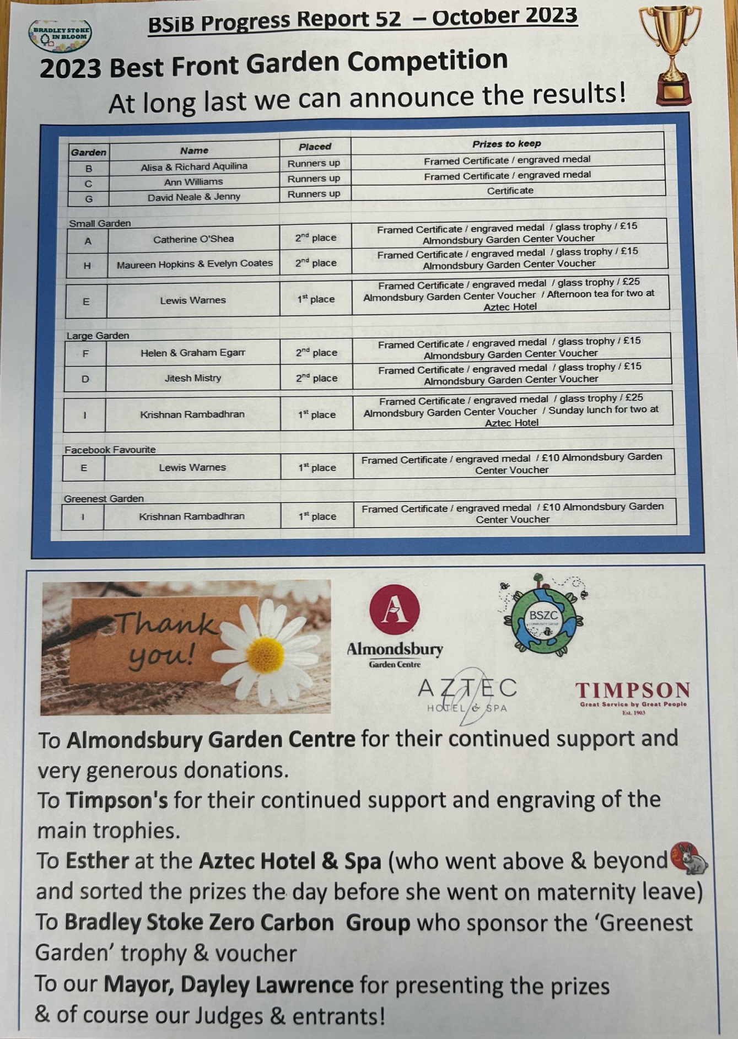

**APPENDIX A**

