### BRADLEY STOKE TOWN COUNCIL

**Leisure, Youth & Amenities Committee**

Minutes of the Meeting of the Leisure, Youth & Amenities Committee of Bradley Stoke Town Council held at The Jubilee Centre, Savages Wood Road, Bradley Stoke on Monday 14th August 2023 at 7.00pm.

PRESENT: Councillors: Aleena Aditya

Natalie Field (Chair)

Jenny James

James Nelson

Ben Randles

Jon Williams

Officers: Sharon Petela (Town Clerk)

Graham Baker (Youth Development & Participation Worker)

Representative from: Bradley Stoke in Bloom

**1 Submissions from the Public**

1.1 Councillor Tom Aditya thanked the Town Council for permitting the Indian Community to raise their flag at the Jubilee Centre to commemorate Indian Independence Day. He extended an invitation to all councillors to join the event on 15th August 2023 at 8.00am.

1.2 Councillor Tom Aditya observed that the wildflower beds on Brook Way now need cutting by South Gloucestershire Council.

1.3 Councillor Tom Aditya observed that a CCTV camera is required on the public highway on Savages Wood Road to capture incidents of anti-social behaviour.

**2 Apologies**

None

**3 Declarations by Members**

None

**4 Announcements by the Chair**

None

**5 To confirm Minutes of Previous Meeting held on 19th June 2023**

Acceptance of the Minutes of the meeting of the Leisure, Youth & Amenities Committee held on 19th June 2023 were proposed by Councillor Jon Williams, seconded by Councillor James Nelson and carried unanimously. Minutes were then signed as a correct record.

**6 Service Level Agreements, Community Development, Grant Aid and Youth Grant Aid Applications**

**6.1 Service Level Agreements (SLA)**

None

**6.2 Community Development Grant Aid (CDGA)**

**6.2.1 CDGA32 - Bradley Stoke Radio update**

Bradley Stoke Radio has submitted the following update.

Developing community and supporting the diverse groups across Bradley Stoke and the surrounding area is key to our commitments as a community radio station. Alongside our staple of music, drama, news and specialist programmes, we are delighted to support at events Like Stoke Lane AFC and the Luke Wheaton charity event, Bradley Stoke Festival and the schools football festival. We also had Wheatfest and Mamas CIC family fun day in our events Calander. We were all geared up to support at these events with a new, small, branded gazebo and flag to build our presence in the community but alas, British summertime put a literal dampener on these events. We are however planning our stand at the South Glos show on August 5th and hope to build more contacts and listeners for community radio at that event. We are actively supporting the BSTC Scarecrow trail and have been promoting that on air, on social media and through our presenters, and a specially commissioned advert - supporting and building community. We have featured charities, sports groups, events, holiday clubs, schools, and more on air. We held a very informative agm and annual training with bbq at Brookway, welcoming new members and training current members. The plan to continue to support presenters to make full use of the studios and to keep them as open as possible for the community while continuing to support and develop the vibrant community around us.

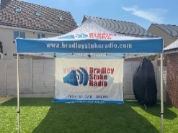Looking forward to raising our profile and that of so many groups, schools, charities etc that build our community - in our new, smaller gazebo - with flag at events for years to come. We thank Bradley Stoke Town Council for the ongoing support of Bradley Stoke Radio 103.4fm DAB Online.

|  |  |  |  |
| --- | --- | --- | --- |
| **Community Grant** | **Expense** | **Cost** | **Remainder** |
| £745.27 – 8/6/23 |  |  |  |
| 27/6/23 | Branded Gazebo | £682.80 | £62.47 |
| 30/6/23 | Branded flag | £70.12 | -£7.76 |
|  |  |  | £0.00 |

**6.3 Grant Aid (GA)**

None

**6.4 Larger Grant Aid**

None

**7 Matters arising from the minutes of the meeting held on 19th June 2023**

**7.1 Adoption of BSTC Youth Work Policy**

Graham Baker, Youth Development & Participation Worker explained that in September 2020, the National Youth Work Agency produced a generic youth work curriculum document which was brought to the town council to be adopted. However, councillors wanted a more bespoke document with relevance to Bradley Stoke.

Following discussion, Councillor Jon Williams proposed adoption of the Bradley Stoke Youth Work curriculum as circulated (which includes local youth work photos), seconded by Councillor Natalie Field, carried unanimously.

**7.2 Provision of taster sessions at the skatepark**

Graham Baker, Youth Development & Participation Worker explained that the Town Council continues to offer loan scooters and helmets during our skatepark sessions and at our Girls Project. We regularly help young people maintain their scooters and carry various spare parts, that have been donated and we offer free of charge, alongside encouragement and informal mentoring for children and young people using the park. This includes year 5/6 children who are actually below the age that we are funded for, but it is good to have active engagement with these younger year groups.

We are progressing with arrangements for more formal scooter mentoring/ coaching at the skatepark and having identified someone to deliver the sessions (a member of the Town Council youth work team) and they are now constructing a ‘graded’ training programme.

Councillors asked for sight of the training programme once completed.

**7.3 Possible Memorial Garden/Garden of Reflection at Brook Way Activity Centre**

Much discussion took place on the background to this idea (initial idea came from Bradley Stoke in Bloom) and whether better value for money could be achieved by spreading planting ideas across the whole of Bradley Stoke rather than just one small area which is likely to be costly to create and has the potential for significant oncosts in maintenance.

Following discussion, Councillor Jon Williams proposed that any further work on this idea is delayed to enable discussion at the forthcoming Strategic Planning meeting, seconded by Councillor Natalie Field, carried unanimously.

**8 Matters within the scope of the Leisure, Youth & Amenities Committee**

**8.1 Bradley Stoke in Bloom (BSIB) update by Steering Group**

The representative from BSiB gave the update in Appendix A. The Best Front Garden competition has now closed and the Facebook best garden vote is now running. Less entries than in previous years which could be due to the weather.

**8.2 Youth Development & Participation Worker (YDPW) update by Graham Baker**

Graham Baker, Youth Development & Participation Worker presented the following report:

**Headline news since last LYA Committee report (19th June 2023).**

* **Youth work sessions delivered:** since the last report, we have continued to **deliver four core youth work sessions per week** (28 sessions during this reporting period). The sessions have taken place at the skatepark, the Jubilee Centre (Girls Project) and Jubilee Hardcourts. All the core sessions continue to be popular and well attended. Please see below for information on other youth work sessions and support.
* **Summer holiday programme:** in addition to the above ‘core’ sessions, we are currently delivering an extra double session throughout the first four weeks of August (i.e., six sessions per week). The programme includes some off-site trips (e.g., bowling and ice skating); street art workshops; first aid workshops and project work (building some picnic benches).
* **School work experience placements:** during the last week of the school summer term, we had two year 10 BSCS students on their work experience placements. The week focused on youth work and briefly the role of the Town Council and involved helping with session and programme preparation and delivery and lots of discussions.
* **Partnership meetings, funding, training, and multi-agency liaison:** this has been another busy period with submission of a joint 5-year YAO (Youth Activity Offer) partnership bid, further liaison re ASB, contractor meetings, etc.

**Our recent and planned youth work delivery is highlighted below:**

* **Girls’ Project youth work sessions**:every Tuesday (apart from one week’s annual leave) we’ve delivered well attended weekly sessions, offering a safe space and a range of activities, discussions, and support. We promote the Girls Project using closed group Instagram and this helps inform/ remind people of upcoming sessions, any specific focus, and future projects as well as help supportively signposting to organisations or useful information. We also support individuals/ small groups outside of the formal session (e.g., recently helping reengage with CAMHS). Two members of the group also did their July school work experience placements with us.
* **Skatepark building and outreach youth work sessions:** at the skateparkwe have continued to runtwo well attended core youth work sessions per week. In addition, when attending the site for various reasons, we regularly provide extra ad hoc support and/ or engagement, with young people and the wider community.

The youth work sessions engage both regular skatepark users and young people who attend mainly for the youth work sessions and a safe, supportive, social space that also offers free food and drink. Our food offer is supported by the Fareshare (recycled food) charity through bi-weekly collections from Tesco (Hatchet Rd). Following some recent external funding (through Magnox/South Gloucestershire Council (SGC) - £2,900), we have been able to further enhance the kitchen with some additional equipment (including a fridge/freezer for the skatepark kitchen), gas BBQ, pizza oven, smoothie makers, air fryers etc. for youth work across skatepark and Jubilee Centre. This funding also paid for the graffiti/artwork project at the recent Festival skatepark event.

**Jubilee Hardcourt youth work sessions:** these sessions offer the opportunity for informal engagement in sporting activities (basically a kick about or a chance to have a go at tennis, frisbee, etc), drinks squash/ hot chocolate, occasional BBQs (a couple planned over the summer), etc. As with all our sessions, we offer an environment for support, discussion and challenge on numerous topics, issues, lifestyle choices, and anti-social behaviours. We also offer support and activities outside of the formal sessions, including supportive signposting, advocacy, etc (see one to one below).

* **Occasional detached and outreach youth work** with young people in the Jubilee Centre area, Willowbrook, etc. We continue a limited amount of outreach sessions. Detached, outreach and project youth work sessions will increase in frequency when we recruit additional part team sessional youth workers.
* **One to one support:** 1-2-1 / small group work has continued throughout this period, including support for parents/ carers. This work can cover a wide range of issues including, liaison with parents/ carers, peer conflict, informal counselling, bereavement, mental health and well-being, college/ school work experience placements, NEET, CV writing support, references, etc.
* **Summer youth work activities:**

Over the school summer holidays, during the first four weeks of August, we are offering some additional site-based activities and workshops and some off-site trips (see above). The First Aid training is part funded by the police violence reduction unit and focuses on unconsciousness and knife use.

**Scooter coaching/ mentoring at the skatepark:** covered earlier on the agenda

* **Partnership and multi-agency working:**

As members of the SG Youth Work Partnership, we have continued to focus on the retendering process with our own bid information being merged into the larger partnership bid submissions. If successful, the new contract with SGC will commence April 2024 and will run for five years with a possible two-year extension. The SG Youth Work Partnership also acts as a consultative body, exploring opportunities, including other funding, sharing ideas, for mutual support and to plan and deliver staff training, including an annual staff conference currently being planned for November this year. The partnership meetings also offer a chance to liaise and/or meet with other agencies.

ASB multi agency meetings have also been attended and are helping to improve aspects of communication between agencies.

* **Staff training, development, and recruitment**: During this period the YD&PW has participated with various training including a Conflict resolution refresher and a follow up ‘Mankind’ training session (looking at ‘Toxic’ masculinity: unfortunately, a very current issue among a minority of boys and young men). As previously reported, there continues to be recruitment challenges across the South Glos Youth Work Partnership. Youth work training is starting to be re-introduced across the whole area, so this may help in youth worker recruitment.
* **Strategic lead on other current & evolving projects.**
* **Development & review of Youth Work Policies & Procedures.**
* **Reporting, evaluating & data collection:** including regular reporting to SGC on SG Youth Offer funding, including submissions for future funding.

Councillors commented that it would be good to see facts and figures regarding attendance at the youth work sessions – Graham Baker said that he has to collect information linked to youth work funding returns to SGC, so this is feasible.

**8.3 Organisation of Community Events for 2024 – International Women’s Day (8th March) and 80th Anniversary of D-Day (6th June)**

The Town Council is looking at organising two new events in 2024.

**International Women’s Day – Friday 8th March 2024**

In order to celebrate International Women’s Day, we are keen to organise an innovative textile project (working with local schools and community groups across the area) to produce a piece of embroidery which can be sown onto a dress which will be displayed at a number of venues across the area, with a final event (format to be decided) being held at one of the Town Council sites on International Women’s Day. The project is based on the model used for the worldwide community development approach to produce ‘The Red Dress’ (see web link and photos below): <https://reddressembroidery.com/>

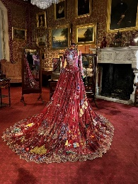

Embroidery pieces would be produced by the local schools, groups and organisations by the end of January 2024 to allow for sufficient time for all the pieces to be added to the dress with a completion date of end of February.

Following discussion, Councillor Jon Williams proposed that the Town Council organises an International Women’s Day event as detailed above, seconded by Councillor Jenny James, carried unanimously.

**80th Anniversary of D-Day – Thursday 6th June 2024**

Villages, towns, cities and organisations of all sizes across the country are being asked to mark the 80th anniversary of D-Day by lighting a beacon and reading a tribute at 9.15pm on 6th June 2024. There will also be a range of events involving schools and communities during the day. It is suggested that a fish and chip supper could be incorporated within the day’s celebrations as National Fish & Chip Day has been moved to this day for 2024. This can also include a vegan/vegetarian option to be inclusive. The Town Council already has a beacon which they purchased for Platinum Jubilee and we can purchase a new 80th anniversary D-Day crown/top for this beacon. The cost of the new top will be £235 + VAT (this includes delivery).

Following discussion, Councillor Ben Randles proposed that the Town Council organises an 80th Anniversary of D-Day event as detailed above, seconded by Councillor James Nelson, carried unanimously.

Following further discussion, Councillor Jon Williams proposed that a total of £1,000 be allocated from Community Development Grant Aid budget (Nominal Code 5074) to cover the cost of both the above detailed events, seconded by Councillor James Nelson, carried unanimously.

**8.4 Annual Review of Policies & Procedures**

**8.4.1 Safeguarding Children, Young People and Vulnerable Adults Policy**

Councillor James Nelson proposed deferring this to Staffing Committee meeting on 30th October 2023 pending inclusion of reference to possible safeguarding training for all staff plus clarification regarding DBS checks, seconded by Councillor Jon Williams, carried unanimously.

**8.4.2 Detached Youth Work Policy & Guidelines**

Councillor James Nelson proposed deferring this to the October Leisure, Youth & Amenities Committee meeting to enable full review of policy by Youth Development & Participation Worker, seconded by Councillor Jenny James, carried unanimously.

**9 Date of next meeting**

Monday 16th October 2023 at 7.00pm.

The meeting closed at 8.45pm

**APPENDIX A**

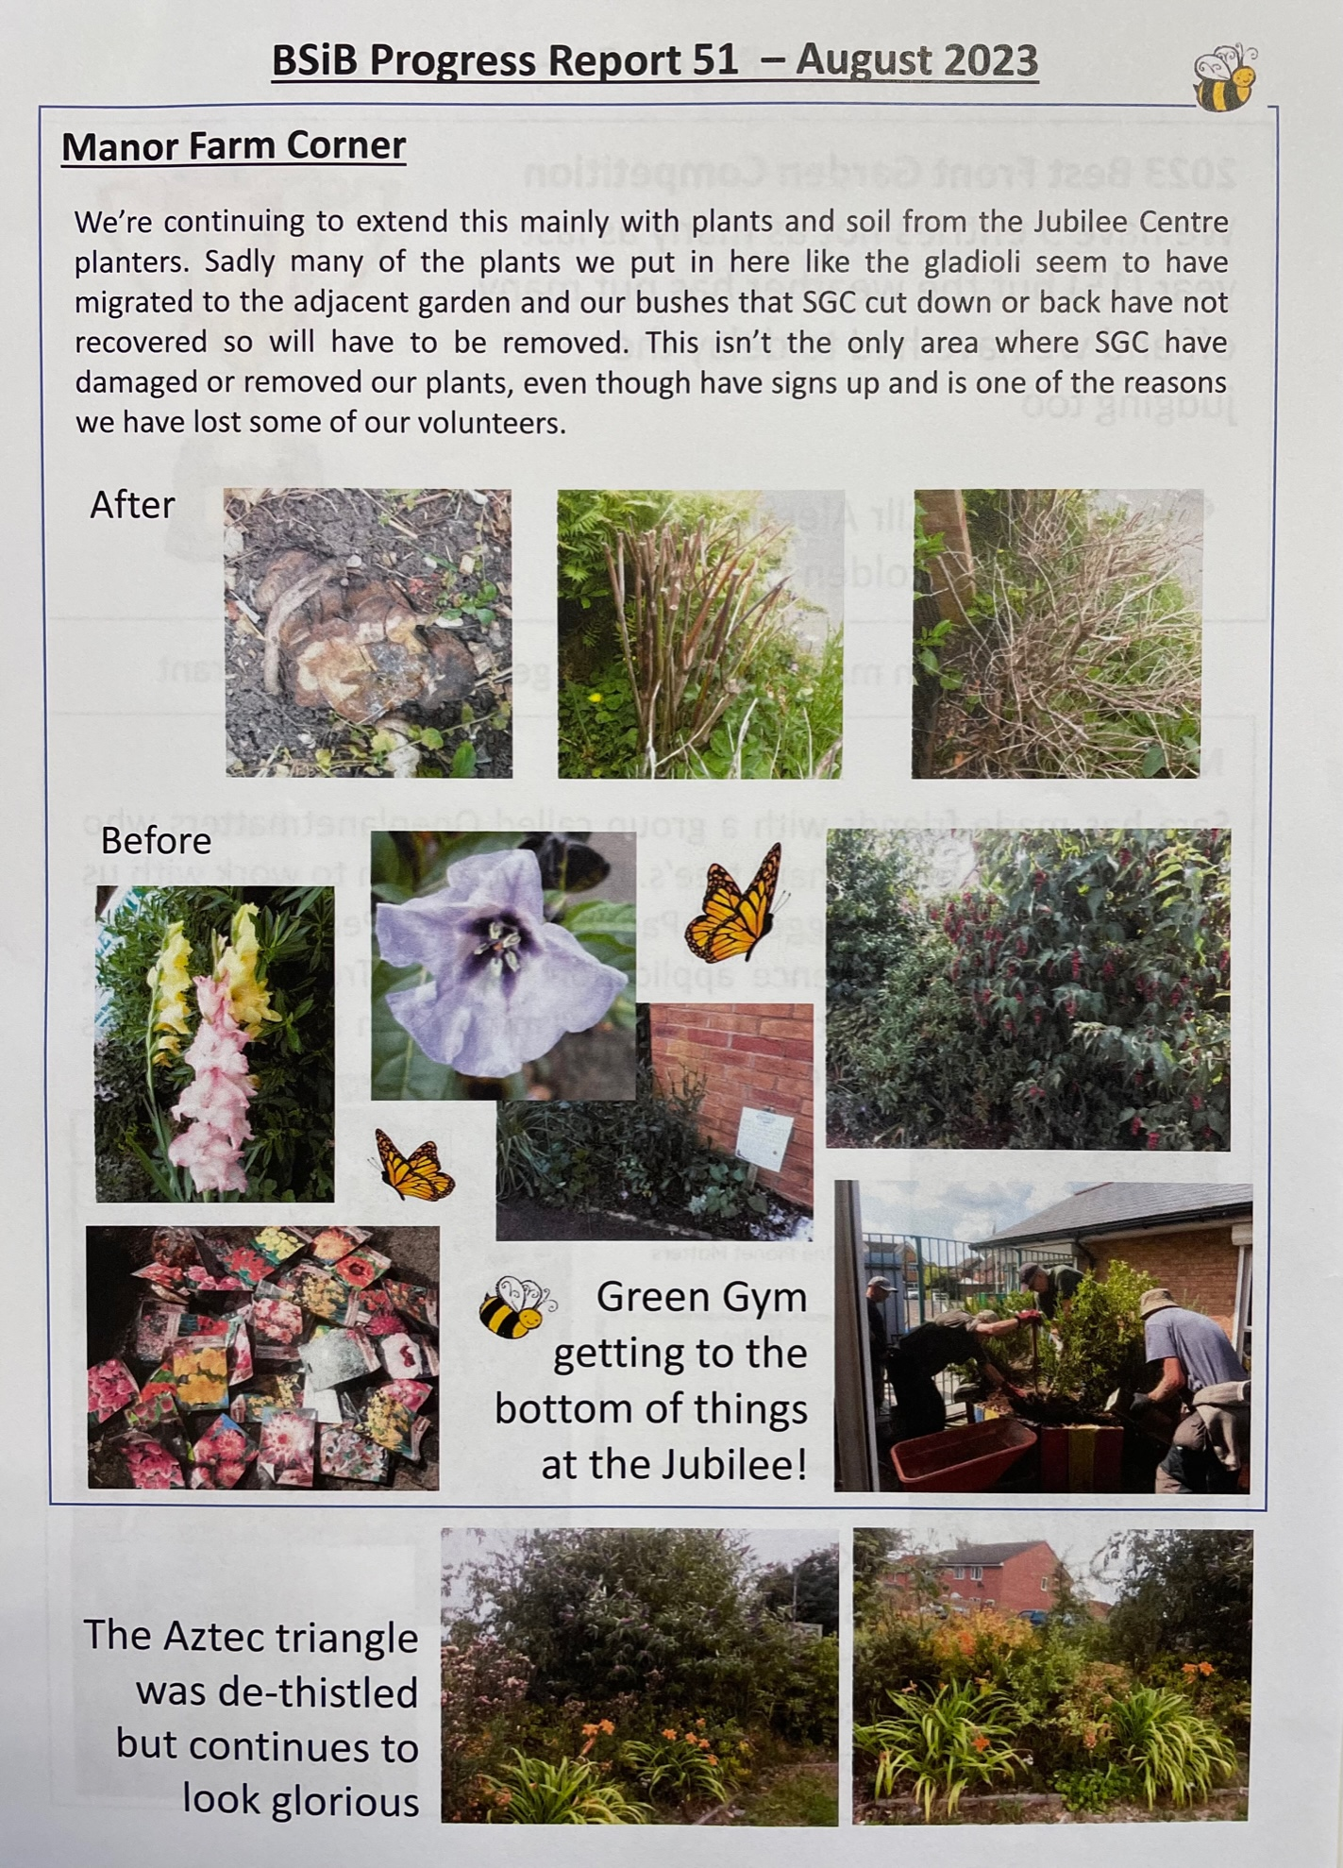

**APPENDIX A**

