International Women’s Day/Red Dress Project Event
Friday 8th March 2024 (6.30 – 8.30pm)
Bradley Stoke Community School

Programme for the Event (subject to change)
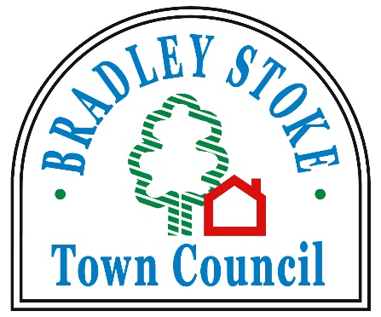
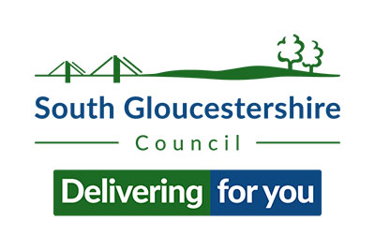
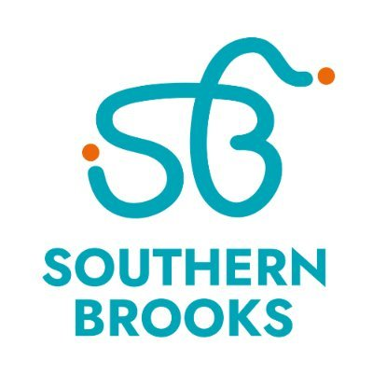
Approximate Timings
6.15 | Arrival
6.30 | Welcome and Introduction to the Evening | Councillor Natalie Field  Liz Evans, Southern Brooks
6.35 | The Origins of International Women’s Day | Councillor Natalie Field  Liz Evans, Southern Brooks
6.40 | Women’s Heritage – The Past  The Origins of Women’s Rights Movement | Councillor Jenny James
6.55 | Selection of Songs Empowering to Women | Bradley Stoke Community Singers
7.05 | Women at Work | Fleur Mosley – Specialist Paramedic in critical care at Great Western Air Ambulance Charity
7.15 | Short Comfort Break
7.25 | The International Red Dress Project – The Present  A 14 year, award winning, global, collaborative embroidery project | Kirstie Macleod – the British Artist who conceived the innovative project
7.45 | Refreshment break and opportunity to visit information stalls in the dining room
8.10 | We Rise – The Future  An organisation dedicated to empowering women and transforming lives through education, advocacy and support | Aaliyah Hussain – founder of We Rise
8.20 | Our Local Pink/Red Dress Project | Councillor Natalie Field  Liz Evans, Southern Brooks
8.30 | Video from International Women’s Day 2023
8.35 | Finish

